Regression Analysis Project
Session: Fall 2011
Registration ID: 38079767
Student Name: xxxxx xxxx

Contraceptive use
1. Introduction
For this project, logistic regression analysis was designed to analyze the relationship of contraception with 3 explanatory variables: I used (i) children number ,(ii) age of woman, (iii) region of residence as explanatory variables.

2. Data
I’ve used “Bang” data which is published in “epicalc” package in R. The dataset Bang consists of a subset of data from the '1988 Bangladesh Fertility Survey'. This data is provided in “Exercises” section in “epicalc” package. The file consists of a subsample of 1934 women grouped in 60 districts. I have tried to apply regression analysis using “Bang” data. The dataset is available at http://127.0.0.1:12476/library/epicalc/html/bang.html. The source is from “Huq, N. M., and Cleland, J. 1990. Bangladesh Fertility Survey 1989 (Main Report). Dhaka: National Institute of Population Research and Training”.

This data “Bang” utilizes the following format and variables:

-------------------------------------------------------------------------------------------------------------
A data frame with 1934 observations on the following 7 variables.
woman
identifying code of each woman
district
identifying code for each district
user
1 = using contraceptive 0 = not using
living.children
Number of living children at time of survey
 | 1 | = none
 | 2 | = 1
 | 3 | = 2
 | 4 | = 3 or more
age_mean
age of woman in years, centred around the mean
urban
Type of region of residence: 1 = urban, 0 = rural
constant
constant term = 1
-------------------------------------------------------------------------------------------------------------
To explore the determinants whether contraceptive use or not among women, we fit models using binary logistic regression. The effects of the logistic regression model are reported as odds ratios (ORs) and 95% confidence intervals (CIs). ORs were adjusted for number of living children at time of survey (living.children), age of woman in years centred around the mean (age_mean), and type of region of residence (urban). The data was analyzed using R software (version 2.13.1).

3. Results
3.1 Descriptive statistics
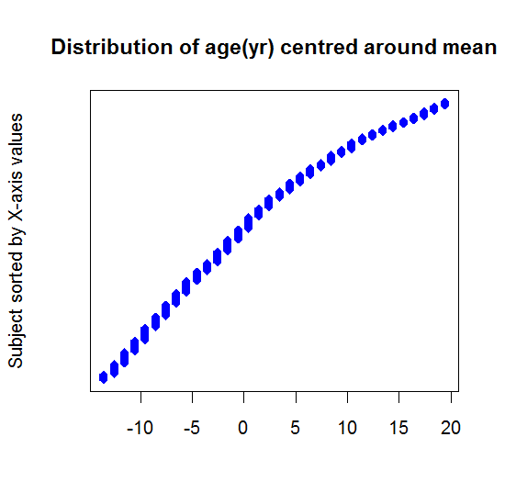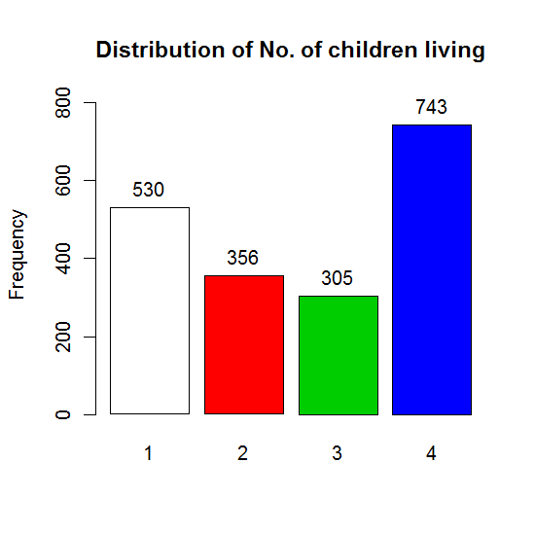
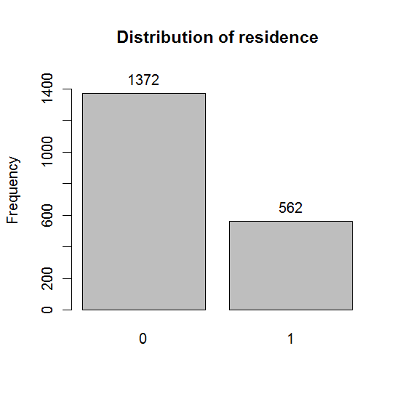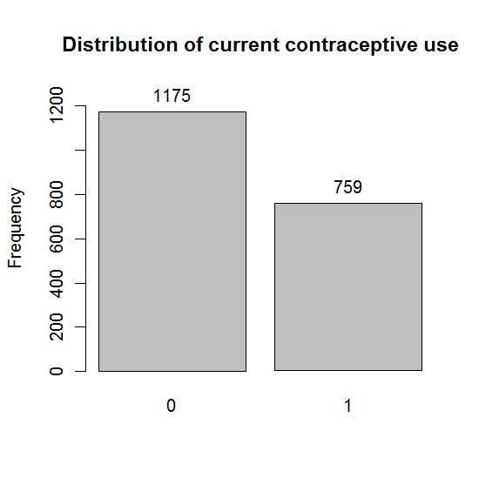
Figures present the distributions of age centered around mean, number of children living, residence and current contraceptive use. The number of people with contraceptive use was 759 (39.2%) of the total survey population. Women with 3 or more living children at time of survey was 743 (38.7%) of all respondents.

3.2 Logistic regression (using glm, family=binomial)

MODEL 1(only one covariate : living.children)
Table 1. Odds ratios (95% confidence intervals) of contraceptive use
 | Estimate | Std.Error |  | aORs |  | 95% CI | P (Wald's test) | P (LR-test)
Intercept | -1.0936 | 0.1002
living.children 1 |  |  |  | ref
living.children 2 | 0.936 | 0.1461 |  | 2.55 |  | 1.91-3.39 | <0.001 | <0.001
living.children 3 | 1.0214 | 0.1522 |  | 2.78 |  | 2.06-3.74 | <0.001
living.children 4 | 0.787 | 0.1247 |  | 2.20 |  | 1.72-2.81 | <0.001
Note: aOR =Adjusted odds ratio
CI=Confidence interval

MODEL 2 (two covariate : living.children, age_mean)
Table 2. Odds ratios (95% confidence intervals) of contraceptive use
 | Estimate | Std.Error |  | aORs |  | 95% CI | P (Wald's test) | P (LR-test)
Intercept | -1.2651 | 0.1167
living.children 1 |  |  |  | ref
living.children 2 | 1.0222 | 0.1495 |  | 2.78 |  | 2.07-3.73 | <0.001 | <0.001
living.children 3 | 1.1976 | 0.1643 |  | 3.31 |  | 2.4-4.57 | <0.001
living.children 4 | 1.1144 | 0.1677 |  | 3.05 |  | 2.19-4.23 | <0.001
age_mean | -0.0218 | 0.0074 |  | 0.98 |  | 0.96-0.99 | 0.003 | 0.003
Note: aOR =Adjusted odds ratio
CI=Confidence interval

MODEL 3 (three covariate : living.children, age_mean, urban)
Table 3. Odds ratios (95% confidence intervals) of contraceptive use
 | Estimate |  | Std.Error | aORs |  | 95% CI | P (Wald's test) | P (LR-test)
Intercept | -1.568 |  | 0.1262
living.children 1 |  |  |  | ref
living.children 2 | 1.0592 |  | 0.152 | 2.88 |  | 2.14-3.88 | <0.001 | <0.001
living.children 3 | 1.2878 |  | 0.1672 | 3.62 |  | 2.61-5.03 | <0.001
living.children 4 | 1.2164 |  | 0.1706 | 3.38 |  | 2.42-4.71 | <0.001
age_mean | -0.024 |  | 0.0075 | 0.98 |  | 0.96-0.99 | 0.001 | 0.001
urban 1 | 0.7971 |  | 0.1052 | 2.22 |  | 1.81-2.73 | <0.001 | <0.001
Note: aOR =Adjusted odds ratio
CI=Confidence interval

Table 3 is final model. The ORs for ‘number of living children’ was statistically significant and similar to that seen from the model 1 and 2. Lower age was less likely to use contraception than older age. Living urban area increase the risk significantly compared to living rural area.

4. Conclusion
This paper identified several relevant factors related with contraceptive use such as age, current number of children and type of residence. Younger age women were less likely to use contraception after adjusting for other variables. In addition, respondents with having children had significantly higher ORs of contraceptive use than no children. Living urban area was higher ORs than those with rural area.

