xxxxx xxxxxx
Time Series Project
Exam session: Summer 2010
Project Date: April 5, 2012

Introduction
For my time series project, I chose to model the price of Poultry, specifically chicken. It is one of the healthier meats at the grocers, and the only kind that my family consumes. I thought it would be interesting to model the price of this item over time for my project.
Data
The source of my data is http://www.indexmundi.com/commodities/?commodity=chicken&months=120 , their original source being the USDA Market News. Data was taken as is without any validation other than reasonability checks. The price is spot US Cents per Pound of weight for the whole bird, Georgia docks. Data is for every month for 10 years from Jan 2002 - Dec 2011.
Analysis
First I graphed the price over time to find if there was any variability in price at all. Please refer tab Original Time Series in the accompanying worksheet.
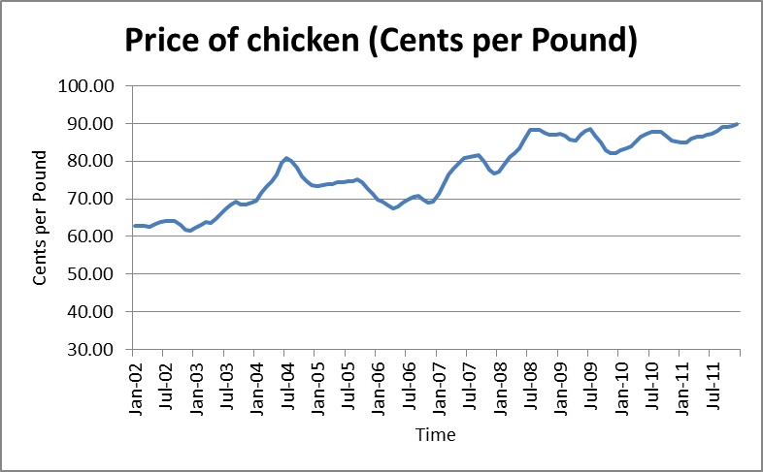
It is clear that the price varies over time and that there is an overall upward trend in the prices over 10 years. Since there are some ups and downs within the 10 years, I decided to test for seasonality by graphing each years data separately by month. Please refer tab Seasonality.
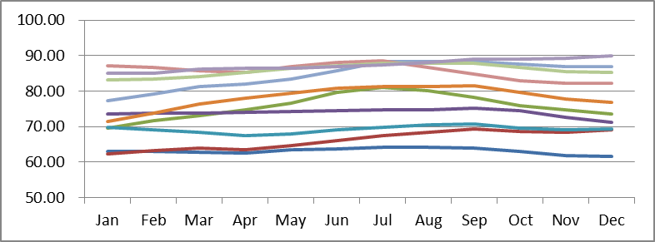
Each line in the graph represents one year’s trend. Although there is some downward trend in prices starting from Sep-Oct, it is not evident in all years and therefore I ruled out seasonality in price of chicken.
Test for Stationarity of Original Time Series
Before modeling the price, I had to first determine if the time series is stationary. For this, I used the formulas provided in the Illustrative worksheet from NEAS, where the autocorrelation is calculated using the following formula assuming stationarity:
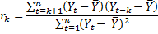
Please refer tab Original Time Series for the autocorrelation calculations. The graph of the autocorrelation is below:
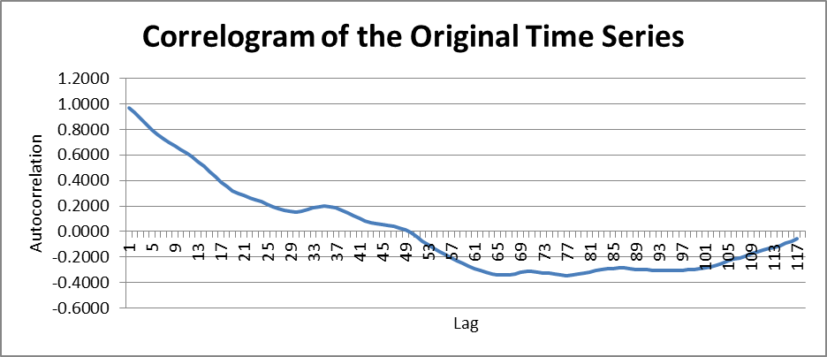
For the time series to be stationary, the autocorrelation has to quickly drop off to zero and oscillate around it. At 95% confidence level, the autocorrelation points have to be within + or – 0.179. This is not happening in the graph above. Therefore we conclude that the original time series is not stationary.

Transformation using First Differences
Since the time series is not exhibiting an exponential trend, taking first differences to achieve stationarity is a good first option. Please refer to tab First Diff for the calculation of the First Diff using the formula , and the autocorrelation calculations. The following graph was produced:

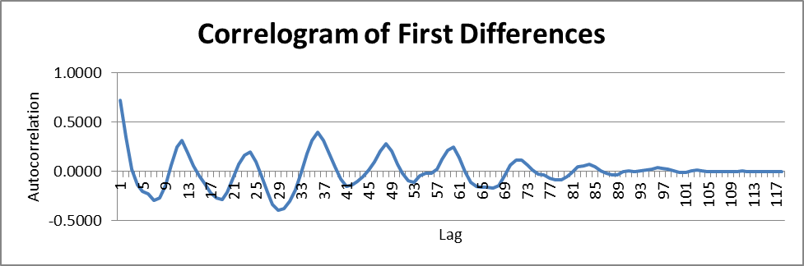
From the above, it is obvious that the autocorrelation quickly drops to zero around lag 4 and oscillates around it till tapering off to zero eventually. This points to a stationary process. Therefore, I did not do any further differencing or other transformations. We can proceed now with modeling the first difference of the original time series.

ARIMA Models
I decided to use the most common ARIMA model for first differences, namely AR(p) that is the equivalent of ARIMA(p,1,0). The excel function Regression was used to calculate these. Detailed results can be found in the tabs AR(1), AR(2), and AR(3). Following are the results:

First Order Auto Regressive Process - AR(1)
Second Order Auto Regressive Process - AR(2)
Third Order Auto Regressive Process - AR(3)
Analysis of results

Test of stationarity:

AR(1):

The solution of the AR(1) process should satisfy the stationarity condition of .

For our data,

The condition is satisfied.

AR(2):

The solution of the AR(2) process should satisfy the following stationarity conditions:

, , and .

For our data,

All three conditions are satisfied.

AR(3):

The solution of the AR(3) process should satisfy the following stationarity conditions:
, and

For our data,

Both conditions are satisfied.

Test of the null hypothesis that the residuals are white noise

Two tests are used to test this hypothesis – the Durbin Watson (DW) test and the Box-Pierce Q (BPQ) test. A DW statistic close to 2 and a BPQ statistic lower than the critical chi-square value would result in us not rejecting the null hypothesis. The results from the regression analysis are below. Detailed calculations were made in the excel spreadsheet using the formulas provided in the illustrative worksheet.

Model | Durbin Watson statistic | Box Pierce Q statistic | Critical Chi-square value for 10% significance level | Chi-square p value | Degrees of Freedom
AR1 | 1.4543 | 150.24 | 133.73 | 0.0130 | 114
AR2 | 2.0905 | 86.58 | 134.81 | 0.9778 | 113
AR3 | 1.9649 | 77.10 | 133.73 | 0.9968 | 112

AR(1) is rejected as a good model since the BPQ statistic is bigger than the critical chi-square value. The AR(2) model has a DW statistic of 2.0905, which, along with the BPQ statistic being lower than the critical chi-square value proves to be a very good model in predicting the first differences of the price of chicken. The AR(3) model, while statistically sound, is more complex to model and we might run into the risk of overfitting and hence is rejected.

Further, a look at the R Square and Adjusted R Square values shows marked improvement from AR(1) to AR(2), but very little value is added by AR(3), confirming our pick of AR(2) as the optimum model for our data.

 | AR1 | AR2 | AR3
R Square | 0.52315 | 0.59050 | 0.59602
Adjusted R Square | 0.51904 | 0.58331 | 0.58520

Graphical representation of the fit of AR(2)

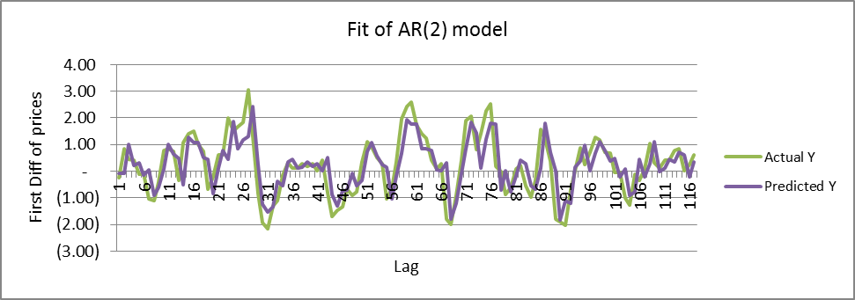

The above graph is further proof that the AR(2) model is a good fit as a predictor of the first differences of the price of chicken using historical data of 10 years.

Conclusion

After achieving stationarity through first differences, the AR(2) model can be used as a valid statistical tool to predict the price of chicken. However, if seasonality in prices is more pronounced than now, the data has to be deseasonalized and the appropriate models used.

