Introduction
Killer whales have long been a focus of human interest and held in high regards scientifically, spiritually and culturally and vastly for entertainment purposes. Various communities of the killer whale are known to inhabit different regions of the oceans, but their colossal range, numbers and concentrations have the researchers both baffled in terms of determining their exact regional densities.
In 2005, November, the Southern Resident Killer Whales of the North Pacific Ocean were added to the list of endangered species according to the Endangered Species Act 2005, being the only community of Killer Whales falling in the category. It had been a subject of vast study since the previous decades, focusing on behavior patterns, threats and population growth rates. Conservation projects are currently underway to protect this group of Killer Whales, and the reservation measures have resulted in an increase in population since then.
This study is based on the population statistics of the Southern Resident Killer Whales documented from 1976 to 2006.
Data
I have used the 31 data points from 1976 to 2006 to test different models, and use the one that fits best for residual analysis.
Data Source: http://www.data360.org/dsg.aspx?Data_Set_Group_Id=800&count=all
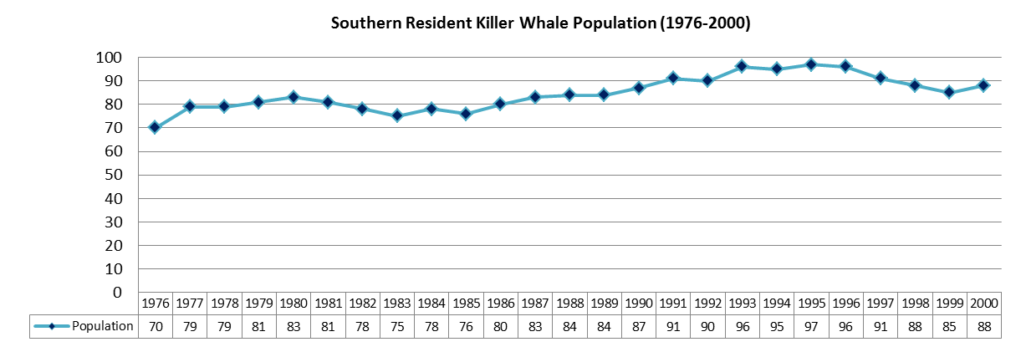
As the data is annual, a seasonality check is not required.
There seems to be a somewhat upward trend in the population statistics. Also, based on the increase in population as a result of the conservative projects, there is good reason to assume an upward sloping graph after 2006. Therefore, an AR(1) Model will not be appropriate as |φ| would be greater than 1.
To better decide on a suitable model I used the Sample Autocorrelation Function (ACF) and a plot of the corresponding correlogram of the initial data based on the 31 data points with a lag of 30 [Excel worksheet: Initial Level ACF].
[To compute the Autocorrelation Functions (ACF) and plotted illustrations of the correlograms for this study, I have used the excel add-in written by Kurt Annen, www.web-reg.de, the link to which I found on one of the NEAS Time Series student project discussions.]
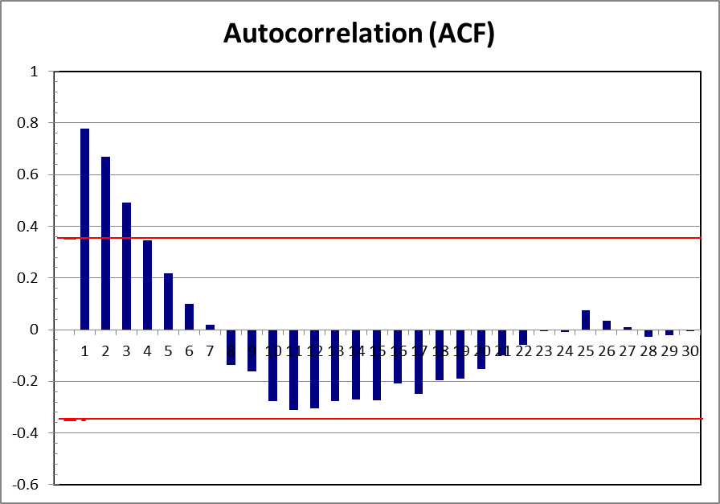

The correlogram seems to suggest a AR(2) model with the ACF dropping to zero by lag 7, decreasing further, then increasing from lag 12 and oscillating around zero from lag 23 to 30. However, before proceeding, I considered the AR(1) and AR(2) Models of the first difference of the log-transformed values of the population figures, i.e.: ARI(1,1) and ARI(1,2), taking into account the somewhat increasing trend of the population graph .
ARI (1,1) of Log-Transformed Population
[Excel Worksheet: ARI(1,1)]
I first computed the log-transformed values of the 31 data points. (Column C), and then used the first differences (Column D) for the AR(1) and AR(2) Models. The ACF of the ARI(1,1) Model with 29 lags is as under:
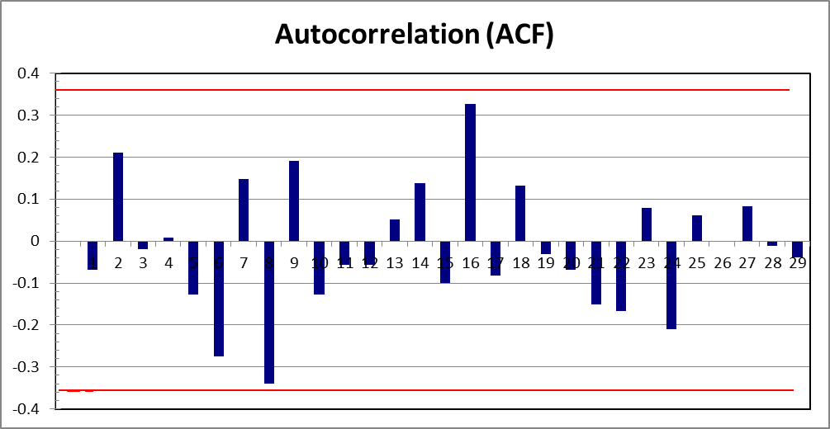
The ACF seems well near zero most of the time. The ACF’s at lags 8 and 16 catch my attention due to being higher than the rest but can be ignored as they are both within the red dotted lines, and therefore not significant.
A regression test gives R-Square equal to 6.29%, in comparison to 74.67% of the AR(2), indicating a very poor model, and can therefore be rejected.

ARI (1,2) of Log-Transformed Population
[Excel Worksheet: ARI(1,2)]
Relating to the same ACF as the ARI(1,1), a regression of this model gives R-Square equal to 6.49%, which is yet again an indication of a poor model. Thus this can be also be rejected.
AR(2) of Original Data
[Excel Worksheet: AR(2)]
Getting back to the AR(2) Model, with an equation of:
Y_{t}= Φ₁Y_{t-1} + Φ₂Y_{t-2} + θ₀ + e_{t}
To calculate the values of Φ_{k,} I carried a regression of the data using the Excel Data Analysis add-in.
We get:
Y_{t}= 0.82Y_{t-1} + 0.03Y_{t-2} + 12.75 + e_{t}
Where e_{t} accounts for residuals.
The stationary conditions of AR(2) are also met:
- Φ₁ + Φ₂ ₌ 0.82+0.03=0.85 < 1
- Φ₂ – Φ₁ ₌ 0.03–0.82 = -0.79 < 1
- | Φ₂ | = 0.03 < 1

Residual Analysis of AR(2) Model
The residuals are the difference between the actual (observed) data and that predicted by the fitted model. In a model of perfect fit, the residuals are normally distributed with mean zero. In other words, the residuals are described to be white noise.
The actual population and that predicted by the fitted AR(2) Model are graphed as under:
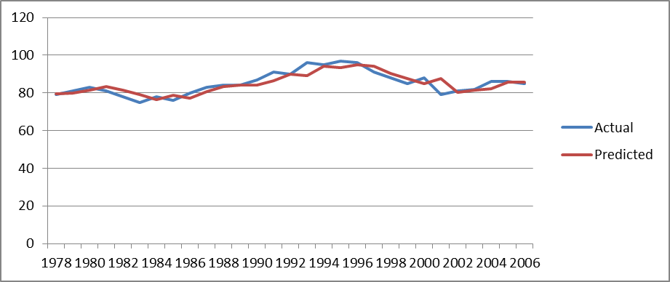
Actual vs Predicted Population Under AR(2) Model
As evident, the predicted figures sway from those observed, resulting in residuals at almost intervals, with barely existing between 1978 and 1981. Calculation of the residuals is present in Excel Worksheet: Residuals Under AR(2).
A Q-Q plot of the residuals based on our AR(2) model [Excel Worksheet: Residual Q-Q Plot] is as under:
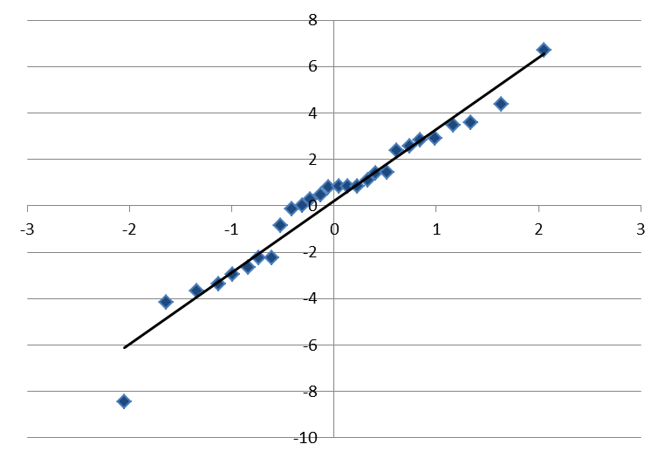
Residuals
Residuals Q-Q Plot
In comparison to the 45degree trend line, the residuals do not seem to be normally distributed, as they clearly do not form a straight line, with one noticeable outlier of -8 at a rank based Z- score of -2.05. However, the residual amounts mostly fall within the range (-4,4) with heavy tails at -8 and 7, which seems a good enough estimate of the population.
Conclusion
I tested the AR(1) and AR(2) models based on the original data, and the ARI(1,1) and ARI(1,2) Models based on the first difference of the log-transformed data values. After analyzing the ACF’s and R-Square values of the various models, the AR(2) Model was chosen to be of the better fit. Putting the fitted model to test over the data of 1978 to 2006, ignoring 1976 and 1977 owing to the two year lag component of the AR(2) Model, it was noticed that the predicted data swayed from that observed, a measure known as Residuals. These residuals were then calculated from 1978 to 2006, and tested for the white noise assumption using a Q-Q plot. The results of this communicated that the residuals do not follow a normal distribution, but fall within a range that demonstrates that the chosen AR(2) model, even though not perfectly capable of predicting future population statistics for the Southern resident Killer Whale, produces results close enough to be considered a dependable model for population forecasting.

