Professional Liability Market Pricing

Introduction

This study attempts to quantify the effects of several rating characteristics and policy conditions on the pricing of professional liability insurance policies. Intuitively, there should be strong correlations here because these are some of the same characteristics that were used to price the policy originally. However, premiums are usually adjusted through underwriter opinion. Often times this adjustment reflects a need to meet market rates, something that is not directly contained in the data. There is a distinct possibility that there are rates being charged for characteristics that are deemed inappropriate by the marketplace. These inappropriate rates may be considered inaccurate, or the characteristics themselves may just be considered insignificant. This study will shed some light on the differences between the company’s pricing methodology and that of the marketplace.

Data

The data has been intentionally generalized or altered in order to protect intellectual property. This has been done by using aliases and does not actually affect the structure of the data at all. The data being used for this study is a block of 3,260 professional liability policies from a three year period. The policies and fields were selected with the requirement that there was an entry for every field and every record. Figure 1 displays the field definitions.

Field | Description | Values
Premium | The final price that was charged for the policy | Continuous: Numeric and positive
Deductible | The deductible for the policy | Discrete: Numeric and positive
Occ Limit | The limit per reported claim that will be paid out | Discrete: Numeric and positive
Agg X | The limit per policy as a multiple of occurrence limit | Discrete: 1, 2, 3
New Renew | New/Renewal indicator | Discrete: N, R
OEP | Optional Extended Reporting period indicator | Discrete: Y, N
Prior Acts | Indicates if prior acts are covered | Discrete: I, D
Manual Quote | Indicates how the policy was quoted | Discrete: A, M
Class | Indicates the risk class of the insured | Discrete: Low, Medium, High
Type | Indicates the type of the insured | Discrete: I, II, III
License | Indicates if the insured has a license | Discrete: Y, N
Degree | Indicates if the insured has an advanced degree | Discrete: Y, N
Loss History | Indicates if the insured’s loss history is a concern | Discrete: Y, N

Figure 1: These are the field definitions in the dataset for this study.

It is evident that there will need to be some transformations done to the data before the regression is performed. All of the boolean indicators will be translated to a 0 or 1 field. Class, Type, and Agg X have three values so they will be transformed into two fields each. For every field that will be treated as a discrete field, the base class is selected as the one which is most prevalent in the data. Despite the fact that Deductible and Occ Limit are discrete and only contain a handful of values, these will be treated as continuous fields. This is done frequently in the industry to determine increased limit factors and deductible factors. Also, the relative magnitudes do have meaning, hence it is not just a class variable. This is further supported in the transformation that is applied to Premium, Deductible, and Occ Limit.

Data Preparation

Often, regression analysis is more useful, and intuitive, when transformations are applied to the underlying data. A q-q plot can determine the need for such transformations. Figure 2 shows the q-q plots for Premium, Deductible, and Occ Limit alongside those for the natural logarithm of the associated field.

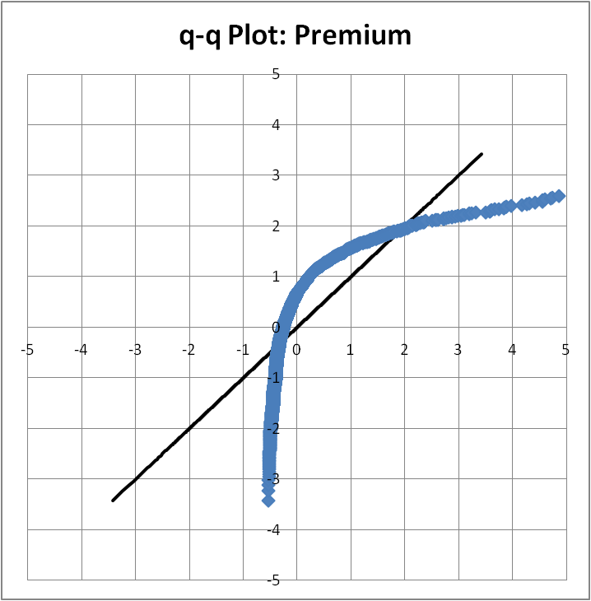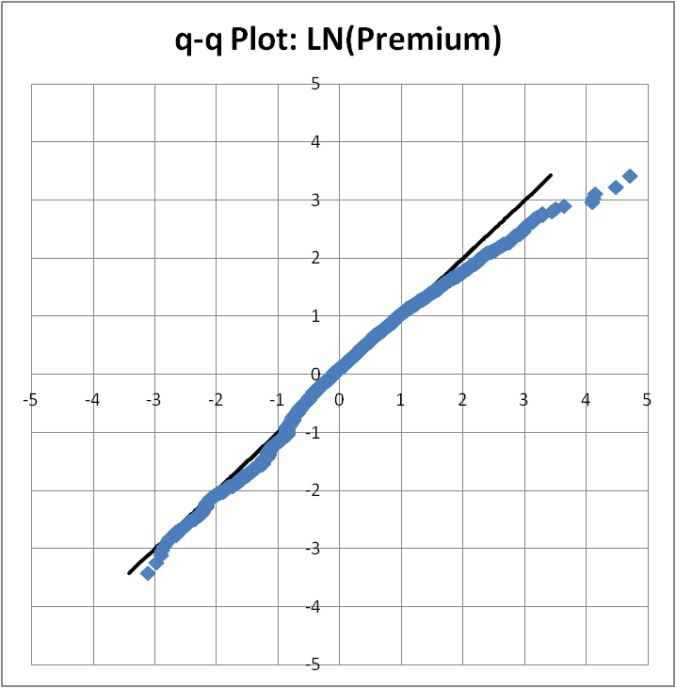
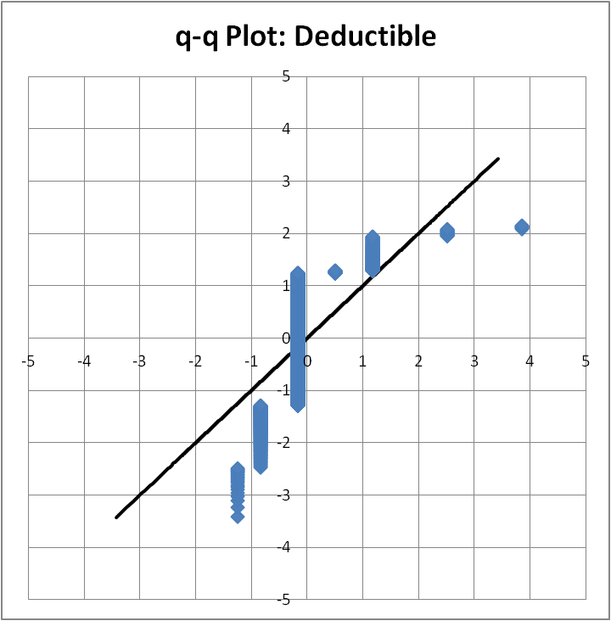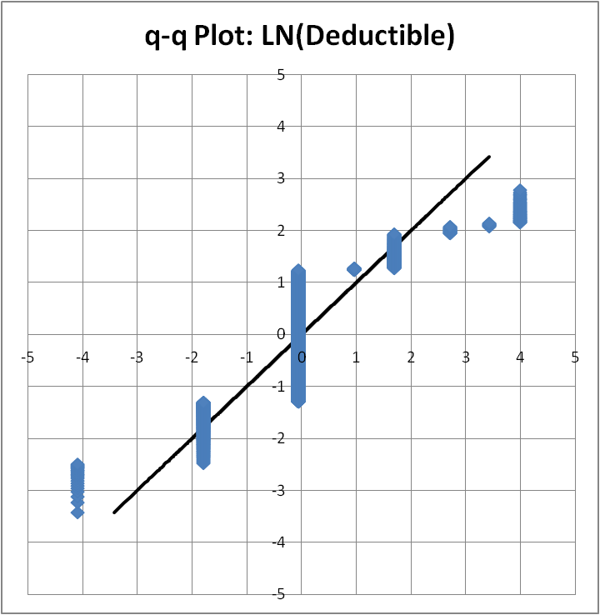
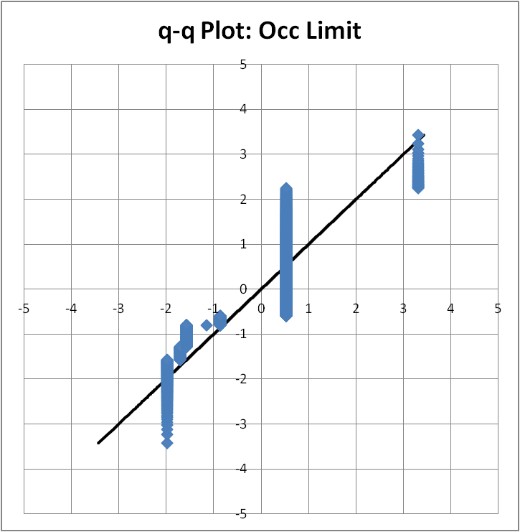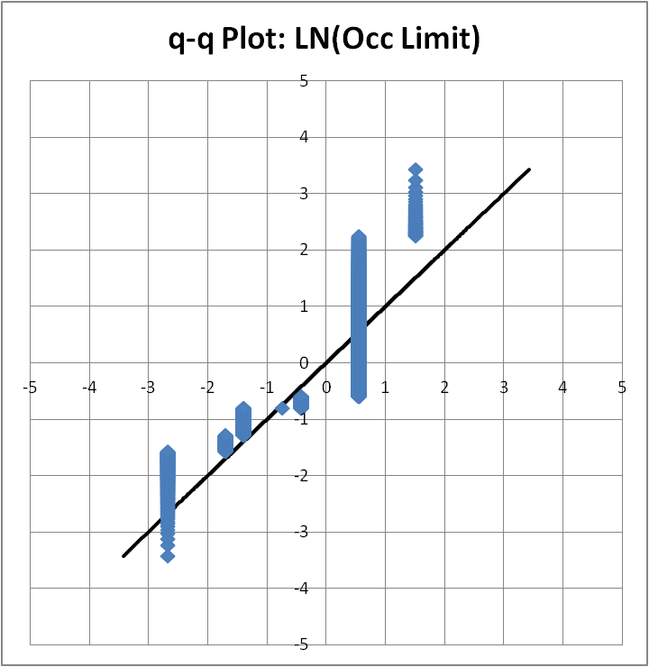

Figure 2: q-q Plots for Premium, Deductible, and Occ Limit and their natural logarithm transformations. In all three cases there is evidence that the transformation improves the normality of the data.

The q-q plots demonstrate that the natural logarithm transformation will improve the normality of all three variables. This turns an additive model into a multiplicative model which makes intuitive sense since most rating characteristics affect the premium in a multiplicative fashion. After taking these transformations into consideration and after accounting for polytomous variables with dummy variables, Figure 3 shows the new data definitions that will be used for the regression analysis.

Field | Base Class (if applicable) | Type
LN(Premium) | N/A | Continuous
LN(Deductible) | N/A | Continuous
LN(Occ Limit) | N/A | Continuous
Agg X1 | 3 | 0, 1
Agg X2 | 3 | 0, 1
New Policy | Renew | 0, 1
OEP | N | 0, 1
Retro Inception | D | 0, 1
Manual Quote | Auto-quote | 0, 1
High | Low | 0, 1
Medium | Low | 0, 1
TypeII | TypeI | 0, 1
TypeIII | TypeI | 0, 1
License | N | 0, 1
Degree | N | 0, 1
Loss History | N | 0, 1

Figure 3: These are data definitions for the fields as they will be used in the regression analysis. The complete base class is the auto-quoted renewal of a low risk type I, who has no license or advanced degree, has no loss history, did not elect for an optional extended reporting period, has prior acts coverage and whose policy limit is 3 times its occurrence limit.

There are a few obvious correlations in this dataset. For instance, retro-inception policies will almost always be new policies. Also, a high risk insured will most likely have a concerning loss history. The table of correlations in Figure 4 will help to quantify the extent of these correlations and to uncover some correlations which are not as obvious. These correlations will be considered during the model selection process. When there is a high correlation between two explanatory variables, one can be omitted from the model. This will simplify the model while only marginally degrading the explanatory power of the model.

 | LN(Deductible) | LN(Occ Limit) | Agg X1 | Agg X2 | New Policy | OEP | Retro Inception | Manual Quote | High | Medium | TypeII | TypeIII | License | Degree
LN(Occ Limit) | -0.02
Agg X1 | 0.01 | -0.04
Agg X2 | 0.03 | -0.07 | -0.02
New Policy | -0.07 | 0.01 | -0.01 | -0.02
OEP | 0.02 | 0.03 | -0.02 | 0.00 | -0.01
Retro Inception | -0.10 | 0.00 | 0.00 | 0.00 | 0.82 | 0.00
Manual Quote | 0.11 | -0.03 | 0.00 | 0.00 | -0.01 | 0.43 | -0.03
High | 0.07 | -0.05 | 0.00 | -0.02 | 0.06 | -0.01 | 0.14 | -0.04
Medium | -0.02 | 0.05 | -0.02 | -0.02 | 0.05 | 0.01 | 0.04 | -0.02 | -0.14
TypeII | -0.13 | 0.08 | 0.04 | 0.05 | -0.09 | -0.03 | -0.04 | -0.07 | 0.27 | 0.00
TypeIII | 0.01 | 0.04 | -0.04 | -0.04 | 0.01 | -0.03 | -0.02 | -0.05 | 0.16 | -0.03 | -0.16
License | 0.05 | -0.03 | -0.04 | 0.00 | 0.00 | 0.02 | -0.02 | 0.05 | -0.08 | -0.04 | -0.28 | 0.05
Degree | 0.06 | -0.02 | -0.05 | -0.01 | 0.05 | 0.02 | -0.01 | 0.05 | -0.02 | -0.04 | -0.22 | 0.09 | 0.60
Loss History | 0.05 | 0.04 | 0.00 | -0.03 | -0.01 | -0.02 | 0.02 | -0.01 | 0.58 | -0.08 | 0.17 | 0.13 | 0.02 | 0.07

Figure 4: This table of correlations shows the interdependencies of the explanatory variables. Most of the correlations are acceptable. The highlighted correlations are cause for some concern.

Model Consideration

The approach that will be taken in this study is a top down approach. A model with every characteristic will be considered first. Insignificant variables will become evident. These will be removed and the regression will be rerun. Figure 5 shows the regression analysis results of the “Full” model and Figure 6 shows the resulting q-q plot for the residuals.

Regression Statistics
Multiple R | 0.6851
R Square | 0.4694
Adjusted R Square | 0.4669
Standard Error | 0.6754
Observations | 3260

ANOVA
 | df | SS | MS | F | Significance F
Regression | 15 | 1308.8655 | 87.2577 | 191.2962 | 0
Residual | 3244 | 1479.7156 | 0.4561
Total | 3259 | 2788.5811

 | Coefficients | Standard Error | t Stat | P-value | Lower 95% | Upper 95%
Intercept | -0.4588 | 0.3463 | -1.3251 | 0.1852 | -1.1377 | 0.2201
LN(Deductible) | 0.7225 | 0.0307 | 23.5630 | 0.0000 | 0.6624 | 0.7826
LN(Occ Limit) | 0.2754 | 0.0168 | 16.3474 | 0.0000 | 0.2424 | 0.3084
Agg X1 | -0.1440 | 0.0792 | -1.8173 | 0.0693 | -0.2993 | 0.0114
Agg X2 | -0.1852 | 0.0846 | -2.1893 | 0.0286 | -0.3510 | -0.0193
New Policy | 0.1769 | 0.0439 | 4.0289 | 0.0001 | 0.0908 | 0.2630
OEP | 0.6953 | 0.1071 | 6.4950 | 0.0000 | 0.4854 | 0.9052
Retro Inception | -0.9093 | 0.0480 | -18.9312 | 0.0000 | -1.0035 | -0.8152
Manual Quote | 0.2502 | 0.0499 | 5.0164 | 0.0000 | 0.1524 | 0.3481
High | 0.4648 | 0.0365 | 12.7466 | 0.0000 | 0.3933 | 0.5363
Medium | 0.0874 | 0.0503 | 1.7375 | 0.0824 | -0.0112 | 0.1861
TypeII | -0.5940 | 0.0302 | -19.6810 | 0.0000 | -0.6531 | -0.5348
TypeIII | 0.0793 | 0.0512 | 1.5493 | 0.1214 | -0.0211 | 0.1797
License | 0.0533 | 0.0321 | 1.6604 | 0.0969 | -0.0096 | 0.1163
Degree | 0.2331 | 0.0339 | 6.8762 | 0.0000 | 0.1666 | 0.2995
Loss History | 0.1500 | 0.0493 | 3.0436 | 0.0024 | 0.0534 | 0.2466

Figure 5: These are the results from Excel’s Regression Analysis tool for the “Full” model.

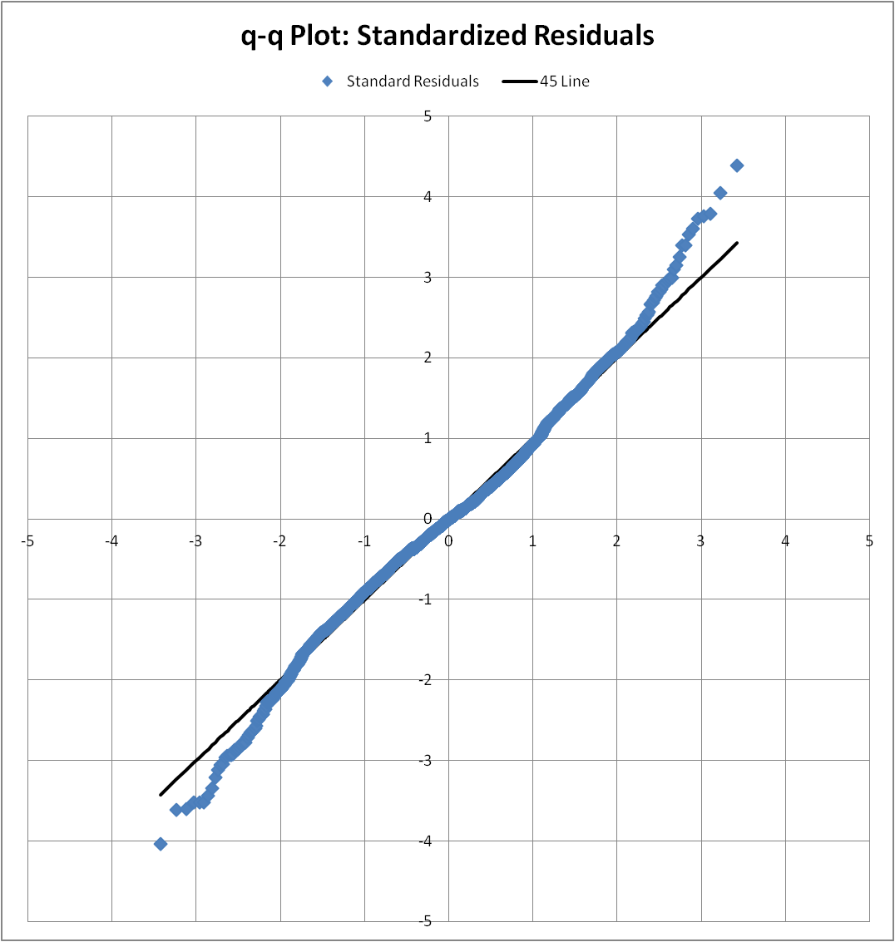

Figure 6: The q-q plot for the “Full” model. The residuals are clearly not normally distributed.

The adjusted R² value of .4669 is not exactly stellar. However, many characteristics that were used to rate these policies were removed so this is expected. The alarming item in these results is the q-q plot. This shows that the residuals are clearly not normally distributed. The plot indicates that the distribution of the residuals is roughly symmetric and heavy-tailed. A transformation down the ladder of powers to the premium should be able to fix this. After some investigation, the selected transformation is LN(Premium)~^.75. The ~ indicates it is mean adjusted to preserve the symmetry. Figure 7 shows the results of the regression after performing this transformation.

Regression Statistics
Multiple R | 0.6855
R Square | 0.4699
Adjusted R Square | 0.4675
Standard Error | 0.6327
Observations | 3260

ANOVA
 | df | SS | MS | F | Significance F
Regression | 15 | 1151.1528 | 76.7435 | 191.7301 | 0
Residual | 3244 | 1298.4709 | 0.4003
Total | 3259 | 2449.6237

 | Coefficients | Standard Error | t Stat | P-value | Lower 95% | Upper 95%
Intercept | -8.8403 | 0.3244 | -27.2546 | 0.0000 | -9.4762 | -8.2043
LN(Deductible) | 0.6320 | 0.0287 | 22.0034 | 0.0000 | 0.5757 | 0.6883
LN(Occ Limit) | 0.2625 | 0.0158 | 16.6341 | 0.0000 | 0.2316 | 0.2935
Agg X1 | -0.1328 | 0.0742 | -1.7892 | 0.0737 | -0.2783 | 0.0127
Agg X2 | -0.1687 | 0.0792 | -2.1289 | 0.0333 | -0.3240 | -0.0133
New Policy | 0.1576 | 0.0411 | 3.8308 | 0.0001 | 0.0769 | 0.2382
OEP | 0.7076 | 0.1003 | 7.0562 | 0.0000 | 0.5110 | 0.9042
Retro Inception | -0.8688 | 0.0450 | -19.3075 | 0.0000 | -0.9570 | -0.7805
Manual Quote | 0.1858 | 0.0467 | 3.9765 | 0.0001 | 0.0942 | 0.2774
High | 0.4397 | 0.0342 | 12.8709 | 0.0000 | 0.3727 | 0.5067
Medium | 0.0958 | 0.0471 | 2.0330 | 0.0421 | 0.0034 | 0.1883
TypeII | -0.5798 | 0.0283 | -20.5070 | 0.0000 | -0.6352 | -0.5243
TypeIII | 0.1372 | 0.0480 | 2.8619 | 0.0042 | 0.0432 | 0.2313
License | 0.0622 | 0.0301 | 2.0683 | 0.0387 | 0.0032 | 0.1212
Degree | 0.2082 | 0.0318 | 6.5566 | 0.0000 | 0.1459 | 0.2705
Loss History | 0.1240 | 0.0462 | 2.6858 | 0.0073 | 0.0335 | 0.2145

Figure 7: These are the results from Excel’s Regression Analysis tool for the “Full” model after the transformation.

The adjusted R² value did not change very much at all. However, the p-values of all of the coefficients moved in the direction of more significance. Figure 8 shows the results of the q-q plot of the standardized residuals after this transformation. These residuals are very close to normally distributed with one outlier. Figure 8 also has the q-q plot of the premium after this transformation. A comparison of this plot to the corresponding plot in Figure 2 shows that the premium is not significantly less normally distributed while still achieving a normal distribution of the residuals.
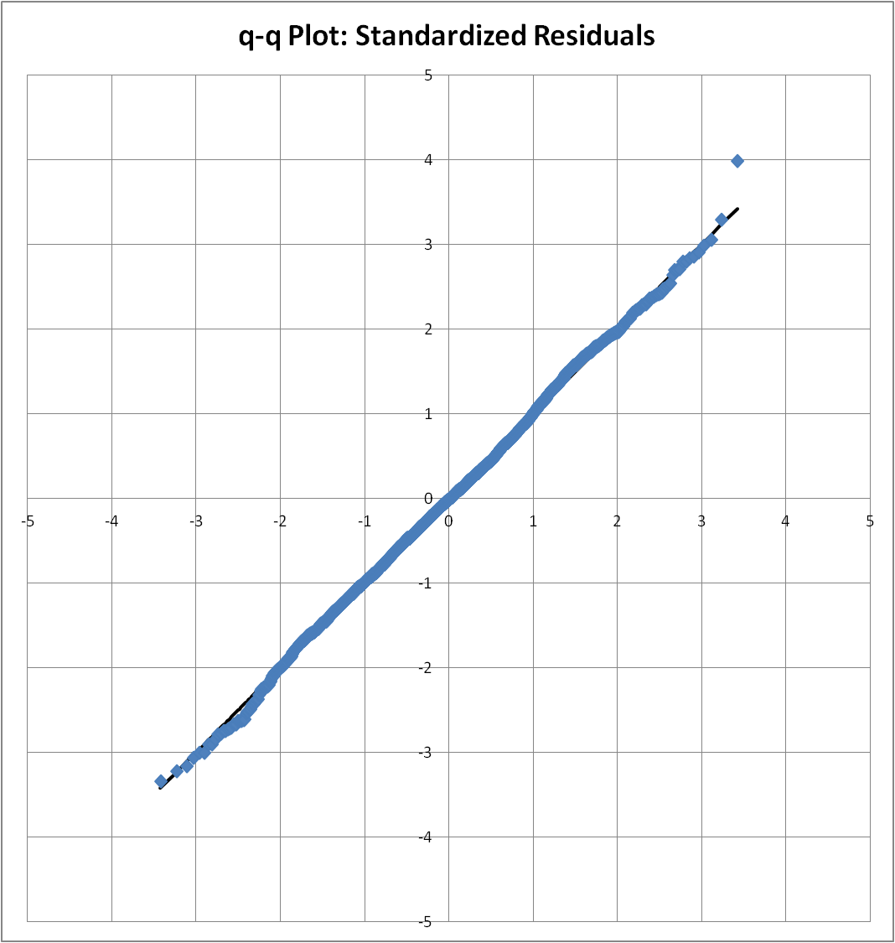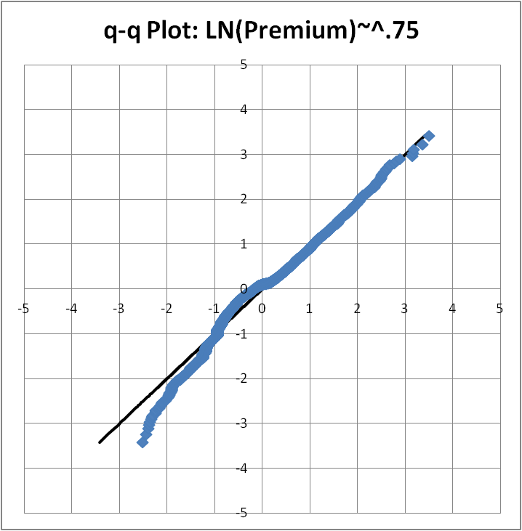

Figure 8: On the left is the q-q plot for the “Full” model after the power transformation. The residuals closely resemble a normal distribution. On the right is the q-q plot of the premium after the power transformation. The premium distribution now shows that a thin right tail was replaced by a thick left tail.

At this point, some explanatory variables will be eliminated in order to simplify the model. The logical variables to start with are those which have strong correlations with other explanatory variable as indicated in Figure 4. The strongest correlation is between the New Policy indicator and the Retro Inception indicator. Since a policy cannot be forced to be new, the Retro Inception indicator makes more sense to keep. The correlation between the price and the Retro Inception indicator also has a more intuitive explanation. Likewise, whether a policy is auto-quoted or manually quoted is determined by several other characteristics of the policy and of the insured. The Manual Quote indicator may not show a strong correlation for all of the explanatory variables, but there should be a correlation for combinations of variables. Since there is also a strong correlation between the Manual Quote indicator and the OEP indicator, it would make sense to then remove the Manual Quote indicator from the model. Surprisingly, there is only one explanatory variable which has a strong correlation with the Loss History indicator. Most likely, this is strongly considered when assigning an insured with the High risk class designation. The Medium indicator has no strong correlations with the other variables. Since the High indicator and the Medium indicator are dummy variables created from the same indicator, Loss History should be removed from the model. The last correlation to consider is that between the License and Degree indicators. There is no clear reason to choose one of these over the other. Because of that, the regression will be run once with each to make the determination. Figures 9 and 10 show the results of these two regressions.

Regression Statistics
Multiple R | 0.6804
R Square | 0.4630
Adjusted R Square | 0.4611
Standard Error | 0.6364
Observations | 3260

ANOVA
 | df | SS | MS | F | Significance F
Regression | 11 | 1134.0680 | 103.0971 | 254.5383 | 0
Residual | 3248 | 1315.5557 | 0.4050
Total | 3259 | 2449.6237

 | Coefficients | Standard Error | t Stat | P-value | Lower 95% | Upper 95%
Intercept | -8.9402 | 0.3252 | -27.4952 | 0.0000 | -9.5777 | -8.3027
LN(Deductible) | 0.6467 | 0.0287 | 22.5120 | 0.0000 | 0.5904 | 0.7030
LN(Occ Limit) | 0.2640 | 0.0158 | 16.6973 | 0.0000 | 0.2330 | 0.2950
Agg X1 | -0.1344 | 0.0746 | -1.8001 | 0.0719 | -0.2807 | 0.0120
Agg X2 | -0.1831 | 0.0796 | -2.2999 | 0.0215 | -0.3393 | -0.0270
OEP | 0.8761 | 0.0909 | 9.6370 | 0.0000 | 0.6978 | 1.0543
Retro Inception | -0.7350 | 0.0262 | -28.0829 | 0.0000 | -0.7863 | -0.6837
High | 0.4762 | 0.0288 | 16.5434 | 0.0000 | 0.4198 | 0.5327
Medium | 0.0935 | 0.0474 | 1.9737 | 0.0485 | 0.0006 | 0.1864
TypeII | -0.5971 | 0.0279 | -21.3994 | 0.0000 | -0.6519 | -0.5424
TypeIII | 0.1393 | 0.0481 | 2.8939 | 0.0038 | 0.0449 | 0.2336
Degree | 0.2628 | 0.0261 | 10.0782 | 0.0000 | 0.2117 | 0.3139

Figure 9: These are the results of the regression analysis with a reduce number of explanatory variables and including Degree.

Regression Statistics
Multiple R | 0.6748
R Square | 0.4553
Adjusted R Square | 0.4535
Standard Error | 0.6409
Observations | 3260

 | Coefficients | Standard Error | t Stat | P-value | Lower 95% | Upper 95%
Intercept | -9.0021 | 0.3276 | -27.4756 | 0.0000 | -9.6445 | -8.3597
LN(Deductible) | 0.6536 | 0.0289 | 22.5983 | 0.0000 | 0.5968 | 0.7103
LN(Occ Limit) | 0.2646 | 0.0159 | 16.6218 | 0.0000 | 0.2334 | 0.2959
Agg X1 | -0.1437 | 0.0752 | -1.9112 | 0.0561 | -0.2910 | 0.0037
Agg X2 | -0.1882 | 0.0802 | -2.3463 | 0.0190 | -0.3454 | -0.0309
OEP | 0.8802 | 0.0915 | 9.6142 | 0.0000 | 0.7007 | 1.0597
Retro Inception | -0.7336 | 0.0264 | -27.8243 | 0.0000 | -0.7852 | -0.6819
High | 0.4852 | 0.0290 | 16.7395 | 0.0000 | 0.4283 | 0.5420
Medium | 0.0909 | 0.0477 | 1.9048 | 0.0569 | -0.0027 | 0.1845
TypeII | -0.5990 | 0.0285 | -21.0273 | 0.0000 | -0.6548 | -0.5431
TypeIII | 0.1604 | 0.0484 | 3.3133 | 0.0009 | 0.0655 | 0.2553
License | 0.1846 | 0.0250 | 7.3889 | 0.0000 | 0.1356 | 0.2335

ANOVA
 | df | SS | MS | F | Significance F
Regression | 11 | 1115.3567 | 101.3961 | 246.8280 | 0
Residual | 3248 | 1334.2670 | 0.4108
Total | 3259 | 2449.6237

Figure 10: These are the results of the regression analysis with a reduce number of explanatory variables and including License.

Judging from the adjusted R² values, the t-stats, and the coefficients, Degree has both a more significant impact and a more sizable impact on the premium. Hence, License will be removed. An F-test on this reduced model is expected to show very little significance in the coefficients of the four removed variable. The F-stat is 10.67, corresponding to a p-value of 1.37E-8. This easily fails to reject the null hypothesis and the new model is favored.
In Figure 9, it is evident that that the Aggregate Limit X1 fails to be significant at the 95% confidence level. Additionally, the coefficient produced does not make sense relative to the coefficient for that of Aggregate Limit X2. An aggregate limit multiple of 2 should always cost more than an aggregate limit multiple of 1 because more coverage is afforded. Because these variables are dummy variables formed from the same underlying variable, the regression will be run removing both of them for comparison. Figure 11 shows these results.

Regression Statistics
Multiple R | 0.6794
R Square | 0.4616
Adjusted R Square | 0.4601
Standard Error | 0.6370
Observations | 3260

ANOVA
 | df | SS | MS | F | Significance F
Regression | 9 | 1130.7088 | 125.6343 | 309.5814 | 0
Residual | 3250 | 1318.9149 | 0.4058
Total | 3259 | 2449.6237

 | Coefficients | Standard Error | t Stat | P-value | Lower 95% | Upper 95%
Intercept | -8.9714 | 0.3253 | -27.5797 | 0.0000 | -9.6091 | -8.3336
LN(Deductible) | 0.6435 | 0.0287 | 22.3966 | 0.0000 | 0.5871 | 0.6998
LN(Occ Limit) | 0.2678 | 0.0158 | 16.9893 | 0.0000 | 0.2369 | 0.2988
OEP | 0.8784 | 0.0910 | 9.6550 | 0.0000 | 0.7000 | 1.0568
Retro Inception | -0.7359 | 0.0262 | -28.0929 | 0.0000 | -0.7872 | -0.6845
High | 0.4792 | 0.0288 | 16.6444 | 0.0000 | 0.4228 | 0.5357
Medium | 0.0978 | 0.0474 | 2.0636 | 0.0391 | 0.0049 | 0.1908
TypeII | -0.6029 | 0.0279 | -21.6391 | 0.0000 | -0.6575 | -0.5482
TypeIII | 0.1435 | 0.0481 | 2.9799 | 0.0029 | 0.0491 | 0.2379
Degree | 0.2642 | 0.0261 | 10.1286 | 0.0000 | 0.2130 | 0.3153

Figure 11: These are the results of the regression analysis after removing the aggregate deductible. The adjusted R² value did not degrade much at all indicating that this variable can be removed.

Removing the aggregate deductible had virtually no effect on the adjusted R² value. The F-stat is 4.15, corresponding to a p-value of .0159. A failure to reject the null hypothesis at a 2% significance level supports the argument to remove the aggregate deductible field in order to produce a simpler model. The only remaining explanatory variable with a p-value large enough to consider exclusion is the Medium risk class. While this is a dummy variable setup as part of the Class variable, the findings may suggest that there should be no distinction between the Low and Medium risk classes. Removal of this variable will answer that question. Figure 12 shows the results.

Regression Statistics
Multiple R | 0.6789
R Square | 0.4609
Adjusted R Square | 0.4596
Standard Error | 0.6374
Observations | 3260

ANOVA
 | df | SS | MS | F | Significance F
Regression | 8 | 1128.9806 | 141.1226 | 347.3985 | 0
Residual | 3251 | 1320.6431 | 0.4062
Total | 3259 | 2449.6237

 | Coefficients | Standard Error | t Stat | P-value | Lower 95% | Upper 95%
Intercept | -8.9840 | 0.3254 | -27.6098 | 0.0000 | -9.6220 | -8.3460
LN(Deductible) | 0.6440 | 0.0287 | 22.4062 | 0.0000 | 0.5877 | 0.7004
LN(Occ Limit) | 0.2690 | 0.0158 | 17.0617 | 0.0000 | 0.2381 | 0.2999
OEP | 0.8802 | 0.0910 | 9.6702 | 0.0000 | 0.7017 | 1.0587
Retro Inception | -0.7326 | 0.0262 | -28.0056 | 0.0000 | -0.7839 | -0.6813
High | 0.4703 | 0.0285 | 16.5132 | 0.0000 | 0.4145 | 0.5262
TypeII | -0.6008 | 0.0279 | -21.5686 | 0.0000 | -0.6554 | -0.5462
TypeIII | 0.1436 | 0.0482 | 2.9820 | 0.0029 | 0.0492 | 0.2381
Degree | 0.2621 | 0.0261 | 10.0528 | 0.0000 | 0.2110 | 0.3133

Figure 12: These are the results of the regression analysis after removing the Medium risk class. The adjusted R² value did not degrade very much.

The adjusted R² value did not degrade very much with the removal of the Medium risk class. However, the F-stat for this iteration is 4.26, corresponding to a p-value of .0391. This suggests that the Medium risk class cannot be removed at the 2% significance level. At this point, the model has been reduced to its simplest form while still maintaining a significant portion of the predictive power of the full model. The final model is:

LN(Premium)^.75 = -8.9714 + .6435LN(Deductible) + .2678LN(OccLimit) + .8784OEP - .7359RetroInception + .4792High + .0978Medium - .6029TypeII + .1435TypeIII + .2642Degree

