xxxxxx xxxxx
Time Series Project
Winter 2012

Introduction
I love ice cream. I eat it all year long, regardless of the season. They know me at my local ice cream shop. Anything I can do to understand the pricing of ice cream would be to my benefit! For example, are price changes seasonal? Am I better off stocking up in the winter months and living off my stock during pricier summer months?
Data
Ice Cream Retail Price in dollars per half gallon for the US from 1980 to 2012 was obtained from the University of Wisconsin Dairy Marketing and Risk Management Program (http://future.aae.wisc.edu/data/monthly_values/by_area/304?tab=prices&grid=true&area=US). For purposes of this project and the associated analyses, I have assumed that this data is reliable and accurate.
A graph of the data (time on the x-axis, and price in dollars on the y-axis) shows a somewhat linear upward trend, indicating that the data is not stationary. This is not unexpected, as the price of most goods increases over time.
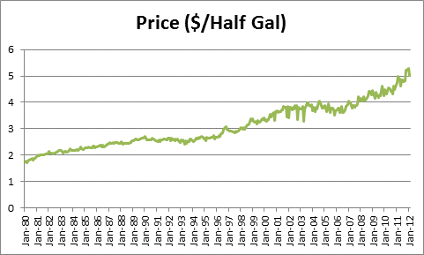
Graph 1: Full set of data, Excel tab: Formatted Data
In an effort to get a more accurate model, the data for the most recent 15 years will be used: January 1997 through December 2008 will be analyzed and January 2009 through February 2012 will be used to gauge the predictability of the model.
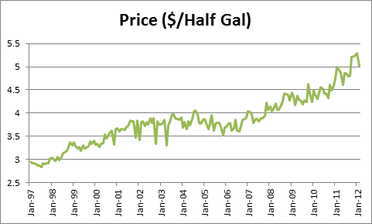
Graph 2: Most recent data to be used in analysis, Excel tabs: Graphs and ACF

Data Analysis
To check for seasonality, I honed in on the most recent 5 years of data:
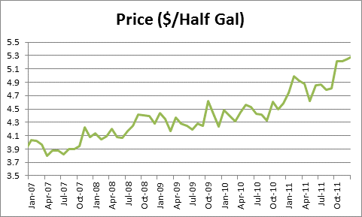
Graph 3: Recent 5 years of data, Excel tabs: Graphs
The peaks and troughs of the data do not appear to be consistently occurring for a given month or season (for example, the winter versus summer months as one may have presumed). We will see additional non-evidence of seasonality upon further analysis of the autocorrelations in the correlograms below.
But first, the fact that this data is not stationary is further confirmed upon analysis of the graph of the sample autocorrelations:
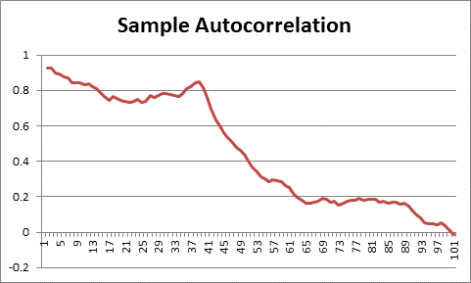
Graph 4: Correlogram of recent data, Excel tabs: Graphs and ACF

The autocorrelations do not reach zero until nearly lag 100, which is much too slow to be considered “quick decay” and indicate stationary data.
Because the original model was somewhat linear, it makes sense to, in an effort to make the data stationary, take first differences (as opposed to logs and then first differences). The result of taking first differences is the following:
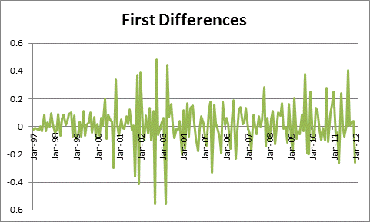
Graph 5: Recent data after taking first differences, Excel tabs: Graphs and First Differences

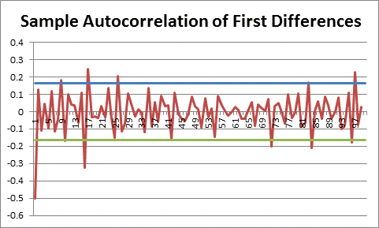
Graph 6: Correlogram after taking first differences, along with upper and lower bounds of 95% confidence interval, Excel tabs: Graphs and First Differences

The graph of the data is now centered around zero, not increasing or decreasing with time, indicating stationarity. Furthermore, the sample autocorrelations are also centered around zero, with both positive and negative values. Additionally, the majority of the sample autocorrelations are within the 95% confidence interval of zero ,or 1.96*standard deviation, where the standard deviation is calculated as the sqrt(1/n) where n is the number of data points, in this case 144 as 12 years of monthly data was used to develop the model. While there are a few outliers, for example at lags 9, 16, 17, 26, 72, 84, and 97, these are not significant points in time indicating any type of seasonality, therefore more likely indicating white noise fluctuation. And if there is any weak seasonality (72+12=84) there must be enough other factors affecting the price of ice cream as to make it almost entirely insignificant.
In an effort to refine the model, second differences were also examined. However, this did not significantly add to the precision of the model and therefore the more simple model of first differences will be used. (See Excel workbook, tabs Graphs and Second Differences.)
Model
A review of the sample autocorrelations after first differences shows that after lag 1, the autocorrelations quickly drop to zero, indicating a moving average model of order 1 (as opposed to geometric decay which would indicate an autoregressive model). Therefore, an ARIMA(0,1,1) or IMA(1,1) will be used to model the ice cream prices. The equation of an IMA(1,1) is:
Y_{t} – Y_{t-1} = e_{t} – θe_{t-1}
Using the Yule-Walker equation:
ρ₁=-θ/(1+θ²)
and our sample autocorrelation r₁ as an estimate of ρ₁ we can calculate θ. Specifically, because r₁ = -0.49937, we calculate θ = 0.95093 (see Excel workbook, tab Results). Note that as expected, because the autocorrelation for the moving average model of order 1 is close to negative 0.5, the moving average coefficient is close to positive 1.
Therefore, our model is now
Y_{t} – Y_{t-1} = e_{t} – 0.95093e_{t-1}.
Using the forecast equation:
Y_{t} (1) = Y_{t} – 0.95093e_{t}
and assuming zero error for the first data point, we can see how closely our model fits the actual data:
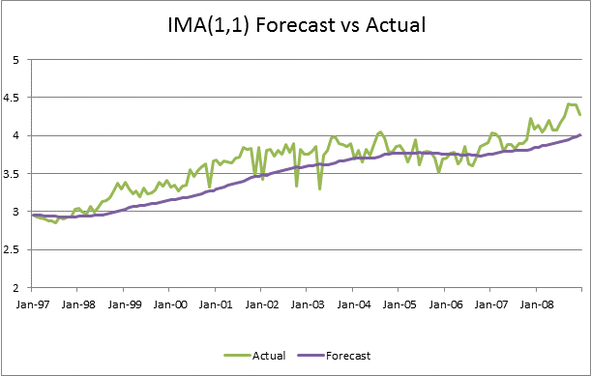
Graph 7: Actual Data Jan. 1997 – Dec. 2008 versus Forecast Data from IMA(1,1) Model, Excel tab: Results

Additionally, using this same equation, we can check to see how well the data fits future data points not initially used to calculate the model:

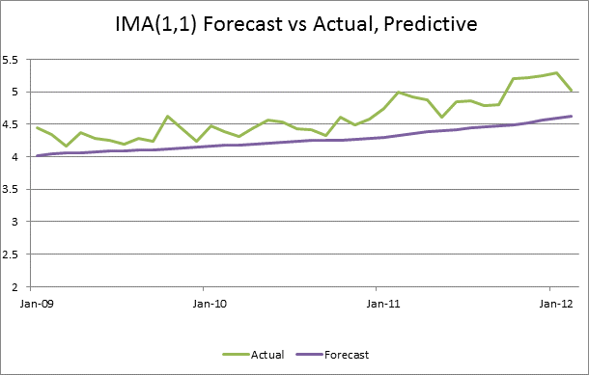
Graph 8: “Projected” Actual Data Jan. 2009 – Feb. 2012 versus Forecast Data from IMA(1,1) Model, Excel tab: Results

Conclusion
Given its simplicity, the model fits fairly well. However, we can see it is not perfect, particularly in terms of predicting the future. Additional tests such as Box-Pierce (or Ljung-Box if we wish to be even tougher) could be compared to the chi-squared statistic and, if larger, could be used to reject the null hypothesis that the residuals are just white noise. Or, perhaps an additional source of fluctuation, for example inflation, is not truly captured in this model and another iteration might lead to adding in an autoregressive coefficient.
What seems to be clear from this simple analysis, however, is that the price of ice cream is not more expensive in the summer months than in the winter months. While further more in-depth analysis as well as additional monitoring of the data would help solidify the conclusion, it seems I am safe to continue buying ice cream all year long.

