xxxxx xxx
Winter 2011 Session
Regression Analysis

SECTION I. Introduction

Regression analysis can be a very useful tool to support actuarial work. The health care cost is approximately 16% for American GDP each year. Therefore to accurately interpret the cost trend from experienced data becomes very important. In this project, I will present the development of an appropriate regression equation for estimating the medical cost trend of the selected population.

The population that I am targeting is the temporary assistant needy family (TANF) under the Medicaid program. I will apply regression analytical tools to project the medical cost trend of this population in West Virginia State.

The health insurance claim consist the components of frequency and severity. The frequency of the claim is based on the healthcare utilization of our members. The severity of the claim is determined by the results of the contract negotiation with providers. In this project, we will assume the contractual increase is the same through-out all the reporting period of our claim data.

The shifting in the membership enrollment can cause changes in the monthly medical expense. In order to exclude the membership effects in the claim expense fluctuation, we will be analyzing the monthly medical cost in the unit of per member per month (PMPM). In addition, the medical cost of our analysis consist the claim types of inpatient, outpatient, and physician claims. Incurred-but-not-paid (IBNP) factor has been applied to the claims in order to complete the incurring claim cost. In this project, we will assume the IBNP factor is accurate.

Real company data were extracted from the company’s data mart, and the transformed by 2 constants ‘Y’ and ‘Z’ in order to protect the financial cost information.

An excel spreadsheet will be provided along with this document. In the following sections below, Section II detail the data transformation. Section III provides the regression modeling scenarios and reasons for my approach. Section IV below summarizes my finding and provides a conclusion.

SECTION II. Data Scaling

Due to the confidentiality of the company financial information, the true medical claim and enrollment information cannot be enclosed in this analysis. Therefore, the original claim PMPM is re-scaled to obtain a transformed PMPM. This PMPM will be hard-coded in the Excel working spreadsheet.

To keep the actual data anonymous, the following equation is used to generate sample PMPM from the original data. ‘Y’ and ‘Z’ are the selected constants that are ensuring the transformed PMPM remains positive. Due to the confidentiality issue, the value of these 2 constants will not be provided in the analysis.

Xnew = (Xold – Y) / Z where (Xold – Y) is greater than zero for all data points
Figure 1
Original PMPM and transformed PMPM distribution
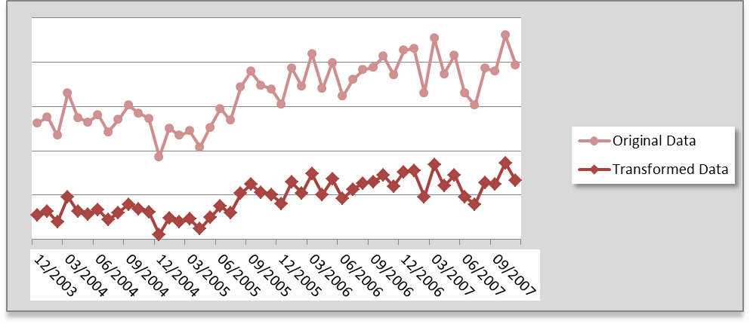

SECTION III. Regression Model
Traditional actuaries use exponential functions to predict claim utilization and severity trends. The insurance claim cost is assumed to be an exponential function of time t. Based on this assumption; I would expect the following exponential regression function to fit the PMPM data

Y = f(t) = e^{α+βt}
and
Y’ = ln(Y) = α + βt

In the above equation:

Y = estimated PMPM
e^{α} = base value of PMPM
e^{β} = PMPM trending rate
t = number of months

The explanatory variable of my analysis are the number of months or lags. The response of my analysis is the log of medical cost PMPM. In this project, I am evaluating three different reporting periods to determine the proper amount of data I should obtain in my model to determine the overall medical cost trend. The reporting periods that I selected are:
- Scenario 1: CY2004 – CY2005
- Scenario 2: CY2004 – CY2006
- Scenario 3: CY2004 – CY2007

The hypothesis test is to determine whether β = 0 in my model with each of the three time periods. The statistical results from these three models are generated and compared against each other for validation.

In Figure 2 below, it illustrates the regression statistics and ANOVA result for ln(Y) against the number of months in lags for the reporting period CY2004 to CY2005.

Using the Excel regression tool, I used this regression result to fit the trend line of data. It is shown as the following:

ln(Y) = 4.9687396 + 0.0040691 * t

The R-square of the result is 0.1063, and the adjusted R-square is 0.0657. The significance F value is 0.120032. The R-square value and the adjusted R-square describe how much the response variable can be explained by the explanatory variable. The outcome indicates a weak correlation between the medical cost PMPM and time. According to the F-test at 95% significance level, the variable time is not significant to explain the variation in the monthly medical cost.

Figure 2
CY2004 – 2005 regression result

In Figure 3 below, the summary provides the regression statistics and ANOVA result for ln(Y) against the number of months in lags for the reporting period CY2004 to CY2006.

Using the Excel regression tool, I used this regression result to fit the trend line of data. It is shown as the following:

ln(Y) = 4.9340419 + 0.0076388 * t

The R-square of the result is 0.5136, and the adjusted R-square is 0.4993. The significance F value is 0.000001. The R-square value describes how much the response variable can be explained by the explanatory variable. The outcome indicates that we can explain 51.4% of the monthly claim cost variation by the variable of time/lags. According to the F-test at 95% significant, the variable time is significant to explain the variation in the monthly medical cost.

Figure 3
CY2004 – 2006 regression result

In Figure 4 below, the summary provides the regression statistics and ANOVA result for ln(Y) against the number of months in lags for the reporting period CY2004 to CY2007.

Using the Excel regression tool, I used this regression result to fit the trend line of data. It is shown as the following:

ln(Y) = 4.9505864 + 0.0065598 * t

The R-square of the result is 0.5661, and the adjusted R-square is 0.5567. The significance F value is 0.000000. The R-square value describes how much the response variable can be explained by the explanatory variable. The outcome indicates that we can explain 56.6% of the monthly claim cost variation by the variable of time/lags. According to the F-test at 95% significant, the variable time is significant to explain the variation in the monthly medical cost.

In addition, Figure 5 below summarizes all the statistical result obtained from these 3 models. The medical cost trends are derived using the following equation:

Annual Medical Cost Trend = e^{β*12} – 1

The first model with 2 year time period suggests an annual trend of 5.00%. The second model with 3 year time period suggests an annual trend of 9.60%. The final model with 4 year time period suggests an annual trend of 8.19%. The 4 year time period CY2004 to CY2007 appears to provide the most correlation between monthly claim cost and the number of lags.

Figure 4
CY2004 – 2007 regression result

Figure 5
All modeling result summary
Model | Report Period | Adjusted R Value | Significance F | Estimated Value | Trends
1 | CY2004-2005 | 0.065653 | 0.120032 | 0.004069 | 5.00%
2 | CY2004-2006 | 0.499334 | 0.000001 | 0.007639 | 9.60%
3 | CY2004-2007 | 0.556660 | 0.000000 | 0.006560 | 8.19%

SECTION IV. Conclusion
Out of all the models that we evaluated, scenario 3 with 4 years of data suggests a most favorable adjusted R-square value of 55.7%. Using the coefficient generated by the regression result, Figure 6 below illustrates how predicted PMPM fitted against the actual month claim PMPM.

Figure 6
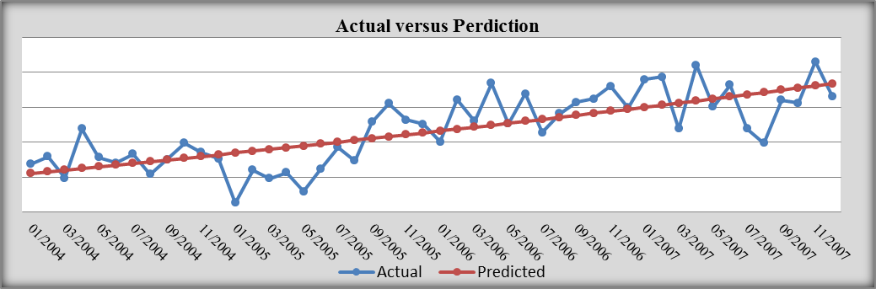

As addressed in section III above, the predicted PMPM is derived using the coefficients α and β using the following equation:

Y = f(t) = e^{α+βt}

Figure 6 shows a fairly good fit between predicted PMPM and the actual PMPM. Based on the past four years of data, it appears that the medical cost trend for West Virginia Medicaid population is trending at 8.19%.

