xxxxxxxxx xxxx
NEAS Time Series
Winter 2012

Introduction
As someone who enjoys picking out jewelry, I must admit that the few gold items that I have are among my favorites. Thus, I thought it would be interesting to analyze movements in the price of gold and use this information to determine the time series that would best model the data.
To begin my analysis, I will gather information on historical gold prices from data. Next, I will test to see if this data forms a stationary process by examining the graph of the data and its correlogram. If it is not stationary, I will take differences to try to make it stationary. I will then use sample autocorrelations and Bartlett’s test to see whether stationarity was achieved. The next step will be to determine the moving average and/or autoregressive parameters that best fit the model. Finally, I will compare the fitted data to the actual data to test how good the model is at forecasting future data.
Data
I obtained the data for my time series analysis of gold prices from the following website: http://www.indexmundi.com/commodities/?commodity=gold&months=240.
This website lists the monthly gold price (based on an average of daily London gold prices) in units of US dollars per troy ounce. The website allows you to choose how many years of data you want to see. I chose to use twenty years of data (from March 1992 through March 2012), based on the premise that a larger data sample should lead to a more accurate conclusion that a smaller data sample would. A copy of this data can be found on the “Gold Price Data (All Years)” sheet in the Monthly Price column.
Test for Stationarity
The first step in my analysis is to determine whether the monthly gold price data form a stationary time series.
By definition, a stationary process has probability laws that remain constant over time, such as a constant mean function (Cryer and Chan pg.16-17). Thus, I would not expect to see a trend in the data, since it would cause the mean and other probability measures to vary over time.
To begin this process, I graphed the monthly gold prices over time. This graph can be found in the Excel worksheet “Graph of Price (All Years)” and is shown below.

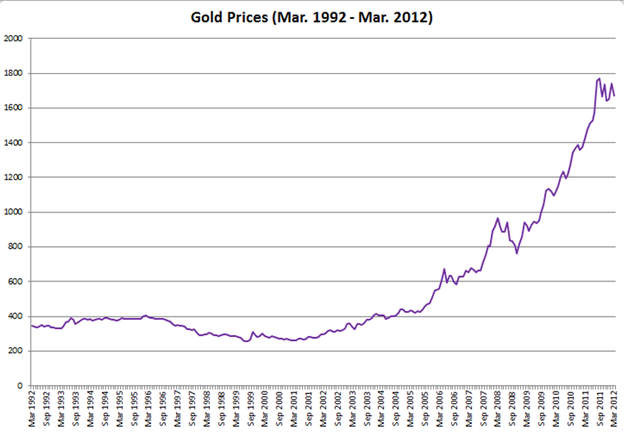
Monthly Gold Price (US $ per troy ounce)
Time Period

As you can see from the graph, the price of gold has been steadily increasing over the past ten years. This trend indicates that the probability functions are not constant over time in this case. For example, if you were to break this graph into pieces, the mean in the early years (1992-1995, for instance) would be significantly lower than the mean in the later years (2010-2012, for instance.) An increasing trend indicates that this process is not stationary.
The lack of stationarity can also be seen by examining the correlogram of this data, which plots the sample autocorrelation function against the lag.
The following equation can be used to determine the sample autocorrelation in lag k (abbreviated r_{k}):
r_{k} =
I solved for this equation in the Excel workbook in steps. First, I solved for in the column labeled ‘Deviation from the mean’, where is the average monthly price over all periods. Next, I solved for (² in the column labeled ‘(Deviation from the mean)²’; the sum of this value in all periods is the denominator in the above equation. In the column labeled ‘SumProduct’, I calculated the numerator of the above formula for each lag. Finally, r_{k} is calculated in the column called ‘Sample Autocorrelation’. This set of calculations is present in the “Gold Price Data (All Years)” sheet and “Gold Price Data (2007-2012)” sheet; in both cases, the calculations in columns C-F are related to the monthly gold prices.
This graph of the correlogram for monthly gold prices can be found in the Excel worksheet “Correlogram_Price” and is shown below.

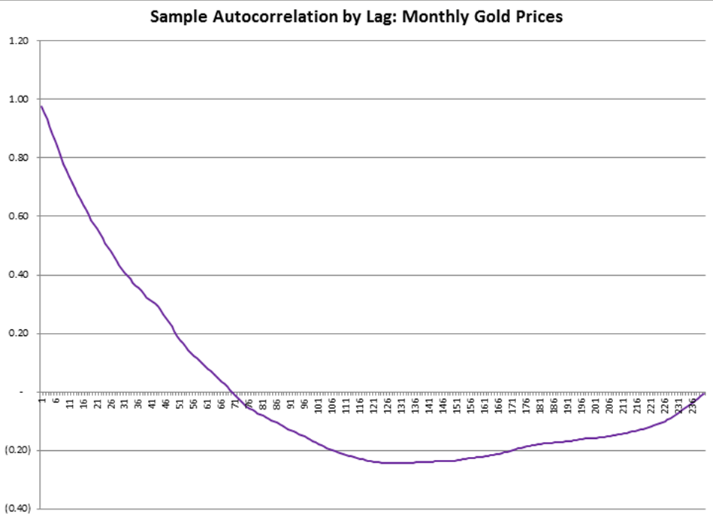
Sample Autocorrelation
Lag

If the process was stationary, I would expect that the correlogram would eventually show a white noise process that has a mean of zero and small random fluctuations. I would expect to see the graph quickly drop to 0 and remain there (allowing for random fluctuations) or to see the graph oscillate around 0 as it geometrically declines to 0. Instead, this graph does not reach zero until lag 70, and afterwards it continues to drop for a number of lags and then gradually increase back to 0, not reaching it again until around period 240. Its pattern is much more of a linear one, first with a negative slope and then switching around duration 150 to a less steep positive slope. This correlogram supports my conclusion that the monthly gold prices do not form a stationary process.
First Differences
In order to form a stationary process, I took the first differences of the monthly gold prices, calculated as the price of gold in the current month minus the price of gold in the previous month. This equation is often written as = . The resulting values can be found on the “Gold Price Data (All Years)” sheet in column J.
The graph of the first differences can be found on the “Graph of Price (All Years)” and is shown below.
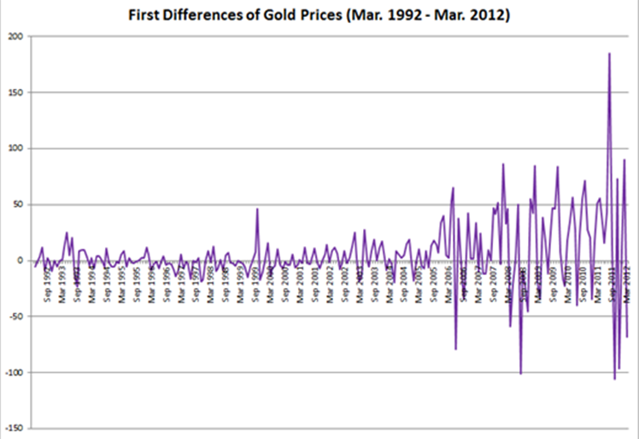
First Differences of Monthly Gold Prices
Time Period

Comparing this graph to that of the gold prices, the increasing trend was present in the original graph is no longer present. Instead, the graph of first differences oscillates around the mean. It seems much more likely that this represents a stationary process. I will test for stationarity in this graph in a later section.

Check for Seasonality
Before I proceed with my analysis, it is important to check for seasonality in the data. To enable this process, I created a graph containing only the first differences of the gold prices for 2007 through 2012, since it will be easier to look for seasonality with a smaller segment of the data. This graph can be found in the sheet “Graph of 1st Differences(07-12)” and is shown below.
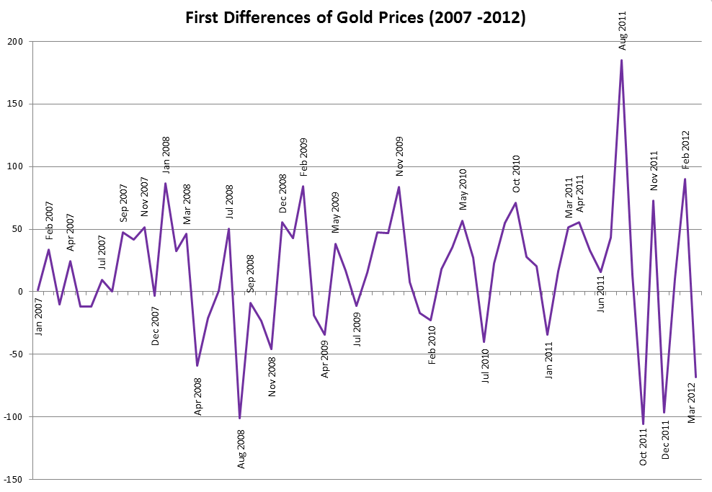
First Differences of Monthly Gold Prices
Time Period
Time Period

Although the graph oscillates around the mean, it does not appear that there is any seasonality associated with this data series, since the relative location of a given month varies without a pattern. For example, the graph shows that the first difference of the monthly price of gold was:
- Very low in August 2008 but very high in August 2011
- Somewhat high in October 2010 but very low in October 2011
- Somewhat high in January 2008 but somewhat low in January 2011
Thus, no seasonal adjustments need to be made to the data.
Correlogram of First Differences
To help verify whether this transformed data series is stationary, I will use Bartlett’s test. If the random fluctuations are due to white noise, they should normally distributed with a mean of 0 and a standard deviation of (1 / number of data points). Assuming a 95% confidence level, the z critical value is 1.96. Since the sample autocorrelations of the first differences of monthly gold prices are measured over 240 data points, the standard deviation of white noise in this case would be 1 / (240^{1/2}) = 0.06455. The 95% confidence interval for white noise would be ± 1.96 * 0.06455 = (-0.1265, 0.1265). Thus, if the data point falls within this range, it can be considered white noise, which is a stationary process.
The correlogram containing the sample autocorrelation by lag for the first differences of monthly gold prices is available in the “Correlogram_First Diff of Price” sheet and is shown below. The calculations supporting this graph can be found in columns K-N of the “Gold Price Data (All Years)” sheet.

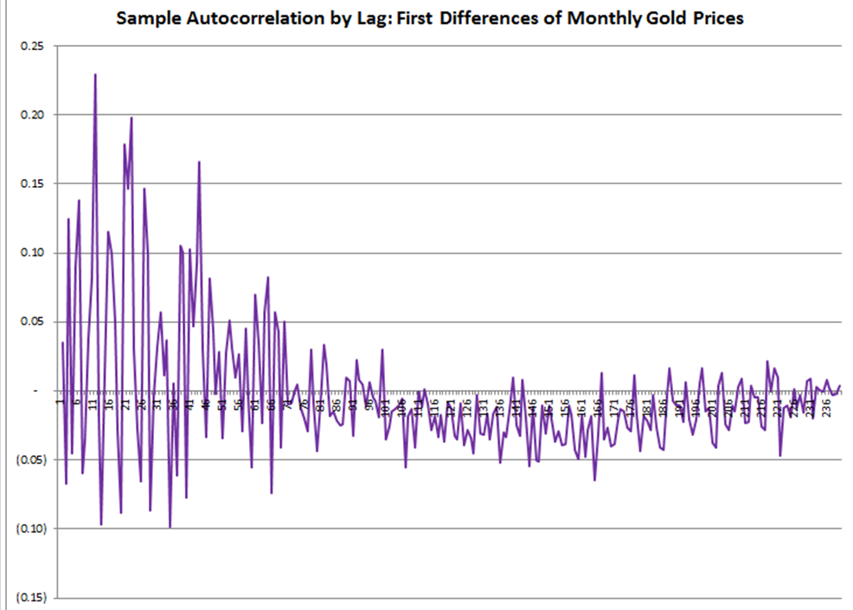
Sample Autocorrelation
Lag

Looking at this graph, the sample autocorrelations oscillate around 0, with the difference from one period to another getting very small as the lag increases. It appears that the autocorrelations form a white noise process over time. To verify whether this is accurate, I will use the confidence interval found above using Barlett’s test.
I examined the data values that formed the correlogram, which can be found in column N of the worksheet called “Gold Price Data (All Years)”). I found that only 7 out of 240 values (2.9%) fall outside the 95% confidence interval. Based on this observation, one can conclude that the sample autocorrelations of the first differences of the monthly gold prices do form a white noise process, and thus the first differences of the monthly gold prices are indeed stationary.

Determining the ARMA process
Now that I have verified that the first differences of the monthly gold price form a stationary process, I can try to determine the model that would best fit the data. The monthly gold prices were a nonstationary ARIMA process. By taking first differences, I transformed the ARIMA(p,1,q) process into a stationary ARMA(p,q) process.
Looking at the graph of sample autocorrelation by lag based on the first differences, it does not appear that there is a moving average component to the process. If there were an MA(q) component, the correlogram would have had a sudden drop to 0 after the first q periods. In this case, there is no sudden drop in the graph, indicating that the ARMA process does not have a moving average component. At this point, I can update the form of the process to an ARMA(p,0) process, which can simply be expressed as an AR(p) process.
Returning to the graph of the sample autocorrelation by lag of the first differences, the graph does show a geometric decay in the sample autocorrelations as the lag period increases, with the oscillations getting closer and closer to 0 as the lag increases. This is indicative of an autoregressive process.
I will now examine three potential autoregressive models – AR(1), AR(2), and AR(3)- to determine which of them would be the best process to model the first differences of monthly gold prices.

AR(1)
A first-order autoregressive model can be expressed by the following equation:
Y_{t} = φY_{t -1} + ε_{t} + θ₀

In order to solve for the variables in this equation, I used Excel’s Regression add-in, with the “Y” values being supplied by column B of the “Data for AR tests” sheet (containing the first differences for the current period) and the “X” value being supplied by column C of the “Data for AR tests” sheet (containing the first differences for one period prior). The results are shown in the table below and are also available in the “AR(1)” worksheet:

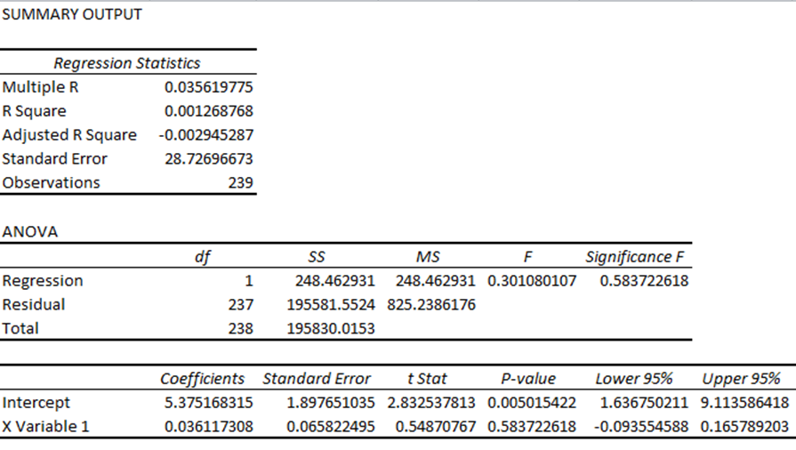
These results suggest that φ₁ = 0.03612 and θ₀ = 5.37517.

Thus, the AR(1) model can be represented by the following equation:
Y_{t} = 0.03612Y_{t -1} + ε_{t} + 5.37517
For an AR(1) process to be stationary, the absolute value of φ₁ must be less than 1. This condition is satisfied here since │φ₁│= 0.03612 < 1. This confirms that this AR(1) process is stationary.
AR(2)

An second-order autoregressive model can be expressed by the following equation:
Y_{t} = φ₁Y_{t -1} + φ₂Y_{t -2} + ε_{t} + θ₀

In order to solve for the variables in this equation, I used Excel’s Regression add-in, with the “Y” values being supplied by column B of the “Data for AR tests” sheet (containing the first differences for the current period) and the “X” values being supplied by columns C and D of the “Data for AR tests” sheet (containing the first differences for one period prior and two period prior, respectively). The results are shown in the table below and are also available in the “AR(2)” worksheet:

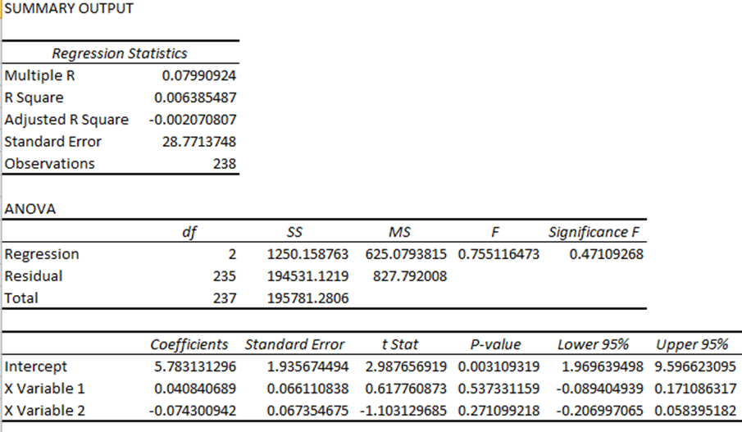
These results suggest that φ₁ = 0.04084, φ₂ = - 0.07430, and θ₀ = 5.78313.

Thus, the AR(2) model can be represented by the following equation:
Y_{t} = 0.04084Y_{t -1} - 0.07430Y_{t -2} + ε_{t} + 5.78313

This AR(2) process satisfies the three “stationarity conditions”, as shown below:
- φ₁ + φ₂ = 0.04084 + -0.07430 = -0.03346 → φ₁ + φ₂ < 1
- φ₂ − φ₁ = -0.07430 - 0.04084 = -0.11514 → φ₂ − φ₁ < 1
- │φ₂│= 0.07430 → │φ₂│ < 1
Since all of the necessary conditions are met, it is appropriate to conclude that this AR(2) process is stationary.
AR(3)
A third-order autoregressive model can be expressed by the following equation:
Y_{t} = φ₁Y_{t -1} + φ₂Y_{t -2} + φ₃Y_{t -3} + ε_{t} + θ₀

In order to solve for the variables in this equation, I used Excel’s Regression add-in, with the “Y” values being supplied by column B of the “Data for AR tests” sheet (containing the first differences for the current period) and the “X” values being supplied by columns C, D, and E of the “Data for AR tests” sheet (containing the first differences for one period prior, two periods prior, and three periods prior, respectively). The results are shown in the table below and are also available in the “AR(3)” worksheet:

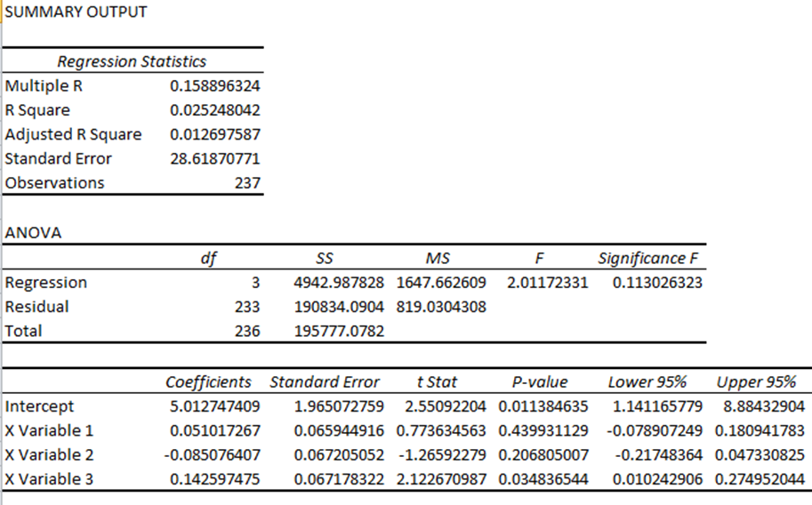
These results suggest that φ₁ = 0.05102, φ₂ = - 0.08508, φ₃ = 0.14260, and θ₀ = 5.01275.

Thus, the AR(3) model can be represented by the following equation:
Y_{t} = 0.05102Y_{t -1} - 0.08508Y_{t -2} + 0.14260Y_{t -3} + ε_{t} + 5.01275

This AR(3) process satisfies the “stationarity conditions” for a general AR(p) process:
- φ₁ + φ₂ + ... + φ_{p} = φ₁ + φ₂ + φ₃ = 0.05102 + -0.08508 + 0.14260 = 0.10854 < 1
- │φ_{p}│= │φ₃│= 0.14260 < 1
Since the conditions are met, the AR(3) process is stationary.

Summary of Autoregressive Models
Below is a summary of the regression statistics of the AR(1), AR(2), and AR(3) models:
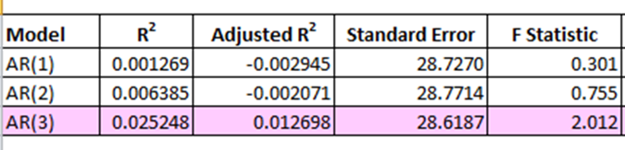
Looking at the three models together, all of the statistics suggest that the AR(3) model is the best fit of the three choices. This can be seen from the fact that the AR(3) model had the highest R² and adjusted R² values, which measure the percentage of the total sum of squares that is attributed to regression as opposed to residuals. In addition, the AR(3) model had the lowest standard error of the three possibilities (although the difference between the three was minimal). Finally, the AR(3) model had the highest F statistic, which means that it is more likely to be statistically significant than the other two models.

Comparison of Actual vs. Fitted Values
To determine how good of a job the AR(3) process does in forecasting future data, I calculated the fitted values of the first differences of monthly gold price and compared them to the actual first differences. The graph with this comparison is shown below. The data supporting this graph can be found in the sheet “Fitted vs Actual Data” and a copy of the graph itself can be seen in the sheet “Graph_Fitted vs Actual 1st Diff”.
First Differences of Monthly Price: Actual vs. Fitted

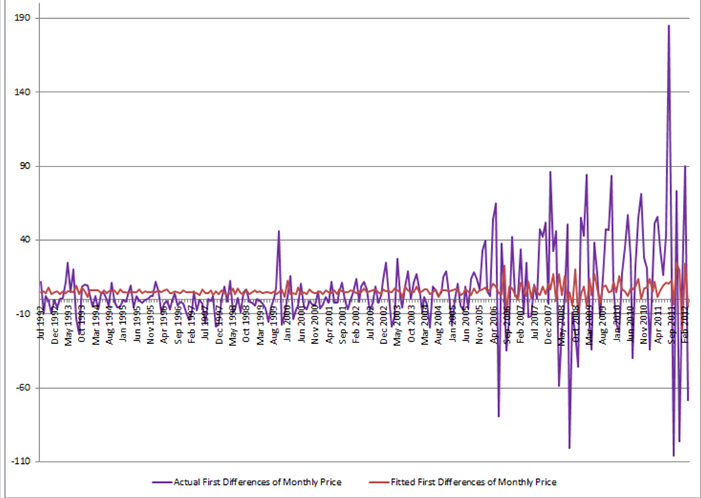
First Difference of Monthly Prices
Time Period

As you can see from the graph, the fitted values did not capture the extreme high and low peaks of the actual data. Given that the AR(2) model was a better fit than the AR(1) model and given that the AR(3) model was a better fit than the AR(2) model, it seems reasonable to conclude that a better fit of the data could be obtained by using a higher-order autoregressive model.

Conclusions
In conclusion, I examined the monthly gold prices for March 1992 through March 2012 and found that they do not form a stationary process. By taking first differences, I was able to form a stationary process. I then confirmed that there was no seasonality in the data. By examining the correlogram, I concluded that there was not a moving average component to the process, but there was an autoregressive component. I tested three potential autoregressive models (first-order, second-order, and third-order) using Excel’s Regression add-in. Comparing the statistical results, I determined that the AR(3) model was the best fit of the data out of the three possibilities. Finally, I used the parameters and constant terms I found for the AR(3) model to solve for the fitted first differences and compared them against the actual first differences of gold prices. The graph showed that the AR(3) did not do a good job of capturing the high and low points of the actual data. If I were to increase the order of the AR model, it would likely do a better job of forecasting future gold prices.

Cryer, Johnathan D. and Chan, Kung-Sik. Time Series Analysis With Application in R. New York: Springer Science+Business Media, LLC, 2008.
Cryer and Chan, pg. 71
Cryer and Chan, pg. 72
Cryer and Chan, pg. 76

