xxxxxxx xxxxx
Regression Analysis
Student Project
Spring 2010

Ben and Jerry’s Ice Cream Caloric Values

Objective

The objective of the regression analysis VEE student project is to apply the concepts I have learned from the course to the real world using statistical software.

Introduction

If I could, I would eat ice cream for every meal of every day. However, this would mean I would be about twice my size! Additionally, I need to start getting in shape for my upcoming wedding! As such, I’ve decided to use Ben and Jerry’s ice cream as the subject for my regression analysis project. Through this analysis, I will be able to determine which components of the ice cream indicate how many calories will be in each serving. My analysis includes the following 5 explanatory variables: total fat (g), cholesterol (g), sodium (g), carbohydrates (g) and sugar (g).

Data

The data for my analysis comes directly from the Ben and Jerry’s website. I chose 20 of my favorite flavors for my analysis. The nutritional information on the website was given for a ½ cup serving size. This data can be found here:

http://www.benjerry.com/flavors/our-flavors/

Since all the data for fat, carbohydrates and sugars were all in grams, I converted the milligram measurements for cholesterol and sodium into grams as well for consistency. The table below summarizes the data for the 20 flavors. This data can also be found in the attached excel file “Gorab – RA Project.xls” on the tab called “Nutritional Info”.

Nutritional Information of Ice Cream Flavors:

Flavor | Calories | Fat (g) | Cholesterol (g) | Sodium (g) | Carbs (g) | Sugars (g)
Boston Cream Pie | 250 | 13 | 0.090 | 0.105 | 29 | 26
Brownie Batter | 290 | 17 | 0.065 | 0.115 | 32 | 25
Cheesecake Brownie | 250 | 14 | 0.070 | 0.085 | 27 | 24
Chocolate | 250 | 14 | 0.040 | 0.050 | 25 | 21
Chocolate Chip Cookie Dough | 270 | 14 | 0.065 | 0.060 | 33 | 25
Chocolate Fudge Brownie | 260 | 12 | 0.040 | 0.065 | 34 | 27
Chubby Hubby | 340 | 20 | 0.055 | 0.140 | 33 | 25
Coffee HEATH Bar Crunch | 280 | 16 | 0.060 | 0.095 | 30 | 27
half baked | 270 | 13 | 0.055 | 0.070 | 35 | 27
Karamel Sutra | 260 | 14 | 0.055 | 0.060 | 31 | 26
Late Night Snack | 270 | 15 | 0.060 | 0.170 | 31 | 21
Milk & Cookies | 270 | 15 | 0.060 | 0.105 | 30 | 23
Mint Chocolate Cookie | 260 | 14 | 0.065 | 0.090 | 28 | 22
New York Super Fudge Chunk | 300 | 20 | 0.050 | 0.055 | 29 | 25
Oatmeal Cookie Chunk | 260 | 14 | 0.055 | 0.115 | 30 | 23
Peanut Butter Cup | 360 | 26 | 0.070 | 0.135 | 27 | 24
Phish food | 280 | 13 | 0.035 | 0.080 | 39 | 28
Stephen Colbert’s AmeriCone Dream | 270 | 15 | 0.065 | 0.090 | 30 | 24
Vanilla Caramel Fudge | 280 | 14 | 0.070 | 0.095 | 34 | 37
Vanilla HEATH Bar Crunch | 280 | 17 | 0.065 | 0.095 | 30 | 27

Equation and Variables

The equation and the 5 variables for the full model are:
Y = α + β₁X₁ + β₂X₂ + β₃X₃ + β₄X₄ + β₅X₅, where

The variables were defined as:
Y: Calories
α: Intercept
β_{i}: Least squares coefficients
X₁: Total Fat (grams)
X₂ : Cholesterol (grams)
X₃ : Sodium (grams)
X₄ : Carbohydrates (grams)
X₅ : Sugars

Hypothesis

The null hypothesis is that all least squares coefficients are zero: β₁ = β₂ = β₃ ₌ β₄ ₌ β₅ = 0

Data Analysis

Correlation

First, I looked at the correlation between each pair of variables. I did this using the regression analysis in Excel to regress calories on each of the 5 individual explanatory variables. These results are summarized below but can also be found on the “Correlation” tab of the spreadsheet.

 | Calories | Fat | Cholesterol | Sodium | Carbs | Sugars
Calories | 1
Fat | 0.9145 | 1
Cholesterol | 0.0930 | 0.1953 | 1
Sodium | 0.4721 | 0.4275 | 0.3889 | 1
Carbs | 0.1433 | -0.2245 | -0.2941 | 0.0064 | 1
Sugars | 0.0804 | -0.1202 | 0.0887 | -0.1949 | 0.5299 | 1

As you can see, there are some relatively large and small correlation values between the explanatory variables. It is good to keep these in mind throughout the analysis to see if any of the variables could be eliminated.

Model analysis

Next, I created a series of models using combinations of calories and the explanatory variables and performed regression analysis on them. The purpose of this analysis is to determine the best model for determining the number of calories in a serving of ice cream. The following analysis is done using the regression analysis tool in Excel.

Model 1: Full Model (all 5 explanatory variables)

The general regression equation for this model is the same as above:

Y = α + β₁X₁ + β₂X₂ + β₃X₃ + β₄X₄ + β₅X₅.

The results from the regression analysis tool in Excel are as follows:

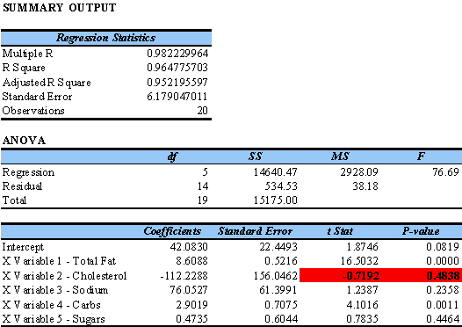

These results can also be found on the “Model1” tab of the spreadsheet.

The updated regression equation for this model is:
Y = 42.0830 + 8.6088 X₁ – 112.2288 X₂ + 76.0527 X₃ + 2.9019 X₄ + 0.4735 X₅

The R² of the regression model is .9648. This implies that 96.48% of variation of calories is explained by the 7 explanatory variables (i.e. the 5 explanatory variables are doing a good job of predicting the number of calories). The fact that cholesterol has the highest P-value (.4838) and the lowest t-Stat value (-0.7192) indicates that it is not a good explanatory variable for the regression model. Therefore, I am removing cholesterol from the model and the remaining 4 explanatory variables will be used to find the best fit.

Model 2: 4 Explanatory Variables – Fat, Sodium, Carbs and Sugars

The general regression equation for this model is the same as above:

Y = α + β₁X₁ + β₂X₂ + β₃X₃ + β₄X₄.

The results from the regression analysis tool in Excel are as follows:

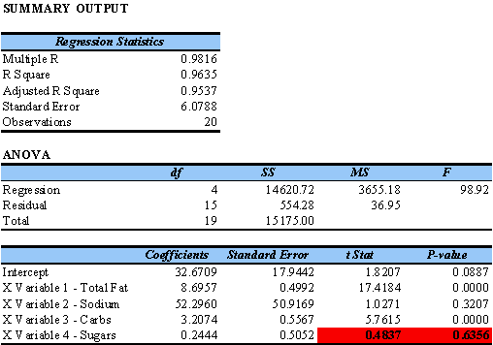

These results can also be found on the “Model2” tab of the spreadsheet.

The updated regression equation for this model is:
Y = 32.6709 + 8.6957 X₁ – 52.2960 X₂ + 3.2074 X₃ + 0.2444 X₄

The R² of the regression model is .9635. This implies that 96.35% of variation of calories is explained by the 4 explanatory variables (i.e. the 4 explanatory variables are doing a good job of predicting the number of calories). However, it is important to note that the R² has decreased slightly from Model 1, indicating that this model is a worse fit.

The fact that sugar has the highest P-value (0.6356) and the lowest t-Stat value (0.4837) indicates that it is not a good explanatory variable for the regression model. Therefore, I am removing sugar from the model and the remaining 3 explanatory variables will be used to find the best fit.

Model 3: 3 Explanatory Variables – Fat, Sodium and Carbs

The general regression equation for this model is the same as above:

Y = α + β₁X₁ + β₂X₂ + β₃X₃.

The results from the regression analysis tool in Excel are as follows:

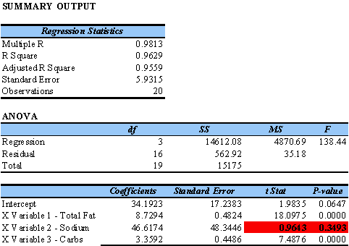

These results can also be found on the “Model3” tab of the spreadsheet.

The updated regression equation for this model is:
Y = 34.1923 + 8.7294 X₁ + 46.6174 X₂ + 3.3592 X₃

The R² of the regression model is .9629. This implies that 96.29% of variation of calories is explained by the 3 explanatory variables (i.e. the 3 explanatory variables are doing a good job of predicting the number of calories). However, it is important to note that the R² has decreased slightly from Model 2, indicating that this model is a worse fit.

The fact that sodium has the highest P-value (0.3493) and the lowest t-Stat value (0.9643) indicates that it is not a good explanatory variable for the regression model. Therefore, I am removing sodium from the model and the remaining 2 explanatory variables will be used to find the best fit.
Model 4: 2 Explanatory Variables – Fat and Carbs

The general regression equation for this model is the same as above:

Y = α + β₁X₁ + β₂X₂.

The results from the regression analysis tool in Excel are as follows:

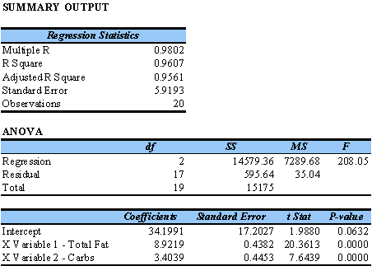

These results can also be found on the “Model4” tab of the spreadsheet.

The updated regression equation for this model is:
Y = 34.1991 + 8.9219 X₁ + 3.4039 X₂

The R² of the regression model is .9607. This implies that 96.07% of variation of calories is explained by the 2 explanatory variables (i.e. the 2 explanatory variables are doing a good job of predicting the number of calories). However, it is important to note that the R² has decreased slightly from Model 3, indicating that this model is a worse fit.

Another good thing to note here is that the p-values for the remaining 2 explanatory variables are very close to zero. This indicates that they are a good fit for this model.

Model Selection

Given the results for R² above, one might think that the best model to use would be Model 1. However, it is important to also consider the F-stat and standard error. These values are summarized in the table below for all four models:

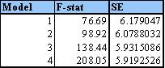

Model 4 has the highest F-statistic value and the lowest standard error value. The p-values for the explanatory variables in Model 4 are all very close to zero which is good as it allows us to reject the null hypothesis. For the above reasons, I have chosen Model 4 as the best fit for the prediction of calories in ice cream.

Conclusion

Based on my analysis above, I have selected Model 4 as the best fit for predicting the number of calories in ice cream.

I began my analysis using the following 5 explanatory variables: total fat, cholesterol, sodium, carbohydrates and sugars. I then eliminated the explanatory variables of cholesterol, sugars and sodium, one by one, by doing a series of regressions to determining which variables were not a good fit for the model.

The resulting equation is as follows:

Y = 34.1991 + 8.9219 X₁ + 3.4039 X₂, where

X₁: Total Fat (grams)
X₂ : Carbohydrates (grams)

In this equation, fat is the biggest indicator of the number of calories in a serving of ice cream.

I determined this to be the best model for predicting the caloric value of ice cream because:
- The p-values of the remaining 2 explanatory variables are very close to zero.
- The F-statistic is the highest among the 4 models I examined and the standard error is the lowest.
- The R² value is still good in comparison to that of the other 3 models.

