Introduction

The Hang Seng Index (HIS) is a freefloat-adjusted market capitalization-weighted stock market index in Hong Kong. It is the main indicator of overall market performance in Hong Kong and it records and monitors the daily changes of the largest companies of Hong Kong stock market. A lot of companies will use the Hang Seng index future contracts to reduce their market risk. Also, Hedgers, Speculators and Arbitrageurs can buy (long) or sell (short) Hang Seng Index future contracts to reduce or increase a risk exposure.

For example, if the investor buys 1 Hang Seng Index future contract, the investor can earn 50 dollar if Hang Seng Index increase by 1 point. On the other hand, if the investor sells 1 contract, he will lose 50 dollar if Hang Seng Index increase by 1. Therefore, investors can earn large profit or lose a lot of money when they trade large number of Index future contract. As a result, it is important for the companies to predict or forecast the Hang Seng Index from the past Index data.

We consider the Monthly Hang Seng Index from December 1997 – November 2007

First we consider the Hang Seng Index series. The plot of the series is shown below
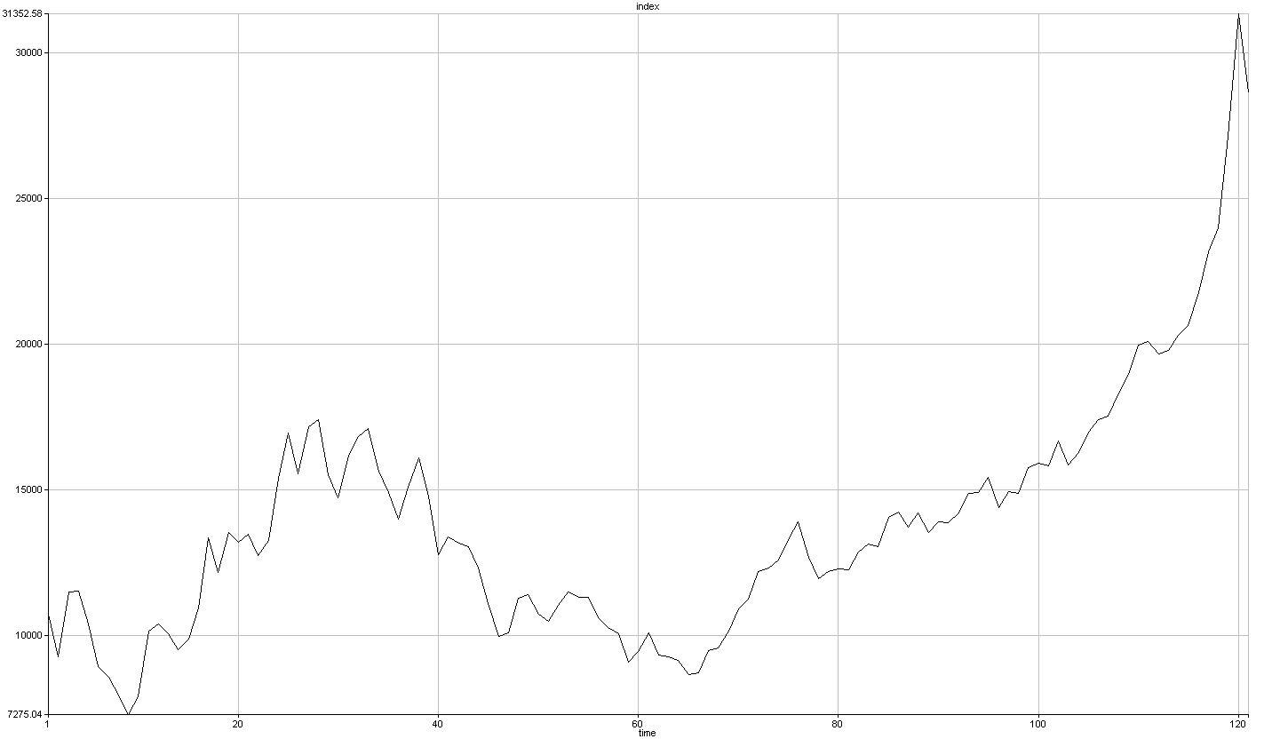

We can see clearly the series has a non-constant mean from the graph above so the series is non-stationary. We can take a difference so that to remove the non-stationary.

The differenced series is shown below
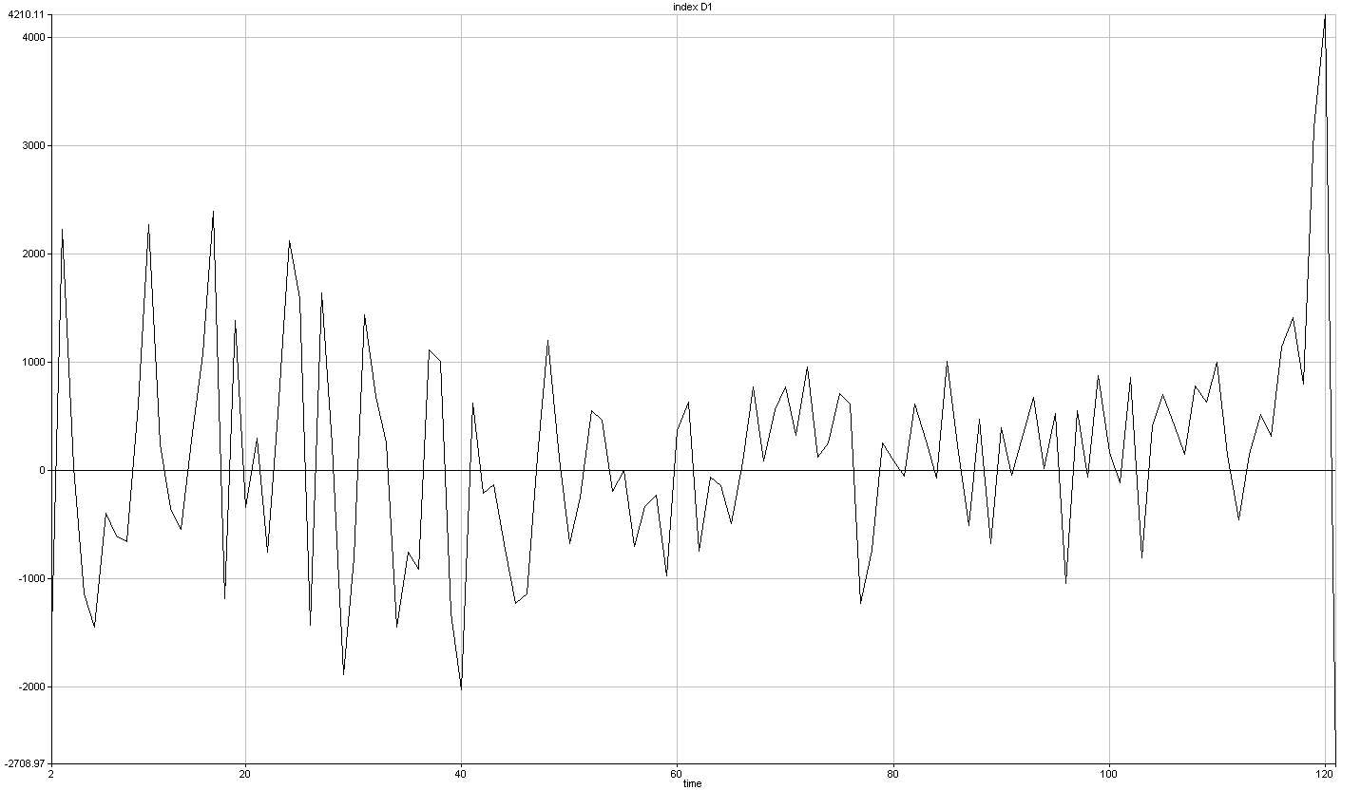
The differenced series looks stationary due to it has a constant mean and an approximately constant variance; however, it is still not stationary from the recent data due to the Hang Seng index increase a lot recently.
We also want to check if this indeed true so we take the ACF and PACF of this series.

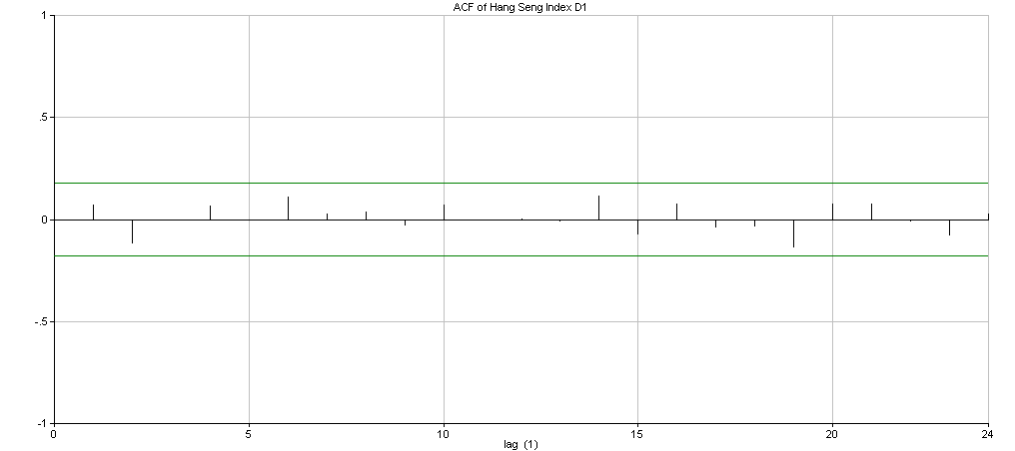

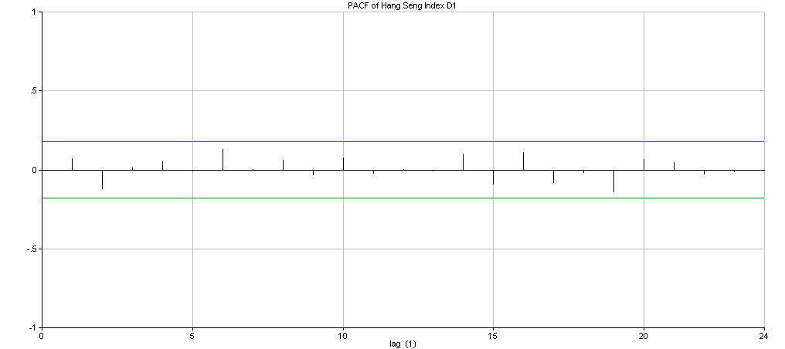

Because there is no trend on ACF and PACF and the data shows that it is independent, it is white noise. Therefore, we have to do one more difference.

The 2-differenced series is shown below
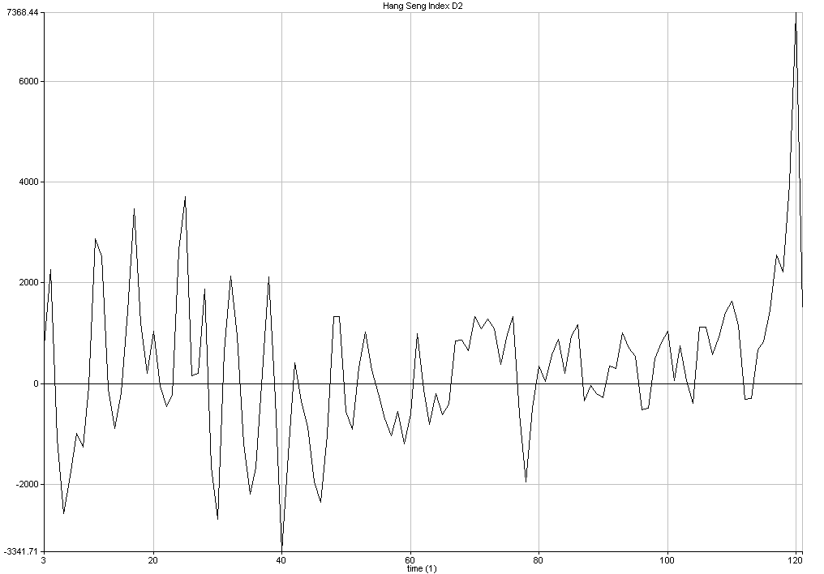
The graph is similar to the 1-differenced series and now we have to check the ACF and PACF.

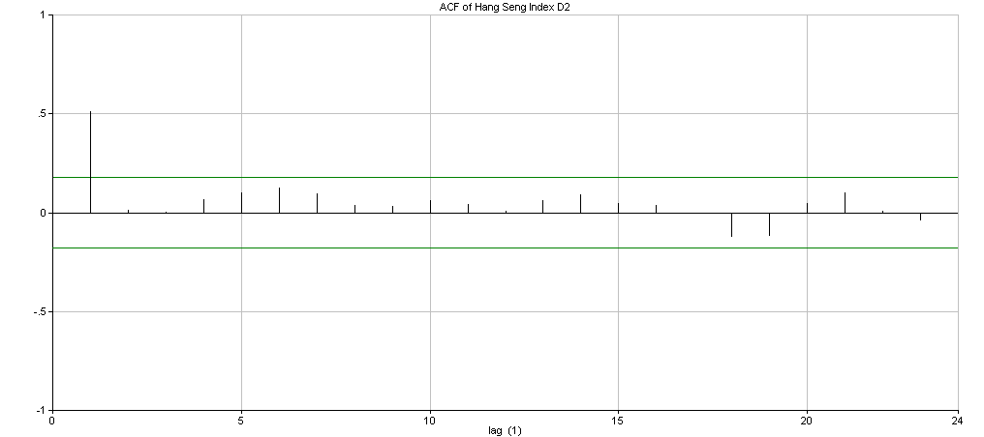
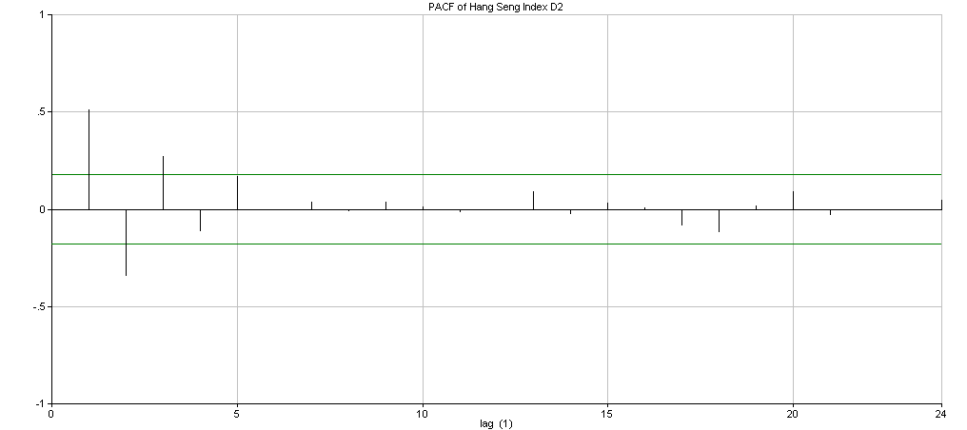
We can see that it is tails off in PACF graph so it may be MA(1) due to the cuts off after lag 1 in ACF graph. Then, we use the ARIMA to find the best model for prediction.

After we run the ARIMA search, we obtained the best model which is ARIMA (3,2,7) due to we take 2-difference

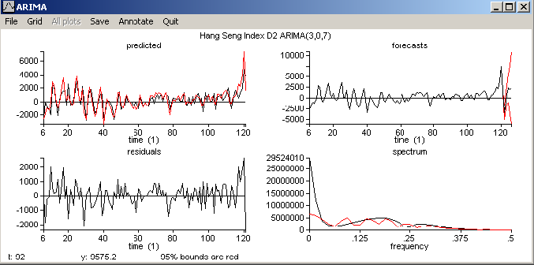
The ARIMA(3,2,7) is the best model for Xt. The ASTSA output for this model is as follows:

ARIMA on Hang Seng Index
ARIMA(3,2,7) from Hang Seng Index
AICc = 14.5379 variance = 671005 d.f. = 106
Start values = .1

predictor coef st. error t-ratio p-value
AR(1) -.4340 .0004345 -999.00 .000
AR(2) -.7430 .0007437 -999.00 .000
AR(3) -.4283 .0004287 -999.00 .000
MA(1) .4244 .0004248 999.00 .000
MA(2) -.3594 .0003716 -967.11 .000
MA(3) .2354 .0003798 619.60 .000
MA(4) .7131 .0007138 999.00 .000
MA(5) .0995 .0003821 260.35 .000
MA(6) -.4415 .0004420 -999.00 .000
MA(7) .1110 .0003835 289.47 .000

(1 +.43B1 +.74B2 +.43B3) X(t) =
(1 -.42B1 +.36B2 -.24B3 -.71B4 -.1B5 +.44B6 -.11B7) w(t)

Then, we should examine the residuals from this model. If this model is appropriate, the residuals should look like white noise. They should have a mean of zero and appear to fluctuate randomly around this mean. It shows the same things in our ARIMA (3,2,7) residuals.
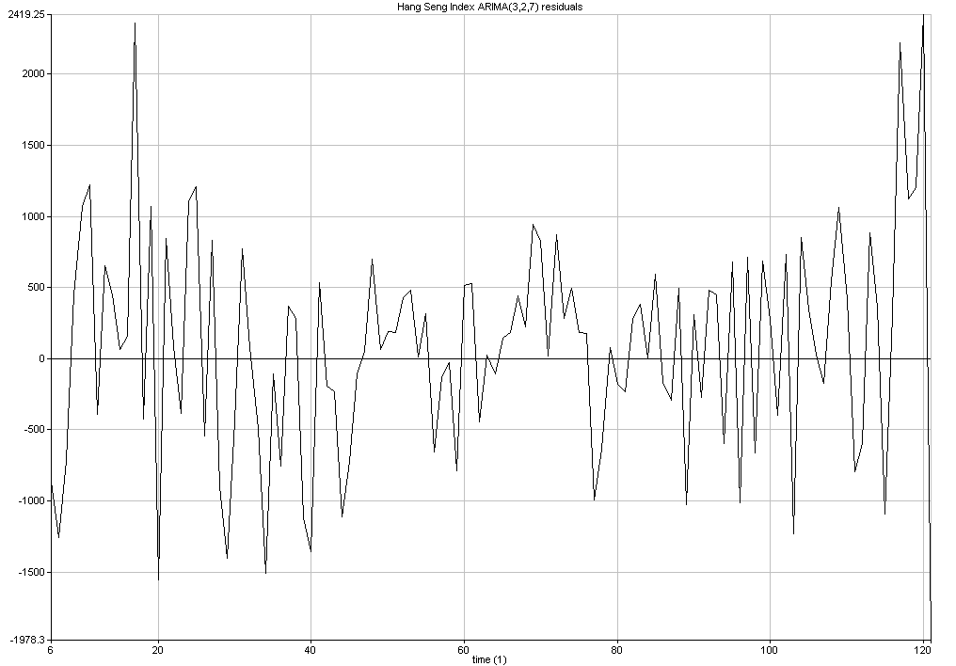
Next, the sample ACF and PACF of the residuals should be approximately zero for all lags if they are to resemble the ACF and PACF of white noise. Our ARIMA(3,2,7) model is in the same case.
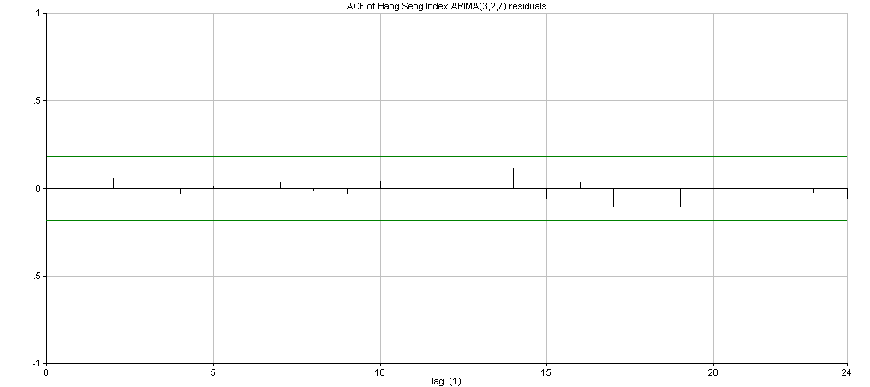
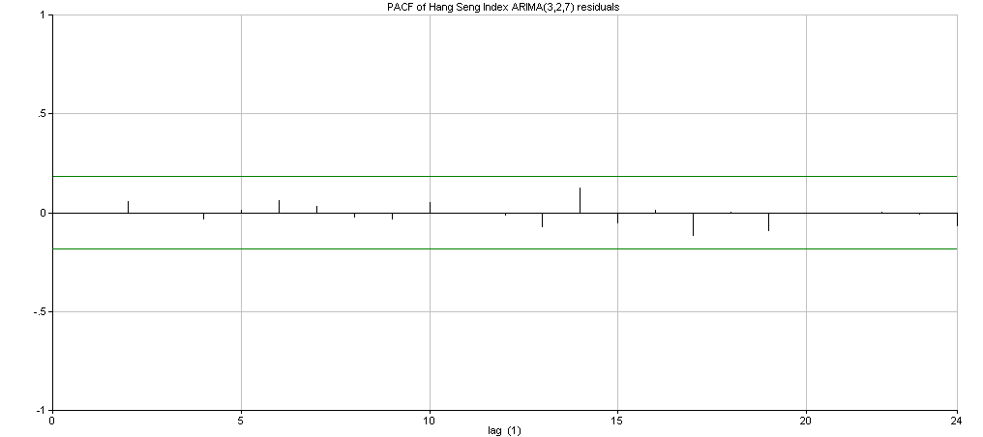
For the ACF, all value of the ACF falls inside the 95% confidence Interval that correspond to p-value is 0.182. By the null hypothesis test Ho:p=0 vs Ha:p≠0, we can retain the Ho with 95% confidence at all lags. Then we use the similar test for the PACF. The value of the PACF at lag 17 and lag 14 are little bit large but it is attributed to randomness so we can ignore it.

We should perform the residual tests on the ARIMA (3,2,7) residuals. If the residuals are white noise, they should pass all the tests and they should be random and normally distributed. The output for the residuals tests is as follows:

Residual tests for Hang Seng Index ARIMA (3,2,7) residuals
T = 116

Cumulative spectrum test
max. diff. p-value
.045 N.S.
Probable constant variance.

Box-Pierce test
lag chi sq. p-value
1 .00 N.S.
20 8.60 N.S.
Probable independence.

Fluctuation test
z p-value
-.44 N.S.
Probable random series.

Outlier detection
max. |z| p-value
2.99 N.S.
No outliers.

Normal test
corr. p-value
.98895 N.S.
Probable Gaussian distribution.
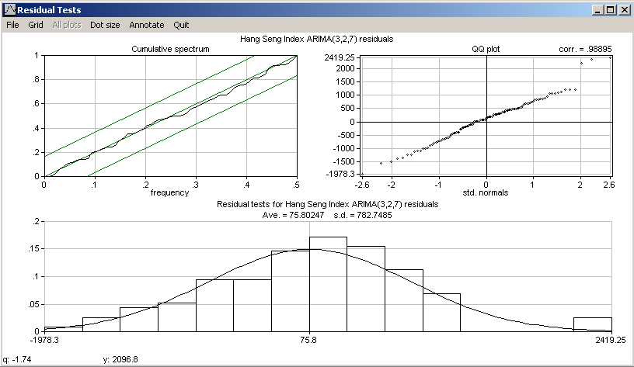
The residuals for the ARIMA(3,2,7) model of {Xt} pass all of the residual tests. Therefore, it is reasonable to conclude that the residuals are white noise.

To test whether the ARIMA(3,2,7) model is appropriate, we can take a subset of the data from t=1 to t=116 and use the model to forecast the t=117 to t=121. Therefore, we can compare these values with the actual values of {Xt} to check how accurate the model can predict the future values of Hang Seng Index.

Forecasts for ARIMA(3,2,7) from Hang Seng Index

95% Conf. bound
95% Conf. bound
t forecast lower upper S.E.
117 22022.7 20619.6 23425.8 715.9
118 21952.4 18802.1 25102.6 1607.3
119 22063.4 12827.9 31298.9 4712.0
120 22362.3 920.9 43803.7 10939.5
121 22463.5 -30183.2 75110.1 26860.5
The actual value is X₁₁₇=23184.94, X₁₁₈=23984.14, X₁₁₉=27142.47, X₁₂₀=31352.58, X₁₂₁=28643.61

We can see that the actual values are all inside of the 95% confidence interval which means that this model is good enough for forecasting. We can see that if we forecast the next five month values at the same time, it is not accurate for the last two. This is because the index value is always based on the values in last month; therefore, the standard deviation will become larger and larger. As a result, we should forecast 1 or 2 month at a time so that to get a more accurate prediction.

Conclusion
For the companies or market trader, they have to use different hedge strategies to reduce different risk such as market risk. The Hang Seng Index future contract is one of the most common and useful hedge methods; therefore, the investors can use above ARIMA model (3,2,7)

(1 +.43B1 +.74B2 +.43B3) X(t) = (1 -.42B1 +.36B2 -.24B3 -.71B4 -.1B5 +.44B6 -.11B7) w(t)

Xt = -0.43Xt-1 – 0.74Xt-2 - 0.43Xt-3 + w_{t} – 0.42 w_{t-1} + 0.36 w_{t-2} – 0.24 w_{t-3} – 0.71 w_{t-4} – 0.1 w_{t-5} + 0.44 w_{t-6} -0.11 w_{t-7}

to estimate the next month Hang Seng Index value so that they can short or long the Hang Seng Index future contracts.

