xxxxxx xxxxxx
Time Series: Student Project
Summer 2011

Introduction
Civilizations across the world depend upon grains for their main source of food. Rice, corn, wheat and barley, among others, are pivotal in dictating dietary customs of people of all nations, and have been so for thousands of years. In this regard, it is necessary for grain and cereal yield to rise in order to support an increase in population. While the percentage of arable land does not usually increase, yield per hectares may be improved and in most countries, this appears to be happening with a greater use of fertilizers and improved irrigation supplies.

However, there is one country that seems to have a particularly volatile trend in yield per hectare for the past few decades. Whilst this study is not to identify the reasons of such a trend, it does raise questions on what were to happen if this trend is soon adopted by other producers as climate changes, weather systems become unpredictable, and global surface temperatures rise.

Sudan is a North-African country that borders Egypt. It has a population close to 44 million, and is one of the few countries that I found with a declining yield per hectare of cereals and grains from the data I have been able to pick up.

Data
I have used 50 data points (from the years 1961 to 2010) to test several models and use the one that fits best for residual analysis.
Source: http://data.worldbank.org/indicator/AG.YLD.CREL.KG/countries/1W?display=default

As the data is annual, a seasonality check is not required.

There seems to be a somewhat downward trend in the statistics though this is not at all pronounced owing to the seemingly haphazard movement of the graph (you may almost think of it as stock prices obeying the Brownian motion). Based on this slightly downward trending set of data, there is some reason to expect an AR(1) model to be more appropriate as |φ| is less than 1.

To help me better decide on a suitable model, I used the Sample Autocorrelation Function, (ACF) and a plot of the corresponding correlogram of the initial data based on the 50 data points with a lag of 49. This may be seen in the Excel Worksheet: Initial Level ACF.

[To compute the Autocorrelation Functions (ACF) and plotted illustrations of the correlograms for this study, I have used the Excel add-in written by Kurt Annen, www.web-reg.de, the link to which I found on one of the NEAS Time Series student project discussions.]

The correlogram seems to suggest an AR(2) model with the ACF dropping to zero by lag 16, decreasing further to lag 17, then following a wave like pattern from lag 18 through lag 39. It oscillates below zero from lag 40 onwards to the end. However, before proceeding, I considered the AR(1) and AR(2) Models of the first difference of the log-transformed values of the population figures, i.e.: ARI(1,1) and ARI(1,2), taking into account the somewhat decreasing trend of the population graph .

ARI (1,1) of Log-Transformed Population

[Excel Worksheet: ARI(1,1)]

I first computed the log-transformed values of the 50 data points. (Column C), and then used the first differences (Column D) for the AR(1) and AR(2) Models. The ACF of the ARI(1,1) Model with 49 lags is as under:

The ACF stays close to zero most of the time. Though not visible here for some reason, red dotted lines appear close to 0.28 mark and the -0.28 mark. In this regard the ACF at lag 1 catches my attention due to it being lower than most values, and the red dotted line, and is therefore significant.

A regression test gives R-Square equal to 40.21%, in comparison to 27.25% of the AR(2), indicating a a more acceptable model. I shall therefore test an ARI(1,2) model later to see if results may be improved.

Residual Analysis of ARI(1,1)

For the ARI(1,1) model, we have Y_{t}= φY_{t-1} + c + e_{t.}

To calculate the value of φ, I used the Regression add-in present in Excel, to get a value of approximately 0.65 where e_{t} accounts for residuals.

The stationarity conditions are also met as |φ| < 1.

The residuals are the difference between the actual (observed) data and that predicted by the fitted model. In a model of perfect fit, the residuals are normally distributed with mean zero. In other words, the residuals are described to be white noise.

The actual population and that predicted by the fitted ARI(1,1) Model are graphed as under:

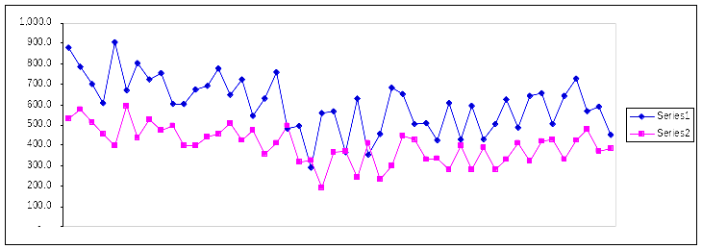

Series 1 indicates the actual data, while Series 2 is the predicted data. There is an obvious gap between the two graphs indicating an unacceptable fit. Residuals have been calculated and are shown in the Excel Worksheet: Residuals under ARI(1,1).

A Q-Q plot based on these residuals is as under:

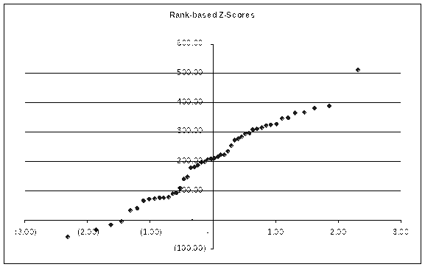

In comparison to a 45 degree line, the residuals are not normally distributed, as they clearly do not form a straight line. However, the residual amounts mostly fall within the domain -2.5 to 2.5 with heavy tails at -58.18 and 511.39.

ARI (1,2) of Log-Transformed Population

[Excel Worksheet: ARI(1,2)]

Relating to the same ACF as the ARI(1,1), a regression of this model gives R-Square equal to 39.26%. This is a marginal decline from the ARI(1,1) R-Square, but for the purposes of this test, I shall reject this.

I know that the AR(2) model is worse than the ARI(1,1) model, but for the sake of completeness, I have run a residual analysis on both models for illustrative purposes.

Residual Analysis of AR(2)

For the AR(2) model, we have Y_{t}= Φ₁Y_{t-1} + Φ₂Y_{t-2} + θ₀ + e_{t}

To calculate the values of Φ_{k,} I carried a regression of the data, again using the Excel Data Analysis add-in.

We get:
Y_{t}= 0.21Y_{t-1} + 0.37Y_{t-2} + 243.96 + e_{t}

Where e_{t} accounts for residuals.

The stationary conditions of AR(2) are also met:
- Φ₁ + Φ₂ ₌ 0.21+0.37=0.58 < 1
- Φ₂ – Φ₁ ₌ 0.37–0.21 = 0.16 < 1
- | Φ₂ | = 0.37 < 1

The actual population and that predicted by the fitted AR(2) Model are graphed as under:

The AR(2) model seems to induce a “calming” effect in the data, and predicts values that are not as volatile as the actual observations. In contrast, this is something that was picked up well by the ARI(1,1). Residuals have been calculated and are shown in the Excel Worksheet: Residuals under AR(2)

A Q-Q plot based on these residuals is as under:

Again, in comparison to a 45 degree line, the residuals do not appear to be normally distributed, as they clearly do not appear to form a straight line. However, as before, the residual amounts mostly fall within the domain -2.5 to 2.5 with heavy tails at -236.75 and 276.31.

Conclusion
I tested the AR(1) and AR(2) models based on the original data, and the ARI(1,1) and ARI(1,2) Models based on the first difference of the log-transformed data values. After analyzing the ACF’s and R-Square values of the various models, the ARI(1,1) Model was chosen to be of the better fit, though a residual analysis was run on AR(2) as well. Putting the fitted models to test over the data of 1961 to 2010 for ARI (1,1), and ignoring 1961 and 1962 owing to the two year lag component of the AR(2) Model, it was noticed that the predicted data swayed from that observed, a measure known as residuals. These residuals were then calculated from 1961 to 2010, and tested for the white noise assumption using a Q-Q plot. The results of this communicated that the residuals do not follow a normal distribution, but fall within a range that demonstrates that the chosen ARI(1,1) model though a better fit than the other models, is not an accurate predictor of yield per hectare. In this regard, I find it difficult to accept the ARI(1,1) model, despite some of the strengths it has over the other models.

