Time Series VEE Course, NEAS, FALL 2011

Student Project

Prepared by: xxx xxxxx xxx

Candidate ID: 38810600

INFLATION RATES

Introduction:
The variation in inflation rate has been a source of great discomfort for investors and general public. People have to adjust for the higher inflation rates, and also have the greater uncertainty about what the inflation rates might be in the future. Being able to predict future inflation rates through regression analysis and time series modeling would not only assist in lessening the stress caused due to unknown future inflation rates, but also help better understand the trends that inflation rates exhibit. This project takes into account historical inflation rates to build an ARIMA model that can be used to project future inflation rates.

Data:
The data used for carrying out this project was taken from the website
http://inflationdata.com/inflation/inflation_rate/historicalinflation.aspx
This source contained monthly data for the last thirty years (i.e. from January 1982 to December 2011). In order to develop time series model, the ten-year period data was selected starting from January 1995 to December 2005. The data from January 2006 to December 2011 was then used to test the accuracy of the model.
The following graph shows the monthly data used to develop my model:
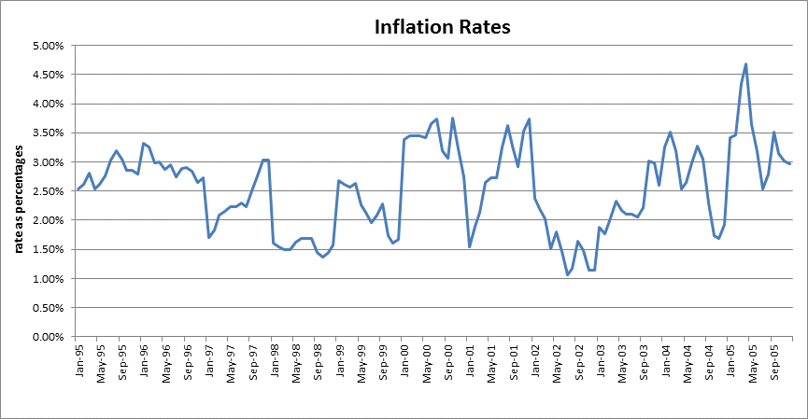
The graph as shown above does not show any signs of seasonal trend in the data and hence does not require any seasonal adjustment.

Stationarity Test:
Before developing the model, the data is required to be examined whether it is stationary or not. One of the ways considered for a data to be a stationary process is if its statistical parameters, such as mean and standard deviation, do not vary over time. Another parameter that must not vary with time is the autocorrelation. In order to check the data, the autocorrelation function will be taken into account and examined for its dependence on time.
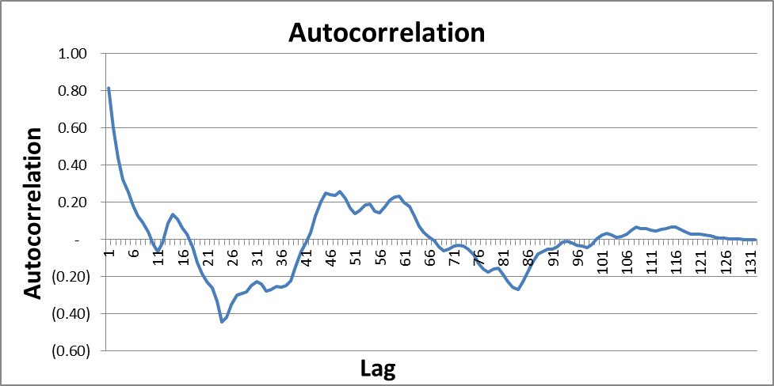

The above graph shows that the series is not stationary as the autocorrelation function shows a strong linear relationship for the first 10 lags, after which it drops below zero and then fluctuates. The autocorrelation function for our process thus, demonstrates a dependence on time, signifying that it is not a stationary process.

First Difference:
Since the original data is not stationary, the first difference of the data was analyzed. A plot of the first difference is shown below:
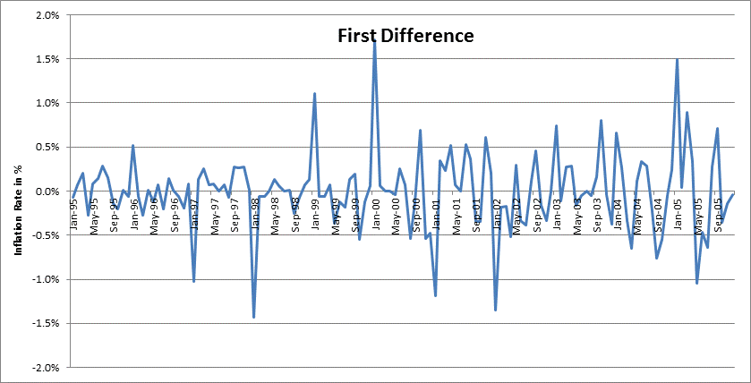
The plot of first difference displays fewer trends than the original series. The following chart displays the correlogram of the first differences to further examine the data for Stationarity:
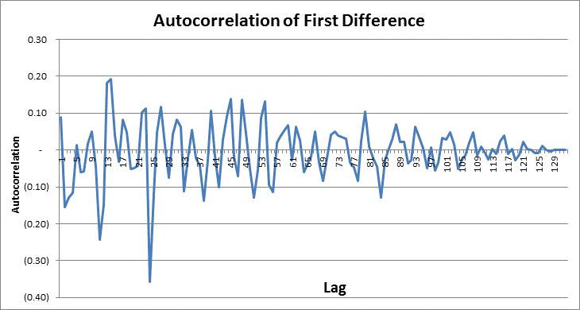
The autocorrelation function of the first difference does not point out any dependence on time. It demonstrates random fluctuations of both positive and negative values, centered towards zero thus, indicating a stationary process. However, additional testing will be done to confirm this observation by performing Bartlett’s test.

Bartlett’s test:
if a series of length T is generated by a white noise process, the estimates of the (partial) autocorrelation coefficients are approximately normally distributed random variables with zero mean and variance 1/T. The confidence limits are then equal to ± z_{1-α/2} /$\sqrt{T}$, with α being the desired significance level and z the percent point function of the standard normal distribution.
Hence, according to this test if a process is white noise, approximately only five percent of the autocorrelation data points will lie outside at the 95% confidence interval centered on zero. The approximate standard deviation of the process is the reciprocal of the square root of the number of terms. In our process we have the following parameters:
σ = 1/$\sqrt{T}$ = 1/$\sqrt{\text{132}}$ = 0.087039
95% Confidence Interval = ±1.96*σ = ±1.96*0.087039=± 0.170596
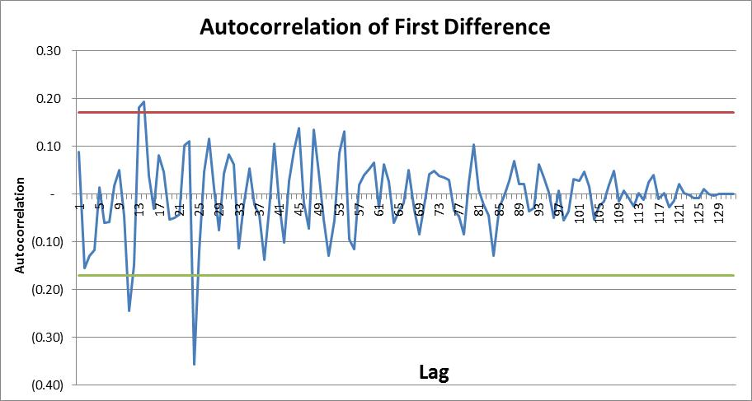
By adding the confidence interval to our correlogram of first difference, it can be seen that only 2 out of the 132 observations fall outside of the interval. This is equivalent to 1.52% and thus implies that the first difference is stationary.

Model Parameterization:
After arriving at a stationary data, we will fit our data using an autoregressive model (AR (p)), using p = 1, 2 and 3. Since we are using the first difference, this is equivalent to ARIMA (p, 1, 0) models.
By Using Excel’s regression data analysis add-in, the following is a summary of the regression results along with the resulting AR equations:

AR (1): Y_{t} = 0.08770Y_{t-1} + 0.0000301464568307521 + ε_{t}

Regression Statistics
Multiple R | 0.087709508
R Square | 0.007692958
Adjusted R Square | 6.55186E-07
Standard Error | 0.004440831
Observations | 131

 | Coefficients | Standard Error | t Stat
Intercept | 3.01465E-05 | 0.000388006 | 0.077695766
X Variable 1 | 0.087703539 | 0.087699804 | 1.000042586

AR (2): Y_{t} =0.102315Y_{t-1} - 0.1646Y_{t-2} +0. 0000308315417746185+ ε_{t}
Regression Statistics
Multiple R | 0.186038886
R Square | 0.034610467
Adjusted R Square | 0.019407482
Standard Error | 0.004414154
Observations | 130

 | Coefficients | Standard Error | t Stat
Intercept | 3.08315E-05 | 0.000387 | 0.079632
X Variable 1 | 0.10231476 | 0.087517 | 1.169073
X Variable 2 | (0.1646259) | 0.087543 | (1.880496)

AR (3): Yt =0. 08471Yt-1 - 0.153708Yt-2 -0.1035576Yt-3 + 0. 0000242696085732451 + εt
Regression Statistics
Multiple R | 0.211409307
R Square | 0.044693895
Adjusted R Square | 0.021766549
Standard Error | 0.004422644
Observations | 129

 | Coefficients | Standard Error | t Stat
Intercept | 2.42696E-05 | 0.00038947 | 0.062314232
X Variable 1 | 0.08471478 | 0.08892043 | 0.952703208
X Variable 2 | (0.1537083) | 0.08817496 | (1.7432192)
X Variable 3 | (0.1035576) | 0.08915639 | (1.1615269)

The following table presents a summary of the results from the auto regression:
 | Sum of Coefficients | R-Square | Adjusted R-Square | Durbin-Watson Statistic | Box - Pierce Q Statistic | Chi - Squared 10%
AR(1) | 0.0877 | 0.0077 | 6.55E-07 | 1.9705 | 92.56 | 147.8048
AR(2) | (0.06231) | 0.0346 | 0.0194 | 2.0333 | 74.45 | 146.7241
AR(3) | (0.1726) | 0.0447 | 0.0218 | 2.0181 | 71.66 | 145.6430

From the above table, it can be seen that the sum of coefficients for each is less than 1, suggesting the models are stationary. The Durbin-Watson statistic is around 2 for each, suggesting no serial correlation. Besides, the Box-Pierce Q statistics are lower than Chi-Squared critical value. We therefore, cannot reject the null hypothesis that the residuals are formed by a white noise process.

Model Selection and Forecasting:
In order to decide the best fit out of the three autoregressive models for the data, we will first look at the Adjusted R-Square statistic which provides a general indication of how well each model formula fits the data. From the table provided above, it can be seen that though there is not much significant difference between the three models, the Adjusted-R square value is highest for the AR (3) model.
The next statistic to be observed is the Durbin-Watson Statistic. The provided table shows that all the three models are showing the Durbin-Watson Statistics pretty closer to 2. Out of these, the highest value is shown by the AR (2) model while AR (3) model is also very close with a negligible difference.
On the basis of all of the above statistics that I have taken into consideration, I have come up to the conclusion that AR (3) process (Y_{t}=0.08471Y_{t-1}-0.153708Y_{t-2}-0.1035576Y_{t-3}+0. 0000242696+ε_{t}) is an appropriate fit for the data as it has a higher Durbin-Watson statistic with a negligible difference from the highest value of the AR (3) model and also a highest Adjusted R-Square value.
Lastly, I will now test the accuracy of the model by comparing it to the actual data taken from January 2006 to December 2011.
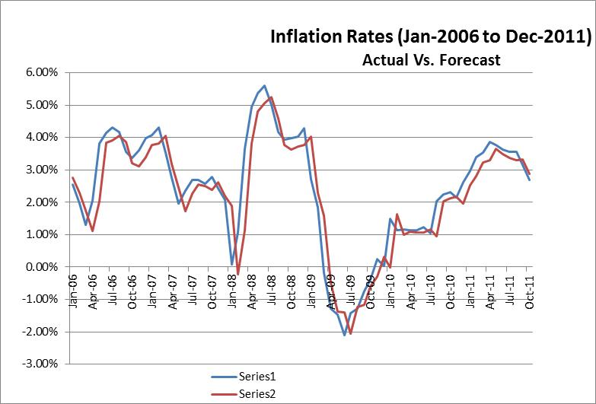

Conclusion:
Although the forecasted values are little higher for most of the time as compared to actual for the AR (3) model which I have decided to use, I feel the model does a decent job of fitting to the actual time series. Also, the shapes of the two series are pretty similar. There are many other factors that could be involved in the value of inflation rates such as global economic conditions. In my opinion, a more accurate model may be produced using other regressors, but given knowing just the prior inflation rates, I believe that this model fits the data reasonably well.

