Time Series Project

Spring 2011
Time Series Modeling: Crude Oil Prices
Registrant ID: 33517844
xxxx xxxxxx xxxxx

Introduction
Over the past many decades, huge leaps in technology and infrastructure have led to a massive increase in demand for energy, and in this regard demand for fuels specifically crude oil has increased dramatically. While these changes may be attributed to many factors, a time series model based on past prices may easily be able to bring together all that information contained in those prices. This project takes into account historical Crude Oil prices to build an ARIMA model that can be used to project future Crude Oil prices.

Data:
The data used for the formulation of this model was taken from:
http://www.indexmundi.com/commodities/

This source contained monthly data for the last twenty years (i.e. from May 1992 to May 2012). In order to develop time series model, an eleven-year period data (132 months) was selected starting from January 1993 to December 2003. The data from January 2004 to May 2012 was then used to test the accuracy of the model.
Following chart illustrates trends in Crude Prices over the period of Jan 1993 to Dec 2003.
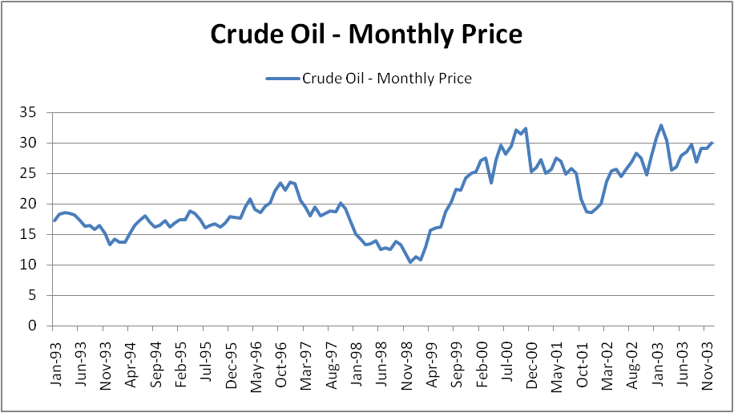
The graph as shown above does no visible signs of seasonal trend in the data and hence does not require any seasonal adjustment.

Stationarity Test:
As a check for stationarity, one of the ways considered for a data to be a stationary process is if its statistical parameters, such as mean and standard deviation, do not vary over time. Another parameter that must not vary with time is the autocorrelation. The chart below illustrates the dependence on time of the autocorrelation.
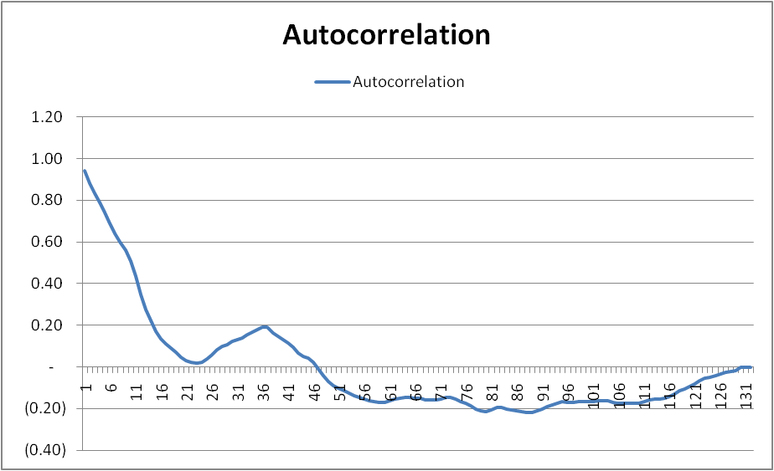
First Difference:
Since the original data is not stationary, the first difference of the data was analyzed. A plot of the first difference is shown below:
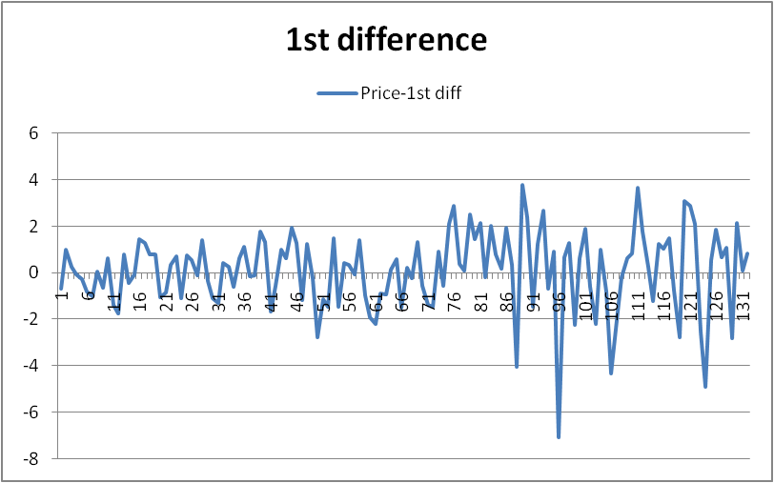
The plot of first difference displays fewer trends than the original series. The following chart displays the correlogram of the first differences to further examine the data for Stationarity:
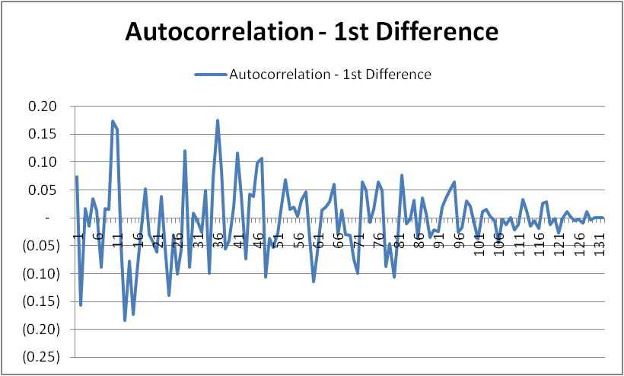
The autocorrelation function of the first difference does not point out any dependence on time. It demonstrates random fluctuations of both positive and negative values, centered towards zero thus, indicating a stationary process. However, additional testing will be done to confirm this observation by performing Bartlett’s test.
Bartlett’s test:
if a series of length T is generated by a white noise process, the estimates of the (partial) autocorrelation coefficients are approximately normally distributed random variables with zero mean and variance 1/T. The confidence limits are then equal to ± z1-α/2 /$\sqrt{T}$, with α being the desired significance level and z the percent point function of the standard normal distribution.
Hence, according to this test if a process is white noise, approximately only five percent of the autocorrelation data points will lie outside at the 95% confidence interval centered on zero. The approximate standard deviation of the process is the reciprocal of the square root of the number of terms. In our process we have the following parameters:
σ = 1/$\sqrt{T}$ = 1/$\sqrt{\text{132}}$ = 0.087039
95% Confidence Interval = ±1.96*σ = ±1.96*0.087039=± 0.170596
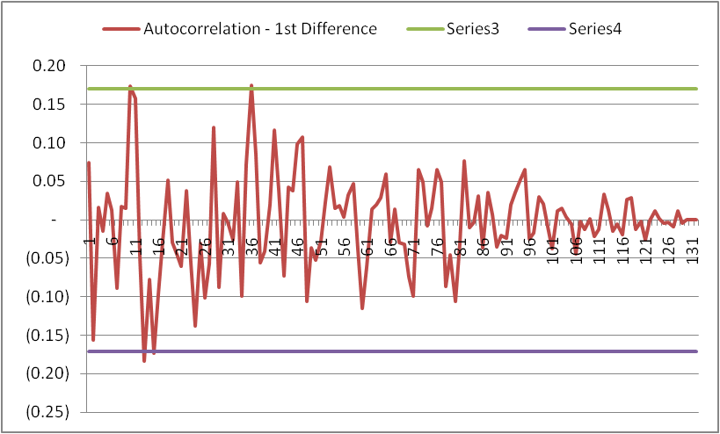
By adding the confidence interval to our correlogram of first difference, it can be seen that only 4 out of the 132 observations fall outside of the interval. This is equivalent to 3% and thus implies that the first difference is stationary.

Model Parameterization:
After arriving at a stationary data, we will fit our data using an autoregressive model (AR (p)), using p = 1, 2 and 3. Since we are using the first difference, this is equivalent to ARIMA (p, 1, 0) models.
By Using Excel’s regression data analysis add-in, the following is a summary of the regression results along with the resulting AR equations:
AR (1): Y_{t} = 0.074Y_{t-1} + 0.0782 + ε_{t}

Regression Statistics
Multiple R | 0.073967566
R Square | 0.005471201
Adjusted R Square | -0.002238325
Standard Error | 1.659793529
Observations | 131

 | Coefficients | Standard Error | t Stat
Intercept | 0.078242652 | 0.145266887 | 0.54
X Variable 1 | 0.073974244 | 0.087811831 | 0.84

AR (2): Y_{t} =0.0881Y_{t-1} - 0.1627Y_{t-2} +0.096+ ε_{t}
Regression Statistics
Multiple R | 0.17934
R Square | 0.03216
Adjusted R Square | 0.01692
Standard Error | 1.64820
Observations | 130

 | Coefficients | Standard Error | t Stat
Intercept | 0.0960 | 0.1449 | 0.6621
X Variable 1 | 0.0881 | 0.0875 | 1.0066
X Variable 2 | (0.1627) | 0.0874 | (1.8605)

AR (3): Yt =0.09555Yt-1 - 0.16655Yt-2 -0.04412Yt-3 + 0.09283 + εt
Regression Statistics
Multiple R | 0.1842310
R Square | 0.0339411
Adjusted R Square | 0.0107557
Standard Error | 1.6597361
Observations | 129

 | Coefficients | Standard Error | t Stat
Intercept | 0.09283 | 0.14667 | 0.63291
X Variable 1 | 0.09555 | 0.08951 | 1.06751
X Variable 2 | (0.16655) | 0.08847 | (1.88241)
X Variable 3 | 0.04412 | 0.08985 | 0.49101

The following table presents a summary of the results from the auto regression:
 | Sum of Coefficients | R-Square | Adjusted R-Square | Durbin-Watson Statistic | Box - Pierce Q Statistic | Chi - Squared 10%
AR(1) | 0.0740 | 0.0055 | (0.0022) | 1.9738 | 60.666 | 147.805
AR(2) | (0.0746) | 0.0322 | 0.0169 | 1.9823 | 60.169 | 146.724
AR(3) | (0.0269) | 0.0339 | 0.0108 | 1.9914 | 59.947 | 145.643

From the above table, it can be seen that the sum of coefficients for each model is less than 1, suggesting the models are stationary. The Durbin-Watson statistic is around 2 for each, suggesting no serial correlation. Besides, the Box-Pierce Q statistics are lower than Chi-Squared critical value. We therefore, cannot reject the null hypothesis that the residuals are formed by a white noise process.
Model Selection and Forecasting:
In order to decide the best fit out of the three autoregressive models for the data, we will first look at the Adjusted R-Square statistic which provides a general indication of how well each model formula fits the data. From the table provided above, it can be seen that though there is not much significant difference between the three models, the Adjusted-R square value is highest for the AR (2) model.
The next statistic to be observed is the Durbin-Watson Statistic. The provided table shows that all the three models are showing the Durbin-Watson Statistics pretty closer to 2. Out of these, the highest value is shown by the AR (3) model while AR (2) model is also very close with a negligible difference.
On the basis of all of the above statistics that it’s safe to conclude that AR (2) process (Y_{t} =0.0881Y_{t-1} - 0.1627Y_{t-2} +0.096+ ε_{t}) is an appropriate fit for the data, having the highest Adjusted R-Square value as well as a high Durbin-Watson statistic with a negligible difference from the highest value of the AR (3) model.
The chart below illustrates the fit of the AR(2) model on actual data taken from January 2004 to May 2012.
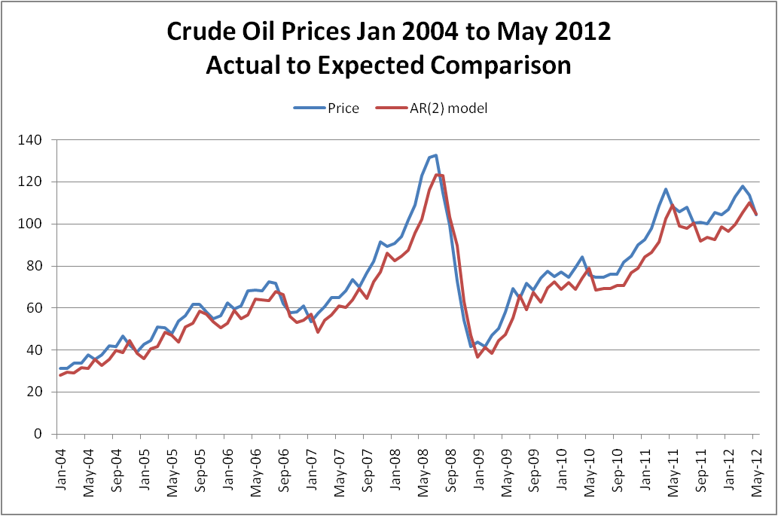
Conclusion:
Although the forecasted values are a little lower most of the time as compared to the actual prices, still the model does a decent job of fitting to the actual time series. Also, the shapes of the two series are very similar. Changes in crude oil prices have seen dramatic change as many factors like growing industries and in contrast the focus on alternate energy sources continues to affect demand. Further, with successful explorations these trends will consequently change.
The model does a good job in projecting values based on the information contained in past couple of prices, while its reliability will be compromised with new developments.

