Course: Time Series Analysis
Sessions: Summer 2012
Date: August 8, 2012

Introduction

One of the biggest dreams many people have is to own their own home someday. For my project I will attempt to develop a time series model to forecast the monthly sale of new homes in the United States.

Data

For this project, I decided to look at the USA monthly new home sales obtained from the following website: http://datamarket.com/data/list/?q=provider:tsdl

The data is illustrated on the “Original Data” tab in the project workbook. The data shows the monthly sales of new homes in the US from 1963 to 2012. For this project, I used a sample of the data from January 1996 through December 2008. The following is a plot of the data before any adjustments:

Exhibit 1 – Plot of Original Data - January 1996 to December 2008

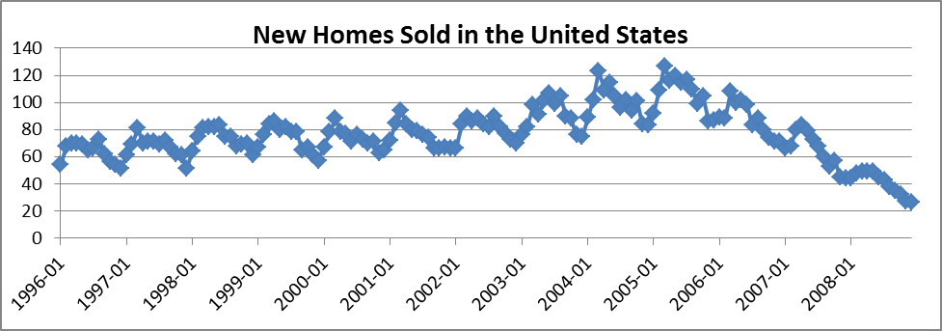

As illustrated in the graph in Exhibit 1, there is a general increase in home sales from 1996 to 2006 followed by a decrease after 2006. Additionally the plot shows a seasonal trend in each 12-month cycle. To confirm this trend, I calculated the sample autocorrelation by lag and the resulting correlogram plot is shown the exhibit 2.

Exhibit 2 – Sample Autocorrelation Function of Original Time Series

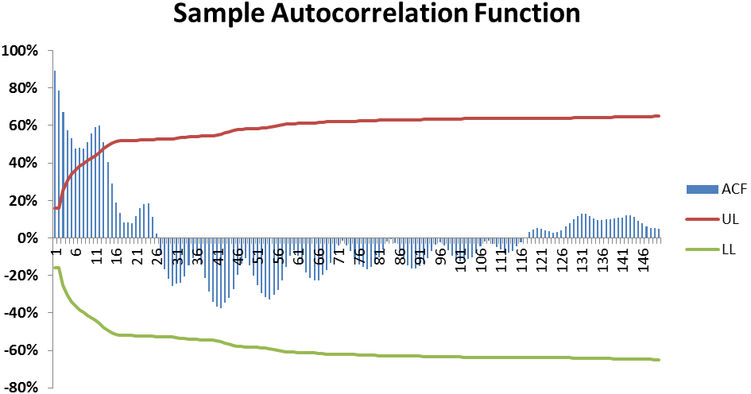

The correlogram above confirms the seasonality of data. See sheet “Unadjusted Data” in the time series project workbook. As illustrated in the graph, there are peaks at all of the lags in multiples of twelve. From Exhibit 1 and 2 we can clearly that the data has an annual seasonal pattern.
In addition to the presence of seasonality, we can use regression analysis to show that this original time series is probably not a white noise process. The result of the analysis is shown in sheet “BPQS_Unadjusted_Data.” As shown in the analysis the Durbin-Watson statistics was determined to be 1.86 and the result of the Box-Pierce test resulted in the rejection of the null hypothesis that the data is from a white noise process.

In addition, as shown above the high R² value gives an indication that there is some amount of correlation.

Before I can attempt to model the data I need to de-seasonalize the data by taking annual differences. Exhibit 3 and 4 below shows the resulting plot of the de-seasonalized data.

Exhibit 3 – Plot of Seasonally Adjusted Time Series
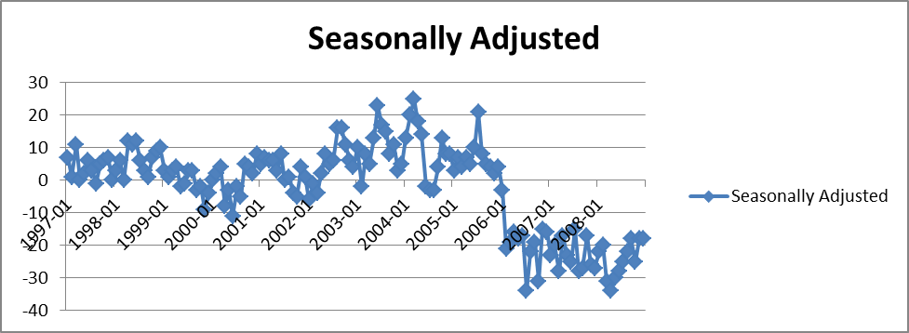

Exhibit 4 – Sample Autocorrelation Function of Seasonally Adjusted Time Series

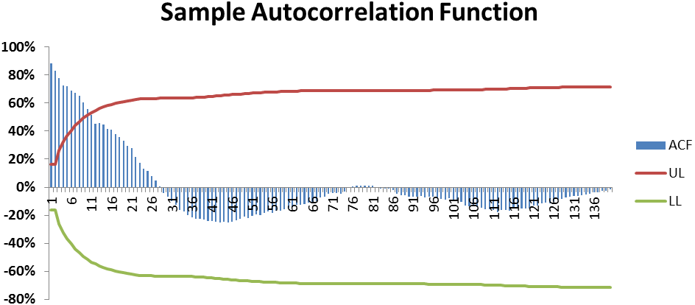

As seen in exhibit 4, the sample autocorrelation values decline to zero, although not very quickly.

Also to make the data stationary I will applied a one lag differencing on the data. Exhibit 5 shows the resulting correlogram. The plot still shows some autocorrelation at the beginning lags. I could perform another differencing in an attempt to remove these but that may result in adding more unwanted trend that will not work for this analysis. Therefore I will overlook these initial lags and assume that the data is stationary.

Exhibit 5 – Sample Autocorrelation Function of Seasonally and 1st Differenced Adjusted Time Series

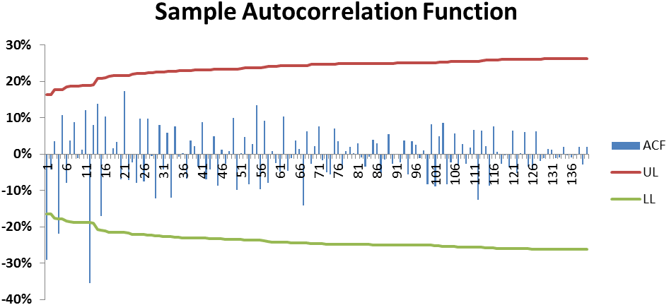

Now that I have a time series data set that is stationary and free of any seasonality it is time to attempt to fit a model. For this part of the analysis I will be using MS Excel.

Modeling and Analysis

Using the seasonally adjusted data, I performed linear regression functions in Excel and obtained the following four probable models for the adjusted time series. Please see the details of the analysis in the project workbook:

AR(1): Y_{t} =-0.1849-0.2905Y_{t-1}+e_{t}

AR(2): Y_{t} =-0.2801- 0.3219Y_{t-1} - 0.1366Y_{t-2+} +e_{t}

AR(3): Y_{t} =-0.2237 - 0.3109Y_{t-1} - 0.1474Y_{t-2}-.0190Y_{t-3} +e_{t}

AR(4): Y_{t} =-0.2980 - 0.3157Y_{t-1} - 0.1838Y_{t-2}-.0999Y_{t-3}-0.2492Y_{t-4+}+e_{t}

The following table shows a summary of the results of the various regression analyses performed on the data.

Model | AR(1) | AR(2) | AR(3) | AR(4)
Box-Pierce Q | 83.46 | 77.75 | 77.29 | 76.26
Chi_Squared (10%) | 163.98 | 162.90 | 161.83 | 160.75
Durbin-Watson | 2.05 | 1.96 | 2.01 | 2.02
Sum of Coefficients | 0.29 | 0.46 | 0.48 | 0.85

For this analysis I calculated the Durbin-Watson (DWS) statistics to be used as a test for autocorrelation among the residuals. The following formula is used and the decision is made based on whether the calculated value is close to zero (indicating positive autocorrelation), close to 2 (indicating the residuals are free of autocorrelation) or close to 4 (indicating negative autocorrelation). In this analysis the Durbin-Watson values for the three proposed models are around 2, indicating that the residuals do not seem to be correlated. Here is the formula used in the calculation:

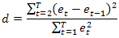

The Box- Pierce test is used to determine if the residuals are a white noise process. If the calculated Q statistic is less than the value in the chi-square table, then we do not reject the hypothesis that the residuals are white noise. The smaller the Q-statistic compared to the chi-squared distribution, the better fit of the proposed model. From the summary table above we would not reject any of the AR models at neither the 10% nor the 20% level of significance.

As a final check of the stationarity of the proposed model I check to see if the sum of the coefficients is less than one. As seen in the summary table above, the absolute values of the sums of the coefficients in all the three models are less than 1 and so we can conclude that the proposed models are stationary.

Conclusion

As a result of the detailed analysis presented above it can be concluded that any of the proposed models could be a potential fit for the time series data presented. I am however selecting the AR(1) model as the best fit for this dataset because it has fewer variables compared to the AR(3) model that has the smallest Q-statistic compared to the chi-squared value and the value of the D-W stat closer to 2 but has 3 variables.

