Introduction
Growing up on a dairy farm, the price of milk per hundredweight (every 100 pounds) was important to the livelihood and well-being of my family. Although I never cared for milk, I do purchase milk to use with cereal. I decided to see how the price of a gallon of milk from a consumer perspective fluctuates.

Data
The data used was from (http://www.bls.gov/data/ → Under Inflation & Prices select Top Picks for Average Price Data → Check “Milk, fresh, whole…” to retrieve data → Change start year to 1995). The data shows the monthly U.S. average price of whole milk from July 1995 to May 2012.

The graph below shows the price of a gallon of milk from July 1995 to May 2012. The graph does not seem stationary; it appears that the price of milk has generally increased as time goes on.

Analysis
The chart on the next page shows the autocorrelation of the price of milk per gallon. The series does not seem stationary because the lag does not reach zero until April 2000. Using Bartlett’s test, 1/√203 * 1.96 = 0.138, where 203 is the number of observations, shows that the absolute value of many of the autocorrelations are above this. We can be 95% confident that the data is not a white noise process.

I took first differences of the data in order to make the time series stationary as graphed below. The graph seems to be stationary since it looks like the first differences revert to zero.
The autocorrelation function for first differences quickly goes to zero and oscillates around zero, indicating that the time series is now stationary.

Model Parameterization
The following uses the Excel regression add-in to fit the data to an AR(1), AR(2) and AR(3) model.

AR(1): Y_{t} = 0.0030 + 0.3458 Y_{t-1} + ε_{t}

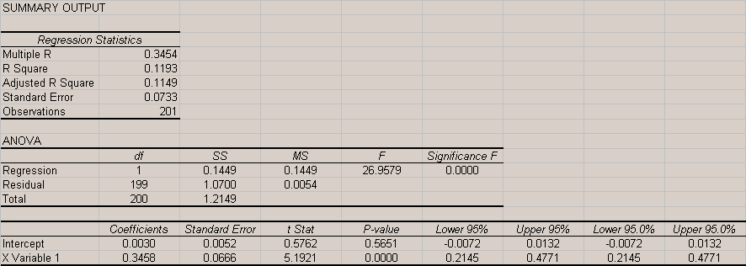

AR(2): Y_{t} = 0.0036 + 0.3945 Y_{t-1} – 0.1414 Y _{t-2} + ε_{t}

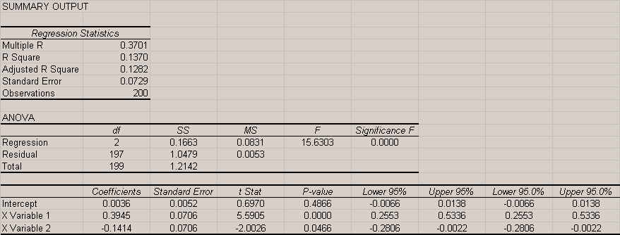

AR(3): Y_{t} = 0.0040 + 0.3778 Y_{t-1} – 0.0938 Y _{t-2} – 0.1215 Y _{t-3} + ε_{t}

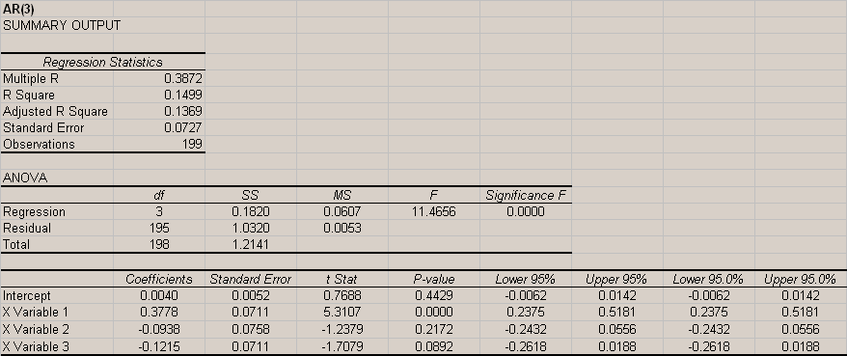

The Durbin-Watson statistic for each of the three models is shown below.
Durbin-Watson Statistic
AR(1) | 1.90
AR(2) | 2.03
AR(3) | 1.99
A Durbin-Watson statistic of 2 indicates no serial correlation with the residuals. All three of these models have a Durbin-Watson statistic close to 2, indicating no correlation among the residuals.

The Box-Pierce Q statistic for each of the three models is shown on the next page along with the corresponding chi-square value at the 10% significance level. If the calculated Box-Pierce Q statistic is lower than the chi-square value we will not reject the model. I used the first 20 residuals to calculate the Box-Pierce Q statistic. The chi-square values are based on 19, 18, and 17 degrees of freedom for AR(1), AR(2), and AR(3), respectively. The degrees of freedom are calculated by subtracting the number of parameters calculated in the model from the total observations. For example, the chi-square value for AR(1) will be based of 19 degrees of freedom since 20 observations were used and 1 parameter is calculated.
Model | Box-Pierce Q | Chi-square, 10% | White Noise
AR(1) | 25.43 | 27.20 | Accept
AR(2) | 23.01 | 25.99 | Accept
AR(3) | 23.09 | 24.77 | Accept
The Box-Pierce Q statistics for all the models are below the chi-square values, meaning that we can not reject the hypothesis that the residuals are white noise. All three models are acceptable.

The sum of the coefficients is shown below for each of the three models.
Sum of Coefficients
AR(1) | 0.3458
AR(2) | 0.2531
AR(3) | 0.1625
Since the sum of the coefficients for all three models is less than one, we know the models are stationary.

Model Selection
Any of the three models seem appropriate to graph the price of milk. However, if I had to select one model to use, I would select AR(2) since its Q-statistic was the lowest of the three models. Below are charts of the autoregressive models compared to the actual first differences. The models are smoother compared to the actual data and do not fully predict sudden changes in the price, although they account for some fluctuations.

