Population Growth Rate of China

Introduction
The purpose of this regression analysis student project is to determine the variable(s) that mainly predict the average Population Growth Rate in China. Four selected explanatory variables are Birth Rate, Mortality Rate, Net Immigration Rate, and Life Expectancy Growth Rate. These explanatory variables will be used in various combinations to determine the best and simplest model by analyzing R², t-statistic, and p-values, Residual Plots, and Standard Residual Plots during the course of my simplification process.

Data
The data used for this analysis is the estimated population for July 1 of each year from the website of the United States Census Bureau (www.census.gov/population/international/data). The population data is taken between the years of 1990 and 2012 as shown below:

Regression Equation #1.
The linear regression equation for the full model with all 4 explanatory variables is:
Y = α + β₁X₁ + β₂X₂ + β₃X₃ + β₄X₄ (1)
Where:
Dependent Variable:
- Y = Average Population Growth Rate of China

Explanatory Variables:
- α = y-intercept
- βi = least squares coefficient
- X₁ = Birth Rate (per 1,000 people)
- X₂ = Mortality Rate (per 1,000 people)
- X₃ = Net Migration Rate (per 1,000 people)
- X₄ = Life Expectancy Growth Rate (per 1,000 people)

Multi-Collinearity
Before we begin the modeling process, we will first take a glance at the correlations between the different explanatory variables as shown in Table 2, where it is easily seen that the Life Expectancy Growth Rate is highly correlated with the Birth Rate and Net Migration Rate as well. Net Migration Rate and Birth Rate are also highly correlated with each other. So, the full model with all 4 explanatories experiences multi-Collinearity. We will consider in the future if we can remove one or more of these variables because they are so highly correlated with each other.

Using the Excel built-in regression tool, the regression summary output as shown in below Table 3 for model #1. By putting the coefficient for each explanatory variable from Table 3. to the model in Regression Equation #1, the model regression equation becomes:
Y = -0.0352% + 0.1032%*X₁ + 0.1201%X₂ - 0.4589%*X₃ - 0.0441%*X₄

Meanwhile, from Table 3., the R² and adjusted R² values are both greater than 0.995 (0.99862 and 0.9972, respectively), which indicates that this model is a very good predictor of Population Growth Rate of China.

The Residual Plot for Model #1 and Standardized Residual plot for Model #1 as shown below indicate that the residuals are very small and there are only a couple of points outside of two standard deviations, and most of the points fall within 2 standard deviations, which also indicates that this full model fits the population data very well.

Our task is now to uphold the high R² and adjusted R² values and small residual and standardized residual while simplifying this equation and more fitted model.
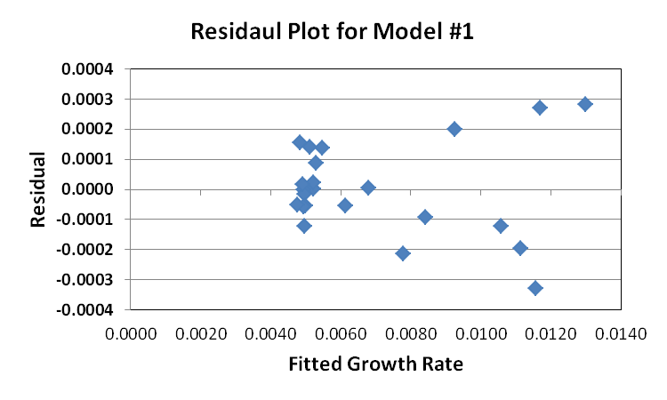
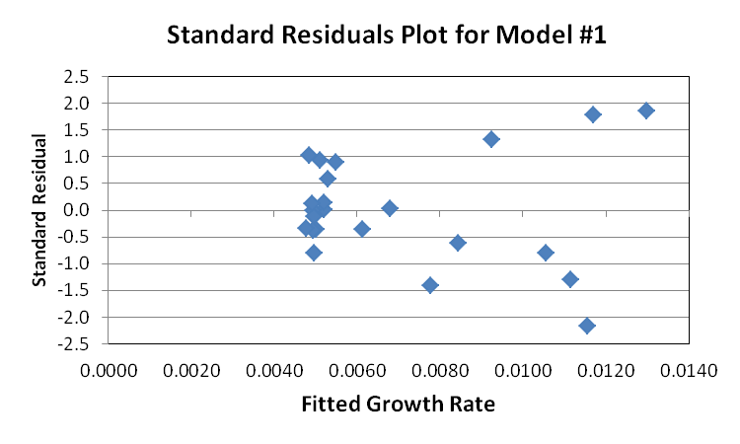

Regression Equation #2
The linear regression equation for the model with 3 explanatory variables, but without Life Expectancy Growth Rate is:
Y = α + β₁X₁ + β₂X₂ + β₃X₃ (2)
Where:
Dependent Variable:
- Y = Average Population Growth Rate of China

Explanatory Variables:
- α = y-intercept
- βi = least squares coefficient
- X₁ = Birth Rate (per 1,000 people)
- X₂ = Mortality Rate (per 1,000 people)
- X₃ = Net Migration Rate (per 1,000 people)

With the Excel built-in regression tool, the regression summary output is shown below in Table 4 for model #2. Using the coefficient for each explanatory variable from Table 4., the model regression equation for Model #2 is:
Y = 0.0393% + 0.1001%*X₁ + 0.1162%X₂ - 0.1070%*X₃

From Table 4., the R² and adjusted R² values are both greater than 0.995 (0.99854 and 0.99708, respectively), but they are a little less than those in Model #1, which indicates that this model is also a good predictor of Population. But the t Stat and P-value are a little better than the corresponding values from Model # 1. So, it is hard to tell which model is better.

From the Residual Plot for Model #2 and Standardized Residual plot for Model #2 as shown below, it indicates that the residuals at most of points are a little bigger than the corresponding values for Model #1, which clearly indicate that Model #1 is a little more fitted than Model #2.

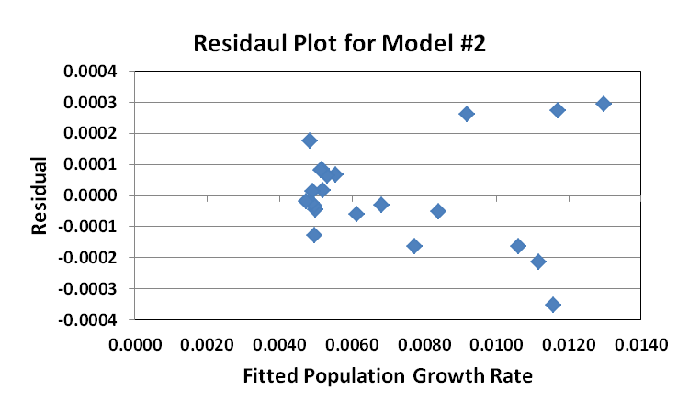
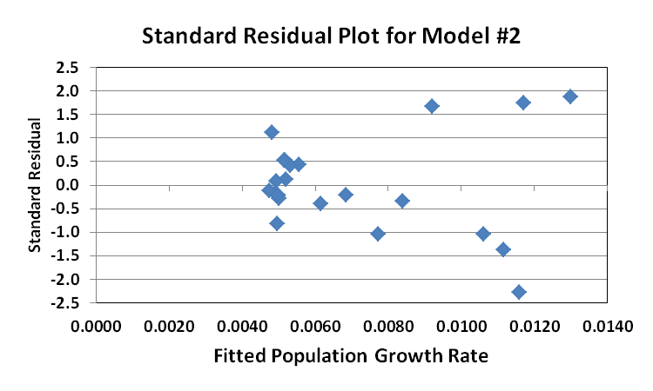
From Table 2., the Net Migration Rate and Birth Rate are highly correlated with each other. So, next, I want to remove the Net Migration Rate and test the model with only two explanatory variables.

Regression Equation #3
The linear regression equation for the full model with 2 explanatory variables is:
Y = α + β₁X₁ + β₂X₂ (3)
Where:
Dependent Variable:
- Y = Average Population Growth Rate of China

Explanatory Variables:
- α = y-intercept
- βi = least squares coefficient
- X₁ = Birth Rate (per 1,000 people)
- X₂ = Mortality Rate (per 1,000 people)

With the Excel built-in regression tool, the regression summary output as shown in below Table 5 for model #3. Using the coefficient for each explanatory variable from Table 5., the model regression equation is:
Y = 0.0669% + 0.0975%*X₁ + 0.1109%X₂

From Table 5., the R² and adjusted R² values are both greater than 0.995 (0.99850 and 0.99700, respectively), but a little less than those in Model #1 and Model #2.While the t Stat and P-value are a little better than the corresponding values from Model # 1 and Model #2. But the Residual Plot for Model #3 and Standardized Residual plot for Model #3 as shown below show that the residuals at most of points become bigger than the corresponding values for Model #1 and Model #2, which clearly indicate that Model #3 is not the best model compared to Model # 1 and Model #2.

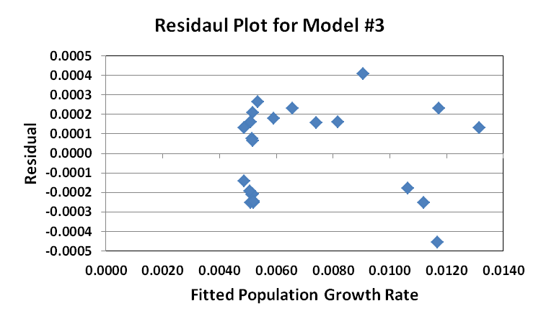

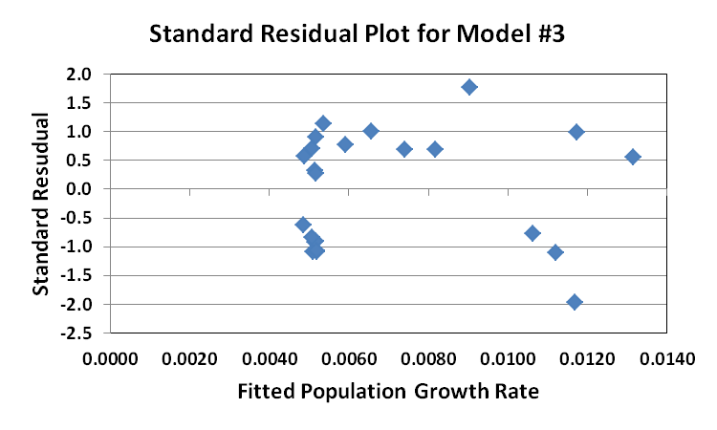
Conclusion
Based on my analysis sated above for each model, I suggest that the two most important factors in predicting the average population growth rate in China are Birth Rate and Mortality Rate. Intuitively, it makes perfect sense as the rates of death and birth are very important to the overall population of a country. Other factors like Net Migration Rate and Life Expectancy Growth Rate are necessary to be used to determine the overall population located to a developing country like China, whose economics is rapidly being developed and living level is becoming better and better in recent a few of decades. So, the best model that predicts the population growth rate of China with the least amount of complexity is:
Y = -0.0352%+ 0.1032%* Birth Rate + 0.1201% Mortality Rate - 0.4589%* Net Migration Rate - 0.0441%* Life Expectancy Growth Rate

