Introduction
Being an avid coffee consumer, I am genuinely interested in coffee price per pound. Although coffee is a price inelastic product to me, I would like to study the historic coffee bean prices and also attempt to predict the near future price.
Data
I was able to gather data from http://www.bls.gov/data/ under Average Price Data → TOP PICKS → Coffee, Ground Roast, All Sizes. Data goes as far back as January 1980 and through August 2012. Unfortunately, data gets spotty in 2007, 2008 and 2009. So I’ve decided to use the monthly data from January 1980 through December 2006 and forecast 2007 through 2012 coffee price per pound and compare to the actual prices between 2007 and 2012 when available. Also, for simplification, I will ignore inflation in this analysis.
When drawn out in a graph as shown below, coffee price does not seem stationary.
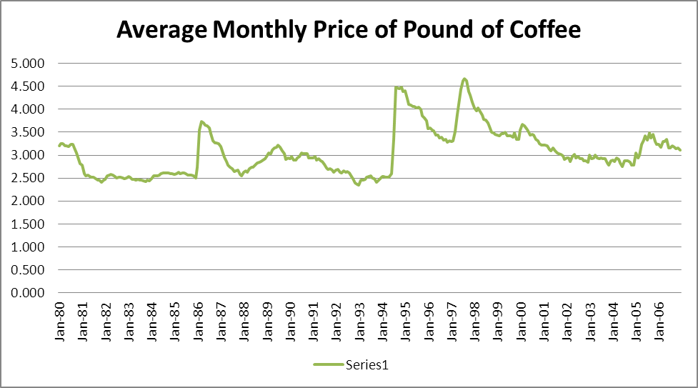

Analysis
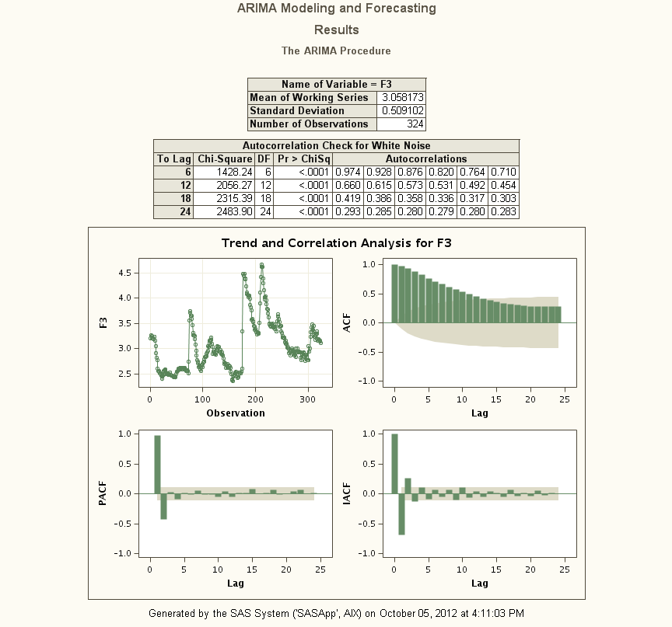

Ordinary Least Squares Method
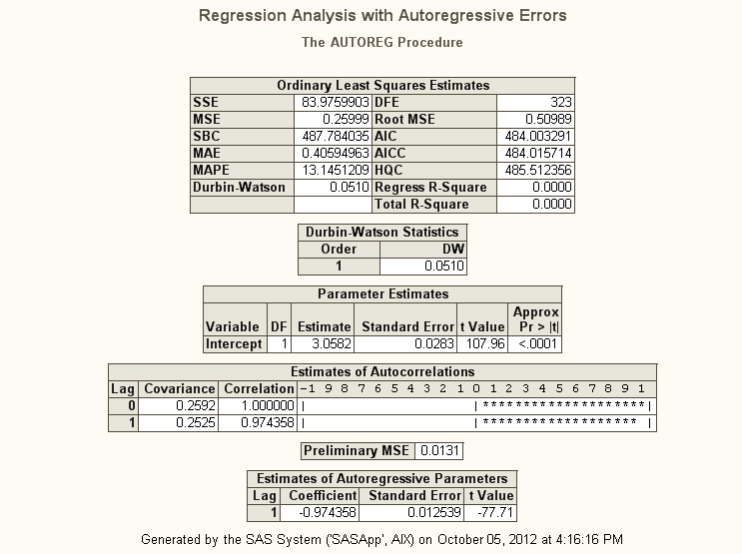

Yule-Walker Method
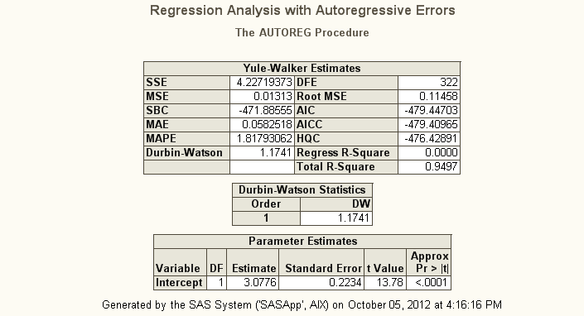

Above analysis is done using SAS EG (Enterprise Guide). Nice thing about using patent software such as SAS was that it does all the work and modeling optimization.
Conclusion
Using the parameter optimized by Ordinary Least Square Estimates, I would select AR(1) model with the coefficient SAS suggests.

