xxxx-xx xxxx
Time Series Student Project
Summer 2012
Introduction
This project will attempt to find an appropriate time series model for unemployment rate. The goal of this project is to model the monthly unemployment rate in Taiwan from January 2002 to December 2010. I’ll use this model to predict 2011 monthly unemployment rates and compare them to rates that were actually seen during this past year.

Data
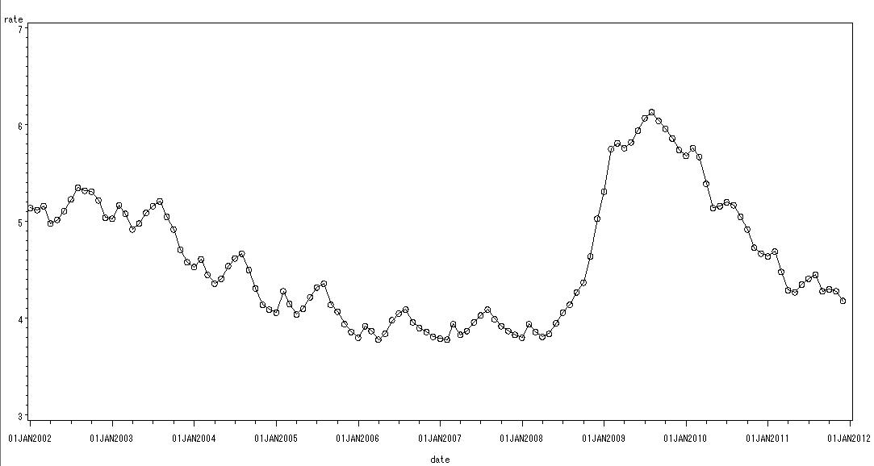
Figure 1
The data of this project came from the following website:
http://www.dgbas.gov.tw/ct.asp?xItem=18843&ctNode=4943&mp=1
Test of Stationarity
We found that the original values in Figure 1 is unstably, so we will convert the data by differential incremental learned. According to the Figure 1, the data hasn’t been increased the variation with the past time. Thus, we determined that there is no need to do pre-differencing transformation with our graphics.
The Method of Differences
We will use the SAC(the sample autocorrelation function) and SPAC(the sample partial autocorrelation function) to find out a working series of stationary time series values. We define the d is First-order linear differential, and D is Order of seasonal differential. The following we will illustrate differential results and from the selection of the appropriate differential method.
- Non Difference (d=0,D=0) : $Z_{t}=y_{t}^{}$
In the SAC of time series values (Figure 2), there have been many spikes and the convergence was not quickly. We judge that the model is unstably.
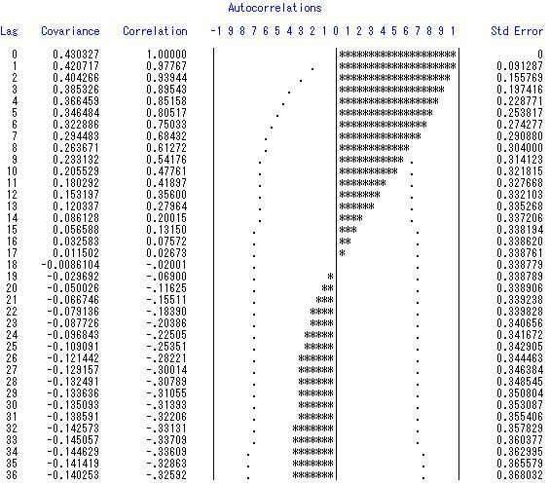
Figure 2
- First-order linear differential (d=1,D=0) : $Z_{t}=y_{t}^{}−y_{t−1}^{}$
It has been convergence rapidly in non-seasonal aspect with the SAC of time series values (Figure 3.1), but the seasonal aspect wasn’t. In the SPAC of time series values (Figure 3.2), both of seasonal and non-seasonal aspect were been converged rapidly. We judge that this is a stationary model.
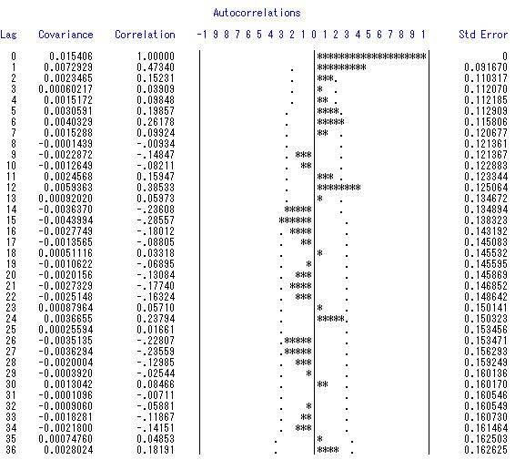
Figure 3.1
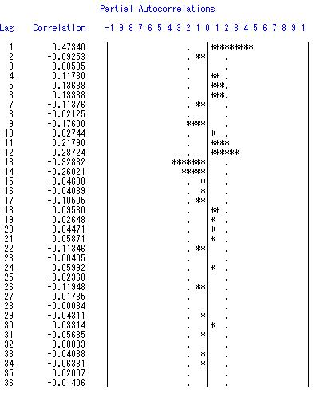
Figure 3.2
- Order of seasonal differential (d=0,D=1) : $Z_{t}=y_{t}^{}−y_{t−\text{12}}^{}$
In the SAC of time series values (Figure 4), there have been many spikes and the convergence was not quickly. As a result, we judge that this model is unstably.
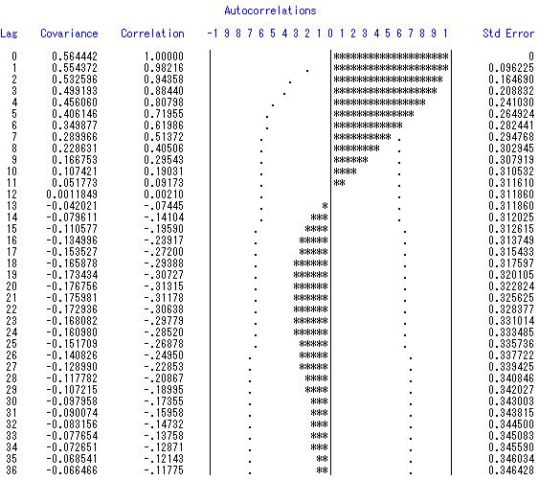
Figure 4
- First-order linear differential and Order of seasonal differential (d=1,D=1) : $Z_{t}=y_{t}^{}−y_{t−1}^{}−y_{t−\text{12}}^{}+y_{t−\text{13}}^{}$
In the SAC of time series values (Figure 5.1), its convergence rapidly in seasonal aspect, but the convergence of non-seasonal was until lag 11. While in the SPAC of time series values (Figure 5.2), both of the seasonal and non-seasonal were converged rapidly. We judge that this is a stationary model.
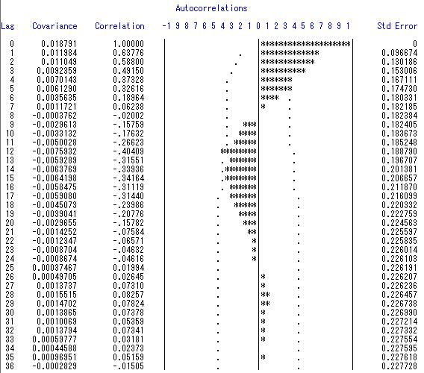
Figure 5.1
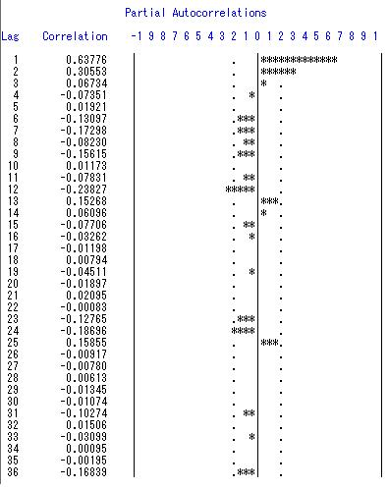
Figure 5.2
Model Fitting
During the above test, we selected two differential conversion model (i.e. First-order linear differential and the mixed of First-order linear differential and Order of seasonal differential) as a model analysis. According to the SAC Figure and SPAC Figure, we’ll establish five models to determine the trend of seasonal level and non-seasonal level. Next, we’ll determine which models are suitable for predict future data by parameter estimation, residuals, the RSAC Figure and the RSPAC Figure.
Model 1： d=1, D=0, AR(1)&AR(1) (seasonal & non-seasonal)
Conditional Least Squares Estimate
If the absolute t-value of the parameter is not greater than 2, we should seriously consider excluding the parameter from the model, because including it would be not a suitable model. If the “Std Error Estimate” is small, parameters are mutually independent.
Although the absolute t-value of the AR(1,1),AR(1,3),AR(1,4) were greater than 2, but the AR(1,2) of the absolute t-value is smaller than 2( Figure M1.1). Thus, there will be some parameters have not need to be placed in this model.
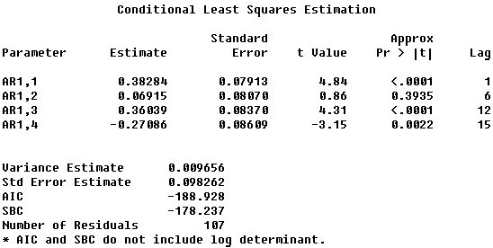
Figure M1.1
Correlations of Parameter Estimates
If the Correlation of Parameter Estimates is smaller than 0.9, the parameters have not be affect to each other. Figure M1.2 present the Correlation of Parameter Estimates is smaller than 0.9, so the parameters have not be affect to each other.
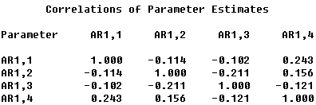
Figure M1.2
Autocorrelation check of residuals
$H_{0}$: There was no significant difference between the residual and 0.
$H_{1}$: There was significant difference between the residual and 0.
If the p-value is greater than 0.05 then we reject$H_{0}$.
Figure M1.3 present the p-value is almost smaller than 0.05 and there is a spike in lag 14(Figure M1.4&M1.5). As a result, we have determined that the model is unstable and inappropriate.
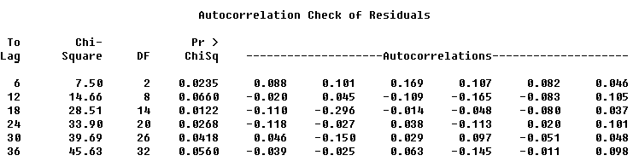
Figure M1.3
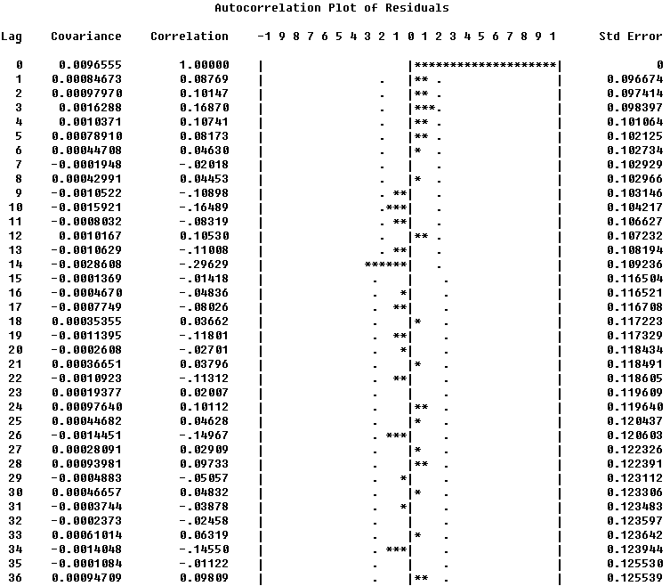
Figure M1.4
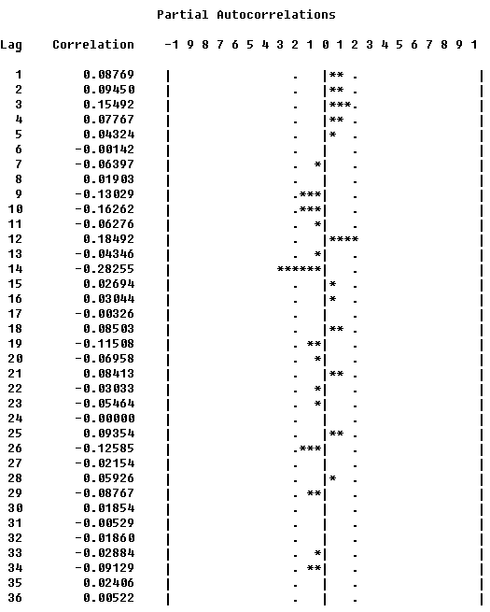
Figure M1.5

Model 2： d=1, D=0, AR(1,2)&AR(1,2)
Conditional Least Squares Estimate
Figure M2.1 present the absolute t-value of the parameter is greater than 2 and the “Std Error Estimate” is small. The model fitting is good and parameters of the model are mutually independent.
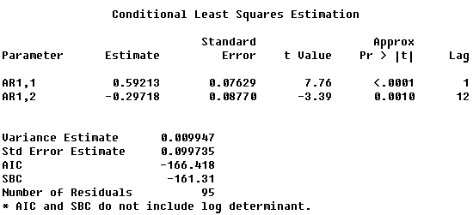
Figure M2.1
Correlations of Parameter Estimates
Figure M2.2 present the Correlation of Parameter Estimates is smaller than 0.9, so the parameters do not affect to each other.
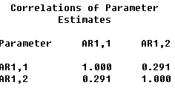
Figure M2.2
Autocorrelation check of residuals
Figure M2.3 present the p-value is smaller than 0.05 in lag 6, lag12, lag24. There was no significant difference between the residual and 0. And there is a spike in lag 2, lag24 (Figure M2.4 & M2.5). According to the above reasons, we determined that the model is unstable and inappropriate.
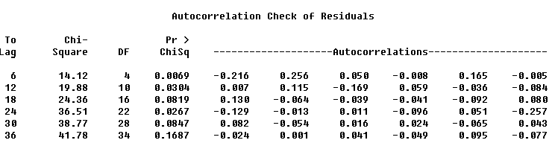
Figure M2.3

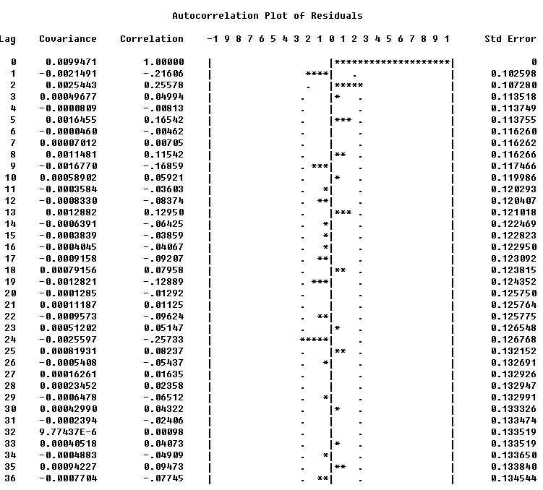
Figure M2.4
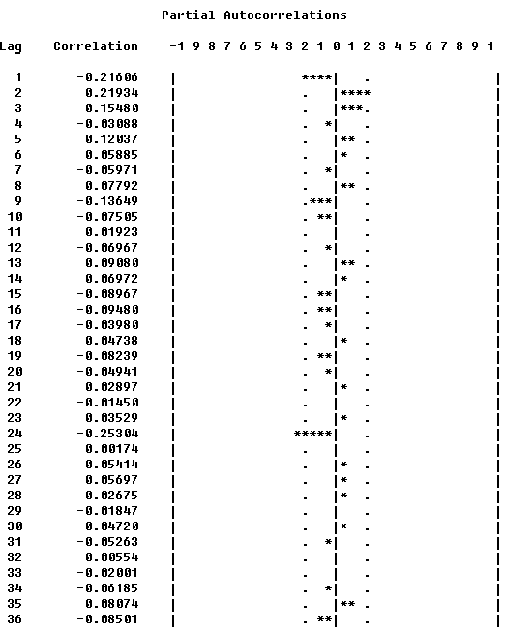
Figure M2.5

Model 3： d=1, D=1, AR(1,2)&MA(1,2)
Conditional Least Squares Estimate
Figure M3.1 present the absolute t-value of the parameter is greater than 2 and the “Std Error Estimate” is small. So the model fitting is good and parameters of the model are mutually independent.
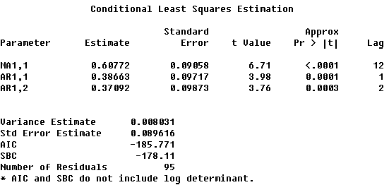
Figure M3.1
Correlations of Parameter Estimates
Figure M3.2 present the “Correlation of Parameter Estimates” is smaller than 0.9, so the parameters do not affect to each other.
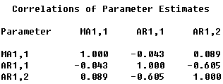
Figure M3.2
Autocorrelation check of residuals
Figure M3.3 present the p-value is not smaller than 0.05, so there was no significant difference between the residual and 0. And there is no spike in the Figure RSAC and Figure RSPAC (Figure M2.4 & M2.5). In conclusion, we determined that the model is stable and appropriate.
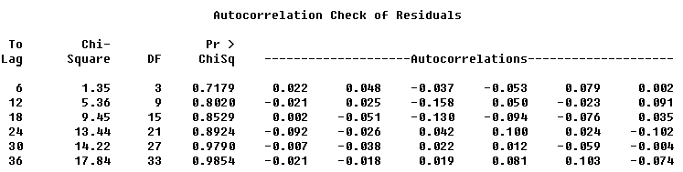
Figure M3.3
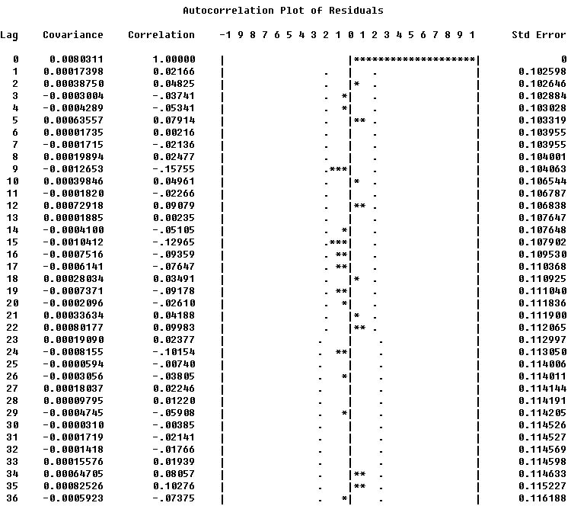
Figure M3.4
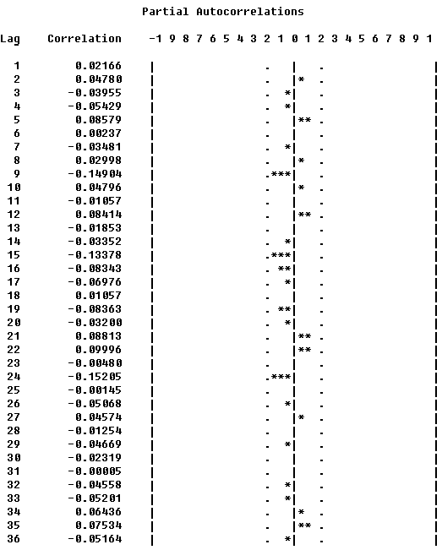
Figure M3.5

Model 4： d=1, D=1, MA(1,2,3,4)&AR(1,2)
Conditional Least Squares Estimate
Although the absolute t-value of the MA(1,1), MA(1,2),MA(1,3),AR(1,1),AR(1,2) were greater than 2, but the MA(1,4) of the absolute t-value is smaller than 2( Figure M4.1). Thus, there will be some parameters have not need to be placed in this model.
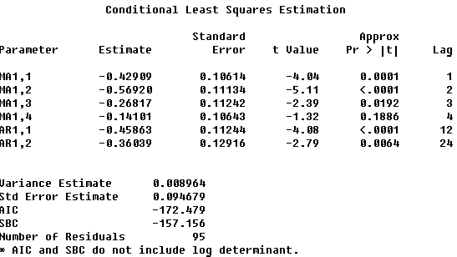
Figure M4.1
Correlations of Parameter Estimates
Figure M4.2 present the “Correlation of Parameter Estimates” is smaller than 0.9, so the parameters do not affect to each other.
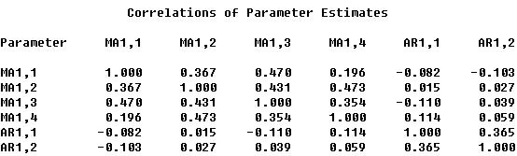
Figure M4.2
Autocorrelation check of residuals
Figure M4.3 present the p-value is greater than 0.05, so there is no significant difference between the residual and 0. And there is a spike in lag 5(Figure M4.4 & M4.5). Due to the above reasons, we determined that the model is unstable and inappropriate.
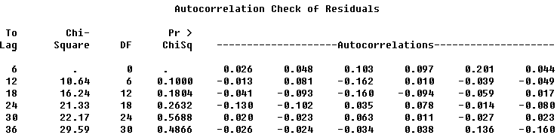
Figure M4.3
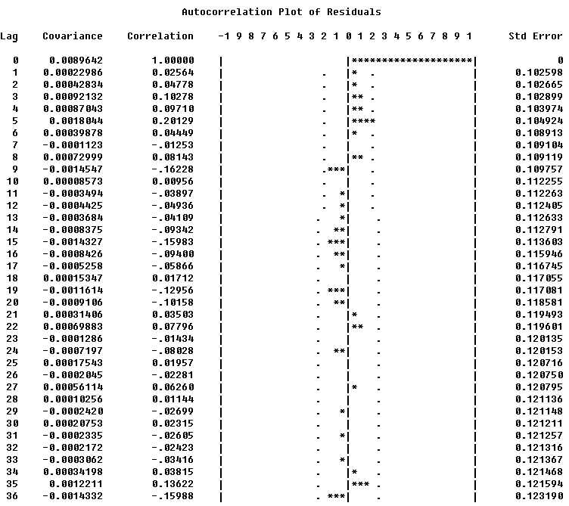
Figure M4.4
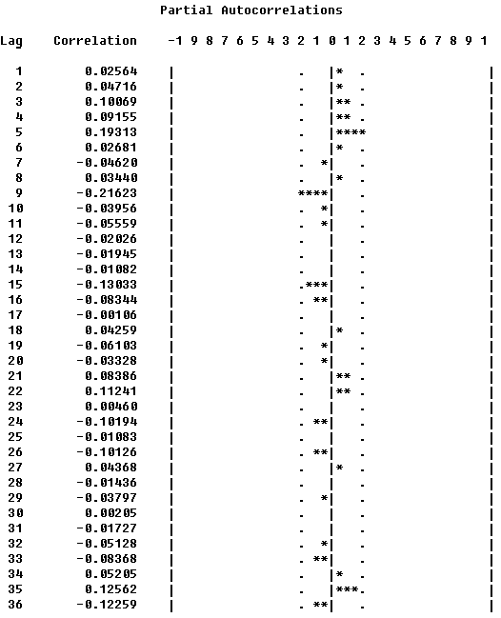
Figure M4.5

Model 5： d=1,D=0, MA(1,2,3,4)&MA(1)
Conditional Least Squares Estimate
Although the absolute t-value of the MA(1,1), MA(1,2),MA(1,5),MAR(1,6),MA(1,7),MA(1,8) are greater than 2, but the MA(1,3),MA(1,4) of the absolute t-value are smaller than 2( Figure M5.1). Thus, there will be some parameters have not need to be placed in this model.

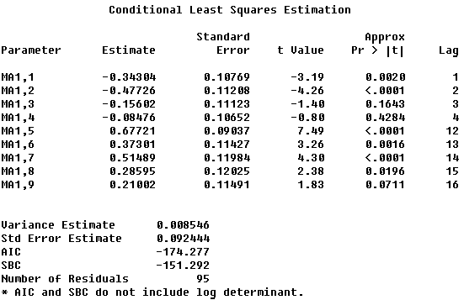
Figure M5.1
Correlations of Parameter Estimates
Figure M5.2 present the “Correlation of Parameter Estimates” is smaller than 0.9, so the parameters do not affect to each other.
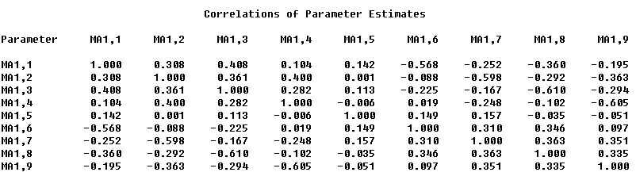
Figure M5.2
Autocorrelation check of residuals
Figure M5.3 present the p-value is greater than 0.05. There is no significant difference between the residual and 0, and there is no spike in the Figure RSAC and Figure RSPAC (Figure M5.4 & M5.5). As a result, we determined that the model is unstable and inappropriate.
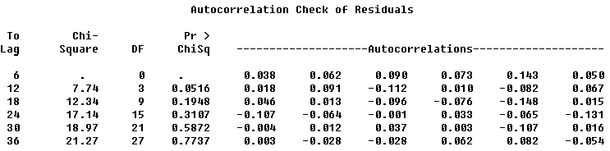
Figure M5.3

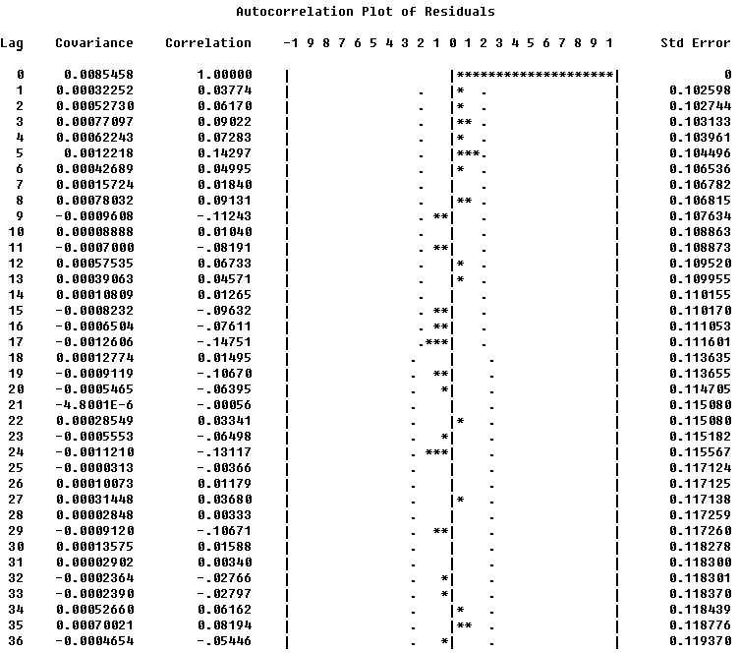
Figure M5.4
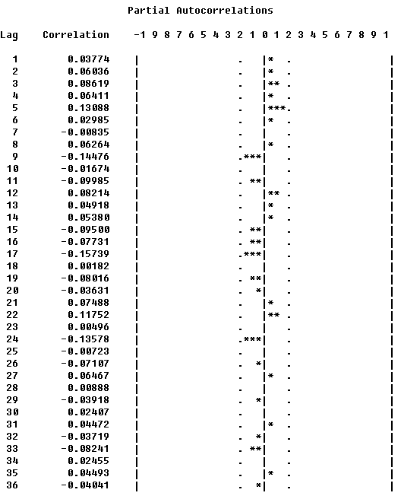
Figure M5.5

Forecasting
Through the above model fitting, we selected the most appropriate model (i.e. the model 3) to predict unemployment rate and its 95% confidence limits during last 12 months, and the results are shown in Figure M3.6. The actual values in the range that we predicted are shown in figure M3.7.
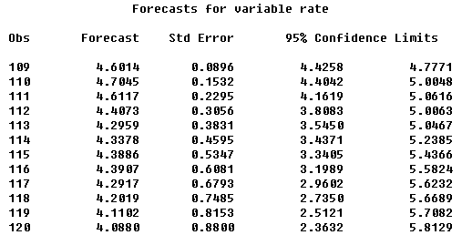
Figure M3.6
Figure M3.7
We use the predicted unemployment rate and the actual unemployment rate to calculate Mean Absolute Percentage Error (MAPE), and to analysis if the model prediction results are good or not. By using MAPE, we can separate any single model is good or not, and there is no need to compare with other models.
MAPE formula as outlined below:
$\text{MAPE}=\frac{1}{M}\sum_{k=1}^{M}{\frac{x(k)−x^{'}(k)}{x(k)}}×\text{100}\text{\%}$
$x(k)$: actual value
$x^{'}(k)$: estimate value
$x(k)−x^{'}(k)=ε_{k}$:error
$M$: the number of samples

MAPE(%) | Significance
<10 | Excellent
10-20 | Good
20-50 | Reasonable
>50 | Inaccurate

$$x(k)$$ | $$x^{'}(k)$$ | MAPE=0.38%
4.64 | 4.6014 | 0.008319
4.69 | 4.7045 | -0.00309
4.48 | 4.6117 | -0.0294
4.29 | 4.4073 | -0.02734
4.27 | 4.2959 | -0.00607
4.35 | 4.3378 | 0.002805
4.41 | 4.3886 | 0.004853
4.45 | 4.3907 | 0.013326
4.28 | 4.2917 | -0.00273
4.3 | 4.2019 | 0.022814
4.28 | 4.1102 | 0.039673
4.18 | 4.0880 | 0.02201
Table MAPE
Conclusion
By using the analysis of historical data, we determined that the Model 3 (i.e. d=1, D=1, AR(1,2) &MA(1,2)) is the best models to predict the unemployment rate from 2002-2010 in Taiwan. With the Table MAPE, it present that the value of the MAPE in model 3 is smaller than 10% (0.38%), so this model is excellent. In conclusion, the model should be suitable for predict the unemployment rate in Taiwan.

