xxxxxx xxxxxx December 5, 2012
Time Series Student Project
Fall 2008

Introduction:
Agricultural raw materials are an important part of the world’s economy and their prices are used by economists and others to forecast changes in a country’s GDP among other economic factors. Futures are also traded on agriculture raw materials creating an interest in their prices within the financial sector as an investment vehicle. In this project I looked at the monthly prices of plywood, an important agricultural raw material used for building and other applications. The goal of this analysis is to fit an ARIMA(p,d,q) time series model that could be used to forecast future plywood prices based on historical monthly plywood price data.

Data:
Source: http://www.indexmundi.com/commodities/?commodity=plywood&months=360
This website has thirty years of monthly plywood prices (US cents per sheet) from November 1982 to October 2012. The data underlying all graphs and model output are provided in the attached Excel workbook, and a graph of this data is shown below.
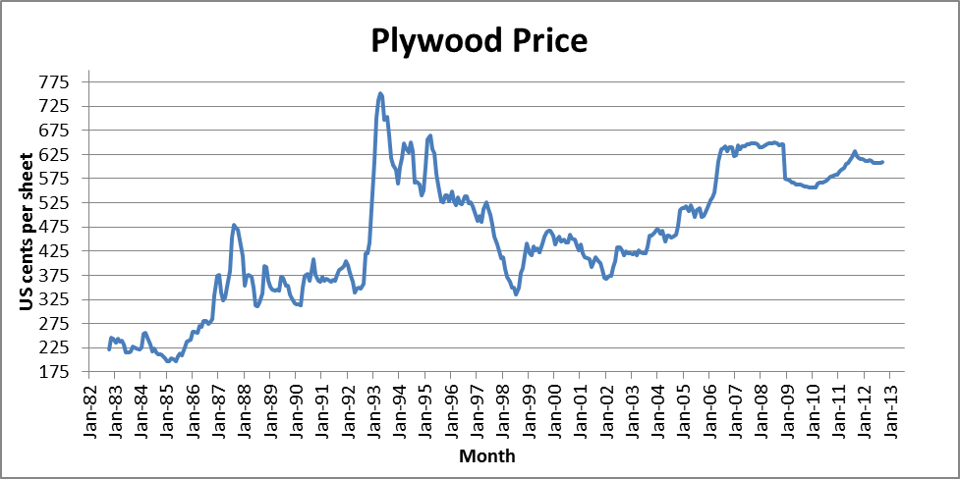

Model Specification:
Though there is volatility in the data (including a particularly large spike in prices in the mid-1990’s) the series exhibits a noticeable upward trend. This suggests that the mean and variance are not constant and the series is not stationary. The graph of the autocorrelation function shown below provides further evidence that this is not a stationary series. For a stationary series the autocorrelation function must approach 0 as the displacement becomes large, and this is not observed in the graph below.
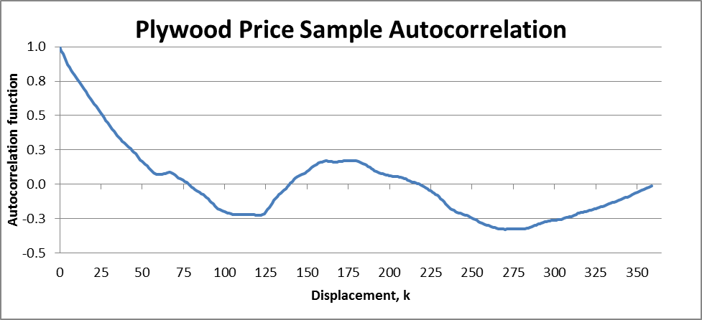
A first goal in specifying the model, then, is to assess the degree of homogeneity. That is, to determine the number of times the series must be differenced to produce a stationary series.
A graph of the series of first differences is shown below. Note that the upward trend is no longer evident, suggesting that the series of first differences may be stationary.
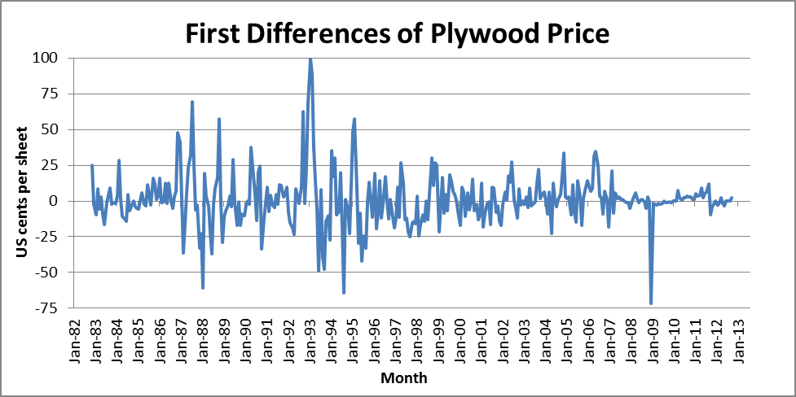
The sample autocorrelation function of the first differences provides further indication that the series of first differences is stationary. Two graphs of this function are shown below. Note that the autocorrelation is approximately 0 for all about K > 2
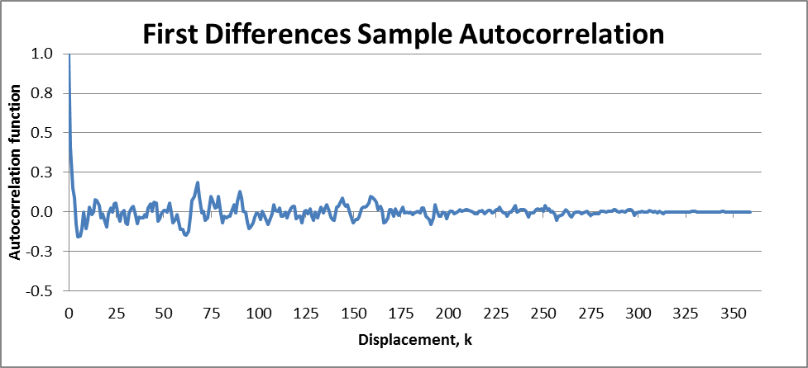
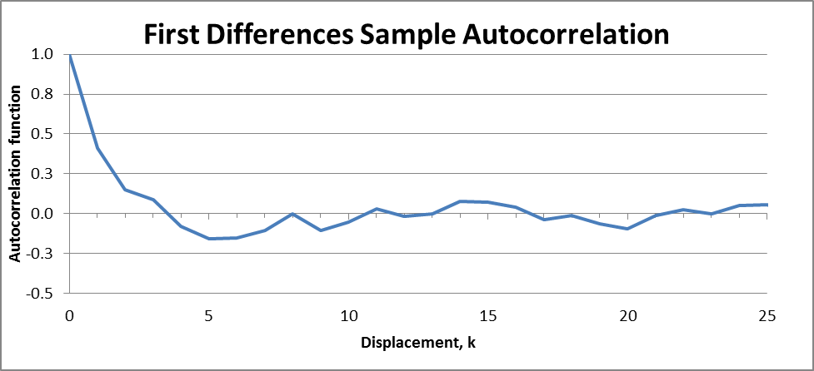
Second differences and transformations of the series (including logarithms) were also considered as options for producing a stationary series, but using the principle of parsimony I selected the first differences (d = 1) as the simplest adjustment that produced a reasonably stationary series.
To determine possible specifications for p and q I first compared the autocorrelation function to those for low-order processes shown in Figues 17.1 to 17.10 of the text (as suggested in the last full paragraph of page 541). I also noted that for a mixed model the autocorrelation function will have moving average characteristics for the first p – q periods and after that will decline geometrically as a purely autoregresive model would. Finally, spikes in the autocorrelation function are also indicative of moving average terms, and we do not see any such spikes. Since the sample autocorrelation function of first differences looks most like a purely autoregressive process, with no decernable set of lower displacements that exhibit moving average characteristics, I selected to use a low-order purely autoregressive model ARI(p,1,0). I will specify and test the three models with p = 1,2,3 to obtain my final model.
Parameter Estimation:
The Regression function within the Excel Data Analysis Add-in was used to estimate the parameters of the three models under consideration. The resulting models and summary statistics are shown below.
Diagnostics:
In addition to the diagnostics such as the R Square and Adjusted R Square provided by the Regression function output, I also computed sum of the parameters, the Durbin-Watson statistic, and Box-Piece Q statistic to evaluate and compare each of the three models. A summary of the results is shown below.
Model | Sum of Parameters | R Square | Adjusted R Square | Durbin-Watson Statistic | Box-Peirce Q Statistic | Chi-Squared Critical value at 10% significance
ARI(1,1,0) | 1.007 | 0.170 | 0.167 | 1.983 | 8.012 | 389.548
ARI(2,1,0) | 1.009 | 0.170 | 0.165 | 1.998 | 7.922 | 387.451
ARI(3,1,0) | 1.010 | 0.171 | 0.164 | 1.989 | 6.686 | 385.354

The sum of parameters should be less than 1, which does not hold for any of the models, though they are very close. For the R Squared and Adjusted R Squared statistics we are looking for values close to 1 of -1, and none of the models seems to perform well by these measures. The Durbin-Watson statistic was calculated from the residuals using the equation as shown on page 165 of the text. For this statistic we are looking for vales close to 2 which would indicate no serial correlation. Each of the models seems acceptable with ARI(2,1,0) holding a very slight edge. The Box-Pierce statistic was also calculated from the residuals using a lag of K=20 using the equation shown on page 555 of the text. If this statistic is greater than the Chi-Squared critical value shown we reject the model. For this statistic as well of the models seems acceptable, with ARI(3,1,0) holding a very slight edge this time.
Conclusion:
There is not a lot of difference among the various diagnostics between the three models. Though ARI(2,1,0) and ARI(3,1,0) each hold a slight edge in one of the various diagnostics, the ARI(1,1,0) model has the highest Adjusted R Squared and the sum of parameters that is closest to 1. I am also considering the principle of parsimony to select the ARI(1,1,0) model. The diagnostics for ARI(1,1,0) are all satisfactory and so selecting one of the other models runs the risk of over-fitting the data and increasing complexity without adding predictive or explanatory abilities.
Predicted prices from the ARI(1,1,0) model were calculated by applying the modeled first differences to the observed plywood prices. For an ARI(1,1,0) model, the large horizon forecast is dominated by the deterministic drift in the process. The drift line, with slope = δ/(1-φ₁) = 0.596/(1-.412) = 1.014, gives a visualization of the approximate level of long-term forecasts. The short-term forecast would still be expected to fluctuate about the drift line, but the model is adaptive in that it would be expected to revert back toward the drift line where this had been observed. A graph comparing the actual and predicted prices, along with the drift line, is shown below.
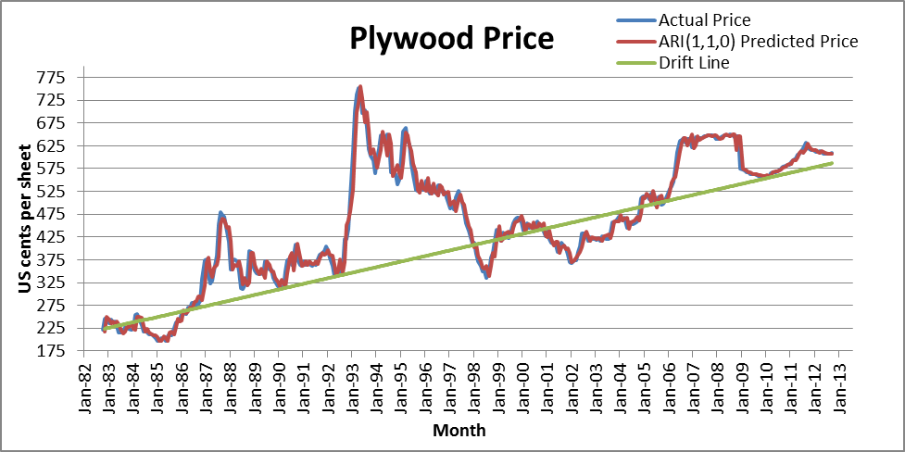
The predicted prices follow the observed prices very closely, indicating a good fit, and nothing suggests that one of the other models considered would have produced a better fit. Additionally, based on the drift line over the 30 year period, the model looks like it could give reasonable general guidance on the long-term prices of plywood. Nevertheless, because of the volatility in the series and the high standard deviation of the residuals, the confidence intervals around the short-term forecasts would be relatively large and hence the short-term forecast of perhaps limited use.

