Regression Analysis Student Project

December 28, 2012
Fall 2012
xxx (xxxxxx) xxx

Introduction:

I am working for a health insurance company in the actuarial department for group health insurance pricing. My daily responsibility includes maintaining the current rating model and implementing new features or updating rating methodologies.

Though my job is more programming oriented, I become more interested in how our pricing is affected by all the parameters we collect from a customer.

The goal of this analysis is to understand the significance of some parameters, our explanatory variables, in driving the premiums, from the model which is a simplified version of the real one, using Ordinary Least-Squares regression.

Model Specification and Data:

See the accompanying workbook “RA - group health premium.xlsx”, page titled “Original Model & Data”. I am using a book of business of 6 months in 2011 which had 2279 sold quotes. There are 15 columns showing the “Number of Quotes”, “Sold Premiums”, explanatory variables ranging from “Network”, “Base Cost”, to “Contract Length” and “Days Since Inception”.

Since I am using my employer’s data, I have disguised it by multiplying a constant and then adding another constant on the “Sold Premium” values.

An excerpt of the data looks like this,
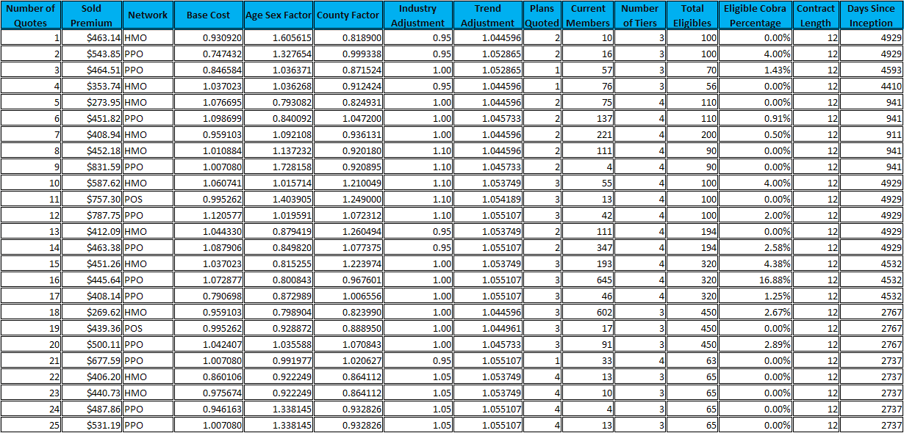

The response variable is defined as:
Y = Sold Premium

The explanatory variables are defined as:
X0 = Intercept
X1 = Network, such as HMO, PPO or POS
X2 = Base Cost, this is a factor of the base cost
X3 = Age Sex Factor, this is a factor of the age and gender
X4 = County Factor, this is a factor of the area
X5 = Industry Adjustment, this is a factor of what industry the
customer is in
X6 = Trend Adjustment, this is a factor of the trend
X7 = Plans Quoted, this tells how many total plans this
customer is quoted with
X8 = Current Members, this is the total number of the current
members of the customer
X9 = Number of Tiers.
3-tier quote structure is employee only,
employee + one depenedent and employee + family.
4-tier quote structure is employee only, employee + one
depenedent, employee + two depenedents and
employee + family
X10 = Total Eligibles, this is the total eligible members
X11 = Eligible Cobra Percentage, this is the cobra eligible
member percentage
X12 = Contract Length, this is the contract length in months
X13 = Days Since Inception, this is the number of days since
the inception of the policy

Several regression analyses will be performed using the Ordinary Least-Squares procedures, starting with the original model with all 14 explanatory variables. The t statistics and P-values will be calculated for each parameter and the models with new hypotheses will then be specified.

Hypothesis 1:

X1 (Network) is not a quantitative variable. X1 is to specify whether the quote is for a HMO plan, or a PPO plan or a POS plan. It is a qualitative polytomous factor and we use two dummy variables D1 and D2 to represent the 3 plans. See page titled “Hypothesis 1” for the values of D1 and D2.
Dummy Regressors | D1 | D2
Coefficients | R1 | R2
POS | 1 | 0
HMO | 0 | 1
PPO | 0 | 0

Hypothesis 1: X1 is not significant in the premium pricing óR1=0 and R2=0

We use Excel Data Analysis Add-in Regression to estimate the parameters of this model. The resulting summary statistics are shown below.
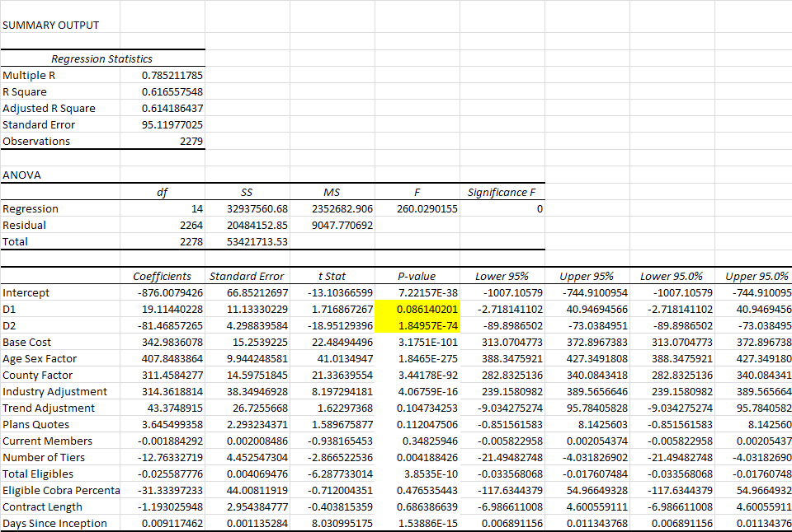
Fitted Y = - 876.01 + 19.11*D1 - 81.47*D2 + 342.98*X2 + 407.85*X3 + 311.46*X4 +
314.36*X5 + 43.37*X6 + 3.65*X7 – 0.00*X8 - 12.76*X9 - 0.03*X10 –
31.33*X11 - 1.19*X12 + 0.01*X13

The R² of 0.6166 is not close to 1.0000, indicating a less than ideal fit for the model. We have included additional explanatory variables that in fact add little additional predictive value.

This analysis examines D1 and D2. When the P-value for the t statistic is less than 0.05, it indicates the significance of the variable. See the two yellow highlighted cells. D2 is significant while D1 is not, because the P-value for D2 is 1.85E-74, which is way less than 0.05, and P-value for D1 is 0.086 which is greater than 0.05. Therefore we reject the null hypothesis. This means that whether a plan is HMO makes a difference in pricing, and PPO and POS can be viewed as in the same category in pricing.

We revise the model, using one dummy regressor to represent HMO plans and non-HMO plans.
Dummy Regressor | D1
Coefficient | R1
POS/PPO | 0
HMO | 1

Rerun the Regression analysis, see page titled “Hypothesis 1 - Rerun”. The resulting summary statistics are shown below.
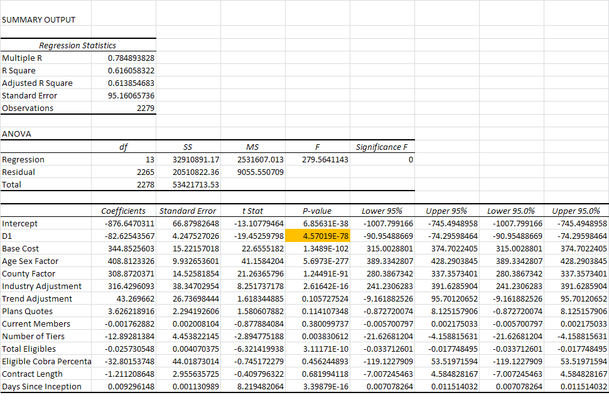

Though the R² value (0.6161 vs. 0.6166) is not changed much yet, the P-value for D1 is much more significant.

Hypothesis 2:

Let’s again examine the results after the rerun of the Regression analysis after Hypothesis 1. See the summary shown below, it is also on page titled “Hypothesis 1 - Rerun”.
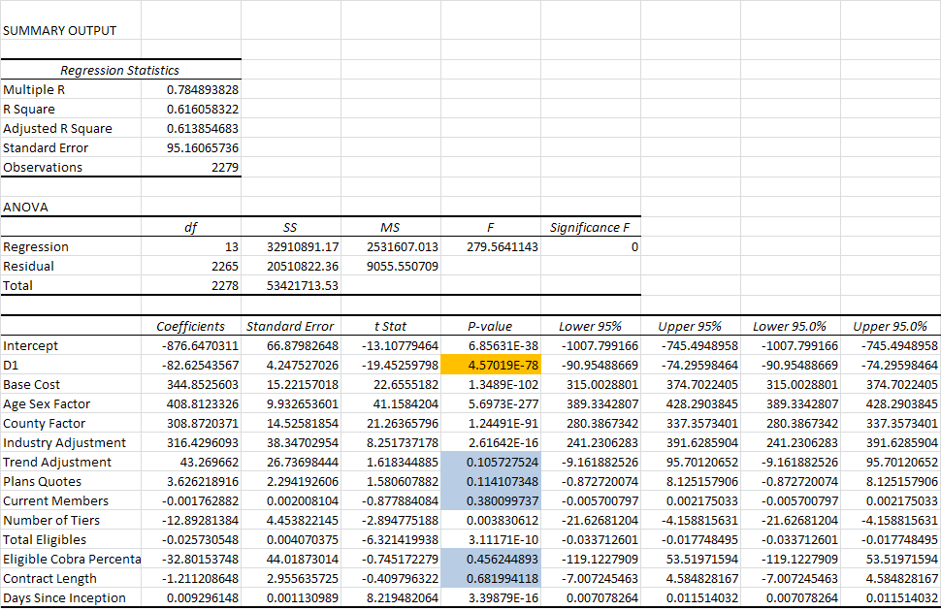

All the blue highlighted cells have P-values greater than 0.05. We will remove the two biggest ones, Eligible Cobra Percentage and Contract Length. We will rerun the Regression analysis with the remaining variables.
Let
Y = B0 + R1*D1 + B2*X2 + B3*X3 + B4*X4 + B5*X5 + B6*X6 + B7*X7 + B8*X8 + B9*X9 +
B10*X10 + B13*X13 + E,
where
X0 = Intercept
D1 = Network indicator, 1 for HMO and 0 for PPO or POS
X2 = Base Cost
X3 = Age Sex Factor
X4 = County Factor
X5 = Industry Adjustment
X6 = Trend Adjustment
X7 = Plans Quoted
X8 = Current Members
X9 = Number of Tiers
X10 = Total Eligibles
X13 = Days Since Inception

Hypothesis 2: B6=0 and B7=0 and B8=0

See page titled “Hypothesis 2” for the summary of the Regression analysis.
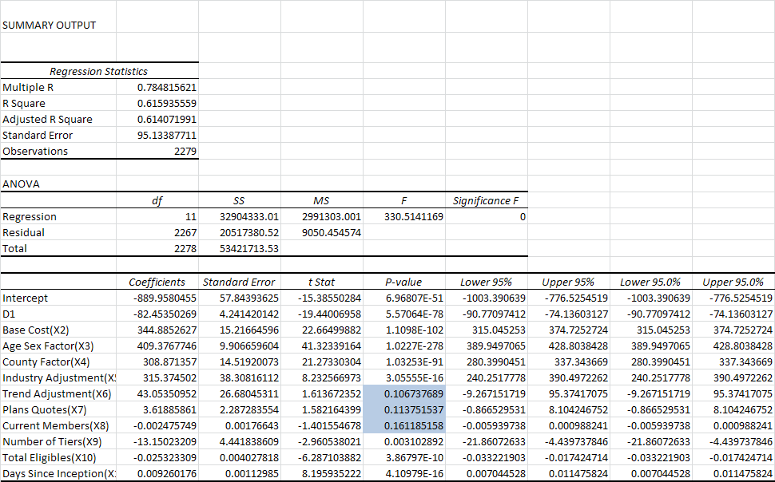

The R² has not improved, indicating the same quality fit. We still have several P-values greater than 0.05. We accept the null hypothesis because the P-values for X6, X7 and X8 are all greater than 0.05, therefore we will remove X6, X7 and X8.

Now the model is reduced to
Let
Y = B0 + R1*D1 + B2*X2 + B3*X3 + B4*X4 + B5*X5 + B9*X9 + B10*X10 + B13*X13 + E,
where
X0 = Intercept
D1 = Network indicator, 1 for HMO and 0 for PPO or POS
X2 = Base Cost
X3 = Age Sex Factor
X4 = County Factor
X5 = Industry Adjustment
X9 = Number of Tiers
X10 = Total Eligibles
X13 = Days Since Inception

Selected Model and the Conclusion:

With the reduced model specified above, the explanatory variables are now the Intercept, Network indicator (HMO), Base Cost, Age Sex Factor, County Factor, Industry Adjustment, Number of Tiers, Total Eligibles and Days Since Inception. See page titled “Selected Model” for the Regression summary.
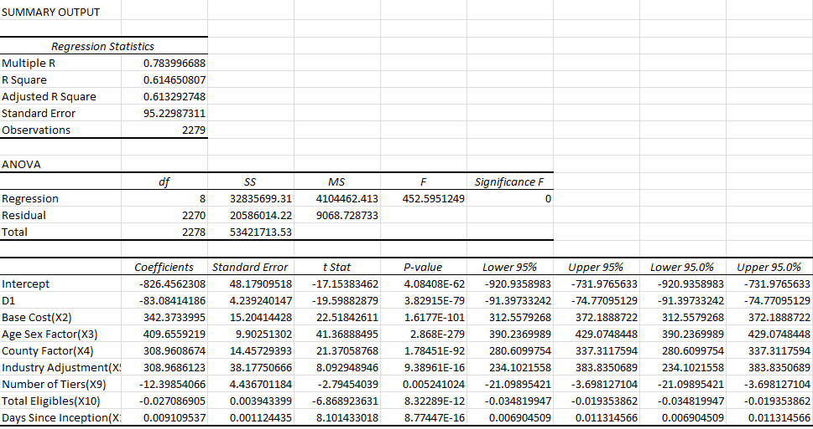

Fitted Y = - 826.46 – 83.08*D1 + 342.37*X2 + 409.66*X3 + 308.96*X4 + 308.97*X5 –
12.40*X9 - 0.03*X10 + 0.01*X13

The R² value does not get close to 1 as we hope, although all the coefficients are now significant, after removing the insignificant ones in Hypothesis 1 and Hypothesis 2. The resulting model is a much more preferred model than the original model, though we suspect that other important explanatory variables have been omitted. None of the tests we performed, however, tests that the model is correctly specified or that the explanatory variables are indeed independent. As noted on pages 145-146 of the text, the most important assumptions to be tested are the homoscedasticity and correlation.
We will plot the residuals against the predicted sold premium to test the assumption of constant variance. This graph is shown below. Note that we do not see the residuals increasing for increased sold premium or other signs that the residuals are non-constant. We conclude for the constant variance.
