Determinants of Traffic Fatalities

xxxxx xxxxx

NEAS Regression Analysis
January 20, 2013
- Introduction
Driving in America has become a necessity more than a luxury. Over 85% of working Americans use an automobile to get to work and 91% of households own at least one car. The overwhelming number of vehicles on the road has added to the necessity of driving. Without a car, one’s job search radius reduces dramatically, time spent on errands greatly increases and choices of recreational activities are limited to what can be reached by foot or bicycle. This necessity has forced many to shoulder the risks associated with sharing the road with so many other drivers.
The federal government as well as state governments have many programs to prevent dangerous driving, but few programs to promote defensive driving. The goal of defensive driving is to anticipate hazardous situations and to adjust driver behavior to compensate. The key to this is anticipation of hazardous situations. How does one know what circumstances will pose a bigger risk than others? The purpose of this study is to analyze some factors that could lead to more dangerous driving situations. Because there are different severity levels of vehicle accidents, likely with differing determinants, this study will focus on fatal accidents.
II. Sample
The sample used in this study is all 50 of the United States of America in 2008.

III. Dependent Variables
Fatalities/Population
This dependent variable is the number of traffic fatalities per 100,000 people in each state. This information is going to be obtained from the National Highway Traffic Safety Administration (NHTSA).

Fatalities/Licensed Drivers
This variable is the number of traffic fatalities per 100,000 licensed drivers in each state. This information going to be obtained by dividing the number of fatalities as reported by the NHTSA by the number of licensed drivers as reported by the US Census Bureau.

Fatalities/Miles Driven
This variable is the number of traffic fatalities per billion miles driven. The number of fatalities comes from the NHTSA and will be divided by the number of vehicle miles driven reported in billions by the US Census Bureau.

IV. Independent Variables
Age 18-24
This variable is the fraction of a state’s population aged 18 to 24. This measure is obtained by dividing the 18 to 24 year old populations obtained from the State and Metropolitan Area Data Book 2010 (uses 2008 figures) by the total population from the same source in the first regression and by the number of licensed drivers in the second and regressions in order to be consistent with the dependent variable in each regression.
It is a commonly held belief that drivers under the age of 25 are a larger accident risk. They are less experienced drivers and tend to be less responsible. This argument is backed up by insurance companies that place premiums on policies that include drivers under the age of 25. It is expected that as this variable rises, so will the number of fatalities.

Male/Female
This variable is the male to female ratio in each state. The State and Metropolitan Area Data Book 2010 reports the number of males per 100 females, then the division is carried out to obtain the number that will be used in this study.
A study done by Quality Planning Corporation showed that men are much more likely than women to break traffic laws intended to keep everyone safe. It found that men receive reckless operation violation 3.41 times more than women. For this reason it is expected that a higher male to female ratio will correspond to a higher number of traffic fatalities.

Seatbelt
This is going to be a dummy variable assigning a value of 1 to states that have a primary law for seatbelt use and 0 to states that have a secondary law or no law at all. A primary seatbelt law is one where a police officer can cite you for a seatbelt violation without having first stopped you for another reason. This information comes from the Governors Highway Safety Association.
A seatbelt’s function is to secure one to their seats during an accident. A seatbelt greatly decreases one’s chance of being ejected from a car in a head on collision or a rolling incident. It follows that a higher seatbelt use should correlate negatively to the number of fatalities in the state.

Precipitation
This variable is the average total rainfall in each state in 2008. This measurement comes from the National Oceanic and Atmospheric Administration. Averaging the observations from all NOAA weather stations in a state creates this variable.
Precipitation in any form is expected to reduce visibility for the driver, which in turn will reduce the time a driver has to react to a situation. Also, precipitation causes cars to have less traction. Rain will bring up oils on the road and also creates the possibility of hydroplaning and snow itself doesn’t provide sufficient traction and leads to ice patches on the road. It is expected that higher precipitation totals will lead to higher fatality totals.

Cell Phone
This variable accounts for states that have a handheld cellular phone ban as a primary law. Like the seat belt law, primary cell phone laws allow law enforcement officers to ticket a driver for cell phone use, without any other traffic offense taking place. This will be set up as a dummy variable, assigning a value of 1 to states with primary cell phone bans and a value of 0 to states without. This information is comes from the Governors Highway Safety Association.
Cell phone use causes a major distraction. The National Highway Traffic Safety Administration cites a study that shows that cell phone use delays reaction time as much as having a blood alcohol level of .08. It is expected that states with primary cell phone laws will have a lower number of fatalities than states without a primary cell phone law.

Speeder
The speeder variable is the maximum fine for a first time violation of the speed limit. This information is obtained from NHTSA
Increased speeds lead to an increased likelihood of losing control of your car. Research done in 2003 by the Insurance Institute studying the effects of the repeal of the National Maximum Speed Limit law found that increases in rural speed limits lead to an average 35% increase in death rates. A higher speeding fine will make speeding a more expensive activity. This will lead to less people speeding, therefore, it is expected that a higher fine will correlate to a lower number of traffic fatalities.

Gas
The Gas variable is a measure of the tax levied per gallon of gasoline by each state in 2008. The differences in gas prices from state to state are mostly in taxes and refining requirements. Since taxes make up the majority of that difference it follows that it would be a reasonable measure of the variation in prices between states. This information will come directly as reported by the Tax Foundation.
Higher gas prices will lead to a decreased demand for gasoline which will manifest itself as fewer people on the road driving. It is assumed that with less people on the road there is less opportunity for traffic accidents. Therefore, it is expected that an increase in this variable will correspond to a decrease in traffic fatalities.
Alcohol
This variable measures the state taxes levied on a gallon of beer. As with gasoline, tax on alcohol is the major determinant for the price difference between states. This information also comes directly as reported by Tax Foundation with the exception of Kentucky and Tennessee, which have a wholesale tax on beer in addition to the excise tax. It is assumed that the wholesale tax will be passed on to the consumer so it will simply be added on to the excise tax for these two states.
The argument for this variable follows the same logic as for gas prices. If the price is higher there should be less consumption. Lower consumption should decrease the instances of driving under the influence, and common knowledge tells us that driving under the influence is extremely dangerous. However, if the majority of drinkers are responsible a lower beer tax will lead to more people drinking and not driving. This would make the roads less congested and safer. Due to the conflicting effects, this variable could be correlated positively or negatively with the dependent variable.

% Licensed Drivers
This variable is the percentage of the total population that is licensed to drive. This information comes from the US Census Bureau.
Since more drivers congest the roadways it is assumed that it would be more dangerous to drive. Also, it is a little more of a stretch but one could assume that a higher percentage of licensed drivers could mean less stringent requirements or licensure and lead to more dangerous roads. Even omitting the latter assumption it would still be expected that this variable will be positively correlated with the dependent variable.

Miles driven
This variable is measured as the millions of miles driven per registered driver. This information comes from the US Census Bureau.
This variable is another measure of congestions, but instead of measuring the number of people on the road it measures how much they are on the road. It would be expected that the more people drive the more opportunity they have to get into an accident. Therefore I hypothesize that this variable will be positively correlated to the dependent variables.
V. Regression Results
For this study I will be running three different regressions with the different dependent variables discussed above. The three regressions will be estimating the following equations:

[1] Fatalities/Population_{i} = β₀+β₁(18-24_{i})+β₂(Male/Female_{i})+β₃(Seatbelt_{i})+β₄(Precip_{i})+β₅(Cell Phone_{i})+β₆(Speeder_{i})+β₇(gas_{i})+β₈(Alcohol_{i})+β₉(% Licensed Drivers_{i})+β₁₀(miles/driver_{i})

[2] Fatalities/Licensed Drivers_{i} = β₀+β₁(18-24_{i})+β₂(Male/Female_{i})+β₃(Seatbelt_{i})+β₄(Precip_{i}) +β₅(Cell Phone_{i})+β₆(Speeder_{i})+β₇(gas_{i})+β₈(Alcohol_{i})+β₉(miles/driver_{i})

[3] Fatalities/Miles Driven_{i} = β₀+β₁(18-24_{i})+β₂(Male/Female_{i})+β₃(Seatbelt_{i})+β₄(Precip_{i})+β₅(Cell Phone_{i})+β₆(Speeder_{i})+β₇(Alcohol_{i})

The first regression will use the dependent variable Fatalities/Population as the denominator and all of the independent variables discussed above. The second will use the dependent variable Fatalities/Licensed Drivers and will omit only one of the variables previously discussed, % Licensed Drivers. This is because the dependent variable accounts for licensed drivers so the control for this will be unnecessary. The third regression is going to use the Fatalities/Miles Driven dependent variable and will omit the Miles/Driver, % Licensed Drivers and Gas independent variables since the dependent variable accounts for the demand to drive by using a measure of miles driven.
The first regression has the highest R² value (.47) of the three regressions. Of the ten independent variables in the first regression, two are marginally significant (10% level) and four are significant at a 5% level. Three of the variables with at least marginal significance have a coefficient with a sign opposite of the predicted sign. These variables will be discussed individually later.
Regression 1
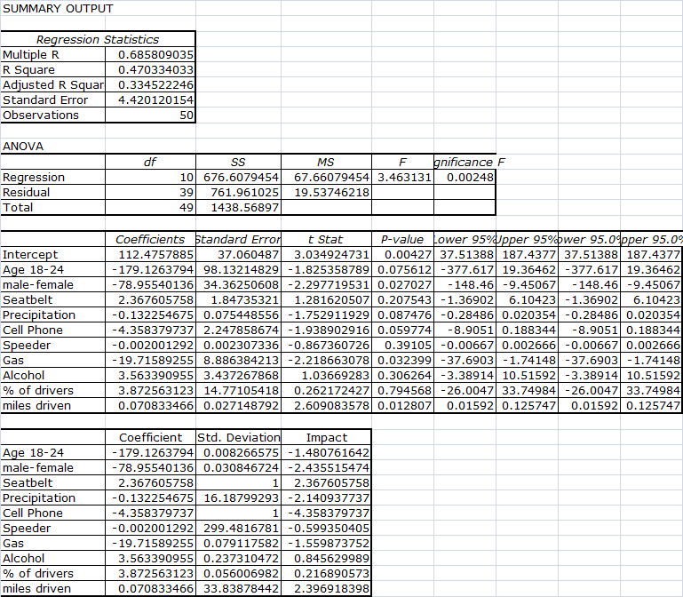
The second regression has an R² value of approximately .42 indicating that this model was slightly less accurate than the first. This regression has nine independent variables, six of which are significant. This regression also gives three variables with a coefficient sign opposite of the prediction.
Regression 2
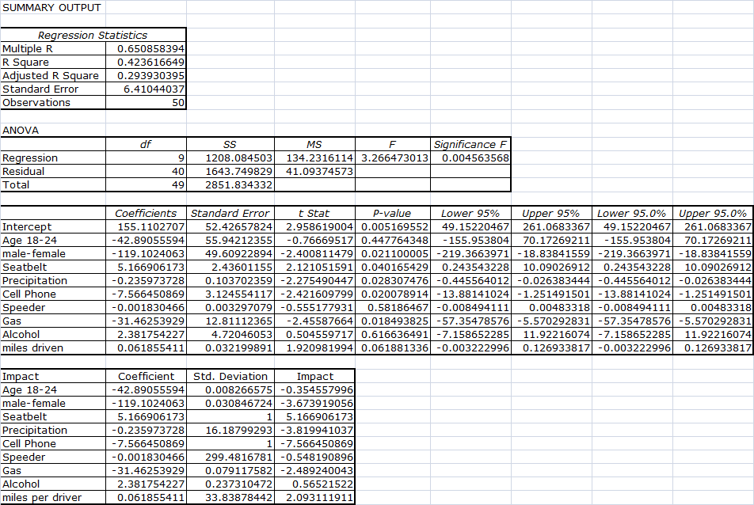
The third regression has the lowest R2 value (.29) of the regressions ran. It contains seven independent variables and returns only three with significant results. Of the three significant variables, two of them had a coefficient sign opposite of the prediction.
Regression 3
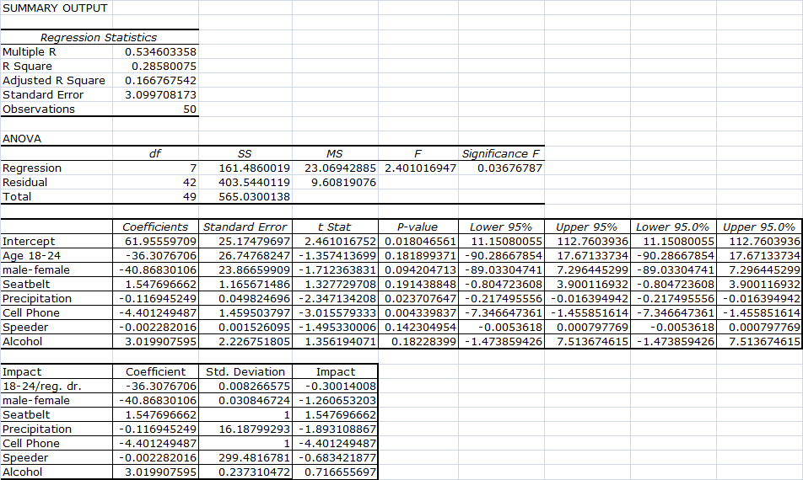
The measurement of the impact of a variable is the coefficient multiplied by the standard deviation. In the case of a dummy variable, it is simply the coefficient of the variable since the coefficient will only have an effect when the value is one. By multiplying the standard deviation by the coefficient one can determine how a reasonable change in the variable will affect the dependent variable. This is a good way to compare the effects of the independent variables to each other.
In the regressions a few variable stood out as being both statistically significant and having higher impacts. First, and by far the most impactful is the Cell Phone variable. This variable is strongly significant in all three regressions and its impact ranged from -4.36 in the first regression to -7.57 in the second regression. That means that enacting a ban on using a cell phone in the car will reduce the number of traffic fatalities by 4.36 for every 100,000 people in the state or by 7.57 for every 100,000 licensed drivers.
The other variable that is both consistently significant and is among the highest impacts in the three regressions is precipitation. Although the coefficient is negative, which was opposite of the predicted sign, the impact indicates that an increase in total precipitation by about sixteen inches will reduce the dependent variable by 2.14, 3.82, and 1.89 in the first, second and third regressions, respectively. A table listing the impacts of each variable can be found on the same pages as the regression results.
Now I will discuss the results of each independent variable separately.
Age 18-24
This variable is marginally significant in only the first regression using a two tail test. Originally I did not plan on using a two tail test since all evidence suggests that this age group will get in more accidents than other age groups, but all three regressions calculated a negative sign for the coefficient. After reviewing the data I found that there is very little variation in most of the observations. This could be why there is only marginal significance at best and has a sign opposite of the predicted sign.
Male/Female
This variable is significant in the first two regressions and marginally significant in the third. The sign is negative which is opposite of the prediction. A possible reason for the unexpected sign could be that women are actually the at risk gender for this particular category of traffic accidents. The prediction assumed that men’s riskier behavior will translate to more fatal accidents, but it could be that their risky behavior could give them the experience with handling a car that can get them out of or lessen the severity of a potentially fatal accident.
Seatbelt
The seatbelt variable is significant only in the second regression. Also, the coefficient is positive which is opposite of what is expected in all three regressions. One reason for the unpredicted result could be that people take more risks behind the wheel knowing that they are safer in their seatbelt. Another possible explanation is that the seatbelt laws were enacted in states where motorist fatalities are already a problem.
Precipitation
This variable is marginally significant in the first regression and significant in the second and third. A two tailed test was used when determining the significance of the variable because the coefficient was negative and opposite of the predicted sign. One possibility for the negative coefficient is that total rainfall as measured in this study does not indicate rain intensity. It is possible that a state that has constant light rain will produce a higher total rainfall without making the roads much less dangerous. Whereas a state that experiences torrential downpours less frequently would have lower total precipitation and create more dangerous driving conditions.
Cell Phone
The cell phone variable is very significant in all three regressions. The sign of the coefficient is negative as was expected.
Speeder
This variable is not significant in the first two regressions and only marginally significant in the third regression. The coefficient is negative which is consistent with the prediction.
Gas
The gas variable is only used in the first two regressions and is very significant in both. The coefficient is negative as was predicted.
Alcohol
This variable is not significant in any of the three regressions. In all of the regressions the coefficient is positive which suggests that drivers are being more responsible and not driving when they are drinking more.
% Licensed Drivers
This variable is only used in the first regression and is not significant.
Miles driven
Miles driven is used in the first and second regressions and is significant in both. The sign of the coefficient is positive as expected.
VI. Conclusion
This study is looking at variables of concern when making decisions on the road. Some of the variables that created the biggest impacts on traffic fatalities are conditions that a driver can control or at least be aware of. The cell phone variable supports the already held belief that drivers using their cell phones while driving are creating a hazard. The method of measurement of this variable combined with the results also implies that abstaining from cell phone use in the car is only half the battle. One must also be aware of other drivers using cellular phones while driving and take appropriate measures to avoid them. Another factor that can be controlled is one’s time spent on the road. The results from the various measures of demand for driving in this paper suggest that a combination of traffic congestion and time of exposure on the road increase a driver’s risk of a fatal accident.
While this paper has confirmed some popular beliefs about driving hazards, it has also turned up a few unexpected results that are backed by strong statistical support. One is the male to female ratio. It has been fairly well accepted that men are more dangerous drivers than women, but his study suggests an effect contrary to popular belief. It would be interesting to focus more on this topic in future studies in order to determine if this result is due to the specific type of accidents being studied or to gender related issues. Another surprising result comes from the precipitation variable. The results suggest that drivers in areas with higher rainfall totals are actually at less risk than drivers in more arid climates. While this could be due to a driver conditioning effect it may be useful to investigate aspects of precipitation that are more specific than total precipitation such as precipitation intensity.
The most important thing to take away form this paper is that there is no one thing to look for when trying to avoid accidents. The low R² values of the regressions suggest that car accidents are highly individual events with many different causes. One can only use the information in this paper to avoid a dangerous situation, but not to eliminate their risk completely.

Information obtained from the U.S. Census Bureau’s “2006 – 2008 American Community Survey.”

