xxxxx xxxxxxxx
NEAS Time Series Project
November 2012 – January 2013

Time Series for Weather in El Paso, TX

Introduction

I chose to pick somewhere in Texas, and El Paso was the first weather station I was able to find data. The purpose of the project is to use data from previous years to make forecasts. I decided to gather the available weather data for El Paso, and to see if I could detect any patterns by using the tools we learned in this time series course.

Methodology

I found the weather station data from El Paso available on the NEAS website included daily high and low temperatures from January 1, 1948 through December 31, 2005. I focused only on the high temperatures. Luckily, there were just a few missing data values that I interpolated. I then used Excel to compile a number of different statistics that are usual fare when conducting an analysis, including the average temperature for each day of the year, the deviation from the daily average for each day available, the temperature change from the day before (first difference), the deviation change from the day before, and autocorrelation values.

I decided to use this project to develop a time series formula for predicting the next few days of weather, using the 365 days following my birth (8/10/1983) as the baseline data and the year after my first birthday as the prediction test. I examined the autocorrelations for the original data to determine the appropriate number of autoregressive coefficients I would need and used these values to develop a model. I then compared the model results against both the average daily temperatures and the actual daily temperatures for the year following my first birthday and made some conclusions about the significance of the model.

Analysis

I began by looking at the original temperature data for the 1983 period on my birthday. Obviously, with the period beginning and ending in hot Texas weather, I expected the temperatures to rise through summer and then decline in winter. I was not expecting a stationary data set. The graph of the daily high temperatures is shown below:

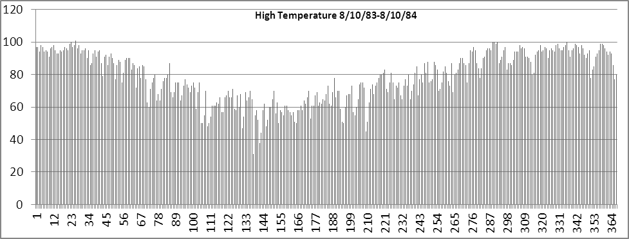
Clearly, the data will not be stationary. One can follow the hot summer to a cooler winter. To negate the seasonality of the weather, I next considered the standard deviation of each day to its mean daily temperature. That is, I calculated a mean temperature and standard deviation for August 10, then determined how many standard deviations August 10, 1983 was from the average. After determining this for each day in the period (this was the most time consuming step, and I used macros to do it), I re-graphed the results presented below:

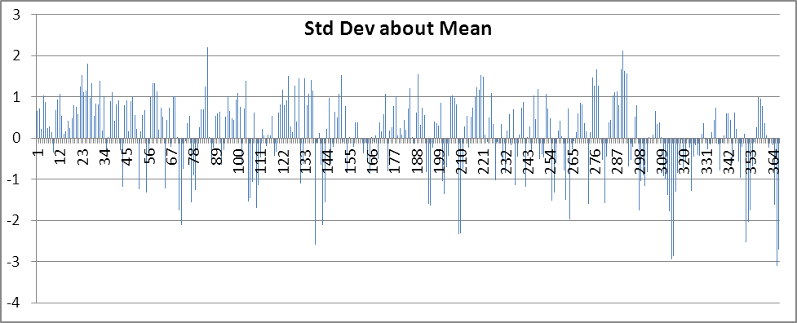

While this graph definitely presented a stationary process, it also appears that multiple elements are related to each other. In other words, a hot day tends to be followed by another hot day. I wanted to analyze if day one is warm, will day two be warmer or digress. To answer this question, I made the first differences in the standard deviations and graphed them, shown below:

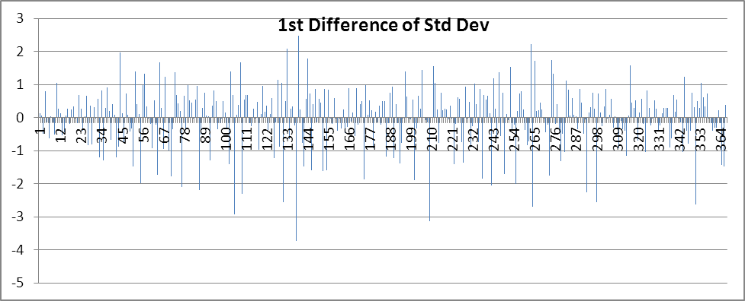

One can see satisfactory results for a time series. The graph shows the random nature of the weather and is obviously stationary about zero. The next step is to determine what predictive value an analysis of the first differences in the daily standard deviations might provide.

I calculated the correlation between and daily temperature and the temperatures in the days preceding it. I produced up to two weeks worth of prior days’ temperatures and developed the correlogram shown below:

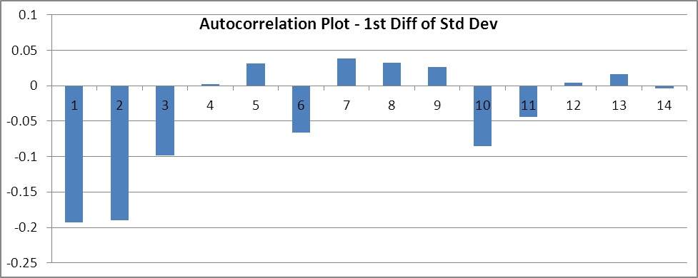
One can see that the first two prior periods have significantly greater correlations than the remaining 12 periods. After the second prior period, the autocorrelation values begin to drop near zero and then fluctuate about zero. This is proof that the time series is indeed stationary. Judging by the graph one can hypothesize the first two lags are significant. I evaluated the statistically significant autocorrelation value, using Bartlett’s test and the 95th percentile, as 1.96 / 365. This resulted in 0.103. This confirmed the fact that two lags was the appropriate number of lags to consider, as only the first two autocorrelation absolute values were greater than 0.103 and we are 95% certain that these two lag coefficients are not zero. As we are using first differences and a second order autoregressive model, this suggest the appropriate use of an ARIMA (2,1,0) model. This model will be my chosen model for the rest of the analysis.
Using the first two autocorrelation values of -.193 and -.189, I determined an ARIMA (2,1,0) model of:
y_{t} = -.193 y_{t-1} + -.189 y_{t-2} + .0018 + $ε_{t}$
I next calculated a Box-Pierce Q-statistic using 365 values and 12 degrees of freedom. This value was 10.18, as compared to the 90th and 95th percentile figures in the Chi-Squared distribution of 18.55 and 21.03. As the 10.18 value is significantly below both of these values, we are not able to reject the possibility that white noise is the cause of the residual errors. For this reason, I felt the model works at a very significant level and became more confident with the ARIMA (2,1,0) model.

The final step was to look at how the model performed in predicting the high temperature for the next year following the end of the evaluation period. As we only have a second order model, it is not expected to have significant difference in the predictions from the average high temperature for more than a few days into the future. Below is a full year’s worth of predictions.

I used the first differences of the standard deviations and then applied them to the daily standard deviation and daily average to achieve a predicted daily high temperature. It is not a surprise that the trend line clearly follows the path of the average daily temperature line, both of which follow the path of actual temperatures through the cyclical year very well. To get a better view of the actual, average, and predicted temperatures, I limited the following graph to the first 14 days:

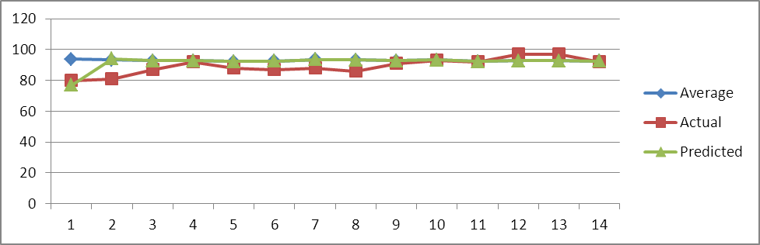

One can observe that all three lines are very close together for the majority of the graph. This is resulting from the actual temperatures were very stable for that week. Actual and predicted values are very close throughout the 2 week period; one can see that the predicted value is closer to the average temperature. Because of the second order model, forecasts will go to the average temperature very quickly.

Overall, the model seems to work. Unfortunately, the model is too simple to impress anyone and be used to predict daily weather solely. It confirms that weather can be roughly estimated looking at historical and a few previous days’ worth of data.

