xxxxxx xxxxxxx xxxxxxx
Time Series
Student Project
Fall 2012

Introduction
Rice is the staple food for Filipinos. In fact, it is rarely missing in the dining table. Whether for breakfast, lunch or dinner, it is hard for a Filipino not to eat a full meal without rice. In this project, I would like to create a model that can predict future retail prices of well-milled rice.

Data
The data I collected is provided by Bureau of Agricultural Statistics in the Philippines (http://countrystat.bas.gov.ph). The website provided the monthly retail price of well-milled rice. Prices are in Philippine pesos. Prices are in per kilogram of well-milled rice.

 | 1990 | 1991 | 1992 | 1993 | 1994 | 1995 | 1996 | 1997
Well Milled Rice (WMR)
January | 9.05 | 10.1 | 9.65 | 10.84 | 12.7 | 13.54 | 18.92 | 17.98
February | 9.1 | 10.05 | 9.6 | 10.91 | 12.93 | 13.52 | 19.51 | 18.16
March | 9.15 | 10 | 9.7 | 11.02 | 12.86 | 13.72 | 19.45 | 18.4
April | 9.25 | 9.9 | 9.75 | 11.17 | 12.9 | 13.85 | 19.4 | 18.39
May | 9.3 | 9.8 | 10.1 | 11.21 | 12.9 | 14.64 | 19.11 | 18.34
June | 9.3 | 9.8 | 10.3 | 11.4 | 13 | 15.28 | 19.33 | 18.41
July | 9.4 | 9.95 | 10.65 | 12 | 13.65 | 15.95 | 19.42 | 18.68
August | 9.7 | 10.35 | 11.2 | 12.47 | 13.99 | 19.7 | 19.21 | 19.08
September | 9.7 | 10.25 | 11.45 | 13.09 | 13.98 | 20.66 | 18.86 | 19.47
October | 9.7 | 10.05 | 11.2 | 12.86 | 13.73 | 19.99 | 18.32 | 18.73
November | 9.6 | 9.75 | 10.85 | 12.57 | 13.4 | 18.73 | 18.13 | 18.46
December | 10 | 9.65 | 10.65 | 12.5 | 13.46 | 18.04 | 18.14 | 18.47

 | 1998 | 1999 | 2000 | 2001 | 2002 | 2003 | 2004 | 2005
Well Milled Rice (WMR)
January | 18.58 | 19.24 | 19 | 19.37 | 19.33 | 19.92 | 20.05 | 21.51
February | 18.72 | 19.37 | 19.12 | 19.36 | 19.4 | 19.85 | 20.06 | 21.56
March | 18.66 | 19.32 | 19.22 | 19.36 | 19.41 | 19.86 | 20.46 | 21.83
April | 18.72 | 19.26 | 19.21 | 19.29 | 19.42 | 19.92 | 20.71 | 22.62
May | 18.84 | 19.23 | 19.27 | 19.33 | 19.49 | 20.13 | 20.9 | 23.12
June | 19 | 19.2 | 19.38 | 19.45 | 19.69 | 20.44 | 21.17 | 23.27
July | 19.11 | 19.24 | 19.74 | 19.64 | 20.16 | 20.7 | 21.75 | 23.6
August | 19.42 | 19.26 | 19.99 | 19.68 | 21 | 20.89 | 22.02 | 23.91
September | 19.57 | 19.1 | 19.96 | 19.57 | 21.31 | 20.57 | 21.82 | 23.62
October | 19.32 | 18.94 | 19.64 | 19.47 | 20.55 | 20.2 | 21.24 | 23.27
November | 19.24 | 18.87 | 19.48 | 19.3 | 20.02 | 19.95 | 21.07 | 23.12
December | 19.08 | 18.83 | 19.37 | 19.31 | 19.94 | 19.97 | 21.23 | 23.15

 | 2006 | 2007 | 2008 | 2009 | 2010 | 2011 | 2012
Well Milled Rice (WMR)
January | 23.23 | 23.72 | 25.84 | 32.89 | 34.2 | 34.34 | 35.08
February | 23.36 | 23.81 | 26.08 | 34.33 | 34.46 | 34.58 | 35.08
March | 23.48 | 24.07 | 27.57 | 34.62 | 34.59 | 34.57 | 35.18
April | 23.5 | 24.17 | 32.2 | 34.53 | 34.4 | 34.57 | 35.24
May | 23.59 | 24.29 | 33.69 | 34.51 | 34.32 | 34.71 | 35.29
June | 23.69 | 24.38 | 38.4 | 34.55 | 34.4 | 34.74 | 35.27
July | 23.78 | 24.69 | 38.76 | 34.44 | 34.46 | 34.78 | 35.43
August | 23.85 | 25.09 | 36.7 | 34.25 | 34.47 | 34.88 | 35.7
September | 23.71 | 25.72 | 34.59 | 33.83 | 34.38 | 34.87 | 35.55
October | 23.5 | 25.7 | 33.54 | 33.63 | 34.18 | 34.81 | 35.31
November | 23.46 | 25.49 | 32.65 | 33.89 | 34.1 | 34.89 | 35.22
December | 23.54 | 25.53 | 32.52 | 33.99 | 34.11 | 34.97 | 35.24

The following graph displays the retail prices of well-milled price (shown above) from the year 1990 to 2012.
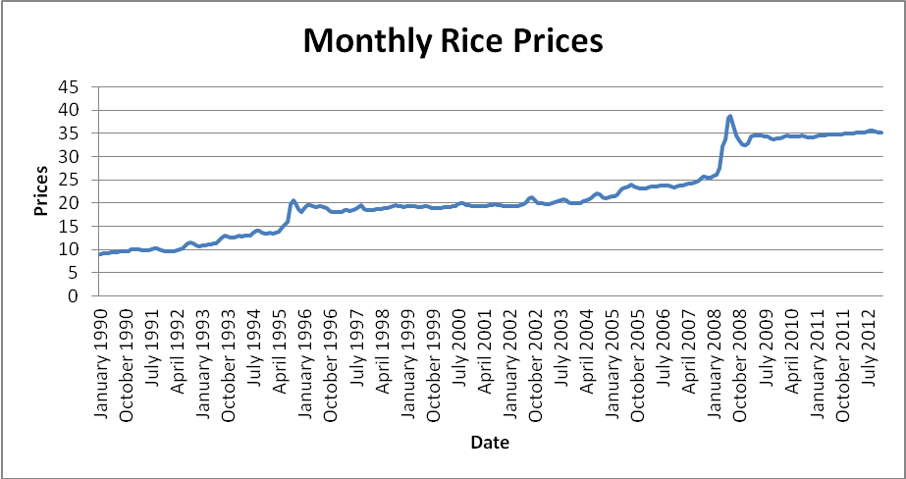

Analysis

To create a model, we have to have a data that shows stationarity. To do this, the sample autocorrelation will be calculated for each lag to create a correlogram to determine if the time-series is stationary. The calculations for the sample autocorrelation for each lag can be found in the accompanying Excel spreadsheet.

Let’s first check the autocorrelation of our original data (the monthly average well-milled rice prices).

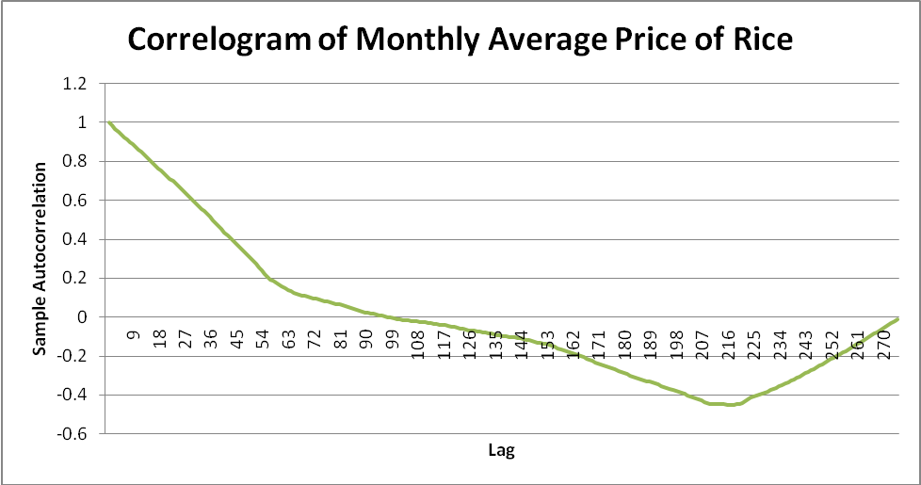

Since the autocorrelation is not converging to zero, this time series is not stationary. Next step is to transform the original data and check if the transformation will result to a stationary time series.

The following graph displays the correlogram of the first differences of the data.

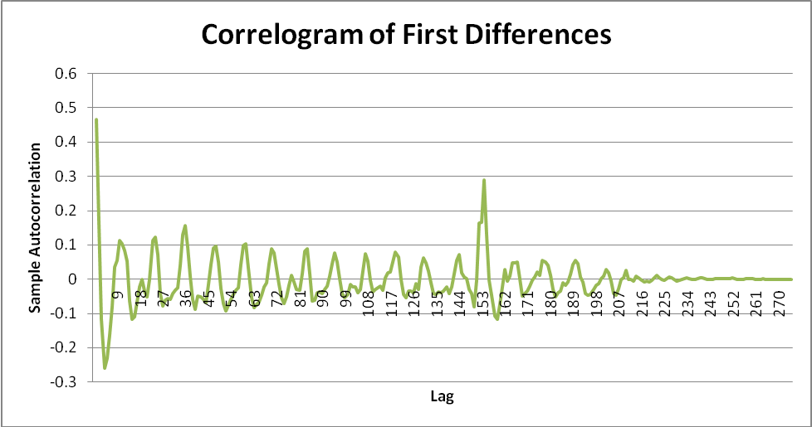

The correlogram actually shows a trend converging to zero. In fact, the average autocorrelation is -0.0018182 which is just slightly below 0. This infers that the data series is stationary. However, let’s check the second differences to see if it will produce better results.

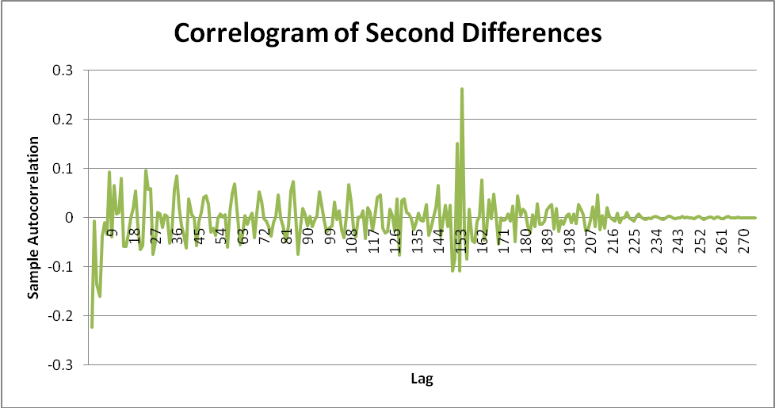

Similarly, this graph of sample autocorrelation shows trend towards zero. Actually, the average autocorrelation for the second differences is also -0.0018182, which is just slightly below 0. This series is also stationary.
Building the Model
Using the regression data analysis add-in in Excel, a regression analysis will be performed in order to fit the data to an autoregressive equation. The results can be checked in the accompanying Excel worksheet in tabs AR(1), AR(2) and AR(3).

The AR(1) equation is:

Y_{t} = 0.998662802Y _{t-1} + 0.123632718 + e_{t}

SUMMARY OUTPUT
Regression Statistics
Multiple R | 0.997387398
R Square | 0.994781622
Adjusted R Square | 0.994762507
Standard Error | 0.581366092
Observations | 275
ANOVA
 | df | SS | MS | F | Significance F
Regression | 1 | 17589.53063 | 17589.53063 | 52042.10497 | 0
Residual | 273 | 92.27032352 | 0.337986533
Total | 274 | 17681.80095
 | Coefficients | Standard Error | t Stat | P-value | Lower 95% | Upper 95% | Lower 95.0% | Upper 95.0%
Intercept | 0.123632718 | 0.099353334 | 1.244374126 | 0.214429174 | -0.071963352 | 0.319228789 | -0.071963352 | 0.319228789
Yt-1 | 0.998662802 | 0.004377654 | 228.1273876 | 0 | 0.990044551 | 1.007281052 | 0.990044551 | 1.007281052

The AR(2) equation is:

Y_{t} =(-0.46838792)Y _{t-2} + 1.465139012Y _{t-1} + 0.119802575 + e_{t}

SUMMARY OUTPUT
Regression Statistics
Multiple R | 0.997942203
R Square | 0.99588864
Adjusted R Square | 0.995858298
Standard Error | 0.515726669
Observations | 274
ANOVA
 | df | SS | MS | F | Significance F
Regression | 2 | 17459.58 | 8729.790002 | 32821.96796 | 0
Residual | 271 | 72.07895314 | 0.265973997
Total | 273 | 17531.65896
 | Coefficients | Standard Error | t Stat | P-value | Lower 95% | Upper 95% | Lower 95.0% | Upper 95.0%
Intercept | 0.119802575 | 0.088648122 | 1.351439508 | 0.177681719 | -0.05472397 | 0.29432912 | -0.05472397 | 0.29432912
Yt-2 | -0.46838792 | 0.053763012 | -8.71208472 | 3.01379E-16 | -0.574234183 | -0.36254165 | -0.574234183 | -0.36254165
Yt-1 | 1.465139012 | 0.053690346 | 27.28868633 | 1.00946E-79 | 1.359435807 | 1.570842217 | 1.359435807 | 1.570842217

The AR(3) equation is:

Y_{t} = 0.055711728Y _{t-3} + (-0.54985092)Y _{t-2} + 1.491113258Y _{t-1} + 0.118176029 + e_{t}

Conclusion
Below is a comparison of the R square values, Adjusted R square values and Standard Errors of the 3 models.

 | R square | Adjusted R Square | Standard Error
AR(1) | 0.994781622 | 0.994762507 | 0.581366092
AR(2) | 0.99588864 | 0.995858298 | 0.515726669
AR(3) | 0.995866221 | 0.99582012 | 0.516824308

Based on the above calculations and analysis, I will select the AR(2) model because it has the highest R square value, highest Adjusted R square value and lowest standard error.
Therefore, the equation or model that will best predict future retail price of well-milled rice is

Y_{t} =(-0.46838792)Y _{t-2} + 1.465139012Y _{t-1} + 0.119802575 + e_{t}

