Project
Name: xxx-xxxx xxxxx
Course: Time Series
Session: Winter 2013

1. Trend:
For this question, you will use quarterly observations on the U.S. real Gross Domestic Product in the files posted on the web site. The quarterly data start from 1947.1 and end at 2006.3. If you choose to import the Excel data into Eviews yourself, then you should set the `sample size' in Eviews to end at 2007.4 since you will try to forecast the eight quarters in 2006 and 2007.

I posted the original Excel data file and an Eviews workfile with the sample size adjusted to 2007.4 as described above.
The first purpose of this assignment is to fit two trend models to the data using observations from 1947.1 to 2005.4 only. Then you’ll forecast out-of-sample from 2006.1 to 2007.4. Note that for estimation purposes, we are going to ignore the data points in 2006. And fit their competing ARIMA models.
- Estimate the linear and quadratic trend models. Use the Schwarz Information Criterion to select the best model.
To develop the linear model, we estimate the equation: realgdp = β₀ + β₁ TIME + ε_{t} , and get the result as below:
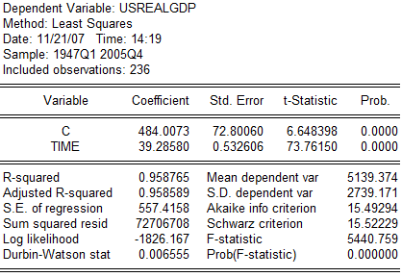

To develop the quadratic model, we estimate the equation: realgdp = β₀ + β₁ TIME + β₂ (TIME²)+ ε_{t} , and get the result as result:
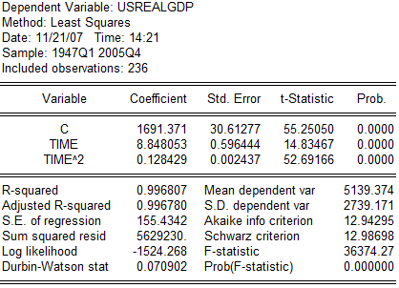

From the result, we see the Schwarz Information Criterion of quadratic model is 12.98698, which is lower than that for the linear model. We know that smaller the SIC value is, the better the estimate equation is, so we choose the quadratic model for forecasting the trend.
(b) Compute by `hand' the one-step-ahead point forecast of the real U.S. GDP for 2006.1, and form a 95% confidence interval forecast of the same object. Make sure you show all your work. How did your model do out-of-sample?
Well the value of time here is 237.So we can estimate GDP value in 2006.1:
USRealGDP_{t+1} =1691.371 + 8.848053*(237) +0.128429(237 ²) =11002.09

The standard error of the regression is 155.4342. Assuming a standard normal distribution, the critical value for a 95% confidence interval is ± 1.96. So, our 95% confidence interval forecast is:

USRealGDP_{t+1} ± (1.96*155.4342)
USRealGDP_{t+1} = [11002.0881– (304.6510), 11002.0881 + (304.6510)]
USRealGDP_{t+1} = [10697.4370, 11306.7391]

(c) Compute the 95% confidence interval forecasts for 2006.1 - 2007.4 using the Forecast facility of Eviews. Plot the 95% confidence interval forecasts and the actual values and briefly comment on the quality of your forecasts. Compare your forecasts to those surveyed by the Economist and briefly discuss any discrepancies.

rgdpf = 1691.371 + 8.848053*TIME + 0.128429*TIME^2
genr upper = rgdpf + (1.96 * 155.4342)
genr lower = rgdpf – (1.96 * 155.4342)
So we get the numbers as follow:
Date | RGDPF | Upper | Lower | Date | RGDPF | Upper | Lower
1947Q1 | 1700.34748 | 2004.9985 | 1395.6965 | 1977Q3 | 4722.68386 | 5027.3349 | 4418.0328
1947Q2 | 1709.58082 | 2014.2319 | 1404.9298 | 1977Q4 | 4763.25388 | 5067.9049 | 4458.6028
1947Q3 | 1719.07102 | 2023.7221 | 1414.42 | 1978Q1 | 4804.08075 | 5108.7318 | 4499.4297
1947Q4 | 1728.81808 | 2033.4691 | 1424.167 | 1978Q2 | 4845.16448 | 5149.8155 | 4540.5135
1948Q1 | 1738.82199 | 2043.473 | 1434.171 | 1978Q3 | 4886.50507 | 5191.1561 | 4581.854
1948Q2 | 1749.08276 | 2053.7338 | 1444.4317 | 1978Q4 | 4928.10252 | 5232.7536 | 4623.4515
1948Q3 | 1759.60039 | 2064.2514 | 1454.9494 | 1979Q1 | 4969.95683 | 5274.6079 | 4665.3058
1948Q4 | 1770.37488 | 2075.0259 | 1465.7238 | 1979Q2 | 5012.06799 | 5316.719 | 4707.417
1949Q1 | 1781.40623 | 2086.0573 | 1476.7552 | 1979Q3 | 5054.43601 | 5359.087 | 4749.785
1949Q2 | 1792.69443 | 2097.3455 | 1488.0434 | 1979Q4 | 5097.06089 | 5401.7119 | 4792.4099
1949Q3 | 1804.23949 | 2108.8905 | 1499.5885 | 1980Q1 | 5139.94263 | 5444.5937 | 4835.2916
1949Q4 | 1816.04141 | 2120.6924 | 1511.3904 | 1980Q2 | 5183.08123 | 5487.7323 | 4878.4302
1950Q1 | 1828.10019 | 2132.7512 | 1523.4492 | 1980Q3 | 5226.47668 | 5531.1277 | 4921.8256
1950Q2 | 1840.41583 | 2145.0669 | 1535.7648 | 1980Q4 | 5270.12899 | 5574.78 | 4965.478
1950Q3 | 1852.98832 | 2157.6394 | 1548.3373 | 1981Q1 | 5314.03816 | 5618.6892 | 5009.3871
1950Q4 | 1865.81767 | 2170.4687 | 1561.1666 | 1981Q2 | 5358.20419 | 5662.8552 | 5053.5532
1951Q1 | 1878.90388 | 2183.5549 | 1574.2529 | 1981Q3 | 5402.62708 | 5707.2781 | 5097.976
1951Q2 | 1892.24695 | 2196.898 | 1587.5959 | 1981Q4 | 5447.30682 | 5751.9579 | 5142.6558
1951Q3 | 1905.84688 | 2210.4979 | 1601.1958 | 1982Q1 | 5492.24342 | 5796.8945 | 5187.5924
1951Q4 | 1919.70366 | 2224.3547 | 1615.0526 | 1982Q2 | 5537.43688 | 5842.0879 | 5232.7859
1952Q1 | 1933.8173 | 2238.4683 | 1629.1663 | 1982Q3 | 5582.8872 | 5887.5382 | 5278.2362
1952Q2 | 1948.1878 | 2252.8388 | 1643.5368 | 1982Q4 | 5628.59438 | 5933.2454 | 5323.9433
1952Q3 | 1962.81516 | 2267.4662 | 1658.1641 | 1983Q1 | 5674.55841 | 5979.2094 | 5369.9074
1952Q4 | 1977.69938 | 2282.3504 | 1673.0483 | 1983Q2 | 5720.7793 | 6025.4303 | 5416.1283
1953Q1 | 1992.84045 | 2297.4915 | 1688.1894 | 1983Q3 | 5767.25705 | 6071.9081 | 5462.606
1953Q2 | 2008.23838 | 2312.8894 | 1703.5874 | 1983Q4 | 5813.99166 | 6118.6427 | 5509.3406
1953Q3 | 2023.89317 | 2328.5442 | 1719.2421 | 1984Q1 | 5860.98313 | 6165.6342 | 5556.3321
1953Q4 | 2039.80482 | 2344.4559 | 1735.1538 | 1984Q2 | 5908.23145 | 6212.8825 | 5603.5804
1954Q1 | 2055.97333 | 2360.6244 | 1751.3223 | 1984Q3 | 5955.73663 | 6260.3877 | 5651.0856
1954Q2 | 2072.39869 | 2377.0497 | 1767.7477 | 1984Q4 | 6003.49867 | 6308.1497 | 5698.8476
1954Q3 | 2089.08091 | 2393.7319 | 1784.4299 | 1985Q1 | 6051.51757 | 6356.1686 | 5746.8665
1954Q4 | 2106.01999 | 2410.671 | 1801.369 | 1985Q2 | 6099.79333 | 6404.4444 | 5795.1423
1955Q1 | 2123.21593 | 2427.867 | 1818.5649 | 1985Q3 | 6148.32594 | 6452.977 | 5843.6749
1955Q2 | 2140.66873 | 2445.3198 | 1836.0177 | 1985Q4 | 6197.11541 | 6501.7664 | 5892.4644
1955Q3 | 2158.37838 | 2463.0294 | 1853.7273 | 1986Q1 | 6246.16174 | 6550.8128 | 5941.5107
1955Q4 | 2176.34489 | 2480.9959 | 1871.6939 | 1986Q2 | 6295.46493 | 6600.116 | 5990.8139
1956Q1 | 2194.56826 | 2499.2193 | 1889.9172 | 1986Q3 | 6345.02498 | 6649.676 | 6040.3739
1956Q2 | 2213.04849 | 2517.6995 | 1908.3975 | 1986Q4 | 6394.84188 | 6699.4929 | 6090.1908
1956Q3 | 2231.78558 | 2536.4366 | 1927.1345 | 1987Q1 | 6444.91564 | 6749.5667 | 6140.2646
1956Q4 | 2250.77952 | 2555.4306 | 1946.1285 | 1987Q2 | 6495.24626 | 6799.8973 | 6190.5952
1957Q1 | 2270.03032 | 2574.6814 | 1965.3793 | 1987Q3 | 6545.83374 | 6850.4848 | 6241.1827
1957Q2 | 2289.53798 | 2594.189 | 1984.887 | 1987Q4 | 6596.67808 | 6901.3291 | 6292.027
1957Q3 | 2309.3025 | 2613.9535 | 2004.6515 | 1988Q1 | 6647.77927 | 6952.4303 | 6343.1282
1957Q4 | 2329.32388 | 2633.9749 | 2024.6728 | 1988Q2 | 6699.13732 | 7003.7884 | 6394.4863
1958Q1 | 2349.60211 | 2654.2531 | 2044.9511 | 1988Q3 | 6750.75223 | 7055.4033 | 6446.1012
1958Q2 | 2370.1372 | 2674.7882 | 2065.4862 | 1988Q4 | 6802.624 | 7107.275 | 6497.973
1958Q3 | 2390.92915 | 2695.5802 | 2086.2781 | 1989Q1 | 6854.75263 | 7159.4037 | 6550.1016
1958Q4 | 2411.97796 | 2716.629 | 2107.3269 | 1989Q2 | 6907.13811 | 7211.7891 | 6602.4871
1959Q1 | 2433.28363 | 2737.9347 | 2128.6326 | 1989Q3 | 6959.78045 | 7264.4315 | 6655.1294
1959Q2 | 2454.84615 | 2759.4972 | 2150.1951 | 1989Q4 | 7012.67965 | 7317.3307 | 6708.0286
1959Q3 | 2476.66553 | 2781.3166 | 2172.0145 | 1990Q1 | 7065.83571 | 7370.4867 | 6761.1847
1959Q4 | 2498.74177 | 2803.3928 | 2194.0907 | 1990Q2 | 7119.24863 | 7423.8997 | 6814.5976
1960Q1 | 2521.07487 | 2825.7259 | 2216.4238 | 1990Q3 | 7172.9184 | 7477.5694 | 6868.2674
1960Q2 | 2543.66483 | 2848.3159 | 2239.0138 | 1990Q4 | 7226.84503 | 7531.4961 | 6922.194
1960Q3 | 2566.51164 | 2871.1627 | 2261.8606 | 1991Q1 | 7281.02852 | 7585.6796 | 6976.3775
1960Q4 | 2589.61531 | 2894.2663 | 2284.9643 | 1991Q2 | 7335.46887 | 7640.1199 | 7030.8178
1961Q1 | 2612.97584 | 2917.6269 | 2308.3248 | 1991Q3 | 7390.16608 | 7694.8171 | 7085.515
1961Q2 | 2636.59323 | 2941.2443 | 2331.9422 | 1991Q4 | 7445.12014 | 7749.7712 | 7140.4691
1961Q3 | 2660.46748 | 2965.1185 | 2355.8164 | 1992Q1 | 7500.33106 | 7804.9821 | 7195.68
1961Q4 | 2684.59858 | 2989.2496 | 2379.9475 | 1992Q2 | 7555.79884 | 7860.4499 | 7251.1478
1962Q1 | 2708.98654 | 3013.6376 | 2404.3355 | 1992Q3 | 7611.52348 | 7916.1745 | 7306.8724
1962Q2 | 2733.63136 | 3038.2824 | 2428.9803 | 1992Q4 | 7667.50498 | 7972.156 | 7362.8539
1962Q3 | 2758.53304 | 3063.1841 | 2453.882 | 1993Q1 | 7723.74333 | 8028.3944 | 7419.0923
1962Q4 | 2783.69158 | 3088.3426 | 2479.0405 | 1993Q2 | 7780.23854 | 8084.8896 | 7475.5875
1963Q1 | 2809.10697 | 3113.758 | 2504.4559 | 1993Q3 | 7836.99061 | 8141.6416 | 7532.3396
1963Q2 | 2834.77922 | 3139.4303 | 2530.1282 | 1993Q4 | 7893.99954 | 8198.6506 | 7589.3485
1963Q3 | 2860.70833 | 3165.3594 | 2556.0573 | 1994Q1 | 7951.26533 | 8255.9164 | 7646.6143
1963Q4 | 2886.8943 | 3191.5453 | 2582.2433 | 1994Q2 | 8008.78797 | 8313.439 | 7704.1369
1964Q1 | 2913.33713 | 3217.9882 | 2608.6861 | 1994Q3 | 8066.56747 | 8371.2185 | 7761.9164
1964Q2 | 2940.03681 | 3244.6878 | 2635.3858 | 1994Q4 | 8124.60383 | 8429.2549 | 7819.9528
1964Q3 | 2966.99335 | 3271.6444 | 2662.3423 | 1995Q1 | 8182.89705 | 8487.5481 | 7878.246
1964Q4 | 2994.20675 | 3298.8578 | 2689.5557 | 1995Q2 | 8241.44713 | 8546.0982 | 7936.7961
1965Q1 | 3021.67701 | 3326.328 | 2717.026 | 1995Q3 | 8300.25406 | 8604.9051 | 7995.603
1965Q2 | 3049.40413 | 3354.0552 | 2744.7531 | 1995Q4 | 8359.31785 | 8663.9689 | 8054.6668
1965Q3 | 3077.3881 | 3382.0391 | 2772.7371 | 1996Q1 | 8418.6385 | 8723.2895 | 8113.9875
1965Q4 | 3105.62893 | 3410.28 | 2800.9779 | 1996Q2 | 8478.21601 | 8782.867 | 8173.565
1966Q1 | 3134.12662 | 3438.7777 | 2829.4756 | 1996Q3 | 8538.05038 | 8842.7014 | 8233.3993
1966Q2 | 3162.88117 | 3467.5322 | 2858.2301 | 1996Q4 | 8598.1416 | 8902.7926 | 8293.4906
1966Q3 | 3191.89258 | 3496.5436 | 2887.2415 | 1997Q1 | 8658.48968 | 8963.1407 | 8353.8387
1966Q4 | 3221.16084 | 3525.8119 | 2916.5098 | 1997Q2 | 8719.09462 | 9023.7457 | 8414.4436
1967Q1 | 3250.68596 | 3555.337 | 2946.0349 | 1997Q3 | 8779.95642 | 9084.6075 | 8475.3054
1967Q2 | 3280.46794 | 3585.119 | 2975.8169 | 1997Q4 | 8841.07508 | 9145.7261 | 8536.424
1967Q3 | 3310.50678 | 3615.1578 | 3005.8557 | 1998Q1 | 8902.45059 | 9207.1016 | 8597.7996
1967Q4 | 3340.80248 | 3645.4535 | 3036.1514 | 1998Q2 | 8964.08296 | 9268.734 | 8659.4319
1968Q1 | 3371.35503 | 3676.0061 | 3066.704 | 1998Q3 | 9025.97219 | 9330.6232 | 8721.3212
1968Q2 | 3402.16444 | 3706.8155 | 3097.5134 | 1998Q4 | 9088.11828 | 9392.7693 | 8783.4672
1968Q3 | 3433.23071 | 3737.8817 | 3128.5797 | 1999Q1 | 9150.52123 | 9455.1723 | 8845.8702
1968Q4 | 3464.55384 | 3769.2049 | 3159.9028 | 1999Q2 | 9213.18103 | 9517.8321 | 8908.53
1969Q1 | 3496.13383 | 3800.7849 | 3191.4828 | 1999Q3 | 9276.09769 | 9580.7487 | 8971.4467
1969Q2 | 3527.97067 | 3832.6217 | 3223.3196 | 1999Q4 | 9339.27121 | 9643.9222 | 9034.6202
1969Q3 | 3560.06437 | 3864.7154 | 3255.4133 | 2000Q1 | 9402.70159 | 9707.3526 | 9098.0506
1969Q4 | 3592.41493 | 3897.066 | 3287.7639 | 2000Q2 | 9466.38883 | 9771.0399 | 9161.7378
1970Q1 | 3625.02235 | 3929.6734 | 3320.3713 | 2000Q3 | 9530.33292 | 9834.984 | 9225.6819
1970Q2 | 3657.88663 | 3962.5377 | 3353.2356 | 2000Q4 | 9594.53387 | 9899.1849 | 9289.8828
1970Q3 | 3691.00776 | 3995.6588 | 3386.3567 | 2001Q1 | 9658.99168 | 9963.6427 | 9354.3407
1970Q4 | 3724.38575 | 4029.0368 | 3419.7347 | 2001Q2 | 9723.70635 | 10028.357 | 9419.0553
1971Q1 | 3758.0206 | 4062.6716 | 3453.3696 | 2001Q3 | 9788.67788 | 10093.329 | 9484.0268
1971Q2 | 3791.91231 | 4096.5633 | 3487.2613 | 2001Q4 | 9853.90626 | 10158.557 | 9549.2552
1971Q3 | 3826.06088 | 4130.7119 | 3521.4098 | 2002Q1 | 9919.3915 | 10224.043 | 9614.7405
1971Q4 | 3860.4663 | 4165.1173 | 3555.8153 | 2002Q2 | 9985.1336 | 10289.785 | 9680.4826
1972Q1 | 3895.12858 | 4199.7796 | 3590.4776 | 2002Q3 | 10051.1326 | 10355.784 | 9746.4815
1972Q2 | 3930.04772 | 4234.6988 | 3625.3967 | 2002Q4 | 10117.3884 | 10422.039 | 9812.7373
1972Q3 | 3965.22372 | 4269.8748 | 3660.5727 | 2003Q1 | 10183.9011 | 10488.552 | 9879.25
1972Q4 | 4000.65658 | 4305.3076 | 3696.0055 | 2003Q2 | 10250.6706 | 10555.322 | 9946.0196
1973Q1 | 4036.34629 | 4340.9973 | 3731.6953 | 2003Q3 | 10317.697 | 10622.348 | 10013.046
1973Q2 | 4072.29286 | 4376.9439 | 3767.6418 | 2003Q4 | 10384.9802 | 10689.631 | 10080.329
1973Q3 | 4108.49629 | 4413.1473 | 3803.8453 | 2004Q1 | 10452.5203 | 10757.171 | 10147.869
1973Q4 | 4144.95658 | 4449.6076 | 3840.3055 | 2004Q2 | 10520.3173 | 10824.968 | 10215.666
1974Q1 | 4181.67373 | 4486.3248 | 3877.0227 | 2004Q3 | 10588.3711 | 10893.022 | 10283.72
1974Q2 | 4218.64773 | 4523.2988 | 3913.9967 | 2004Q4 | 10656.6818 | 10961.333 | 10352.031
1974Q3 | 4255.87859 | 4560.5296 | 3951.2276 | 2005Q1 | 10725.2493 | 11029.9 | 10420.598
1974Q4 | 4293.36631 | 4598.0173 | 3988.7153 | 2005Q2 | 10794.0737 | 11098.725 | 10489.423
1975Q1 | 4331.11089 | 4635.7619 | 4026.4599 | 2005Q3 | 10863.155 | 11167.806 | 10558.504
1975Q2 | 4369.11233 | 4673.7634 | 4064.4613 | 2005Q4 | 10932.4931 | 11237.144 | 10627.842
1975Q3 | 4407.37062 | 4712.0217 | 4102.7196 | 2006Q1 | 11002.0881 | 11306.739 | 10697.437
1975Q4 | 4445.88577 | 4750.5368 | 4141.2347 | 2006Q2 | 11071.9399 | 11376.591 | 10767.289
1976Q1 | 4484.65778 | 4789.3088 | 4180.0068 | 2006Q3 | 11142.0486 | 11446.7 | 10837.398
1976Q2 | 4523.68665 | 4828.3377 | 4219.0356 | 2006Q4 | 11212.4141 | 11517.065 | 10907.763
1976Q3 | 4562.97238 | 4867.6234 | 4258.3213 | 2007Q1 | 11283.0365 | 11587.688 | 10978.385
1976Q4 | 4602.51496 | 4907.166 | 4297.8639 | 2007Q2 | 11353.9158 | 11658.567 | 11049.265
1977Q1 | 4642.3144 | 4946.9654 | 4337.6634 | 2007Q3 | 11425.0519 | 11729.703 | 11120.401
1977Q2 | 4682.3707 | 4987.0217 | 4377.7197

Plotting our forecasts (rgdpf) with upper and lower bounds alongside of the realgdp data:
One way to forecast through 2007 and generate upper and lower confidence intervals using Eviews is to reset the sample size to the end of 2007 and then do the following:

genr rgdpf = β₀ + β₁ TIME + β₂ (TIME²)

rgdpf = 1691.371 + 8.848053*TIME + 0.128429*TIME^2
genr upper = rgdpf + (1.96 * 155.4342)
genr lower = rgdpf – (1.96 * 155.4342)

Open lower, usrealgdp, upper and rgdpf as a group and get the line graph as below:
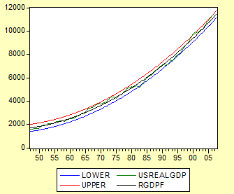

From the above plot, we see that the last two or three quarters of real GDP (from 2006.1 through 2006.3, our last data point) fall outside our 95% confidence interval. So, we can say that real GDP growth has been better than predicted by our quadratic trend model, which predict modest growth for 2006 and 2007. If we retrieve the rgdpf point forecasts from 2006.1 through 2007.3 and compute quarter-over-quarter changes, we’ll see that the model predicts real GDP to grow at an average rate of 0.628% per quarter over this interval (roughly 2.51% per year).

2. Seasonality:
For this question, use Eviews workfile that contains two variables: Advance Monthly Sales for Retail and Food Services (in millions of dollars) called sales, and a similar variable called adjustedsales which has been ‘seasonally adjusted’ by the Census Bureau of the Department of Commerce. The data start from 1992.01 and end at 2006.12, although in the Eviews workfile, I set the sample size to 2007.12, which gives us room to compute forecasts.
Create seasonal dummy variables s₁, s₂, …, s_{12.} Regress the seasonally unadjusted
retail sales, sales, on a constant, a linear trend model, and monthly dummies except for June, using a sample period of 1992.01-2005.12.
Address the following questions:
(a) Which months are different from June regarding retail sales? Describe your statistical inference.
In Eviews, we first generate dummy variables for each month (except for June).
We generate a linear TIME dummy and estimate the following equation over the sample period 1992.01 to 2005.12:

Sales = C + β₀ TIME + β₁ Jandum + β₂ Febdum+…+ β₁₁Decdum (excluding June)
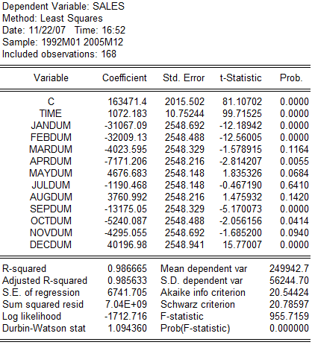

From the formula, we know that the intercept which is 163471.4 is equal to sales in June. The coefficients for the seasonal dummies tell us whether sales are above, below, or similar to the average level in June.

Looking at the t-statistics and p-values for each month, it appears that March, July, and August (in blue) are statistically similar to June and the p-value for each month is greater than 10%. Using a 90% confidence interval, we can not reject the null hypothesis, which asserts that these coefficients are zero.

The coefficient for November (Novdum) might be characterized as a borderline case, with a p-value of just under 10%, but by our decision rule we reject the null hypothesis for November and consider sales in November as significantly different from June.
The coefficients for the other months are statistically different from zero. We see positive coefficients indicating that sales in May and December are larger than sales June. We see that January, February, April, September, October and November have negative coefficients, indicating that sales in these months are less than sales in June.
(b) Are retail sales in the month of June “average”? How would you address this issue using our statistical framework?

We create a seasonal dummy (Jundum) for June, and we estimate the following equation:
Sales = β₀ TIME + β₁ Jandum + β₂ Febdum+…+ β₁₂Decdum (excluding June)
In the above regression, we exclude the intercept term (the constant C) to avoid colinearity problems. The regression output is as follows:
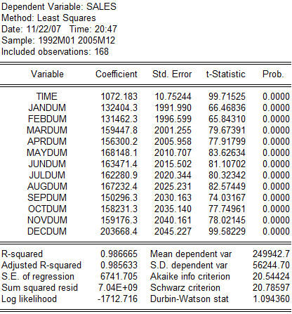
In this model, we have a seasonal dummy variable for each month and we interpret the coefficients as the average sales in each month.
To find average monthly sales, we take an average of the betas for the monthly dummies. Calculating by hand (132404.3 + 131462.3 + … + 203668.4)/12, I find the average monthly sales to be 159,343.

To determine whether sales in June are average, we test the null hypothesis that the beta for June (163471.4) is equal to 159,343. If we can reject the null hypothesis, we can say that June sales are different from average. Our t-test for this null hypothesis is:

T-statistics = βjundum -159343 = 163471.4 – 159,343 = 2.048
SE (βjundum) 2015.502
Since this t-statistic is greater than 1.96, we reject the null hypothesis. We conclude that Jun is above the average month for sales.
(c) What is your forecast for the retail sales in January 2006? Compute this by hand and show all your work. Also compute a 95% confidence interval forecast for January 2006. You have the actual value for January 2006, so evaluate the quality of your forecast.
For part (c), to compute our forecast of retail sales in January 2006, we note that the value of the TIME variable in the period 2006.01 is (168+1) = 169. The forecast is given by: Sales_{2006.01} = β₀ time + β₁jandum
Sales_{2006.01} = (1072.183 *169) + 1324404 x 1
Sales_{2006.01} = ( 313,603.23)

Noting that the standard error of the regression is 6741.705, our 95% confidence interval forecast is:
Sales_{2006.01} = 313,603.23 ₁ ± 1.96 *6741.705
Sales_{2006.01} = (300,603.23, 326,816.97)

The actual value for January 2006 is 322222.0, which falls within our 95% confidence interval.
(d) Now compute (by ‘hand’ again) your forecast for December 2006. How does this compare with the actual?
For part (d), to compute our forecast of retail sales in January 2006, we note that the value of the TIME variable in the period 2006.01 is (179+1) = 180. The forecast is given by: Sales_{2006.12} = β₀ time + β₁decdum
Our forecast for December 2006 is:
Sales_{2006.12} = (1072.183 *180) + (203668.4 * 1)
Sales_{2006.12} = 396,661.34
and our 95% confidence interval is:
Sales_{2006.12} =396,661.34 ± 1.96 *6741.705
Sales_{2006.12} = (383,447.60, 409,875.08)
The actual value for December 2006 is 423874.0, which is outside of our 95% confidence forecast. December 2006 was a stronger month than predicted by our model.

(e) Compute the seasonally adjusted retail sales according to your estimates of seasonality, and compare your adjusted series with that given in the variable adjustedsales. Did our model do a good job? Briefly comment.

For part (e), we want to compute the seasonally adjusted retail sales according to our estimates of seasonality. We could subtract seasonality from the actual sales data: Sales adjusted = Actual sales- Sales seasonal = Salestrend

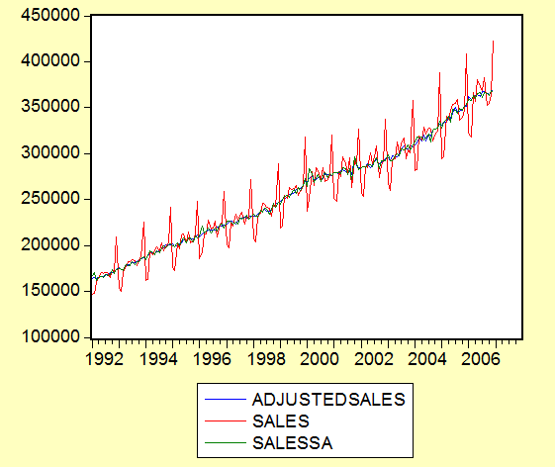

The above graph shows the actual sales, adjustedsales and sales seasonal series. Sales series has a trend and cycle and by subtracting seasonality we get “ADJSALES” which is a series with a much more detailed seasonal and cyclical estimation applied by the Department of Commerce.

3. Try to fit ARIMA Model using USrealGDP, find a parsimonious ARMA (p,d,q) model for USrealGDP. Make sure you follow step-by-step approach. Justify your selection of the chosen model using the test and criteria developed in class. Estimate no more 4 candidate models. Forecast the last 6 six months of the USrealGDP and compare your forecast with the actual.

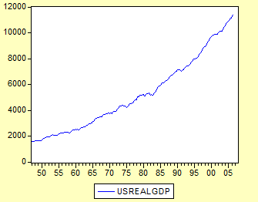

The general pattern of USREALGDP curve show us that it has a upward trend with fluctuations. It is more accurate to see if it is a stationary or nonstationary process in the correlogram as below:

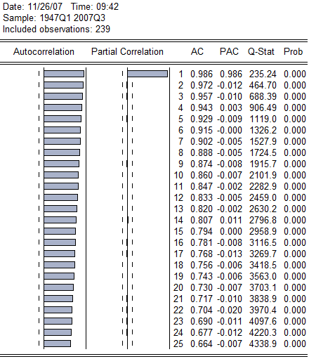
We can see the autocorrelation coefficient of USREALGDP starts at a very high value at lag 1(0.986) and declines very slowly. ACF up 25 lag are individually statistically significantly different from zero, for they all are outside the 95% confidence bounds. After the first lag, the PACF drop dramatically and all PACFs after lag 1 are statistically insignificant.

=239*(239+2)*[0.986^2/(239-1)+0.972^2/(239-2)+0.957^2/(239-3)+0.943^2/(239-4)]
=906.3803
$$χ^{2}(4)=9\text{.}\text{4877}$$
Because Q* is larger than , so first 4 coefficients are jointly significant and we reject the null hypothesis that there is no autocorrelation and first four autocorrelation coefficients together are statistically different from zero. So there exits autocorrelation up to lag 4 and the curve is not white noise.

When we see the first difference of USREALGDP, we do not find any trend in this series, so we might guess that first difference data is stationary.
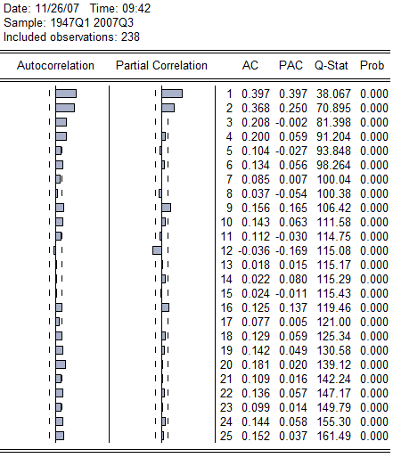

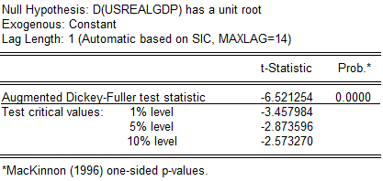

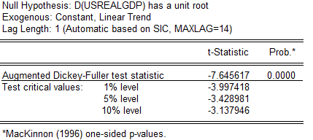

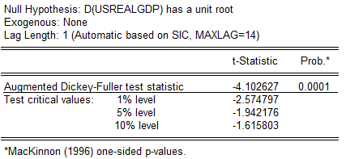

We can see that after first-differencing, time series data is stationary. The autocorrelation declines up to lag 8, then except at lag 20, the rest of them are statistically not different from zero. The partial autocorrelation with spikes at lag 1, 2, 9,12 seem statistically significant. We could use AR(1) model and then generate the first-differenced USREALGDP at the most an AR(12) process. Of course, we do not include all the AR terms up to 12.

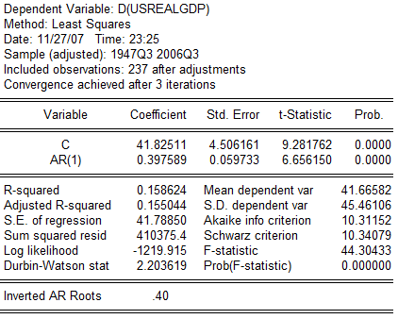

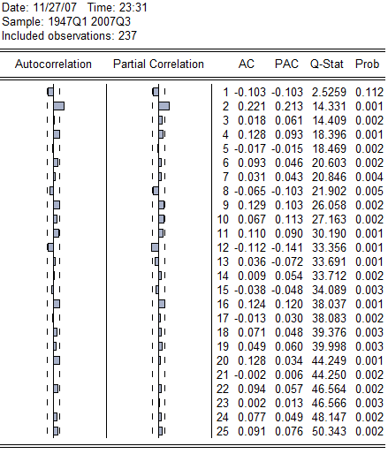

When we use AR(1) model, we obtain residual from the above equation and do the correlogram of the residual. From the graph above, we could see that the ACF and PACF of lag 2 and12 are statistically significant, so the residual estimated from the above equation is not purely random. Hence, we could look at AR(2).
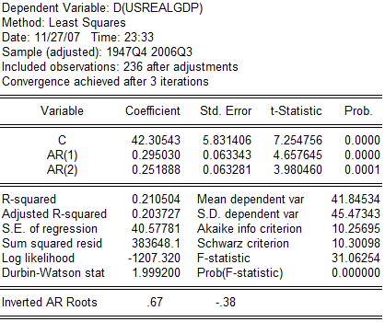
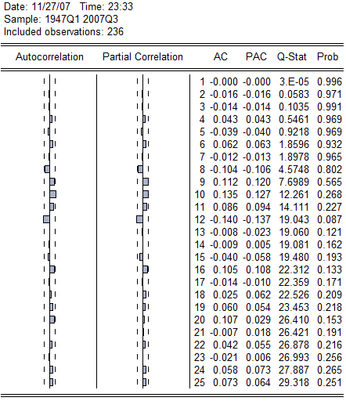
When we use AR(2) model, we obtain residual from the above equation and do the correlogram of the residual. From the graph above, we could see that the ACF and PACF of lag 9 and lag 12 are statistically significant, so the residual estimated from the above equation is not purely random. Hence, we could look at AR(9).

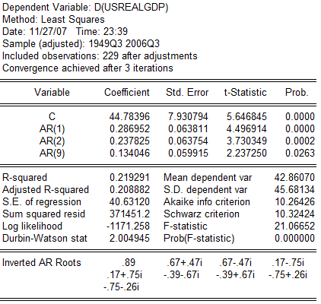
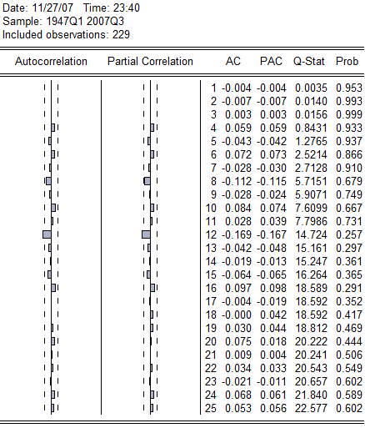
When we use AR(9) model, we obtain residual from the above equation and do the correlogram of the residual. From the graph above, we could see that the ACF and PACF of lag 12 are statistically significant, so the residual estimated from the above equation is not purely random. Hence, we could look at AR(12).

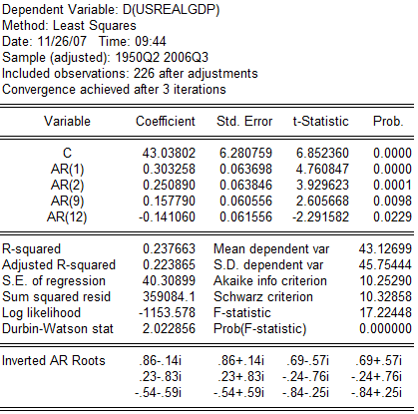

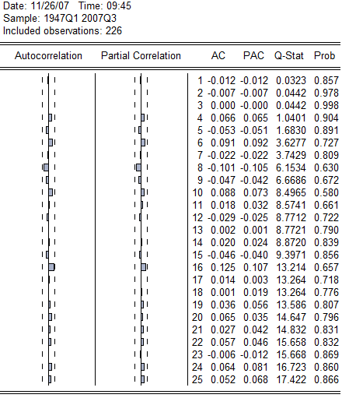

When we use AR(12) model, we obtain residual from the above equation and do the correlogram of the residual. From the graph above, we could see that none of the ACF and PACF is individually statistically significant. Nor is the sum of the 25 squared autocorrelation, as shown by the Box-Pierce Q and LJung-Box statistics, statistically significant. Both ACF and PACF give the impression that the residual estimated from the above equation is purely random. Hence, we do not need to look at another ARIMA model.

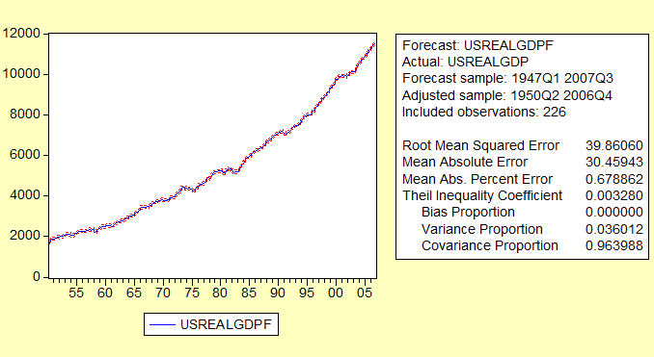

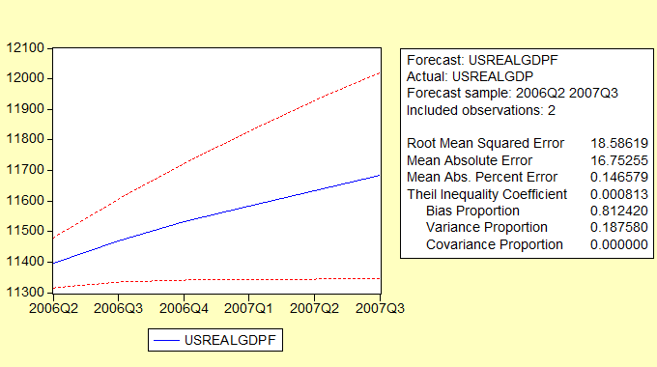

 | rgdp | upper | lower
2006Q2 | 11071.9399 | 11376.591 | 10767.289
2006Q3 | 11142.0486 | 11446.7 | 10837.398
2006Q4 | 11212.4141 | 11517.065 | 10907.763
2007Q1 | 11283.0365 | 11587.688 | 10978.385
2007Q2 | 11353.9158 | 11658.567 | 11049.265
2007Q3 | 11425.0519 | 11729.703 | 11120.401
Well, we could see that the estimated values are outside of our 95% confidence forecast and larger than the actual values.

