xxxx xxxxxx
Time Series
Fall 2008
Student Project

Time Series Student Project – Gold Prices

Introduction
I have chosen to do my student project over the average monthly London Afternoon Gold Prices ranging from 1/1/1991 to 12/31/1995. I downloaded my data from: http://www.usagold.com/reference/prices/history.html. After reviewing the data I don’t believe any changes are needed. It looks accurate and correct to the best of my knowledge.

Data

The graph below shows the average monthly prices from 1/1991 to 12/1995.
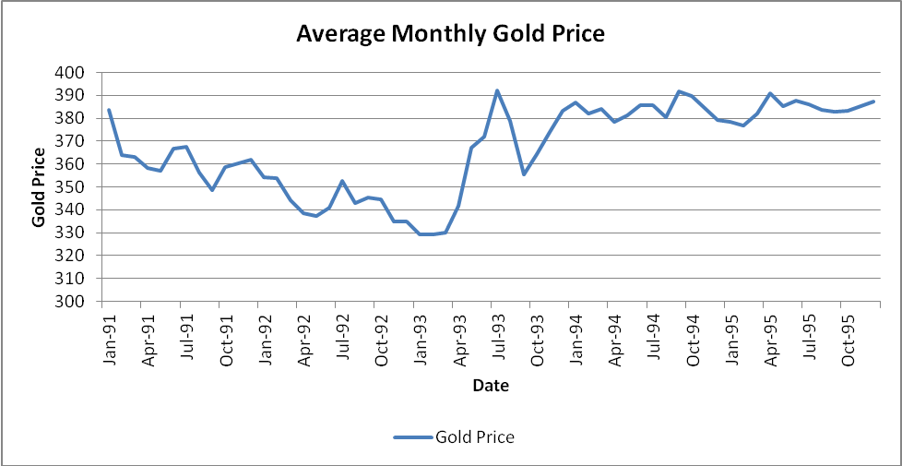

In general, prices:
- Decrease from Jan/1991 to Jan/1993
- Increase sharply from Jan/1993 to Jul/1993
- Decrease sharply over the next 2 months from Jul/1993 to Sept/1993
- Increase sharply from Sept/1993 to Jan/1994
- Remains relatively steady with minor fluctuations from Jan/1994 to Dec/1995

Seasonality

Seasonality can be tested by graphing monthly averages over the different years and looking for trends.

Below is a graph of the monthly average gold prices over the years 1991-1995. Looking at the graph I don’t see any signs of seasonality. No adjustments are needed.
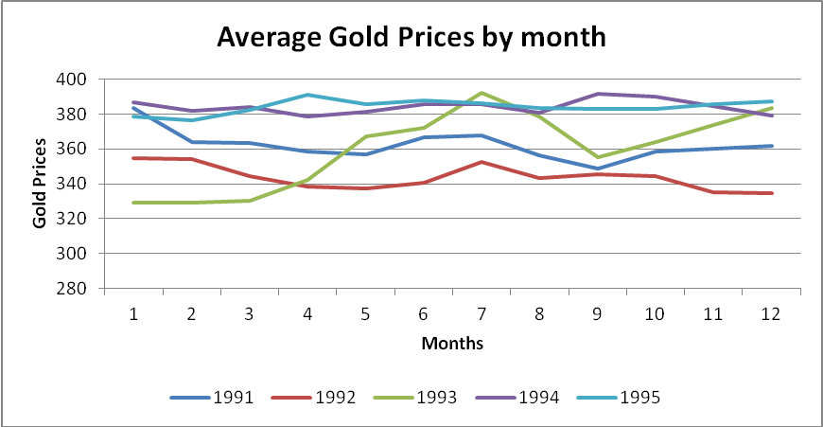

Stationarity and White Noise

An autocorrelation function will provide a partial description of the process for modeling purposes. It will tell us how much correlation there is between the neighboring data points and the series y_{t}.

The sample autocorrelation with lag k is defined as:
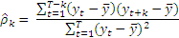

Below is a graph of the sample autocorrelation function of gold prices over the period. The autocorrelation function can be used to test stationarity. Looking at the correlogram I can see the graph decreases until lag 27 then trends to 0 as the lags increases. This is a sign of stationarity. I don’t see any sharp drops or spikes, hence I believe I can model this with only autoregressive terms.

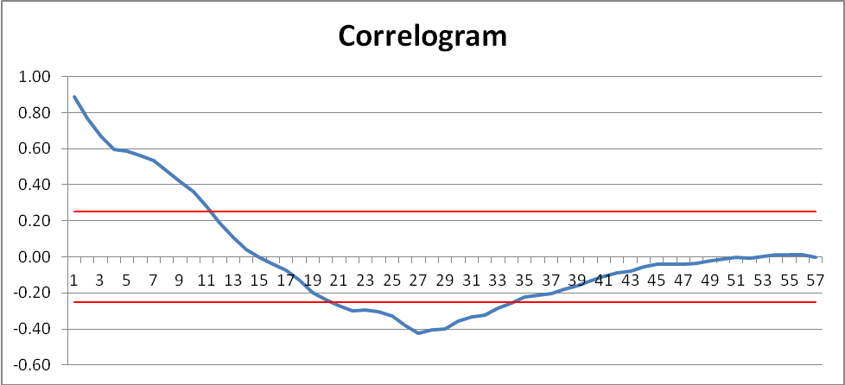

The graph above can also be used to help determine whether it is a white noise process or not. The Bartlett test states that if the autocorrelation coefficients for k > 0 are distributed approximately according to a normal distribution with mean 0 and standard deviation of 1/√T where T is the number of observations then the process is a white noise process. The red line on the graph represent the Bartlett test at 95% confidence interval, 1.96/√60 = +-.25. I can see many of the autocorrelation coefficients are outside the bounds so I can be 95% confident that the true autocorrelation coefficient is not 0.

To test the joint hypothesis that all the autocorrelation coefficients are 0 we can also use the Box and Pierce Q statistic which will be reviewed with each model.

Model Analysis

I chose to review three models: AR(1), AR(2), and AR(3).

I will use the Regression Analysis built into Microsoft Excel to aid in my analysis. The R square statistic produced by Excel shows the goodness of fit of the model. The Regression tool produces the intercept and x variables used in the AR formula. It also produces the predicted y values and residuals.

The Durbin Watson Statistic(DWS) is calculated to test serial correlation. The formula for DWS is:
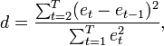

A value close to 2 shows no serial correlation. A value greater than 2 will show negative correlation and a value less than 2 will show positive correlation.

The Box Pierce Q(Q) statistic will be calculated to further test for white noise. The formula for Q is:
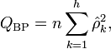
If Q is less than the Chi Square critical level at K lags then we fail to reject the hypotheses that the time series was generated by a white noise process.

Regression Model AR(1)

SUMMARY OUTPUT
Regression Statistics
Multiple R | 0.9049
R Square | 0.8188
Adjusted R Square | 0.8156
Standard Error | 8.2359
Observations | 59

 | Coefficients | Standard Error | t Stat
Intercept | 33.8144 | 20.7593 | 1.6289
X Variable 1 | 0.9079 | 0.0566 | 16.0470

Y_{t} = 33.8144 + .9079 x Y_{t-1} + ℮

DWS = 1.5823

Q₅₈ = 25.9186 Critical Value = 71.0397

Below is a graph of the actual monthly average gold prices and predicted average gold prices.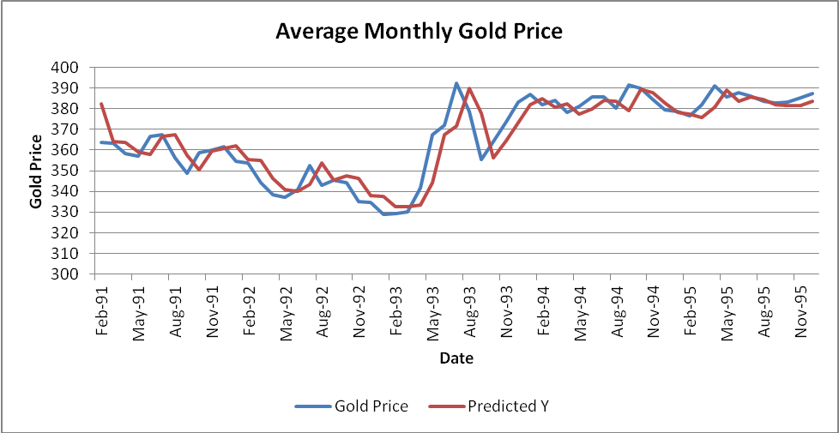
Regression Model AR(2)

SUMMARY OUTPUT
Regression Statistics
Multiple R | 0.9165
R Square | 0.8399
Adjusted R Square | 0.8341
Standard Error | 7.8780
Observations | 58

 | Coefficients | Standard Error | t Stat
Intercept | 34.3895 | 20.5013 | 1.6774
X Variable 1 | 1.0719 | 0.1269 | 8.4450
X Variable 2 | -0.1647 | 0.1271 | -1.2956

Y_{t} = 34.3895 + 1.0719 x Y_{t-1} - .1647 x Y_{t-2} + ℮

DWS = 1.9490

Q₅₇ = 17.1347 Critical Value = 69.9185

Below is a graph of the actual monthly average gold prices and predicted average gold prices.
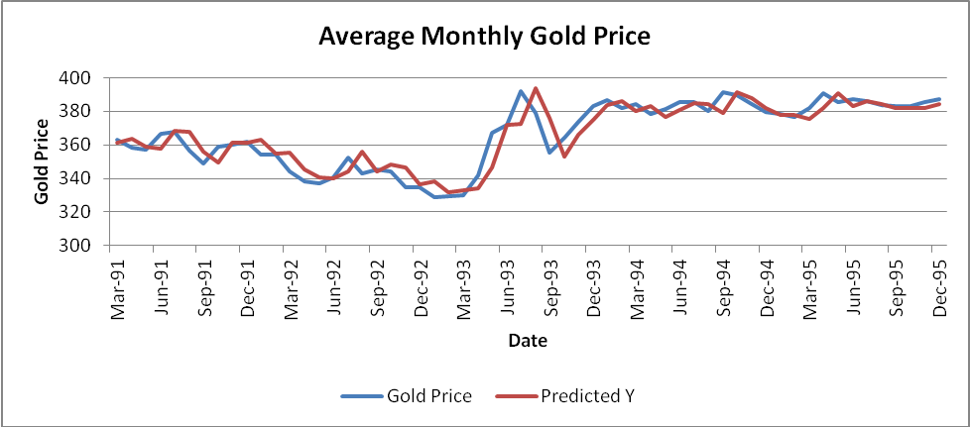

Regression Model AR(3)

SUMMARY OUTPUT
Regression Statistics
Multiple R | 0.9170
R Square | 0.8409
Adjusted R Square | 0.8319
Standard Error | 7.9999
Observations | 57

 | Coefficients | Standard Error | t Stat
Intercept | 31.9835 | 21.5326 | 1.4854
X Variable 1 | 1.0954 | 0.1371 | 7.9887
X Variable 2 | -0.2477 | 0.1953 | -1.2682
X Variable 3 | 0.0660 | 0.1310 | 0.5036

Y_{t} = 31.9835 + 1.0954 x Y_{t-1} - .2477 x Y_{t-2} + .0660 x Y_{t-3} + ℮

DWS = 1.9848

Q₅₆ = 16.5465 Critical Value = 68.7962

Below is a graph of the actual monthly average gold prices and predicted average gold prices.
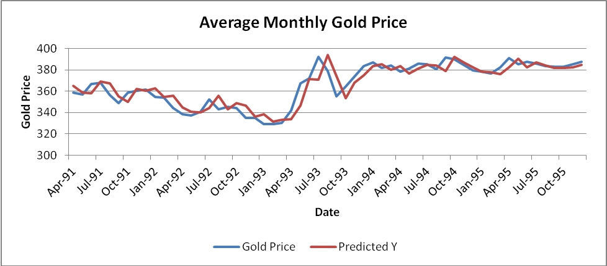

Conclusion

 |  | Durbin- | Box-Pierce | Chi-Square
Model | R-Square | Watson Stat | Q Stat | Critical Value
AR(1) | 0.8188 | 1.5823 | 25.9186 | 71.0397
AR(2) | 0.8399 | 1.9490 | 17.1347 | 69.9185
AR(3) | 0.8409 | 1.9848 | 16.5465 | 68.7962

The three models all have approximately the same R-Square. For the AR(1) model the Durbin-Watson stat is materially lower than 2 which means there is a positive correlation. The AR(2) and AR(3) models both have Durbin-Watson stat’s close to 2 meaning no serial correlation. The Box-Pierce stat’s are all less than the Chi-Square critical value at 10% meaning we fail to reject the hypotheses that the time series was generated by a white noise process. For the fact that the Durbin-Watson is so far below 2 I rule out using the AR(1) model. Due to parsimony I choose to use the AR(2) model over the AR(3) model.

Below is a graph showing the AR(2) model compared to the actual results from 1/1/1996 to 12/31/2002.
