xxxxx xxxx June 7, 2013
NEAS Time Series Student Project
Spring 2013

Modeling the Price of Potato Chips
Potato chips are a snack food staple in the United States. They are required fare for any Super Bowl party, poker game, picnic, or lazy Sunday afternoon. The goal of this analysis is to fit the best available time series model for predicting the price of potato chips per 16 oz in the U.S. Through this project, I hope to help everyone budget their party snacks with greater accuracy.

Data
Source: http://data.bls.gov/timeseries/APU0000718311?data_tool=XGtable
The source of the data is the Bureau of Labor Statistics website. The data is based on monthly potato chip prices per 16 oz. The data is collected from January 2003 to April 2013. Below is a graph of the data. The time series does not appear to be stationary as the data increases over time and thus does not have a constant mean.
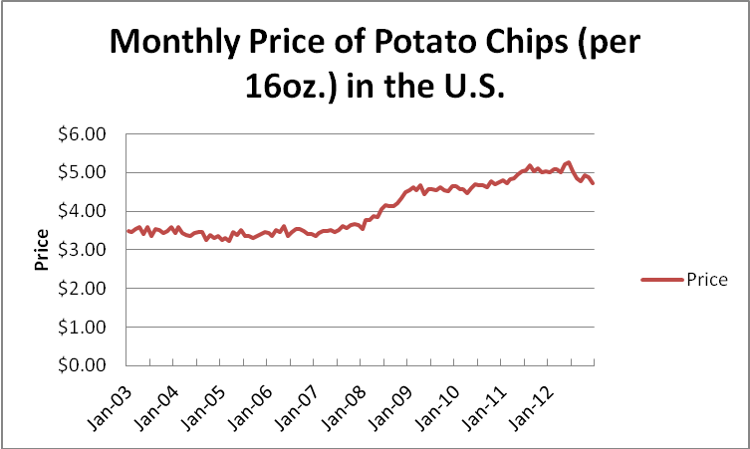
Seasonality
The graph below was created to compare monthly changes in potato chip prices year to year from 2003 to 2012. There are no significant seasonal patterns based on the graph below. Predominantly random fluctuations of price occur for most years.
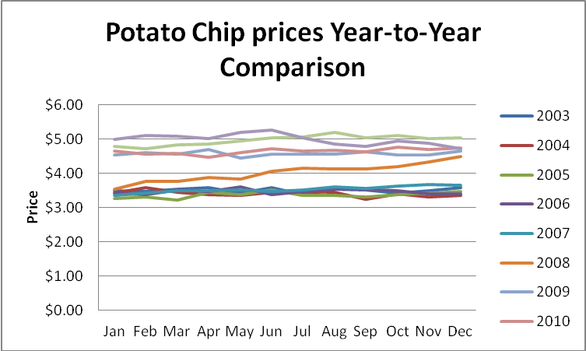

Stationarity
Although the graph above seems to show that the mean is not constant, a check of the sample autocorrelations is appropriate. The following equation is used to create the graph below.

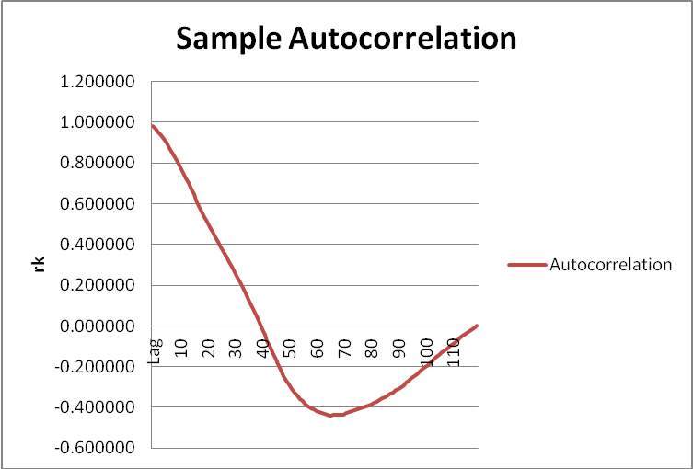

The sample autocorrelation does not approach zero quickly enough. The first difference will be analyzed in the hopes of finding stationarity.

First Difference
Below is the chart of the first difference for potato chip prices.
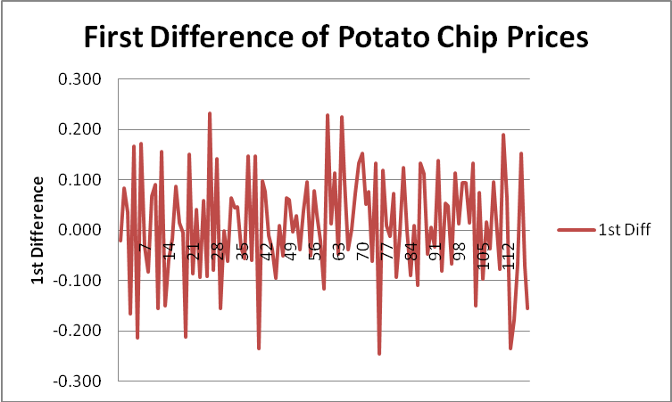
The first difference of the time series now appears to have a constant mean and variance. Below is a graph of the sample autocorrelations of the first differences.
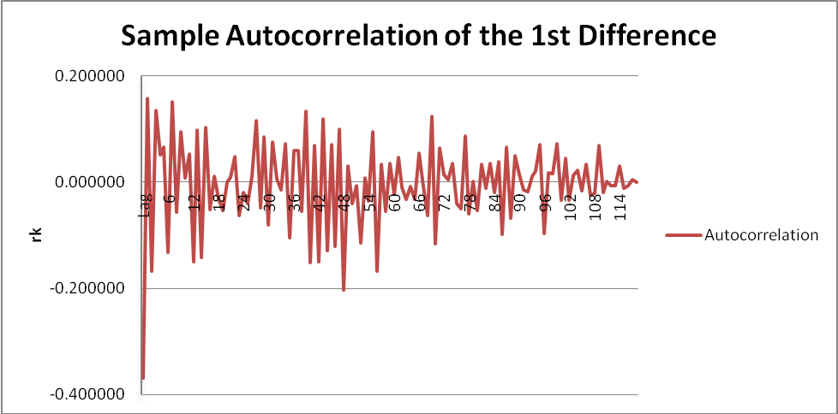
The sample autocorrelation function quickly drops to around zero (at about lag 18) and then oscillates around zero indicating a stationary process.
Model Fitting
With the stationary data gained through the first difference, autoregressive models AR(1), AR(2) and AR(3) will be fit to the data and compared. Since the first difference is being used, these models can also be stated as ARIMA (1,1,0), ARIMA(2,1,0) and ARIMA(3,1,0).
- AR(1):
The regression is shown below.
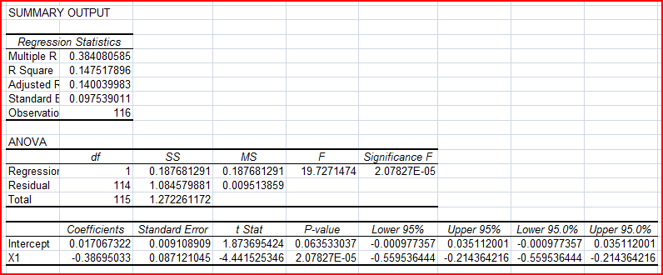

The resulting model is
Y_{t} – Y_{t-1} = 0.017067 – 0.38695(Y_{t-1} – Y_{t-2})

- AR(2):
The regression is shown below.
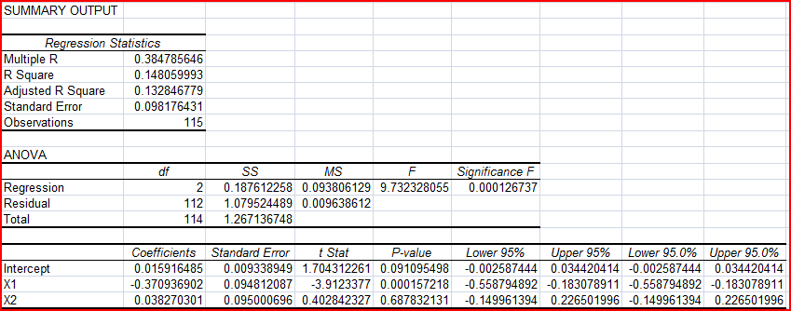
The resulting model is:
Y_{t} – Y_{t-1} = 0.01592 + 0.37094(Y_{t-1} – Y_{t-2}) + 0.03827(Y_{t-2} – Y_{t-3})

- AR(3):
The regression is shown below.
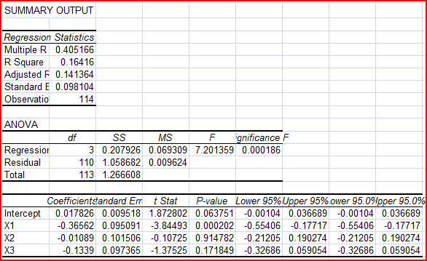

The resulting model is:
Y_{t} – Y_{t-1} = 0.017826 - 0.36562(Y_{t-1} – Y_{t-2}) - 0.01089(Y_{t-2} – Y_{t-3}) - 0.1339(Y_{t-3} – Y_{t-4})

Summary
 | R² | Adjusted R² | Standard Error
AR(1) | 0.1475 | 0.1400 | 0.0975
AR(2) | 0.1481 | 0.1329 | 0.0982
AR(3) | 0.1642 | 0.1414 | 0.0981

The summary of the data shows that the AR(3) model has the highest R2 and the highest Adjusted R2. Although AR(1) has a lower standard error, the difference is insignificant. The AR(3) model appears to be the best fit for forecasting the price of potato chips.

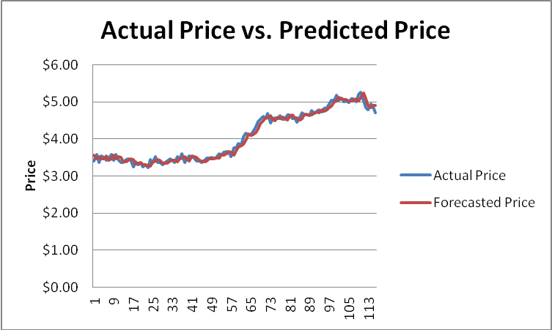
Based on the graph, the AR(3) model appears to be a good fit to the time series data. The residuals are quite small with a maximum deviation of 0.24. This model should be very helpful in budgeting for your next Super Bowl party.

