Spring 2013 Session
Regression Analysis Student Project

Hong Kong Private Residential Property Prices and Interest Rate

xxx, xxx xxx

INTRODUCTION
It is a general believe that when the interest rate rises, residential property prices tend to drop and vice versa. For individuals, the higher the interest rate, the higher the mortgage payments and the lower the ability to purchase residential property. This leads to a lower demand for property and thus lower property prices.
This paper is to examine the relationship between the prices of private residential property in Hong Kong and the interest rate.
DATA
Average prices of private residential property by month, class and location of Hong Kong could be found from the Rating and Valuation Department of the Hong Kong Government. This data is available from January 1999 to April 2013 (172 months).
Five classes of data classified by property size are available. Property that are less than 40 m² belong to Class A; Property sizing from 40 m² to 69.9 m² belong to Class B; Property sizing from 70 m² to 99.9 m² belong to Class C and those ranging from 100 m² to 159.9 m² belong to Class D; Property sizing above 160 m² belong to Class E. In this study, only Classes A to D are used. The reason is that there are always fewer than 20 transactions per month in Class E, with no transactions in some months, and thus not enough data is available for Class E property.
Data is also separated by three locations - Hong Kong (which stands for Hong Kong Island), Kowloon and the New Territories.
In this study, there are 172 months, 4 classes, 3 locations and they form 2064 data points in total. The unit of the prices is Hong Kong Dollar per m².
Prices of private residential property by month could be found from the link below.
http://www.rvd.gov.hk/en/property_market_statistics/index.html
For the interest rate, the 12-month period average Hong Kong Dollar Interest Settlement Rates are used. This is from the Hong Kong Association of Banks (HKAB) and owner of the HKD Interest Settlement Rates. As part of the HKAB FRA terms, daily HKD Interest Settlement Rates are fixed by reference to market rates for HKD deposits in the Hong Kong interbank market. These fixings are made at 11.15 a.m. each business day (excluding Saturdays) on the basis of quotations provided by 20 banks designated by HKAB. The Interest Settlement Rates are calculated as the averages of the middle 14 quotations from the reference banks. They could be found from the Hong Kong Monetary Authority website below. The data is available from July 1996 to May 2013. All data from January 1999 to April 2013 (172 months) will be used in this study.
http://www.hkma.gov.hk/eng/market-data-and-statistics/monthly-statistical-bulletin/table.shtml

METHODOLOGY
The followings variables are chosen in the study.
Response variable
Y: Average Price of Hong Kong Private Residential Property in Hong Kong Dollars per m²
Explanatory variable
X_{1:} Interest Rate in percent per annum.
Dummy -variable Regressors:
D₁, D₂, D₃, D₄ and D₅.The following table shows the Regressors:

Table 1 Dummy variables for Property Class
Class | D1 | D2 | D3
A | 0 | 0 | 0
B | 1 | 0 | 0
C | 0 | 1 | 0
D | 0 | 0 | 1

Table 2 Dummy variables for Location
Location | D4 | D5
Hong Kong Island | 0 | 0
Kowloon | 1 | 0
New Territories | 0 | 1

RESULTS AND ANALYSIS
Regression Model 1
$$Y=α+{βX}_{1}+γ_{1}D_{1}+γ_{2}D_{2}+γ_{3}D_{3}+γ_{4}D_{4}+γ_{5}D_{5}+δ_{1}(X_{1}D_{1})+δ_{2}(X_{1}D_{2})+δ_{3}(X_{1}D_{3})+δ_{4}(X_{1}D_{4})+δ_{5}(X_{1}D_{5})$$
The table below shows the Regression Statistics generated from Excel. Residual Plots for Regression model 1 are shown in Appendix I.
SUMMARY OUTPUT
Regression Statistics
Multiple R | 0.6772
R Square | 0.4585
Adjusted R Square | 0.4556
Standard Error | 25026.7168
Observations | 2064
ANOVA
 | df | SS | MS | F | Significance F
Regression | 11 | 1.08842E+12 | 98947504426 | 157.9782 | 8.9816E-264
Residual | 2052 | 1.28524E+12 | 626336554.7
Total | 2063 | 2.37367E+12
 | Coefficients | Standard Error | t Stat | P-value | Lower 95% | Upper 95% | Lower 95.0% | Upper 95.0%
Intercept | 75,846 | 2,261 | 33.55 | 0.0000 | 71,412 | 80,279 | 71,412 | 80,279
X1 | -5,951 | 626 | -9.51 | 0.0000 | -7,179 | -4,724 | -7,179 | -4,724
D1 | 6,029 | 2,610 | 2.31 | 0.0210 | 910 | 11,148 | 910 | 11,148
D2 | 27,654 | 2,610 | 10.59 | 0.0000 | 22,535 | 32,774 | 22,535 | 32,774
D3 | 45,266 | 2,610 | 17.34 | 0.0000 | 40,146 | 50,385 | 40,146 | 50,385
D4 | -15,147 | 2,261 | -6.70 | 0.0000 | -19,580 | -10,713 | -19,580 | -10,713
D5 | -44,839 | 2,261 | -19.83 | 0.0000 | -49,273 | -40,406 | -49,273 | -40,406
D1X1 | -334 | 723 | -0.46 | 0.6442 | -1,752 | 1,084 | -1,752 | 1,084
D2X1 | -2,317 | 723 | -3.21 | 0.0014 | -3,735 | -899 | -3,735 | -899
D3X1 | -3,780 | 723 | -5.23 | 0.0000 | -5,197 | -2,362 | -5,197 | -2,362
D4X1 | 542 | 626 | 0.87 | 0.3868 | -686 | 1,770 | -686 | 1,770
D5X1 | 4,887 | 626 | 7.81 | 0.0000 | 3,659 | 6,115 | 3,659 | 6,115

The resulting regression model is
$$\begin{aligned}Y=\text{75846-5951}X_{1}+\text{6029}D_{1}+\text{27654}D_{2}+\text{45266}D_{3}\text{-15147}D_{4}\text{-44839}D_{5} \\ \text{-334}(X_{1}D_{1})\text{-2317}(X_{1}D_{2})\text{-3780}(X_{1}D_{3})+\text{542}(X_{1}D_{4})+\text{4887}(X_{1}D_{5})\end{aligned}$$

Results from Model 1 show that:
- Adjusted R² of 0.4556 indicates that less than half of the variable could be explained by the model.
- The coefficient of X₁ is negative, indicating that there is an inverse relationship between property prices and interest rate.
- The coefficients of D₁, D₂ and D₃ are all positive implying that there is a positive relationship of property prices with class (size). Also, the coefficient of D₃ is higher than that of D₂ and the coefficient of D₂ is higher than that of D₁. This implies that the larger the size of the property, the larger the average price per m² of the property.
- The coefficient of D₄ and D₅ are all negative indicating that the property price of Hong Kong Island is higher than that from Kowloon and the New Territories.
- The p-values for X₁D₁ and X₁D₄ are 0.6442 and 0.3868, which are much higher than the acceptance level of 0.05. All other variables have p-value less than 0.05. They are significant at the 95% confidence level.
- The scatter plots of average property prices against the interest rate below shows that average property prices have an inverse relationship with the interest rate. The graph below also suggests that the relationship between average property prices and the interest rate is simple and monotone but non-linear. From Mosteller and Tukey's Bulging rule, the direction of the bulge suggest that log transformation of X and Y would make the distribution linear. This log transformation would be done in Regression Model 2.
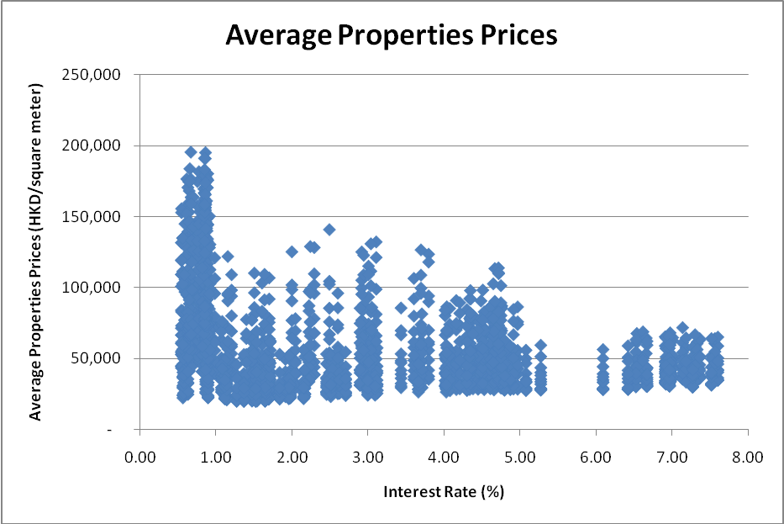
Regression Model 2 – Use Log₁₀ transformation for X and Y
$$\begin{aligned}\text{LogY}=α+β{\text{LogX}}_{1}+γ_{1}D_{1}+γ_{2}D_{2}+γ_{3}D_{3}+γ_{4}D_{4}+γ_{5}D_{5} \\ +δ_{1}({\text{LogX}}_{1}D_{1})+δ_{2}({\text{LogX}}_{1}D_{2})+δ_{3}({\text{LogX}}_{1}D_{3})+δ_{4}({\text{LogX}}_{1}D_{4})+δ_{5}({\text{LogX}}_{1}D_{5})\end{aligned}$$

The table below shows the Regression Statistics generated from Excel. Residual Plots for Regression model 2 are shown in Appendix II.
SUMMARY OUTPUT
Regression Statistics
Multiple R | 0.70858
R Square | 0.50209
Adjusted R Square | 0.49942
Standard Error | 0.15653
Observations | 2064
ANOVA
 | df | SS | MS | F | Significance F
Regression | 11 | 50.70123 | 4.60920276 | 188.1111 | 5.88E-301
Residual | 2052 | 50.27924 | 0.02450255
Total | 2063 | 100.9805
 | Coefficients | Standard Error | t Stat | P-value | Lower 95% | Upper 95% | Lower 95.0% | Upper 95.0%
Intercept | 4.7878 | 0.0114 | 421.7328 | 0.0000 | 4.7656 | 4.8101 | 4.7656 | 4.8101
Log10X1 | -0.2658 | 0.0234 | -11.3609 | 0.0000 | -0.3116 | -0.2199 | -0.3116 | -0.2199
D1 | 0.0451 | 0.0131 | 3.4433 | 0.0006 | 0.0194 | 0.0708 | 0.0194 | 0.0708
D2 | 0.1678 | 0.0131 | 12.7988 | 0.0000 | 0.1421 | 0.1935 | 0.1421 | 0.1935
D3 | 0.2432 | 0.0131 | 18.5485 | 0.0000 | 0.2174 | 0.2689 | 0.2174 | 0.2689
D4 | -0.0930 | 0.0114 | -8.1882 | 0.0000 | -0.1152 | -0.0707 | -0.1152 | -0.0707
D5 | -0.2382 | 0.0114 | -20.9845 | 0.0000 | -0.2605 | -0.2160 | -0.2605 | -0.2160
D1Log10X1 | 0.0057 | 0.0270 | 0.2108 | 0.8330 | -0.0473 | 0.0587 | -0.0473 | 0.0587
D2Log10X1 | -0.0145 | 0.0270 | -0.5380 | 0.5906 | -0.0675 | 0.0384 | -0.0675 | 0.0384
D3Log10X1 | -0.0112 | 0.0270 | -0.4151 | 0.6781 | -0.0642 | 0.0418 | -0.0642 | 0.0418
D4Log10X1 | -0.0303 | 0.0234 | -1.2935 | 0.1960 | -0.0761 | 0.0156 | -0.0761 | 0.0156
D5Log10X1 | 0.0944 | 0.0234 | 4.0340 | 0.0001 | 0.0485 | 0.1402 | 0.0485 | 0.1402

The resulting regression model is
$\text{LogY}=4\text{.}\text{7878-0}\text{.}\text{2658}{\text{LogX}}_{1}$$+0\text{.}\text{0451}D_{1}+0\text{.}\text{1678}D_{2}+0\text{.}\text{2432}D_{3}\text{-0}\text{.}\text{0930}D_{4}\text{-0}\text{.}\text{2382}D_{5}$$+0\text{.}\text{0057}({\text{LogX}}_{1}D_{1})\text{-0}\text{.}\text{0145}({\text{LogX}}_{1}D_{2})\text{-0}\text{.}\text{0112}({\text{LogX}}_{1}D_{3})\text{-0}\text{.}\text{0303}({\text{LogX}}_{1}D_{4})+0\text{.}\text{0944}({\text{LogX}}_{1}D_{5})$

Results from model 2 show that:
- Adjusted R² of 0.4994 indicates that less than half of the variable could be explained by the model. However, it is higher than that of Model 1 (0.4556) showing that the model has been improved with log transformation.
- The coefficient of LogX₁ is negative indicating that there is an inverse relationship between Log property prices and Log interest rate.
- The coefficient of D₁, D₂ and D₃ are all positive, implying that there is a positive relationship of property prices with class (size). Also, the coefficient of D₃ is higher than that of D₂ and the coefficient of D₂ is higher than that of D₁. This implies that the larger the size of the property, the larger the average price per m² of the property.
- The coefficients of D₄ and D₅ are all negative; indicating that the property prices located in Hong Kong Island is higher than that in Kowloon and the New Territories.
- F value in Model 2 (188.11) is higher than that in Model 1 (157.97), indicating that Model 2 has a higher significance.
- The residual plot Log₁₀X₁ suggests a convex parabola (“V” shape). This suggests that the interest rate changes continuously. In Regression Model 3, (Log₁₀X₁)² is also included in the model.
- The p-values for LogX₁D₁, LogX₁D₂, LogX₁D₃ and LogX₁D₄ are 0.833, 0.5906, 0.6781 and 0.196 respectively, which are much higher than the acceptance level of 0.05. This indicates that there are no correlations among the interest rate, class and location (LogX₁ and D_{i}’s). Thus, in Regression Model 3, those variables are removed.

Regression Model 3 – Add (Log₁₀X₁)² and Remove variable LogX₁D₁, LogX₁D₂, LogX₁D₃ and LogX₁D₄
$$\text{LogY}=α+β_{1}{\text{LogX}}_{1}+β_{2}({\text{LogX}}_{1})^{2}+γ_{1}D_{1}+γ_{2}D_{2}+γ_{3}D_{3}+γ_{4}D_{4}+γ_{5}D_{5}$$

The table below shows the Regression Statistics generated from Excel. Residual Plots for Regression model 3 are shown in Appendix III.
SUMMARY OUTPUT
Regression Statistics
Multiple R | 0.744694
R Square | 0.554569
Adjusted R Square | 0.553052
Standard Error | 0.14791
Observations | 2064
ANOVA
 | df | SS | MS | F | Significance F
Regression | 7 | 56.00063 | 8.00009 | 365.679 | 0
Residual | 2056 | 44.97984 | 0.021877
Total | 2063 | 100.9805
 | Coefficients | Standard Error | t Stat | P-value | Lower 95% | Upper 95% | Lower 95.0% | Upper 95.0%
Intercept | 4.7654 | 0.0086 | 556.8654 | 0.0000 | 4.7486 | 4.7822 | 4.7486 | 4.7822
Log10X1 | -0.5824 | 0.0219 | -26.5601 | 0.0000 | -0.6254 | -0.5394 | -0.6254 | -0.5394
(Log10X1)2 | 0.5317 | 0.0319 | 16.6628 | 0.0000 | 0.4691 | 0.5942 | 0.4691 | 0.5942
D1 | 0.0470 | 0.0092 | 5.1026 | 0.0000 | 0.0289 | 0.0650 | 0.0289 | 0.0650
D2 | 0.1631 | 0.0092 | 17.7079 | 0.0000 | 0.1450 | 0.1811 | 0.1450 | 0.1811
D3 | 0.2395 | 0.0092 | 26.0101 | 0.0000 | 0.2215 | 0.2576 | 0.2215 | 0.2576
D4 | -0.1028 | 0.0080 | -12.8881 | 0.0000 | -0.1184 | -0.0871 | -0.1184 | -0.0871
D5 | -0.2076 | 0.0080 | -26.0322 | 0.0000 | -0.2232 | -0.1920 | -0.2232 | -0.1920

The resulting regression model is
$$\begin{aligned}\text{LogY}=4\text{.}\text{7654-0}\text{.}\text{5824}{\text{LogX}}_{1}+0\text{.}\text{5317}({\text{LogX}}_{1})^{2}+0\text{.}\text{0470}D_{1}+0\text{.}\text{1631}D_{2}+0\text{.}\text{2395}D_{3} \\ \text{-0}\text{.}\text{1028}D_{4}\text{-0}\text{.}\text{2076}D_{5}\end{aligned}$$

Results from Model 3 show that:
- Adjusted R² of 0.55305 indicates more than half of variations could be explained by the model. It is higher than that of Model 1 (0.4556) and Model 2 (0.4994) showing that the model has been improved.
- The coefficient of LogX₁ is negative, indicating that there is an inverse relationship between Log property prices and Log interest rate.
- The coefficient of (LogX₁)² is negative, indicating that there is a positive relationship between Log property prices and the square of Log interest rate.
- The coefficients of D₁, D₂ and D₃ are all positive, implying that there is a positive relationship of property prices with class (size). Also, the coefficient of D₃ is higher than that of D₂ and the coefficient of D₂ is higher than that of D₁. This implies that the larger the size of the property, the larger the average price per m² of the property.
- The coefficients of D₄ and D₅ are all negative; indicating that the property prices located in Hong Kong Island is higher than that in Kowloon and the New Territories.
- F value in Model 3 (365.679) in Model 3 is higher than that in Model 2 (188.11) and Model 1 (157.97) indicating that Model 3 has a higher significance.
- The residual plot of Log₁₀X₁ and (Log₁₀X₁)² are flat at the horizontal axis. This suggests that the explanatory variables fully explain the change in parameter.
- All p-values are less than 0.05. They are all significant at the 95% confidence level.

CONCLUSION
The following table summarizes the adjusted R², largest p-value and standard error of three models. It shows that Model 3 has highest Adjusted R square, the least amount of largest p-value and lowest standard error. Thus, it is selected as the final model.
Regression Model | Model 1 | Model 2 | Model 3
Adjusted R Square | 0.455638 | 0.499420 | 0.553052
Largest p-value | 0.644202 | 0.833050 | 0.000000
Standard Error | 25026.716817 | 0.156533 | 0.147910

Final regression equation is:
$$\begin{aligned}\text{LogY}=4\text{.}\text{7654-0}\text{.}\text{5824}{\text{LogX}}_{1}+0\text{.}\text{5317}({\text{LogX}}_{1})^{2}+0\text{.}\text{0470}D_{1}+0\text{.}\text{1631}D_{2}+0\text{.}\text{2395}D_{3} \\ \text{ -0}\text{.}\text{1028}D_{4}\text{-0}\text{.}\text{2076}D_{5}\end{aligned}$$
where
- Y: Average Prices of Hong Kong Private Residential Property in Hong Kong Dollars per m²
- X_{1:} Interest Rate in percent per annum
- D₁, D₂, D₃, D₄ and D₅ are dummy regressors defined as follows.
Table 1 Dummy variables for Property Class
Class | D1 | D2 | D3
A | 0 | 0 | 0
B | 1 | 0 | 0
C | 0 | 1 | 0
D | 0 | 0 | 1
Table 2 Dummy variables for Location
Location | D4 | D5
Hong Kong Island | 0 | 0
Kowloon | 1 | 0
New Territories | 0 | 1

The above results show that average prices of Hong Kong residential property are negatively correlated with the interest rate and are positively correlated with the square of interest rate. Also, it shows that the larger the size of the property, the more expensive the average price per square meter. Besides, it also indicates that the average prices of property are higher in Hong Kong Island when compared with Kowloon and the New Territories.

Appendix I
Residual Plots for Regression Model 1 are shown below.
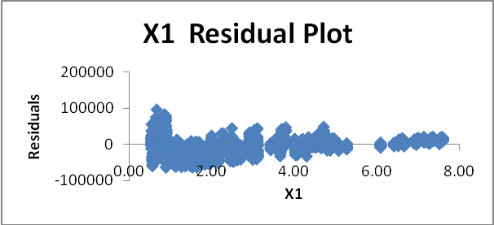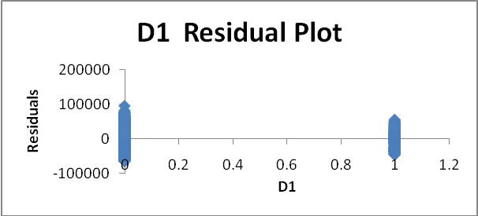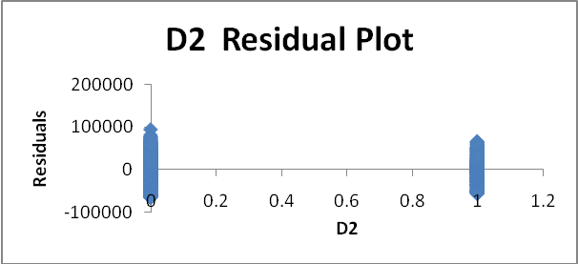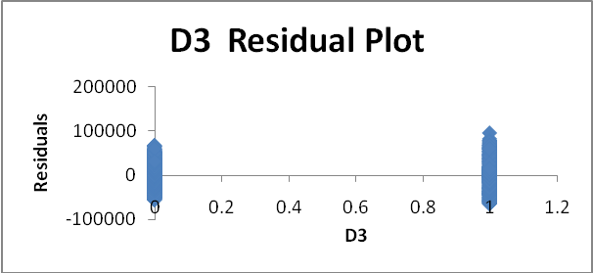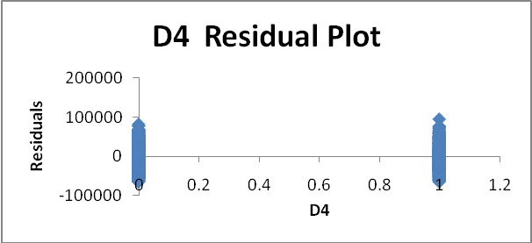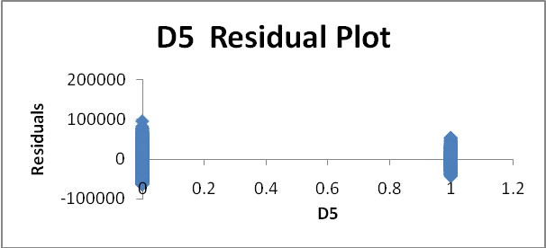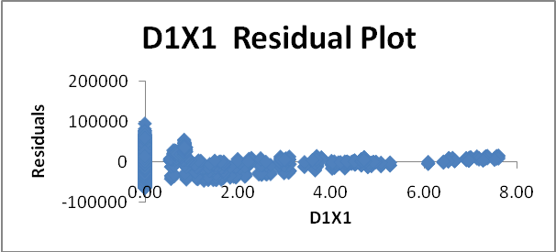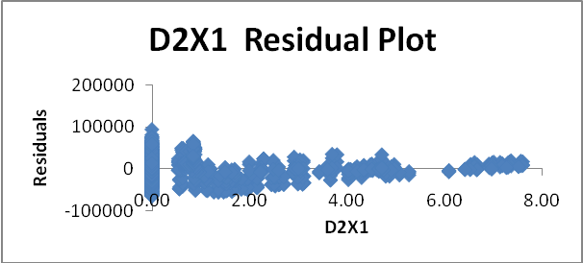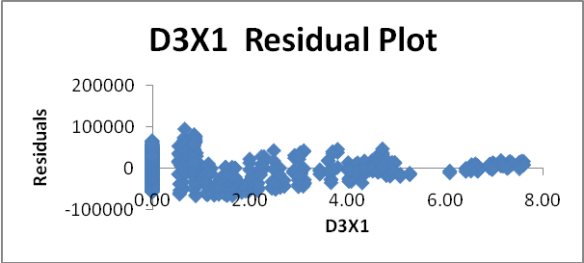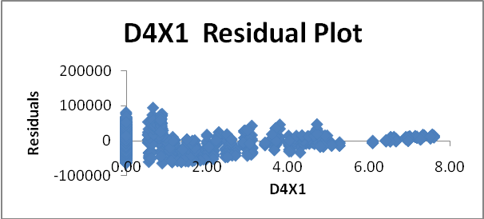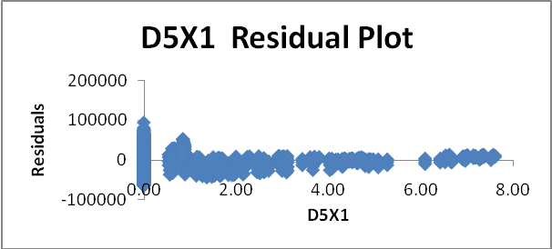

Appendix II
Residual Plots for Regression Model 2 are shown below.
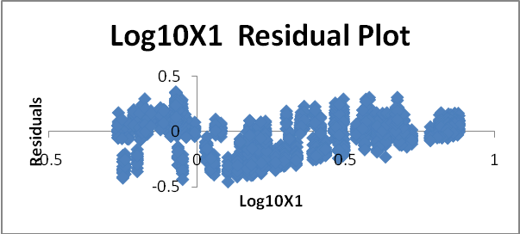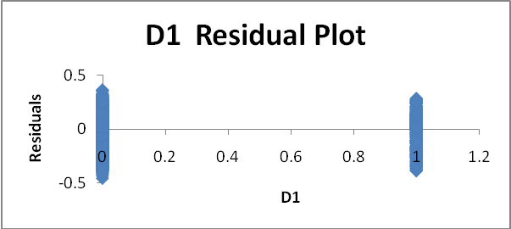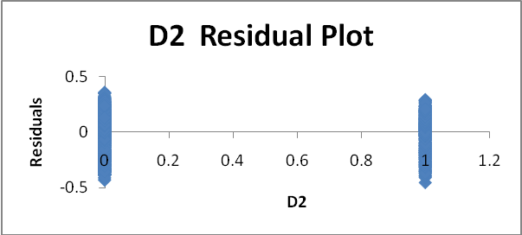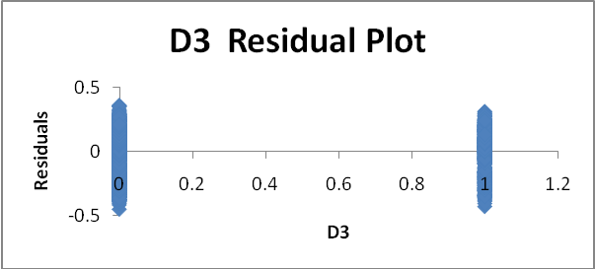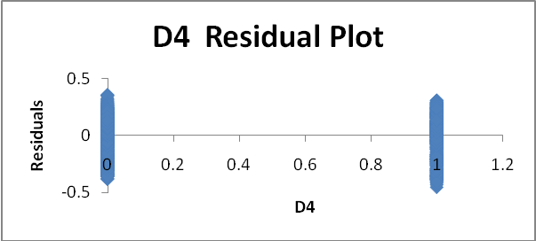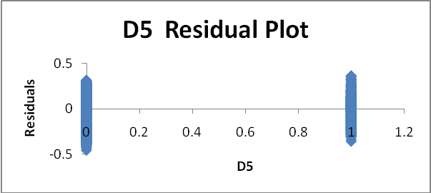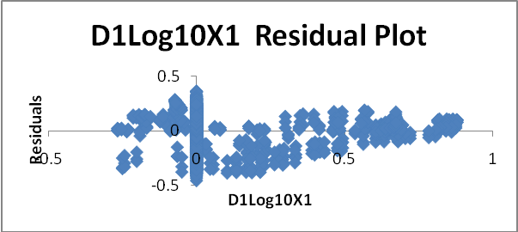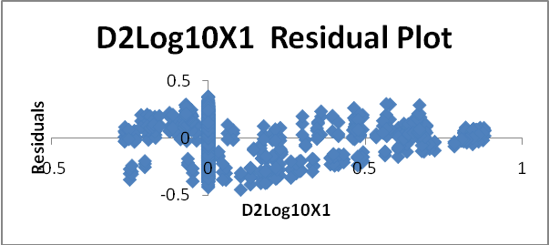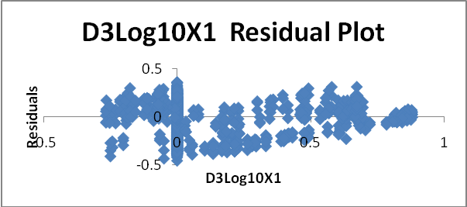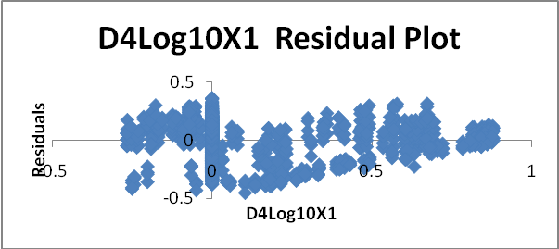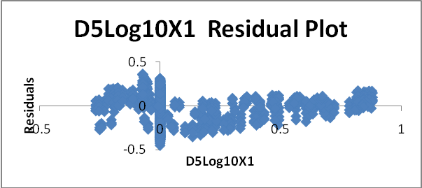

Appendix III
Residual Plots for Regression Model 3 are shown below.
