Time Series Project

Analysis of Chinese urban-rural income gap
based on ARMA model

Session: Summer 2012
Submitted by: xxxxx xxxxxxxxxx
1. Introduction
Since reform and opening, China’s economy develops rapidly, creating the world’s economic miracle. With the rapid economic growth, the overall level of income of urban and rural residents in China has greatly improved. However, it is an indisputable fact that the income differential between urban and rural residents continues to expand. This differential is not only far higher than other countries, but also are great possibilities of further expansion in future years. This trend had made a negative impact on China’s social and economic development, it is not only adverse to the further-sustained development of the national economy, resulting in insufficient domestic demand, but also adverse to social stability and a harmonious socialist society construction. We must pay close attention to it.
This article is based on China’s macro economic data from 1978 to 2011 as sample, and uses ARMA model to analysis and predicts the income differential between urban and rural residents.
2. Data
2.1 The raw data
According to China Statistical Yearbooks, the China's per capita disposable income of urban residents and rural residents from 1978 to 2011 are listed below.
Table 1: The raw income data of urban residents and rural residents (Unit: yuan)
Year | Per capita disposable income |  | X_{t}
Year | Urban residents | Rural residents | X_{t}
1978 | 343 | 134 | 210
1979 | 387 | 160 | 227
1980 | 478 | 191 | 286
1981 | 492 | 223 | 269
1982 | 527 | 270 | 257
1983 | 564 | 310 | 254
1984 | 651 | 355 | 296
1985 | 739 | 398 | 342
1986 | 900 | 424 | 476
1987 | 1,002 | 463 | 540
1988 | 1,181 | 545 | 637
1989 | 1,374 | 602 | 772
1990 | 1,510 | 686 | 824
1991 | 1,701 | 709 | 992
1992 | 2,027 | 784 | 1,243
1993 | 2,577 | 922 | 1,656
1994 | 3,496 | 1,221 | 2,275
1995 | 4,283 | 1,578 | 2,705
1996 | 4,839 | 1,926 | 2,913
1997 | 5,160 | 2,090 | 3,070
1998 | 5,425 | 2,162 | 3,263
1999 | 5,854 | 2,210 | 3,644
2000 | 6,280 | 2,253 | 4,027
2001 | 6,860 | 2,366 | 4,493
2002 | 7,703 | 2,476 | 5,227
2003 | 8,472 | 2,622 | 5,850
2004 | 9,422 | 2,936 | 6,485
2005 | 10,493 | 3,255 | 7,238
2006 | 11,760 | 3,587 | 8,173
2007 | 13,786 | 4,140 | 9,646
2008 | 15,781 | 4,761 | 11,020
2009 | 17,175 | 5,153 | 12,022
2010 | 19,109 | 5,919 | 13,190
2011 | 21,810 | 6,977 | 14,833
Data Resource: China Statistical Yearbooks
Subtract the income data of urban residents and rural residents above，we can get the urban-rural income gap sequence X_{t} , Its trend shows in Figure 1.
Figure 1 Urban-rural income gap sequence
It can be seen from Figure 1 that the urban-rural income gap of China (X_{t}) has an obvious upward trend, and X_{t} is a typical non-stationary sequence。
2.2 Data pre-processing
Since the original series exhibits linear trend, we choose first order difference. Assuming the first order difference sequence is expressed as:
The time sequence of shows that first order difference is relatively stable volatility near the mean. In order to further determine the stationary，we draw the autocorrelation diagram of which shows in figure 2 below：
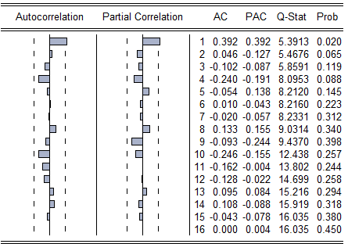
Figure 2 Autocorrelation and partial correlation diagram of
From figure 2 we can know that the autocorrelation diagram of shows strong correlation，so we can infer that is a stationary sequence. We can also know is non-white noise sequence from the P value of Q statistic。
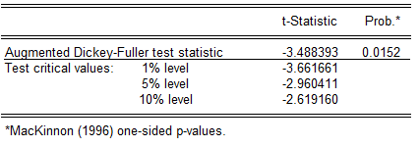
Figure 3 ADF test result
Figure 3 is the ADF test results of , we accept as a stationary sequence at 95% confidence level.
3. Model Construction
3.1 Model structure and parameter estimation
For ARMA(p，q) model, we can use the sample autocorrelation and partial correlation diagram to determine the model structure. Since the sample autocorrelation and partial correlation diagram of are not censored，we consider ARMA(1,4) to fitting the first order sequence.
Figure 4 is the parameter estimation result of ARMA(1,4) model:
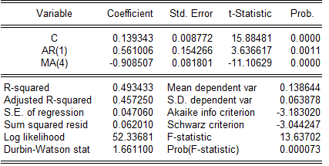
Figure 4 Parameter estimation result
3.2 Model significant test
After we build the ARMA model, we need to prove the residual is a white noise sequence. The autocorrelation and partial correlation diagram of residuals shows the P value of Q statistic are far greater than 0.05，so we infer the residual sequence is a white noise sequence , the model is fully extracted.
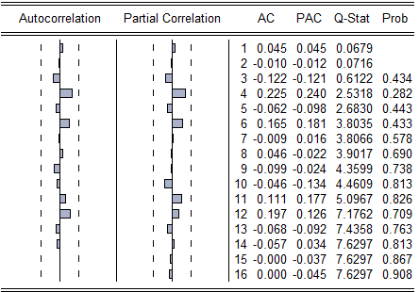
Figure 5 Autocorrelation and partial correlation diagram of residuals
The final fitted model is：
3.3 Model forecasting
From table 1 we know the actual urban-rural income gap of China is 14,833 in 2011, the forecasting value is 14,960. The deviation ratio between actual value and forecasting value is 0.86%. So we can believe the established model has a good effect in prediction。
4. Conclusion
This article is based on China’s macro economic data from 1978 to 2011 as sample, and uses ARMA model to analysis and predicts the income differential between urban and rural residents. The results show that the established model has a good effect in prediction。
5. Appendix

