Regression Analysis – Happiness Index
Summer, 2013
Name: xxx-xxxxx, xx
I. Introduction
How do we define happiness? The Organization for Economic Cooperation and Development (OECD) creates Better Life Index (BLI) to measure happiness, it includes several factors, like: housing, income, jobs, education, environment and health care to examine the areas that impact people's lives. As a result, with reference to BLI’s 11 topics, Directorate-General of Budget, Accounting and Statistics (DGBAS) in R.O.C(Taiwan) starts to develop National Well-being Indicators (NWI). And the objective of this project is to analyze the NWI in Taiwan, using a regression model to examine each variable.

II. Data Resources
The data was downloaded from Taiwan DGBAS website, which used many factors to analyze NWI (http://happy_index.dgbas.gov.tw/local.htm), for more detailed topics and indicators, please refer to Attachment 1. And for other countries, the data was acquired from OECD, the Better Life Index (http://www.oecdbetterlifeindex.org/). In this project, I will use Year 2013 to analyze; meanwhile, use 34 OECD member countries and Brazil, Russia, plus Taiwan, to represent.

- Response Variable (Y) : Better Life Indicator (BLI).

- Explanatory variables (Xi) :
- X1 = Housing expenditure (%) [Housing Condition]
- X2= Household financial wealth ($) [Income and Wealth]
- X3= Personal earnings ($) [Jobs and Earnings]
- X4= Educational attainment (%) [Education and Skills]
- X5= Water quality (%) [Environmental quality]
- X6= Vote turnout (%) [Civic engagement and governance]

(Please refer to Attachment 2 to see the table extracted from OECD.Stat.)

III. Regression Model Analysis
Regression Model 1 : Y = α + β₁X₁ + β₂X₂ + β₃X₃ + β₄X₄+ β₅X₅+ β₆X₆
- Scatter Plot of BLI versus Explanatory variables (Xi) :
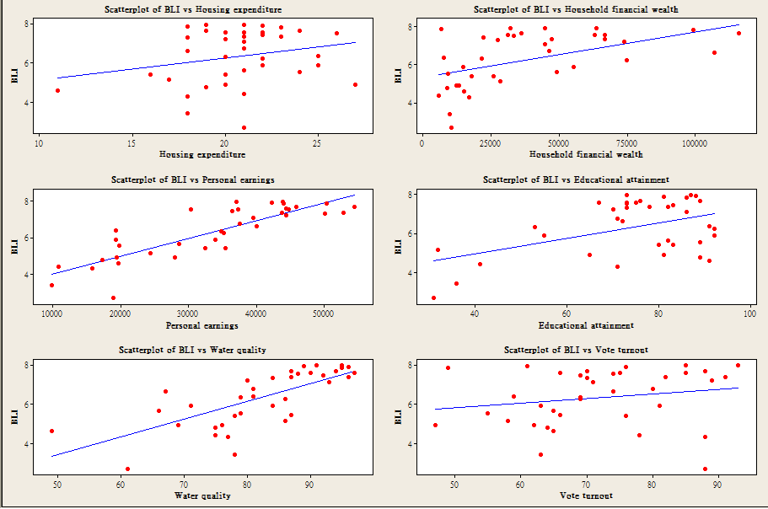
- Histogram (with Normal Curve) :
- Residual Plots for BLI :
- ANOVA :
ANOVA
 | df | SS | MS | F | Significance F
Regression | 6 | 61.49703 | 10.24951 | 31.56216 | 1.13104E-11
Residual | 30 | 9.74221 | 0.32474
Total | 36 | 71.23924
 | Coefficients | Standard Error | t - Stat | P-Value | Lower 95% | Upper 95%
Intercept | -1.8891 | 1.1765 | -1.6057 | 0.1188 | -4.2917 | 0.5136
Housing expenditure | 0.0319 | 0.0343 | 0.9299 | 0.3599 | -0.0381 | 0.1019
Household net financial wealth | 0.0000 | 0.0000 | 0.2106 | 0.8346 | 0.0000 | 0.0000
Personal Earnings | 0.0001 | 0.0000 | 4.2080 | 0.0002 | 0.0000 | 0.0001
Educational attainment | 0.0188 | 0.0064 | 2.9461 | 0.0062 | 0.0058 | 0.0319
Water quality | 0.0437 | 0.0118 | 3.7044 | 0.0009 | 0.0196 | 0.0679
Voter turnout | 0.0057 | 0.0092 | 0.6258 | 0.5362 | -0.0130 | 0.0245

The regression equation is
BLI = - 1.89 + 0.0319 Housing expenditure + 0.000001 Household financial wealth
+ 0.000063 Personal earnings + 0.0188 Educational attainment
+ 0.0437 Water quality + 0.00575 Vote turnout
Regression Model 2 : Y = α+ β₁X₁ +β₃X₃ + β₄X₄+ β₅X₅+ β₆X₆
From Regression Model 1, we find the “Household net financial wealth” has the highest P-value of 0.8346 and the lowest absolute t-Stat value of 0.2106, therefore, we delete this factor (X₂₎ and run the regression again in order to get lower Adjusted R Square.
- Residual Plots for BLI :
- ANOVA :
ANOVA
 | df | SS | MS | F | Significance F
Regression | 5 | 61.48263 | 12.29653 | 39.07013 | 1.73601E-12
Residual | 31 | 9.75662 | 0.31473
Total | 36 | 71.23924
 | Coefficients | Standard Error | t - Stat | P-Value | Lower 95% | Upper 95%
Intercept | -1.8451 | 1.1398 | -1.6188 | 0.1156 | -4.1698 | 0.4796
Household net financial wealth | 0.0325 | 0.0336 | 0.9662 | 0.3414 | -0.0361 | 0.1011
Personal Earnings | 0.0001 | 0.0000 | 6.2813 | 0.0000 | 0.0000 | 0.0001
Educational attainment | 0.0188 | 0.0063 | 2.9876 | 0.0055 | 0.0060 | 0.0316
Water quality | 0.0430 | 0.0111 | 3.8868 | 0.0005 | 0.0204 | 0.0655
Voter turnout | 0.0054 | 0.0089 | 0.6067 | 0.5485 | -0.0127 | 0.0235
The regression equation is
BLI = - 1.845 + 0.0325 Housing expenditure + 0.000065 Personal earnings
+ 0.0188 Educational attainment + 0.0430 Water quality
+ 0.00539 Vote turnout
IV. Conclusion
Regression Model  Comparison : | Model 1 | Model 2
Multiple R | 0.92911 | 0.92900
R Square | 0.86325 | 0.86304
Adjusted R Square | 0.83590 | 0.84095
Standard Error | 0.56986 | 0.56101
From the result, we succeed in increasing the Adjusted R Square and decreasing the Standard Error from Model 1 to Model 2. Therefore, we could interpret that the Household financial wealth isn’t the key factor, maybe just like the old saying goes that ‘Money can’t buy happiness’.

