Time Series
Summer 2012
Student Project
Modeling Taiwan life expectancy from 1970-2012

Introduction:
Population ageing is now recognised as a global issue of increasing importance, and has many implications for health care and other areas of social. The recent and life expectancy rises have been a major component in political discussions on the national health care system, immigration, social security.
In this project, I sought to understand the time series model that can best describe the Taiwan life expectancy rise.
Taiwan life expectancy data is available from Department of Household Registration, M.O.I (http://sowf.moi.gov.tw/stat/Life/quary-1age.htm#taiwan-a-title.gif).

Model Specification:
I first plotted the life expectancy from 1970-2012, as shown below.
Figure 1: Time Serious Plot of the life expectancy

There is an significant upward trend in the life expectancy and I have a good reason to believe that trend would persist after 2012.

To help in selecting a tentative model, I then calculate the sample autocorrelation function (“ACF” as described in the following equation) of the original data by different lags and plot the correlograms.
$$r_{k}=\frac{\sum_{t=k+1}^{n}{\left(Y_{t}−\overline{Y}\right)\left(Y_{t−k}−\overline{Y}\right)}}{\sum_{t=1}^{n}{{\left(Y_{t}−\overline{Y}\right)}^{2}}}$$
The corresponding correlograms was produced and can be seen here:
Figure 2 : Autocorrelation graph
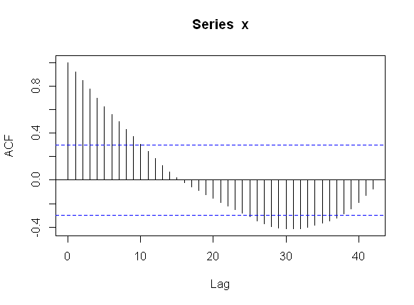
Looking at the Figure 1: Time Serious Plot of the population and Figure 2 : Autocorrelation graph above, it is highly unlikely that the series is a MA (q) since the ACF did not reduce to zero quickly enough. For MA(q), r_{k} equals zero when k>q. From our data, we didn’t observe a sudden drop in r_{k}, but rather it decreased gradually and changed the sign, displaying a damped sine function.
It is possible that this represents an AR(q) time series, since the correlation steadily decreases until negative, then rises back up. I suspect that it could be represented by an AR(1) or AR (2) process.
Model fitting:

AR(1)
Regression Statistics
Multiple R |  | 0.9965
R Square |  | 0.9930
Adjusted R Square |  | 0.9928
Standard Error |  | 0.2282
Observations |  | 42
ANOVA
 | df | SS | MS | F | Significance F
Regression | 1 | 296.4178 | 296.4178 | 5692.305 | 9.42E-45
Residual | 40 | 2.082937 | 0.052073
Total | 41 | 298.5007
 | Coefficients | Standard Error | t Stat | P-value | Lower 95% | Upper 95%
θ₀ | 0.9405 | 0.940507 | 0.999966 | 0.323338 | -0.96036 | 2.841312
φ₁ | 0.9901 | 0.013123 | 75.44737 | 9.42E-45 | 0.963587 | 1.016632

AR(2)
Regression Statistics
Multiple R |  | 0.9964
R Square |  | 0.9927
Adjusted R Square |  | 0.9923
Standard Error |  | 0.2301
Observations |  | 41
ANOVA
 | df | SS | MS | F | Significance F
Regression | 2 | 274.2475 | 137.1237 | 2589.322 | 2.43E-41
Residual | 38 | 2.012381 | 0.052957
Total | 40 | 276.2599
 | Coefficients | Standard Error | t Stat | P-value | Lower 95% | Upper 95%
θ₀ | 0.5880 | 0.999458 | 0.588368 | 0.559766 | -1.43525 | 2.611345
φ₁ | 1.0208 | 0.162932 | 6.265275 | 2.46E-07 | 0.690974 | 1.35065
φ₂ | -0.0260 | 0.161179 | -0.16104 | 0.872915 | -0.35225 | 0.300333

Model Diagnostic
Firstly, it can be noted that the adjusted R² statistic is almost equal to 1 in all 2 models. This implies all 2 models would be a good fit to the data.

The residual plot is shown in Figure 3 ~ Figure 4. We can see that the model fitted the data very well.

Figure 3:Residules from AR(1) model
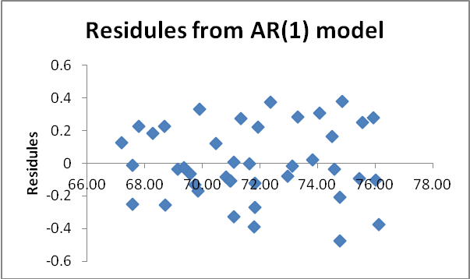

Figure 4:Residules from AR(2) model
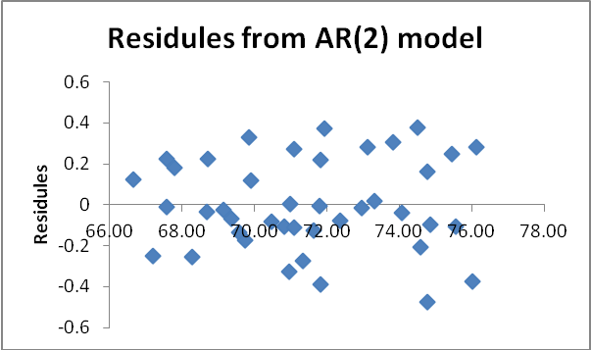

Conclusion:
Based on the analysis, Taiwan life expectancy for the past 43 years can be best modeled by an AR(1) or AR(2) model. MA(q) models were not good candidates for this specific time series because of the characteristics of the data.
Simple is best, so I recommend AR(1) model.( $Y_{t}=0\text{.}\text{9405}+0\text{.}\text{9901}Y_{t−1}+ε_{t}$). We than can use that model to forecast future Taiwan populations. The 2013 forecast is 0.9405+0.9901*76.41=76.59.

