Introduction

Thailand is one of developing countries that is located in south-east Asia. Most of Thai population still living in rural area are farmers who work in agricultural sector that producing food. For Thai Life Insurance, more than half of insurance premiums came from customers who are in this agricultural section. And recently this customer group has many more power to buy insurance than metropolitan customers do. Thus we need to know how richer our customers get or how many new business premiums that corporate should target for this customer group for the next coming year.

The purpose of this project is to consider various time series models for forecasting Thailand food production index, select the one that is most appropriate, and then use that model to forecast food production index.

Data Analysis

I first plotted Thailand food production Index from 1961-2011, as shown below.
Figure 1: Time Serious Plot of Thailand food production Index
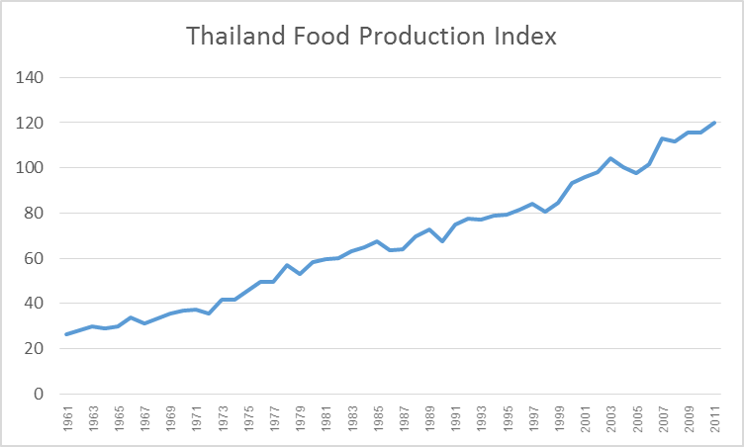

Data Source website (http://www.wordbank.or.th)

In the chart, there is increasing trend but non seasonal in 1996-2011. To help in selecting a tentative model, I plot the correlograms the sample autocorrelation function and partial autocorrelation function of the original data by different lags, as shown below.

Figure 2 : Sample autocorrelation graph

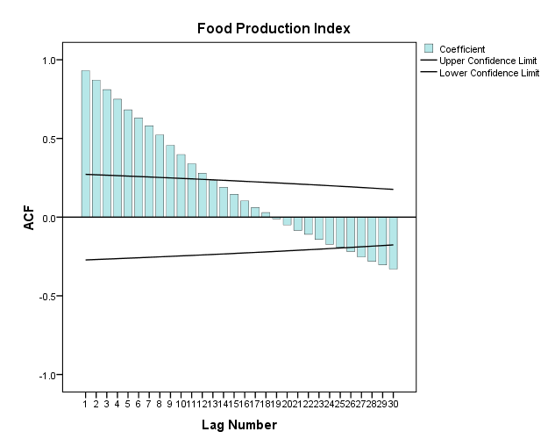
Figure 3 : Partial autocorrelation graph
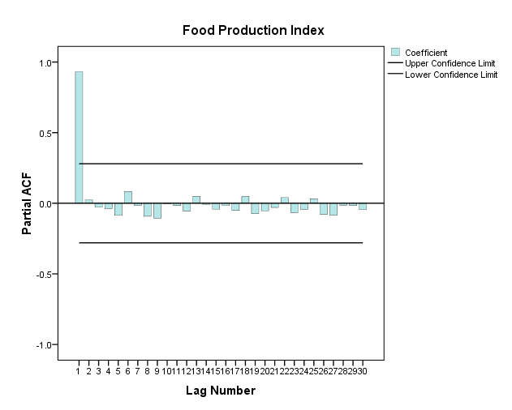

Looking at the Figure 2 : Autocorrelation graph above, it is decreased to 0 ,so the same as Exponential distribution but Partial Autocorrelation graph has only lag 1 (Figure 3)
It is possible that this represents an AR(q) time series, since the correlation steadily decreases until negative, then rises back up. I suspect that it could be represented by an AR(1).

Model Fitting

Our data analysis led us to fit a model to the AR(1) SPSS tool was used and the results for each are summarized below:

Model Statistics
Model | Number of Predictors | Model Fit statistics | Ljung-Box Q(18) |  |  | Number of Outliers
Model | Number of Predictors | Stationary R-squared | Statistics | DF | Sig. | Number of Outliers
FoodProduction-Model_1 | 1 | .987 | 15.534 | 17 | .557 | 0

ARIMA Model Parameters
 |  |  |  |  | Estimate | SE | t | Sig.
FoodProduction-Model_1 | Food Production | No Transformation | Constant |  | -673.644 | 24.360 | -27.654 | .000
FoodProduction-Model_1 | Food Production | No Transformation | AR | Lag 1 | .536 | .123 | 4.348 | .000

Model : Yt = 0.536Y_{t-1} – 673.644 + E_{t}

Figure 4 : Residual of autocorrelation and Residual of partial autocorrelation
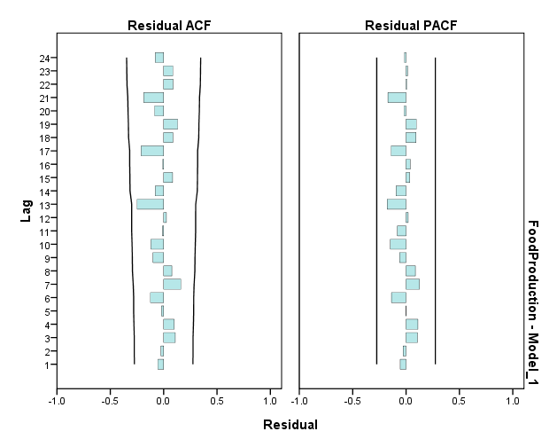

The residual plot is shown in Figure 4. We can see that the model fitted the data very well.

Forecasting
The selected model was used to forecast future food production index results for the period 1961 to 2011. The graph below illustrates that the model performed moderately well for forecasting future food production index.

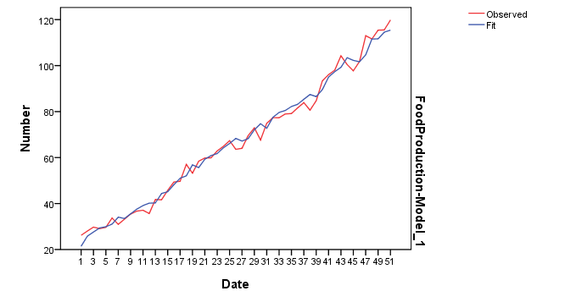

Conclusion:

To forecast future Thailand food production Index, based on data analysis for the past 51 years from 1961 to 2011, we can best apply with time series model as an AR(1) Model Yt = 0.536Y_{t-1} – 673.644 + E_{t}

