STUDENT PROJECT FOR NEAS VEE - TIME SERIES

Subject: Death caused by Cancer in South Korea
Name: xxxxxx xxx

- Introduction
Cancer is a broad group of diseases involving unregulated cell growth. There are over 200 different known cancers that affect humans. The chances of surviving the disease vary greatly by the type and location of the cancer and the extent of disease at the start of treatment. In 2007, cancer caused about 13% of all human deaths worldwide. Rates are rising as more people live to an old age and as mass lifestyle changes occur in the developing world. This project attempts to perform a time series analysis of the death by cancer in Korea

- Data
The data for this project is obtained from Statistics information system of Korea (web address: http://www.index.go.kr/potal/main/EachDtlPage.do). The study includes 30 years of data from 1983 to 2012.

The following Graph below displays the movement of the number of death caused by cancer during the period. It is shown upward direction which implied non-stationary.

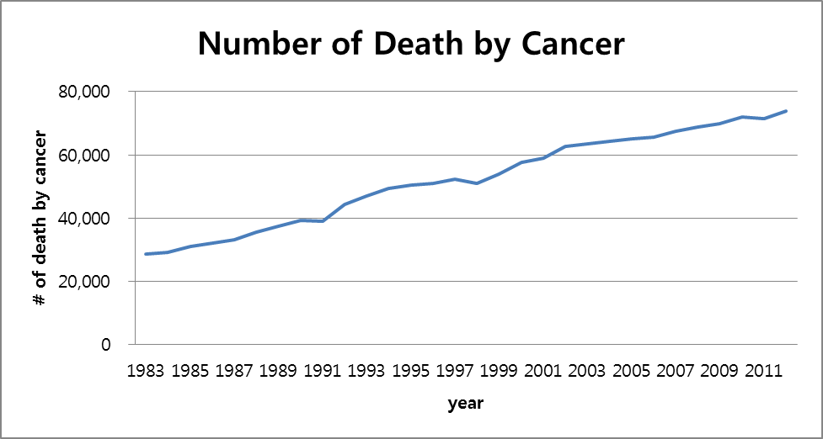

- Analysis
We can observe from the graph that the death caused by cancer demonstrates an upward trend over time and therefore nonstationary. To confirm this, we will compute the sample autocorrelation function (“ACF”) at different lags using the following formula:

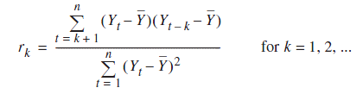
The subsequent correlogram plots the calculated ACF versus lag k:
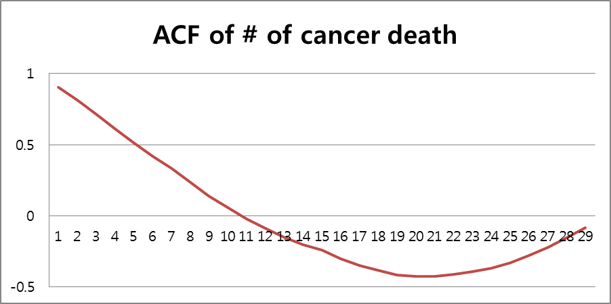

The illustration above shows that the ACF becomes less than zero starting lag 11, proving nonstationarity. We now proceed with obtaining stationarity through differencing.
FIRST DIFFERENCE
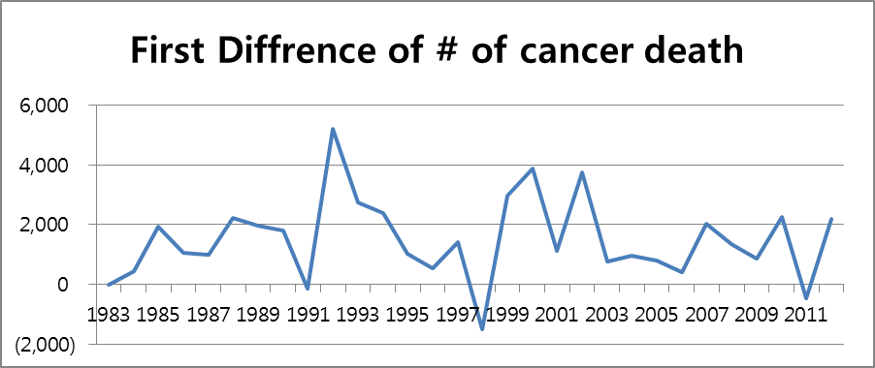

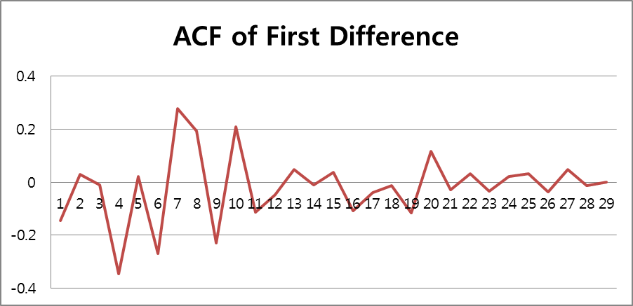

SECOND DIFFERENCE
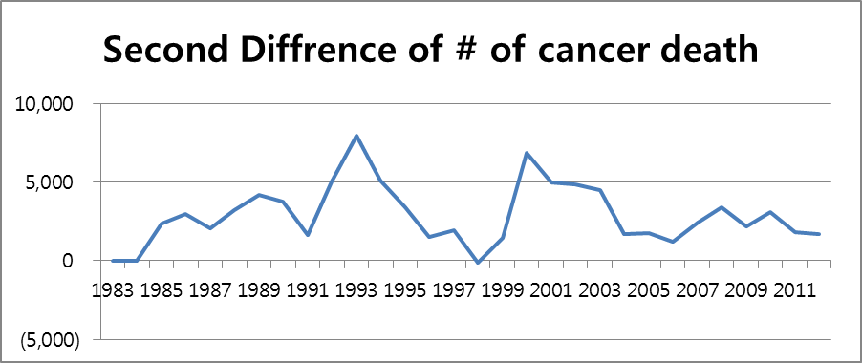

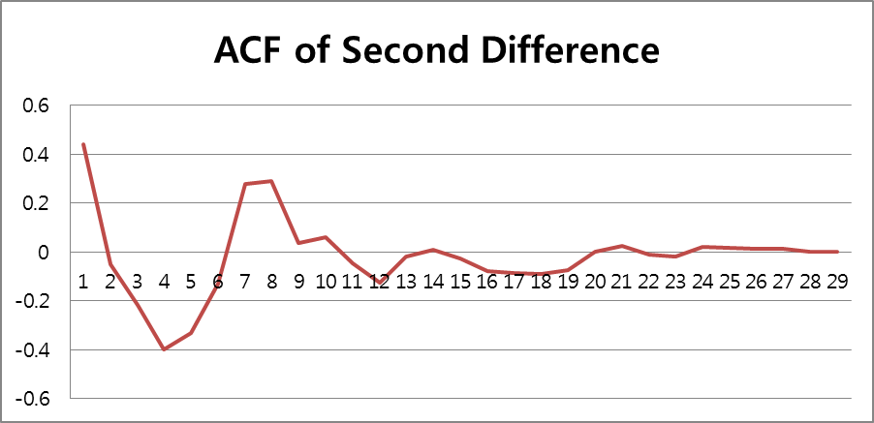

Comparing the R-Square for both models, we see that they are all quite close to 1. AR(1) has better R-Square than AR(2).

- Conclusion
In conclusion, AR(1) model of Yt = 2193.049954 + 0.98751969Yt-1 is adopted. Using this model, we can project the number of cancer death throughout the same period and compare it with the actual one as below.
