xxxxxxxx xxxxxxx
Summer 2010
Time Series

Time Series Project

Part 1: Data and Objective

I looked at the stability of Treasury bill interest rates over time. I took the actual interest rates along with actual inflation (calculate from the non-seasonal CPI index) and calculated the real interest rate. This was done by subtracting the inflation rate from the nominal interest rate to remove the impact of inflation so a comparison of interest rates over time could be performed. To achieve the highest accuracy I used almost all available data (January 1960 – August 2001). I excluded data post August 2001 because there is a time period from September 2001 through May 2008 where there is no data available. For the purposes of this exercise, I deemed it to be acceptable to cut off the data at August 2001 despite more recent data being available (June 2008-March 2014). Below is a graph of the monthly real interest rates:

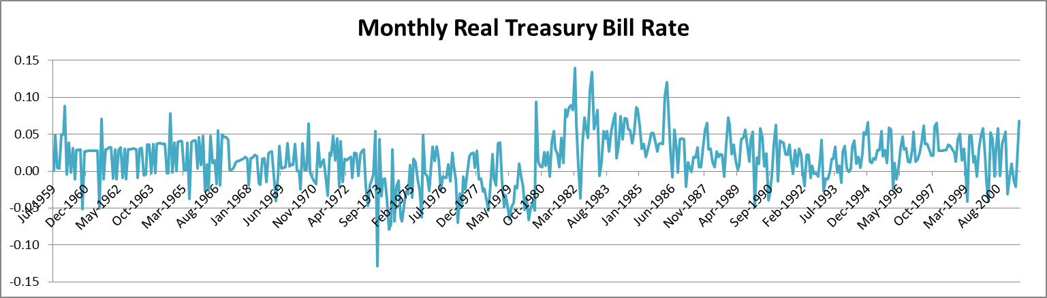

To remove the seasonality seen here, I used a 12-month average of both the nominal interest rate and the inflation rate to find the yearly real interest rate:

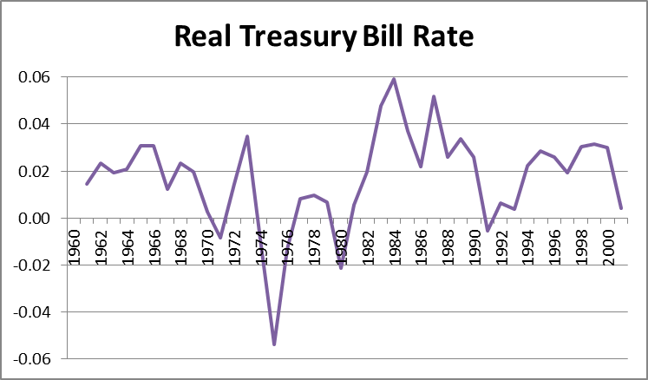

Part 2: Techniques and Results

Using the techniques described in the instructions, I calculated the correlation, correlogram adjusted for degrees of freedom and the auto-correlation. The graphs can be found on the ‘Correlation Charts’ tab in the excel workbook. The correlation graph fluctuates quite a bit; however, it is smoothed out by adjusting it for degrees of freedom as shown below:

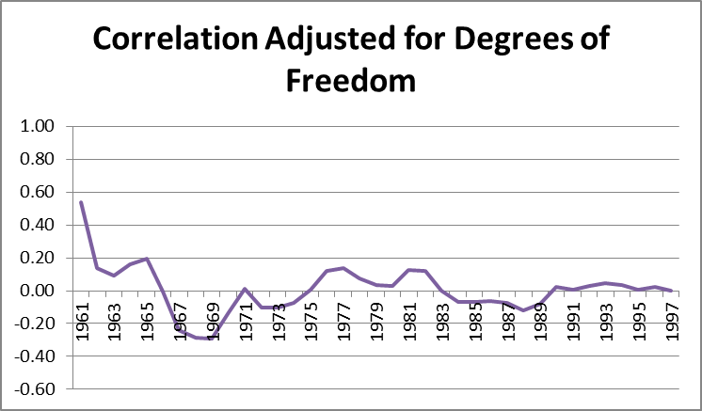

Auto-correlation graph:

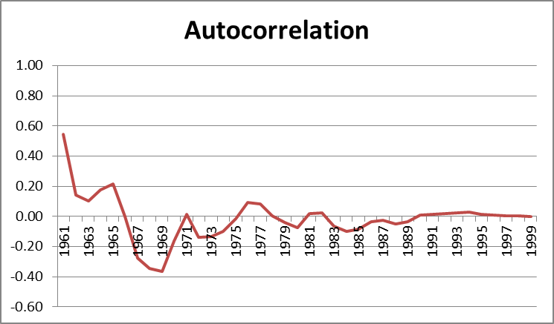

The auto-correlation vs. the time lag drops off dramatically immediately then hovers around zero. This is evidence that the first difference of the real interest rate (AR(1)) is stationary. According to the text (Econometric Models and Economic Forecasts), the fact that the autocorrelation function is so close to zero for most of the lags indicates that the process is most likely a white noise process which cannot be forecasted using a model.

Subsequent this, I tested for serial correlation using the Durbin-Watson test as the text feels it is the most popular and widely used test. Using both the regression add-in function in excel as well as the posted instructions. I calculated the Durbin-Watson statistic using the real interest rates. A DW statistic near 2 indicates no first-order serial correlation. A value below 2 indicates positive correlation and above 2 indicates negative correlation. The DW statistic I calculated was 1.704 indicating very slight positive correlation but most likely a white-noise process.

From both the autocorrelation and the Durbin-Watson test I formed a hypothesis that the real interest rates form a white-noise process and cannot be forecasted using a time-series model. I calculated the Box-Pierce Q statistic to test this hypothesis. Depending on the degrees of freedom and the confidence interval, if the Q-statistic is less than the specific number in the Box, then it is a white noise process. I used 40 observations so I had 39 degrees of freedom. The Q-statistic is approximately distributed as a chi-square distribution with K-p-q degrees of freedom. The critical value for the chi-square with 39 degrees of freedom and .5% significance is 20.71. Thus, the Q-statistic of 14.0 was below the Χ² values and therefore I cannot reject my hypothesis that this is a white noise process.

