Student Name: xxxx xx
Course: Regression Analysis
Semester: Summer 2013
Research on Life Insurance Premium Income in China
Introduction
During the thirty years since liberalization in 1978, China economy had a rapid growth. At the same time, the level of people's income is also increasing, more and more people buy life insurance for themselves and their families.
The purpose of this project is to study the relationship between life insurance premium income and economic development and the population. I will complete this project based on the cross-section data of 31 provinces in China.
Per capita Gross Regional Product is often used as a measure of a region’s economic development, and this data is very easy to get. So I choose Per capita Gross Regional Product as one of the explanatory variables in my regression model. The other explanatory variable is population, which is also easy to find. The response variable is life insurance premium income. The regression equation is:
Y_{i} = α + β₁ × X_{1i} + β₂ × X_{2i} + ε_{i}
Where:
Y is life insurance premium income
X₁ is Per capita Gross Regional Product
X₂ is Population
Data
- The data of life insurance premium income is from China Insurance Regulatory Commision:
http://www.circ.gov.cn/web/site0/tab5205/info234404.htm
- The data of Per capita Gross Regional Product in China and population by region is from China Statistical Yearbook 2013:
http://www.stats.gov.cn/tjsj/ndsj/2013/indexch.htm
I summarize the data in the table below:
Region | Premium Income in 2012  (CNY billion) | Per Capita Gross Regional Product in 2012  (CNY thousand) | Population  in 2012  (million persons)
Beijing | 55.43 | 87.48 | 20.69
Tianjin | 12.70 | 93.17 | 14.13
Hebei | 45.90 | 36.58 | 72.88
Shanxi | 23.41 | 33.63 | 36.11
Inner Mongolia | 10.95 | 63.89 | 24.90
Liaoning | 31.78 | 56.65 | 43.89
Jilin | 13.82 | 43.42 | 27.50
Heilongjiang | 21.96 | 35.71 | 38.34
Shanghai | 48.24 | 85.37 | 23.80
Jiangsu | 76.59 | 68.35 | 23.80
Zhejiang | 47.05 | 63.37 | 54.77
Anhui | 25.79 | 28.79 | 59.88
Fujian | 25.48 | 52.76 | 37.48
Jiangxi | 15.52 | 28.80 | 45.04
Shandong | 65.39 | 51.77 | 96.85
Henan | 59.55 | 31.50 | 94.06
Hubei | 35.73 | 38.57 | 57.79
Hunan | 28.36 | 33.48 | 66.39
Guangdong | 97.07 | 54.10 | 105.94
Guangxi | 12.43 | 27.95 | 46.82
Hainan | 3.08 | 32.38 | 8.87
Chongqing | 20.70 | 38.91 | 29.45
Sichuan | 48.31 | 29.61 | 80.76
Guizhou | 6.84 | 19.71 | 34.84
Yunnan | 11.62 | 22.20 | 46.59
Tibet | 0.10 | 22.94 | 3.08
Shaanxi | 22.36 | 38.56 | 37.53
Gansu | 9.08 | 21.98 | 25.78
Qinghai | 1.32 | 33.18 | 5.73
Ningxia | 2.87 | 36.39 | 6.47
Xinjiang | 11.37 | 33.80 | 22.33
Below is the scatter plot of Per capita Gross Regional Product versus life insurance premium income: we can see that some regions with higher per capita GRP like Tianjin, their premium income is low. The reason is that population in these regions is small. In other regions such as Guangdong, its per capita GRP is moderate, but it has the most premium income. The reason is that Guangdong is the most populous province in China.
Tianjin
Guangdong
Below is the scatter plot of population versus life insurance premium income: we can see that there is an obvious linear relation between population and premium income, namely, the more population the more premium income. Of course, there are a few exceptions, such as Shanghai. Shanghai is one of the most developed regions in China, its population is not large, but its premium income is high.
Shanghai
Model Estimation
I use Excel and get the following results:
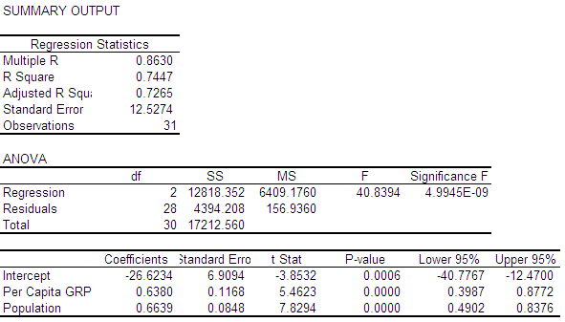
So the regression equation is:
Y = -26.6234 + 0.638X₁ + 0.6639X₂
Analysis
- R²
The R² for this model is 0.7447, which indicates that 74.47% of the error is explained by the regression. Moreover, it also shows that the regression equation fit better.
- Correlation analysis
Below table is the correlation relationship between the two explanatory variables. We can see that there is not significant correlaton between the two variables.
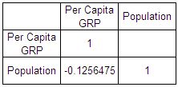
- T-test
I use Excel to calculate the critical value of t distribution at 5% significant level, the excel function is TINV(0.05, 28) = 2.048. 28 is degrees of freedom, which is n-k-1 = 31-2-1=28.
From the above Excel output, we know that t statistic for α, β₁ and β₂ are -3.8532, 5.4623 and 7.8294 respectively. Their absolute value are all higher than the above critical value 2.048, so they are all significant at 5% level and we should not remove any variables from the regression model. In addition, we also can reject the null hypothesis that α = 0, β₁ = 0 and β₂ = 0 respectively.
- F-test
I use Excel to calculate the critical value of F distribution at 5% significant level, the excel function is FINV(0.05, 2, 28) = 3.3404. 2 is degrees of freedom for numerator and 28 is degrees of freedom for denominator.
From the above Excel output, we know that F statistic is 40.8394, which is higher than the critical value 3.3404, so we can reject the null hypothesis that α = β₁ = β₂ = 0.
- Coefficients analysis
  - β₁ = 0.638, this indicates that keeping population unchanged, life insurance premium income shows a positive correlation with per capita GRP. CNY one thousand increase in per capita GRP will lead to premium income increase 0.638 CNY billion.
  - β₂ = 0.6639, this indicates that keeping per capita GRP unchanged, life insurance premium income shows a positive correlation with population. One million persons increase in population will lead to premium income increase 0.6639 CNY billion.
Conclusion
Based on the above regression model and analysis, I find that both economic development and population have important influence on life insurance premium income.
In the next few years, China’s economic will keep growing rapidly, and per capita GDP will continue increase. For population, although China’s one-child policy is implemented, polulation will still increase due to the large population base. So I predict that life insurance premium income will maintain rapid growth in the next few years.

