Name: xxxxxxxxx xxxxxxxxxxxxxx
Course: Time Series Project
Session: Spring 2012 (14 May – 6 July 2012)

Study of Gold Price Movement

Introduction
Gold is one of precious metal that has been involved in our human lives for thousands of years. In the past precious metals such as gold commonly served as a monetary unit. Because of the property of gold in store of value, central banks of many countries used gold as collateral behind their currency to gain trust from other countries in holding their fiat money. In addition when money loses its property as a store of value in times of high inflation, people would prefer to hold gold for their security. Nowadays besides the basic properties of gold, people also buy and sell it in security market for speculative purposes. In my opinion, the study of gold price movement would be interesting because the movement of price is not only reflect their real value but also reflect current and future economic environment in the view of investors and corporate institutions.
The purpose of this project is to model the spot price of gold in Thai baht currency.
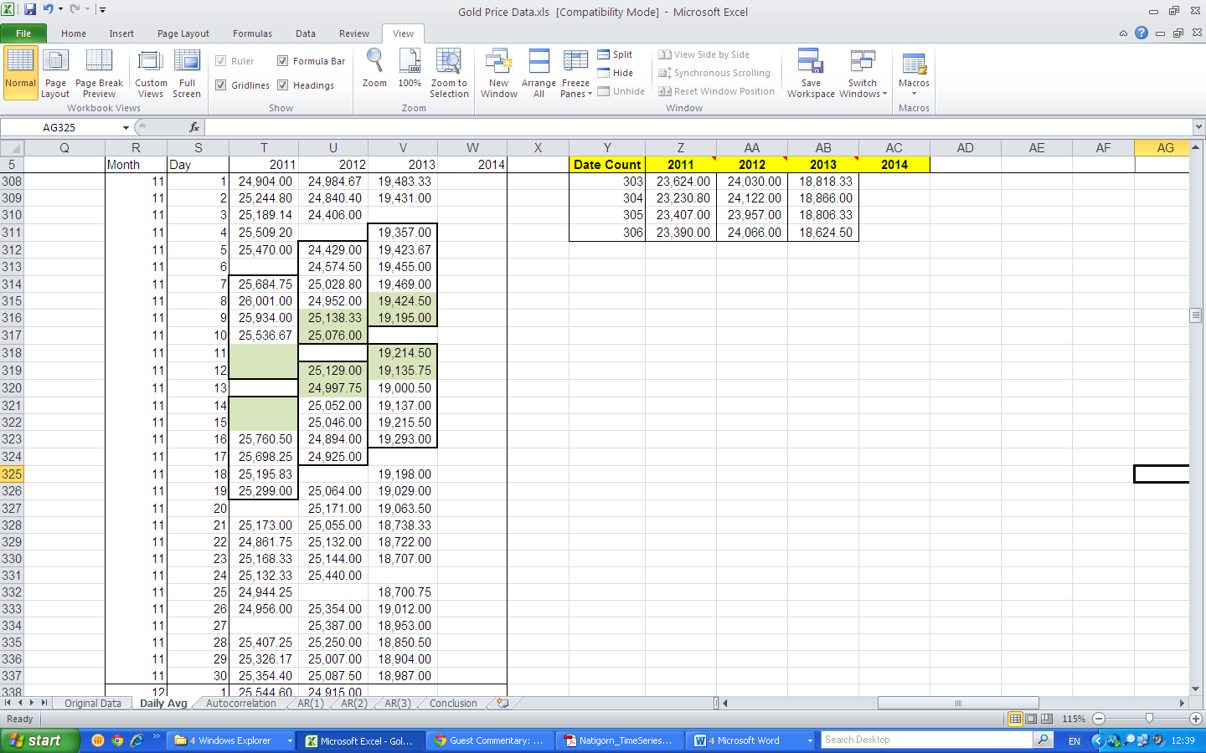
Data
For this project, I used data of gold spot prices from 1 January 2011 to 14 May 2014. Spot prices In Thailand is come from spot price (Kitco) and exchange rate of Thai Baht and US dollar. Specifically, I calculated daily average prices data from data provided in the following site: http://www.taradthong.com/content/%E0%B8%A3%E0%B8%B2%E0%B8%84%E0%B8%B2%E0%B8%97%E0%B8%AD%E0%B8%87%E0%B8%84%E0%B8%B3%E0%B8%A2%E0%B9%89%E0%B8%AD%E0%B8%99%E0%B8%AB%E0%B8%A5%E0%B8%B1%E0%B8%87
From the data provided the price data during 11 November-15 November 2011 is absent abnormally, so I decided to exclude the data during 9 November-13 November 2012 and 8-12 November 2013 to make the gap and movement of data in each year have the same pattern. So we omitted data 25,138.33, 25,076.00, 25,129.00, 24,925.00, 19,424.50, 19,195.00, 19,214.50, 19,135.75 respectively.
Analysis
As you can see in the chart directly below, I modeled daily average gold prices from 1 January 2011 to 14 May 2014.
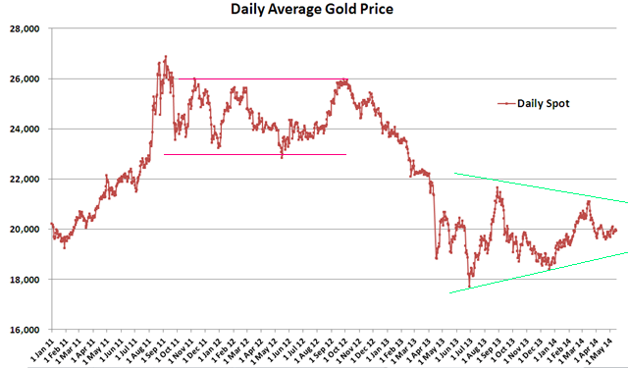
The prices of gold show an upward trend until it reach its peak (26,868.32) at 6 Sep 2011. Then the prices swing between 23,000 and 26,000 during Sep 2011 to Sep 2012 before gradually decline until reach its minimum at 17,713.20 (28 June 2013). After the price reaches its minimum, the price had rebounded and has swung around 20,000 Baht at a decreasing price frame.
Seasonality
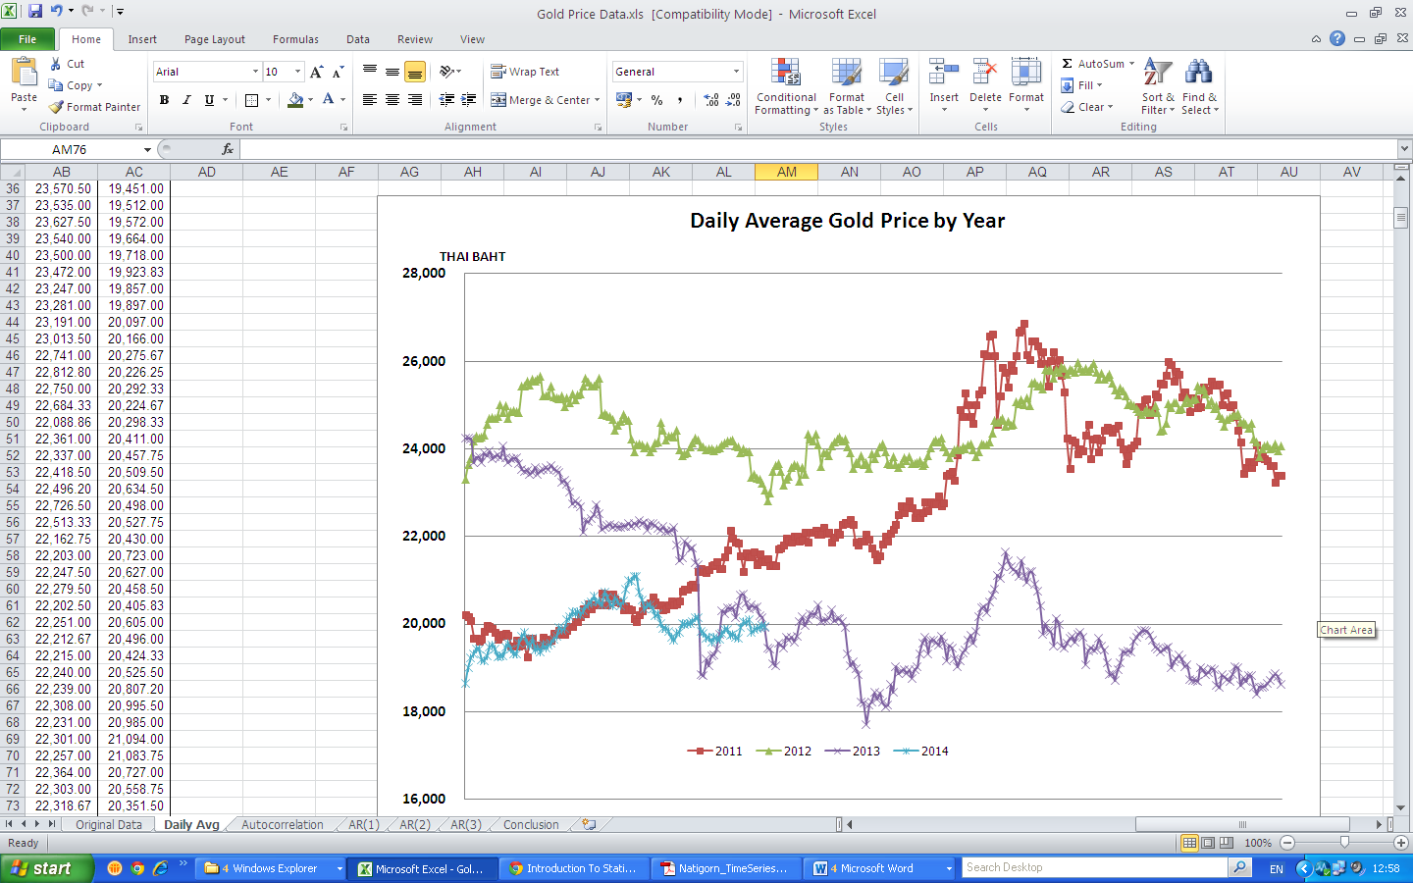
From graph above,
Year 2011, the price continuously increase until around end of July and then significantly increase and swing around 26,000 and plunge after 22 September 2011, and almost constant for a month before increasing to 26,000 again and decreasing in December.
Year 2012, prices move in price frame of 24,000 and 26,000.
Year 2013, price continuously decrease during first half of a year and then start to climb up again after it reach its minimum in 28 Jun 2013. Prices start decreasing since 28 August till the end of the year .
Year 2014, Prices swing around 20,000 Baht.
Do not see the seasonality trend in the relationship of Daily prices and date in each year. So we don’t have to make any seasonality adjustments to the data.

Autocorrelation plot
The next graph shows autocorrelation of the price of gold on all possible lag points given the gold price dataset. The sample autocorrelation with lag k is defined as:
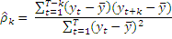

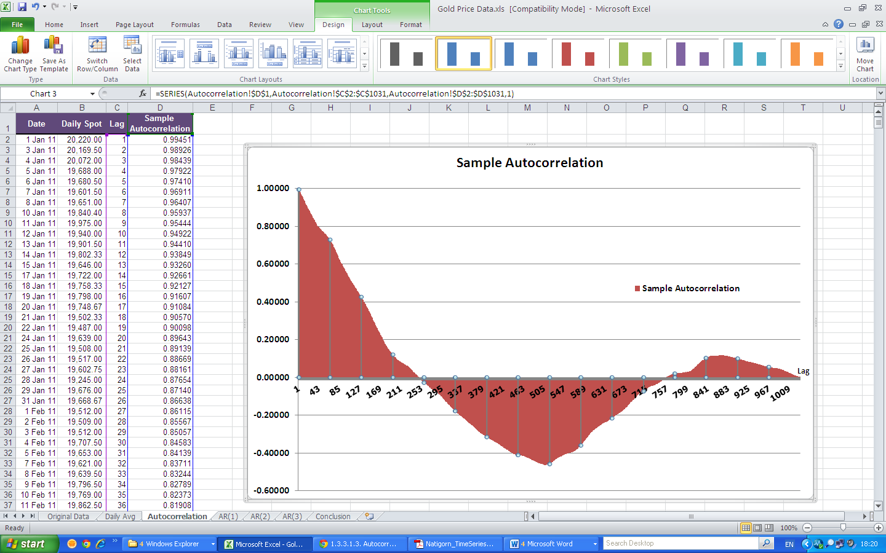
From the graph above, the correlations are positive for the first 247 lags and then negative until lag 755. After that, the lags oscillate to become positive again. The plot starts with a high autocorrelation at lag 1 (only slightly less than 1) that slowly declines. It continues decreasing until it becomes negative and starts showing an increasing negative autocorrelation. The decreasing autocorrelation is generally linear with little noise. Such a pattern is the autocorrelation plot signature of "strong autocorrelation", which in turn provides high predictability if modeled properly. We can conclude that the data come from an underlying autoregressive model with strong autocorrelation.

Model Analysis
I created three models ~ AR(1), AR(2) and AR(3). I used Microsoft Excel Analysis Tool Pak Add-in for Excel to run the regression analysis. I then used ANOVA and the Regression Statistics to evaluate each autoregressive model

Regression Model AR(1)
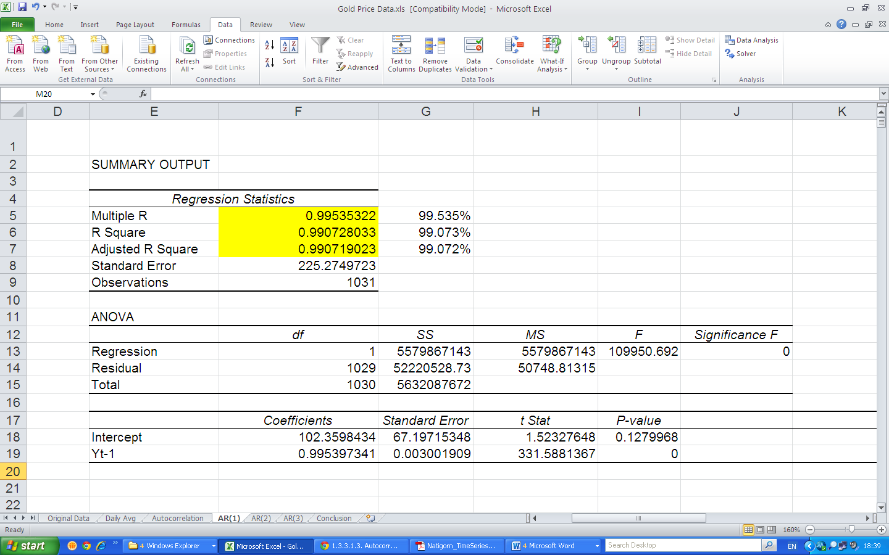
Y_{t} = 102.3598 + .0.9954Y_{t-1}

Regression Model AR(2)
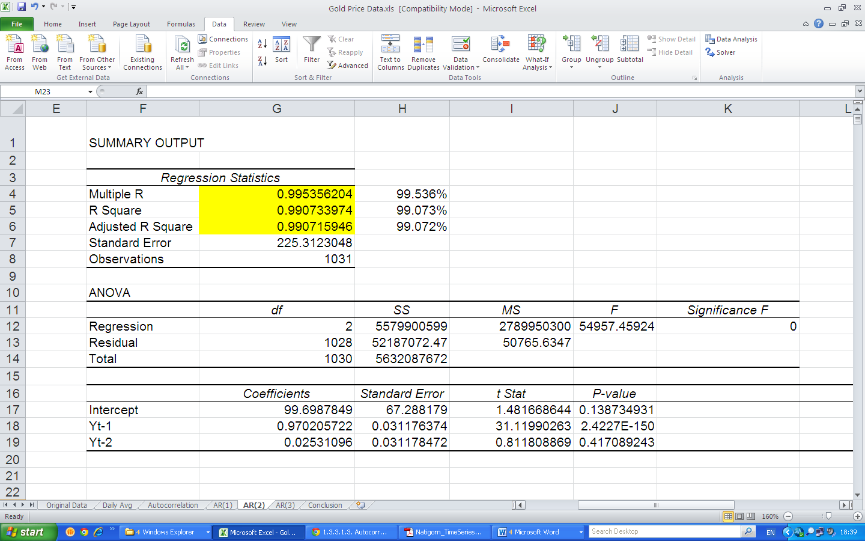
Y_{t} = 99.6988+0.9702Y_{t-1} - 0 .0253Y_{t-2}

Regression Model AR(3)
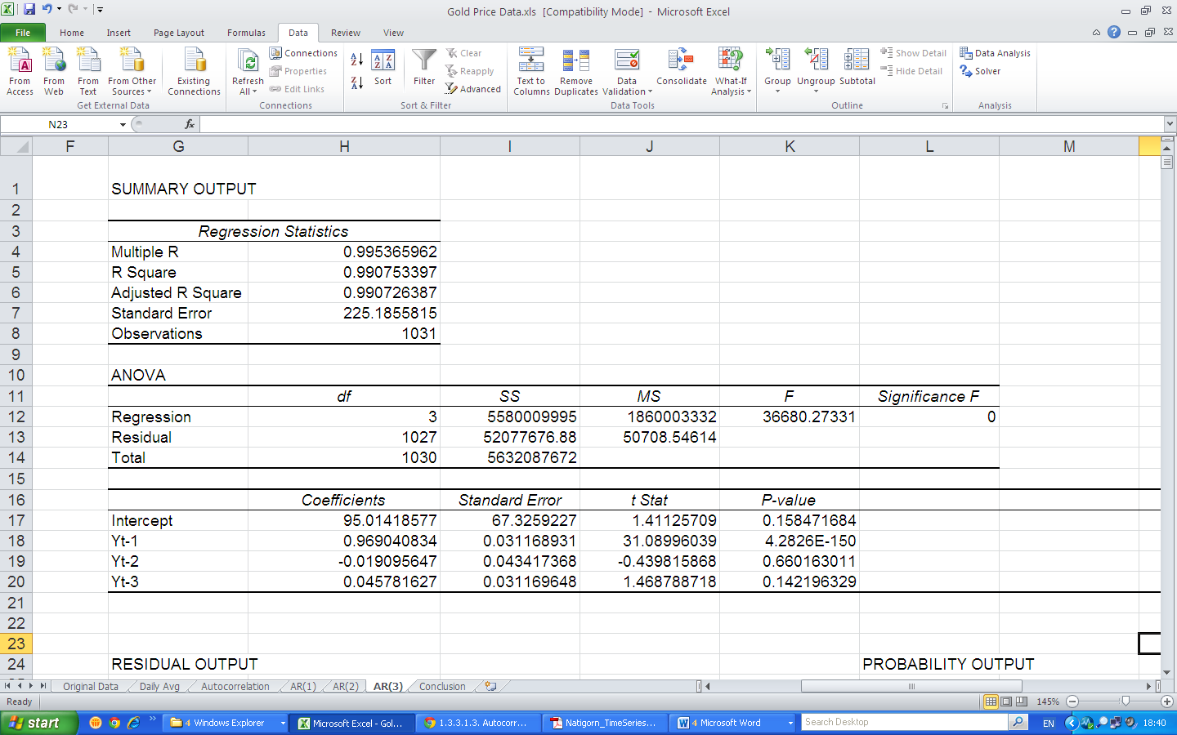
Y_{t} = 95.0142+0.9690Y_{t-1} – 0.0191Y_{t-2} + 0.0458Y_{t-3}

Conclusion
 | AR(1) | AR(2) | AR(3)
R-Square | 99.0728% | 99.0734% | 99.0753%
Adjusted R-Square | 99.0719% | 99.0716% | 99.0726%
Standard Error | 225.2750 | 225.3123 | 225.1856
Intercept | 102.3598 | 99.6988 | 95.0142
Y_{t-1} | 0.9954 | 0.9702 | 0.9690
Y_{t-2} |  | 0.0253 | -0.0191
Y_{t-3} |  |  | 0.0458
P-value (Y_{t-1}) | 0 | 0 | 0
P-value (Y_{t-2}) |  | 0.4171 | 0.6602
P-value (Y_{t-3}) |  |  | 0.1422

All 3 models create really close results. All R-square are around 99.07%. Comparing 3 models with adjusted R-Square, AR (3) seems to be the best model because it has the highest value with lowest standard error. Due to the fact that results are not significantly different in term of accuracy, thus in my opinion AR(1) is the best in terms practical as well as accuracy.
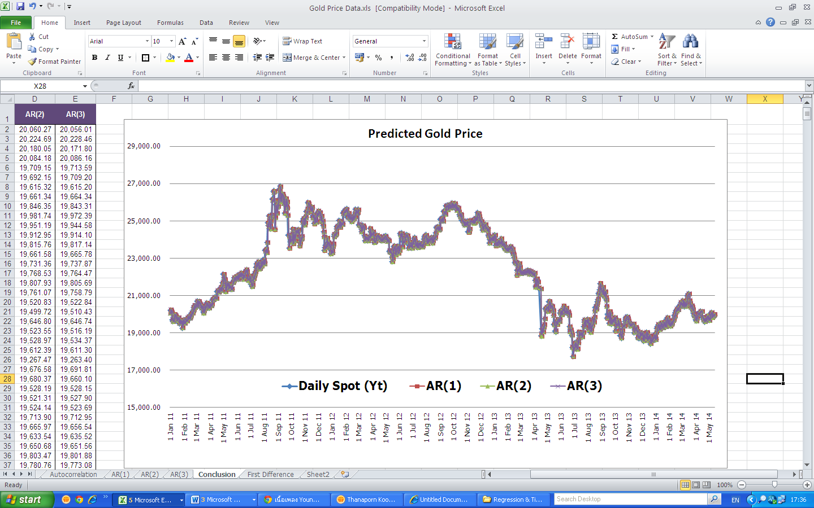
From the graph above is the plot of actual values and predicted values of all 3 models. We can see that all 3 models are a very good fit for historical data.

