Time Series Analysis Project

The Anaysis of medical expense in China

Session: Summer 2014
Submitted by: xxx xxx

1. Introduction
China's total health expend in the growing proportion with the population continues to expand. At the same time, the medical expense growth has greatly exceeded the increase of resident income level, the residents of the heavy burden of medical expenses. The development trend of change in the proportion of total health expenditure in China accounted for in the GDP, reflects China's reform and opening up 20 years of health expenditure process of historical development. As can be seen, the total health expenditure of our country in the national economy in the proportion of performance as a detour rising trend. This implies that, individual residents medical expend proportion has been showing a rising trend, medical expenses caused significant influence on the pressure of life. Urban residents demand for the commercial medical insurance has increased substantially, especially long term health insurance.
This article is based on China’s macro economic data of urban residents from 1979 to 2013 as sample, and carries on the analysis and prediction of medical expenditure growth with the ARIMA model and EViews, for reasonable pricing and lay the foundation of the long-term care insurance.
2. Data
2.1 The raw data
According to China Statistical website, the China's medical expense and disposable income per capita of urban residents from 1979 to 2013 are listed below.
Table 1: The raw income data of the China's medical expense and disposable income per capita of urban residents (Unit: yuan)
Year | Urban residents(Unit:yuan)
Year | medical expense per capita | Disposable income per capita | The ratio of medical expense to disposable income(X)
1979 | 11.45 | 405 | 2.83%
1980 | 12.94 | 477.6 | 2.71%
1981 | 14.51 | 500.4 | 2.90%
1982 | 16 | 535.3 | 2.99%
1983 | 17.46 | 564.6 | 3.09%
1984 | 20.14 | 652.1 | 3.09%
1985 | 23.2 | 739.1 | 3.14%
1986 | 26.36 | 900.9 | 2.93%
1987 | 29.38 | 1,002.10 | 2.93%
1988 | 34.73 | 1,180.20 | 2.94%
1989 | 43.96 | 1,373.90 | 3.20%
1990 | 54.61 | 1,510.20 | 3.62%
1991 | 65.37 | 1,700.60 | 3.84%
1992 | 77.14 | 2,026.60 | 3.81%
1993 | 93.61 | 2,577.40 | 3.63%
1994 | 116.25 | 3,496.20 | 3.33%
1995 | 146.95 | 4,283.00 | 3.43%
1996 | 177.93 | 4,838.90 | 3.68%
1997 | 221.38 | 5,160.30 | 4.29%
1998 | 258.58 | 5,425.10 | 4.77%
1999 | 294.86 | 5,854.00 | 5.04%
2000 | 321.78 | 6,280.00 | 5.12%
2001 | 361.88 | 6,859.60 | 5.28%
2002 | 393.8 | 7,702.80 | 5.11%
2003 | 450.75 | 8,472.20 | 5.32%
2004 | 509.5 | 9,421.60 | 5.41%
2005 | 583.92 | 10,493.00 | 5.56%
2006 | 662.3 | 11,759.50 | 5.63%
2007 | 748.84 | 13,785.80 | 5.43%
2008 | 875.96 | 15,780.80 | 5.55%
2009 | 1,094.52 | 17,174.70 | 6.37%
2010 | 1,314.26 | 19,109.40 | 6.88%
2011 | 1,490.06 | 21,809.80 | 6.83%
2012 | 1,806.95 | 24,564.70 | 7.36%
2013 | 2,056.57 | 26,955.10 | 7.63%
Data Resource: http://data.stats.gov.cn/
We can get the ratio of medical expense to disposable income , Its trend shows in Figure 1.
Figure 1 ratio of medical expense to disposable income

It can be seen from data in Table 1 and Figure 1 that China's total health expenditure growth from 1978 ~ 2008. Before the 1990s, the proportion of total health expenditure has been between 3% to 3.6%, but after 90 years, the proportion in the national economy began to rise, reaching 4%, after a four-year trough, rebound for 1998 of 4.29%, to 2008 was 4.77%. It shows that has an obvious upward trend, and is a typical non-stationary sequence.
2.2 Data pre-processing
Since the original series exhibits linear trend, we choose first order difference. Assuming the first order difference sequence is expressed as:
Figure 2 The first order of ln(Xt)
The time sequence of shows in figure 3 that the sample ACF displays significance at lags 1, 3 , 4 and the sample PACF displays significance at lags 1, 3.
Figure 3 Autocorrelation and partial correlation diagram of
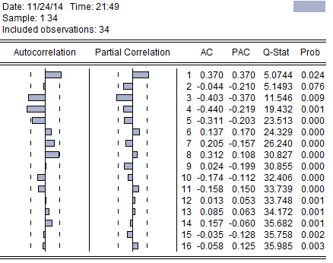
Second order difference is relatively stable volatility near the mean. In order to further determine the stationary，we draw the autocorrelation diagram of which shows in figure 4 below：
Figure 4 The second order of ln(Xt)
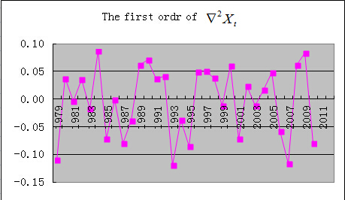

Figure 5 Autocorrelation and partial correlation diagram of
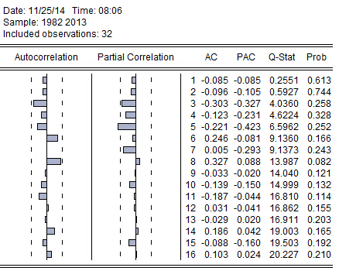

From figure 6 we can know that the autocorrelation diagram of shows strong correlation，so we can infer that is a stationary sequence. We can also know is non-white noise sequence from the P value of Q statistic.
Figure 6 ADF test result
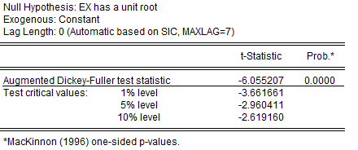

Figure 6 is the ADF test results of , we accept as a stationary sequence at 99% confidence level.
3. Model Construction
3.1 Model structure and parameter estimation
For ARIMA(p, q) model, we can use the sample autocorrelation and partial correlation diagram to determine the model structure. Since the sample autocorrelation and partial correlation diagram of are not censored and we try many types which shows in figure 7 below, we consider ARIMA(3, 2) to fitting the first order sequence.
Figure 7 ARIMA(p, q) model
ARIMA(1, 1)
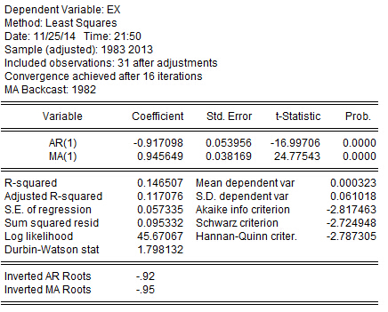
ARIMA(1, 2)
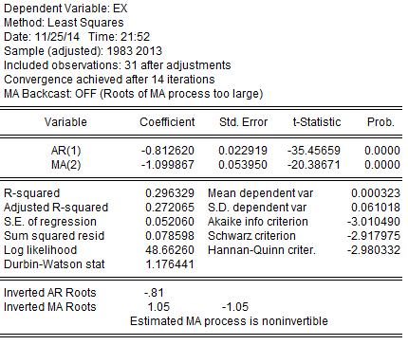
ARIMA(2, 2)
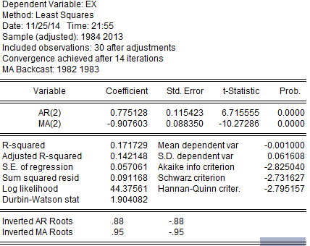
ARIMA(3, 2)
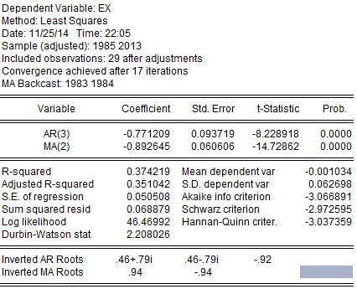

3.2 Model significant test
After we build the ARIMA model, we need to prove the residual is a white noise sequence. The autocorrelation and partial correlation diagram of residuals in figure 8 shows the P value of Q statistic are far greater than 0.05 in the ARIMA(3, 2) model，so we infer the residual sequence is a white noise sequence , the model is fully extracted.
Figure 8 The autocorrelation and partial correlation diagram of residuals
ARIMA(1, 1)
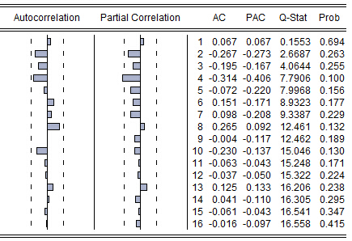
ARIMA(1, 2)
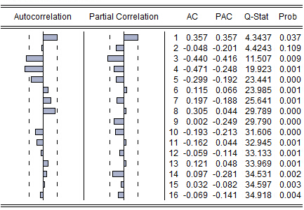
ARIMA(2, 2)
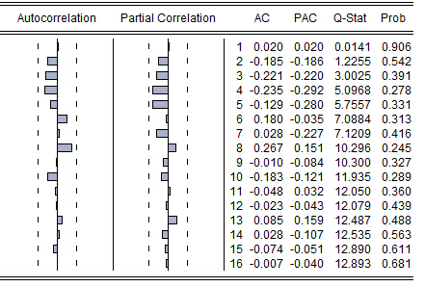
ARIMA(3, 2)
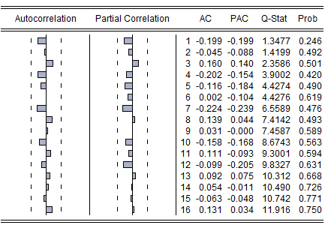
The final fitted model is：

3.3 Model forecasting
From table 1 we know the ratio of medical expense to disposable income is 6.83% in 2012 and 7.63% in 2013, the forecasting value is 7.75%. So we can believe the established model has a good effect in prediction.
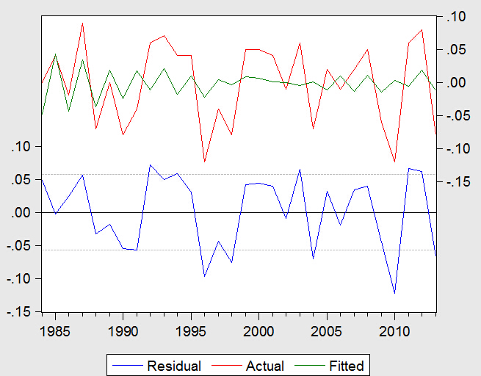

4. Conclusion
This article is based on China’s macro economic data of urban residents from 1979 to 2013 as sample, and carries on the analysis and prediction of medical expenditure growth with the ARIMA model, for reasonable pricing and lay the foundation of the long-term care insurance. The results show that the established model has a good effect in prediction.

