Regression Analysis Project

The influence of life insurance premium income
in China

Session: Summer 2014
Submitted by: xxx xxx

1. Introduction:
With the development of the insurance industry, there are many factors that influence life insurance premium income in China, these factors also changed with time constant. In past years, some important factors from now may no longer dominate. At the same time, there are new factors that have an important impact. Based on the analysis of the life insurance premium data from 31 provinces and cities in 2010, this paper discusses relationships with personal income, children's support rate, social security and other factors with the premium per capita using the multiple regression method.\
2. Analyze:
An illustrative scatter plot matrix for data on the data on the GDP, disposable income of family, the young dependency ratio and the elderly dependency ratio, education, education and social welfare of China in 2010, appears in Figure 1.
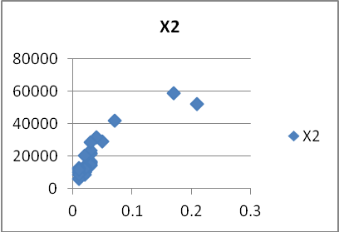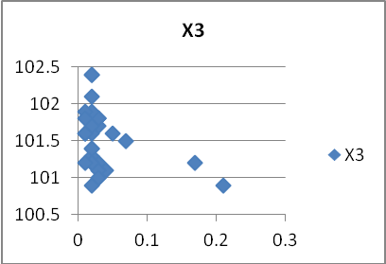
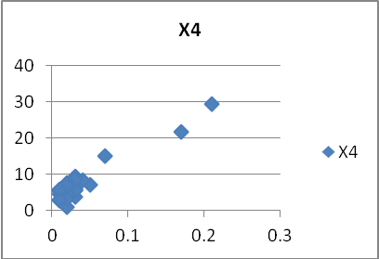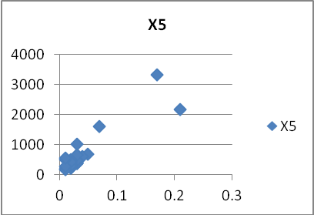
Based on this, we can continue to analysis factors that have influence on the life insurance industry now:
- gross domestic product per capita (GDP) and disposable income of family
No matter from the research results of empirical data or formerly the GDP per capita has a great contribution to the development of the insurance premium rate, the market plays an important role, and both are positive correlation. However, many theoretical studies show that per capita GDP can not completely represent the level of a country's economic development and people's life level. But the main source of China's life insurance premium income urban residents. At the same time, the per capita disposable income of residents has eliminated the influence of tax and other factors, more practical. Therefore, this paper discusses the use of per capita disposable income of residents to replace if GDP will achieve better results.
- Inflation
Inflation is a hot topic this year, which brought out a series of problems. People are worried about how to use financial derivatives to let the value of assets, resulting in decrease in bank deposits, a large amount of funds into the stock market. Compared to the stock, life insurance is a very good investment tool, and has good characteristics. Life insurance policy lasted for a long time, to preserve and increase the value of insurance, insurance risk relative to the low risk of stock. Therefore, this paper uses the consumer price index to measure inflation on life insurance premium income contribution rate.
- Education
The rapid development of the insurance industry in recent years, the reason lies in the unceasing promotion of insurance knowledge. "Business management" mentioned in the book of insurance company, insurance non essential demand. Insurance consciousness of people strongly affects the demand for insurance. Therefore, the level of education is one of the important factors affecting the life insurance premium income.
Based on the above analysis, assuming the initial model of this paper are as follows:
$$\text{ln}Y=C_{1}+C_{2}\text{ln}X_{2}+C_{3}\text{ln}X_{3}+C_{4}\text{ln}X_{4}+C_{5}\text{ln}X_{5}+u$$
3. Data are as follows:
In this paper, the development of the insurance industry in 2006, 31 provinces and cities based on data analysis, as follows.
Table1: The life insurance premium data from 31 provinces and cities in 2010（Unit: ten thousand RMB/year）
Province | Y | $$X_{2}$$ | $$X_{3}$$ | $$X_{4}$$ | $$X_{5}$$
Beijing | 0.21 | 52054 | 100.9 | 29.36 | 2180.02
Tianjing | 0.07 | 42141 | 101.5 | 15.22 | 1600.42
Hebei | 0.03 | 16682 | 101.7 | 3.93 | 393.96
Shanxi | 0.03 | 14497 | 101.8 | 6.65 | 419.15
Neimenggu | 0.02 | 20692 | 101.3 | 6.51 | 499.34
Liaoning | 0.03 | 21914 | 101.1 | 9.57 | 1028.94
Jilin | 0.03 | 15720 | 101.2 | 7.02 | 479.52
Heilongjiang | 0.03 | 16255 | 101.8 | 6.11 | 654.43
Shanghai | 0.17 | 58837 | 101.2 | 21.83 | 3341.18
Jiangsu | 0.05 | 28943 | 101.6 | 7.24 | 684.81
Zhejiang | 0.04 | 31825 | 101.1 | 8.42 | 616.38
Anhui | 0.02 | 9996 | 101.4 | 4.72 | 272.75
Fujian | 0.03 | 21384 | 101.1 | 5.83 | 395.45
Jiangxi | 0.02 | 11145 | 100.9 | 4.74 | 231.33
Shandong | 0.03 | 23603 | 101 | 5.73 | 481.51
Hebei | 0.02 | 13172 | 101.2 | 4.14 | 256.53
Hubei | 0.02 | 13360 | 101.4 | 7.71 | 429.26
Hunan | 0.02 | 12139 | 101.6 | 5.07 | 362.19
Guangdong | 0.03 | 28747 | 101.8 | 5.70 | 478.47
Guangxi | 0.01 | 10121 | 101.6 | 4.57 | 203.15
Hainan | 0.01 | 12810 | 101.2 | 5.43 | 505.94
Chongqing | 0.02 | 13940 | 102.4 | 4.49 | 426.83
Xichuan | 0.02 | 10613 | 102.4 | 4.51 | 358.25
Guizhou | 0.01 | 5932 | 101.6 | 2.72 | 179.75
Yunnan | 0.01 | 8929 | 101.9 | 3.10 | 286.29
Xizhang | 0.02 | 10422 | 101.9 | 1.06 | 233.72
Shanxi | 0.02 | 12724 | 102.1 | 7.46 | 360.77
Gansu | 0.02 | 8757 | 101.2 | 3.30 | 306.55
Qinghai | 0.01 | 11889 | 101.8 | 5.95 | 569.12
Ningxia | 0.02 | 12099 | 101.7 | 7.27 | 440.13
Xinjiang | 0.03 | 15000 | 101 | 8.69 | 655.55

data source: http://192.168.30.168:81/
Y—The premium income in 2010 per person
$X_{2}$—GDP
$X_{3}$—Consumer Price Index
$X_{4}$—Education
$X_{5}$—Social Security Fund per preson
3. Regression modeling
Based on results of previous studies of the life insurance industry, we log the data, and then run the regression by Eviews. Function as:
$$\text{ln}Y=C_{1}+C_{2}\text{ln}X_{2}+C_{3}\text{ln}X_{3}+C_{4}\text{ln}X_{4}+C_{5}\text{ln}X_{5}$$
For the regression, we have the results and analysis of variance table:
$$\text{ln}Y=\text{20}\text{.}\text{20559}+0\text{.}\text{829956ln}X_{2}\text{-7}\text{.}\text{290504ln}X_{3}+0\text{.}\text{019737ln}X_{4}+0\text{.}\text{280518ln}X_{5}$$
(80.24710) (0.246514) (17.30700) (0.214289) (0.249084)
t=(0.251792) (3.366766) (-0.421246) (0.092107) (1.126196)
$R^{2}$=0.799147 F=25.86199
Table 1

Dependent Variable: Y1
Method: Least Squares
Date: 12/24/10 Time: 14:47
Sample: 1 31
Included observations: 31
Variable | Coefficient | Std. Error | t-Statistic | Prob.
C | 20.20559 | 80.24710 | 0.251792 | 0.8032
W2 | 0.829956 | 0.246514 | 3.366766 | 0.0024
W3 | -7.290504 | 17.30700 | -0.421246 | 0.6770
W4 | 0.019737 | 0.214289 | 0.092107 | 0.9273
W5 | 0.280518 | 0.249084 | 1.126196 | 0.2704
R-squared | 0.799147 | Mean dependent var |  | -3.668891
Adjusted R-squared | 0.768247 | S.D. dependent var |  | 0.708230
S.E. of regression | 0.340947 | Akaike info criterion |  | 0.832512
Sum squared resid | 3.022370 | Schwarz criterion |  | 1.063800
Log likelihood | -7.903931 | F-statistic |  | 25.86199
Durbin-Watson stat | 2.029508 | Prob(F-statistic) |  | 0.000000

We therefore suspect the model doesn't work, the result R-squared (0.799147) is too small. So we consider to transform data, this time we do not use the logit of variables. The function changes to:
$$Y=\text{-0}\text{.}\text{237689}+5\text{.}\text{69E-07}X_{2}+0\text{.}\text{002151}X_{3}+0\text{.}\text{005183}X_{4}+1\text{.}\text{06E-05}X_{5}$$
(0.667048) ( 4.88E-07) ( 0.006554) ( 0.001072) (1.03E-05)
t=(-0.356330) ( 1.166267) ( 0.328220) ( 4.833144) ( 1.026794)
$R^{2}$=0.917674 F=72.45452
Table 2

Dependent Variable: Y
Method: Least Squares
Date: 12/24/10 Time: 15:06
Sample: 1 31
Included observations: 31
Variable | Coefficient | Std. Error | t-Statistic | Prob.
C | -0.237689 | 0.667048 | -0.356330 | 0.7245
X2 | 5.69E-07 | 4.88E-07 | 1.166267 | 0.2541
X3 | 0.002151 | 0.006554 | 0.328220 | 0.7454
X4 | 0.005183 | 0.001072 | 4.833144 | 0.0001
X5 | 1.06E-05 | 1.03E-05 | 1.026794 | 0.3140
R-squared | 0.917674 | Mean dependent var |  | 0.035484
Adjusted R-squared | 0.905009 | S.D. dependent var |  | 0.043347
S.E. of regression | 0.013360 | Akaike info criterion |  | -5.646458
Sum squared resid | 0.004641 | Schwarz criterion |  | -5.415169
Log likelihood | 92.52009 | F-statistic |  | 72.45452
Durbin-Watson stat | 2.386765 | Prob(F-statistic) |  | 0.000000

Results from table 2 show the model is good to reflect is a reflection of the relationships between variables.
4. Conclusion
Model estimation results show that when GDP growth per 100 RMB or people have high education, life insurance premium income will increase, based the assumption that the other variables remain unchanged. This indicates that to promote development of life insurance, improve the level of education is better than the effect of increasing GDP.
(1)GDP is still an important factor affecting the life insurance premium income, development of life insurance industry in the future will have a positive role in promoting. So GDP is an important guarantee to maintain the steady growth of the life insurance premium income growth.
(2) Education is a other important factor. To improve people's level of education, vigorously promote the insurance knowledge, there is a great help to promote the development of the insurance industry and the insurance industry.
This paper using the cross-sectional data to analyze the influencing factors of China's life insurance premium income, and draws some important conclusion is: the level of education and awareness of insurance can greatly increase the demand for insurance.

