Name: xxxxxx xx
Course: Time Series
Date: 12/8/2014
Subject: Modeling median age of Hong Kong male at first marriage
Introduction
The main goal of this paper is to determine a proper ARIMA forecast model to forecast the median age of Hong Kong male at first marriage.
Data
The data source can be found in the Census and Statistics Department in Hong Kong (URL: http://www.censtatd.gov.hk/hkstat/sub/sp150.jsp?tableID=004&ID=0&productType=8 – need to click on the “Customize Statistical Table” at the bottom of the page to extract data from all prior years).
In this exercise, we will use all data point from year 1971 to 2012, leaving out year 2013 to validate the ARIMA model.
Stationary and adjustment
By looking at the original data, it’s obvious that there is an upward trend in the Hong Kong male median age at first marriage:
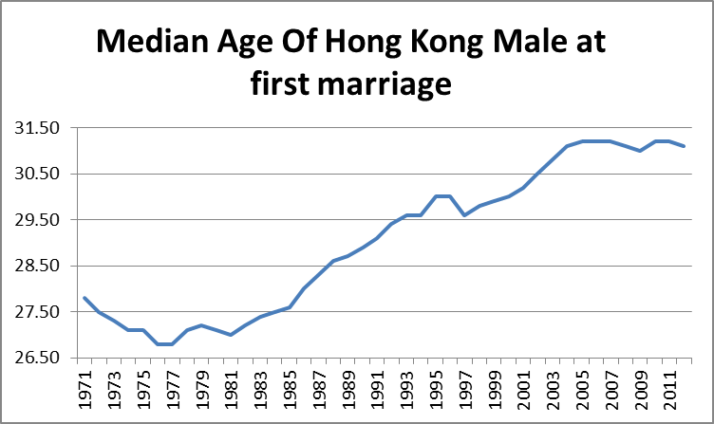
A further look at the sample autocorrelation function (ACF) shows that there is a slow and declaying pattern. It confirms that the time series is NOT stationary:
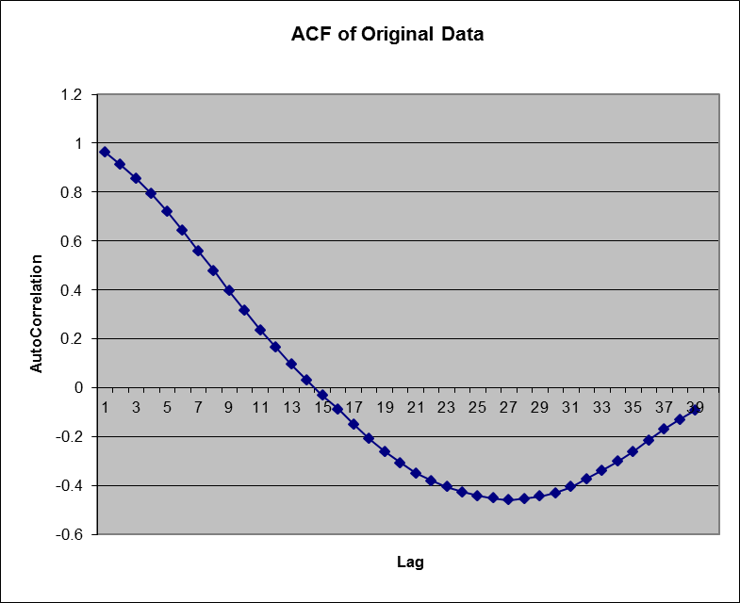

To de-trend the data, we will try the several methods we learnt in class. First is to take the first difference of the original data. The sample ACF is listed below:
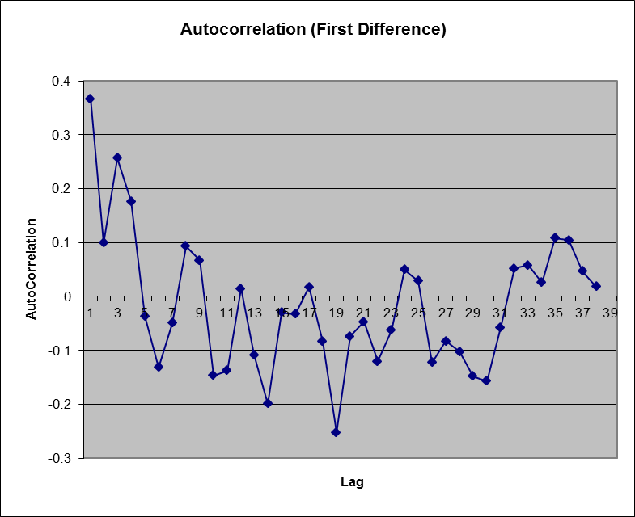
The second method is to use second difference of the original data. Below is the sample ACF:
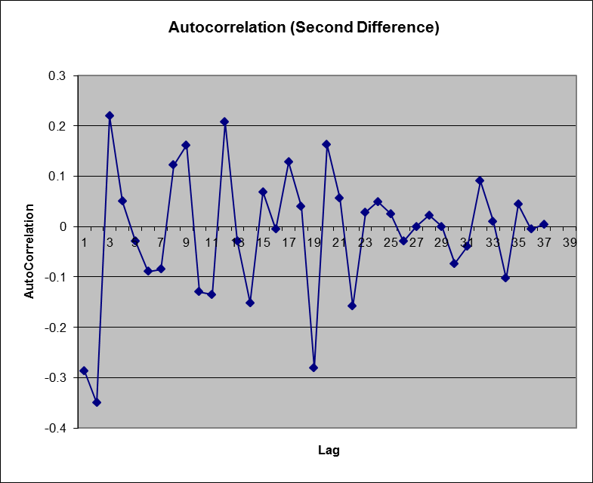
And the last method is to take the first difference of natural log of the origianl values:
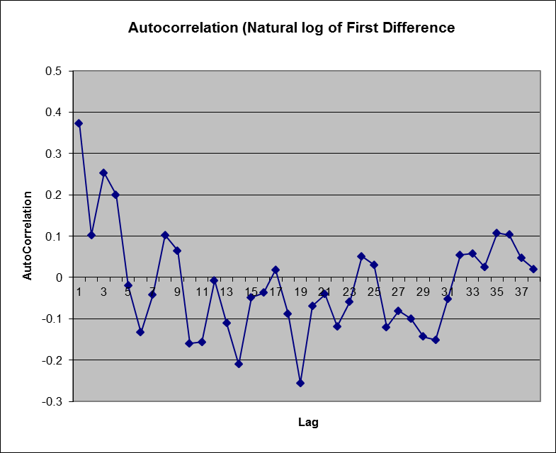
A good method that make a time series stationary should be the one with a correlogram that (i) has very few significant spikes, (ii) has a cutoff that dies down rapidly in a few lags and (iii) remains near zero.
By just looking at the above three charts, it seems that sample ACF of the first difference chart and the first differene of natural chart look pretty simiar. Given the sample size (T) of 38, Bartlett’s test shows us that the sample ACF has 95% probability between the range -0.318 and +0.318 (i.e. 1.96*[1/sqrt(38)]). It means that the all lags (except the first lag) of the “first difference” method and “first difference of natural log” method are not significantly different from zero (which satisfied the “remains near zero” part).
On the other hand, ACF of Lag 2 of the second chart (i.e. second difference) is as low as -0.35. It is likely that using the second difference might be overdifferencing the orignal time series.
Given the similar between the first differnce method and the first difference of natural log method, I’ll not further use the first difference of natural log method in further analysis. I’ll only use the first differnce method as well as the second difference method in the model estimation section to determine the best model.

Model Estimation
After we take the first (or second) difference of the original time series, we can then describe the transformed series by the autoregressive model with different orders as listed below:

$$Y_{t}=δ+\sum_{i=1}^{p}{φ_{i}Y_{t−i}}+ε_{t}$$
where $Y_{t}$ is the difference in observed median age of Hong Kong male at first marriage between time t and t-i
$δ$ is a constant
$φ_{i}$ is the coefficients for lag i data
$ε_{t}$ is the error term at time t
$p$ is the order of auto-regression to be determined
I have used the Excel model that I have provided to test the “AR1” and “AR2” auto regression for both the first difference and second difference. A quick summary of the result is listed below:
ARIMA(1,1,0): Y_{t} = 0.058273 + Y_{t-1}+ 0.3733(Y_{t-1}-Y_{t-2})+ε_{t}
ARIMA(2,1,0): Y_{t} = 0.0673 + Y_{t-1} +0.34(Y_{t-1}-Y_{t-2}) - 0.0252(Y_{t-2}-Y_{t-3}) +ε_{t}
ARIMA(3,1,0): Y_{t} = 0.0675 + Y_{t-1} +0.31(Y_{t-1}-Y_{t-2}) - 0.2(Y_{t-2}-Y_{t-3}) + 0.2(Y_{t-3}-Y_{t-4}) +ε_{t}
ARIMA(1,2,0): Δ Y_{t} = 0.0048 + Δ Y_{t-1} -0.289 (Δ Y_{t-1} - Δ Y_{t-2}) +ε_{t}
ARIMA(2,2,0): Δ Y_{t} = 0.0167 + Δ Y_{t-1} -0.4417 (Δ Y_{t-1} - Δ Y_{t-2}) -0.4785 (Δ Y_{t-2} - Δ Y_{t-3}) +ε_{t}
As we can see in the summary table below, all fitted models have absolute values Σφ_{ι} of less than 1. However, it’s a concern that Σφ_{ι} for the ARIMA(2,2,0) model is as low as -0.92. It represents “unit roor”s and it’s likely that the transformed time series (using second difference) is not stationary. All other fitted models have absolute values Σφ_{ι} of less than 1 which indicates that the transformed times series is stationary.
Even though the ARIMA(2,2,0) model has the R² and adjusted R² among the tested auto regressive models, I’m concerned about over differencing of using second difference and so I suggest using only first difference to transform the time series.

Summary Table
 | Σφ_{ι} | R² | Adj. R²
ARIMA(1,1,0) | 0.373 | 0.151 | 0.128
ARIMA(2,1,0) | 0.316 | 0.114 | 0.065
ARIMA(3,1,0) | 0.412 | 0.184 | 0.113
ARIMA(1,2,0) | -0.289 | 0.083 | 0.059
ARIMA(2,2,0) | -0.92 | 0.309 | 0.27

Residual diagnosis
The auto correlations of the residuals of all fitted models (using only the first difference transformation) are very close to zero, which is a good indicator that there is no serial correlation among the residuals of the fitted models.
Another key observation from the result is that all the ARIMA(1,1,0), ARIMA(2,1,0) and ARIMA(3,1,0) fitted model have a Durbin-Watson statistics of really close to 2, which indicates there is no serial correlation among the residuals.
 | AutoCorr of resudials | Durbin-Watson test
ARIMA(1,1,0) | -0.031 | 2.022
ARIMA(2,1,0) | -0.021 | 1.983
ARIMA(3,1,0) | 0.011 | 1.967

Forecasting
Above tests show the residuals of all fitted models (using first difference transformation) are unlikely to be correlated, and they pretty much are white noise process. Since the R² and adjusted R² are not significantly different between the ARIMA(1,1,0) and ARIMA(3,1,0) fitted models, I would recommend the ARIMA(1,1,0) model due to the rule of parsimony
ARIMA(1,1,0): Y_{t} = 0.058273 + Y_{t-1}+ 0.3733(Y_{t-1}-Y_{t-2})+ε_{t}

To validate the model, I have also compared real observations and the predicted values from the ARIMA(1,1,0) fitted models using the year 2013 data:
 | Actual observation in 2013 | Predicted values
ARIMA(1,1,0) | 31.2 | 31.12

Ideally, I should leave out a few more data point to be used to validate the fitted model. However, given that there are only 43 data points in the original time series, leaving out too many data points might lead to other problems. I’d say that the predicted value is satisfactory using the 2013 data.
Using the ARIMA(1,1,0) model, the predicted value of 2014 is 31.3.
Conclusion
Median age of Hong Kong male at first marriage was examined in the paper. Five auto-regression models – ARIMA(1,1,0), ARIMA(2,1,0), ARIMA(3,1,0),ARIMA(1,2,0) and ARIMA(2,2,0) were examined in this papers. Even though the ARIMA(2,2,0) fitted model provided the highest R² among all models, I have decided not to use the second differencing method due to the possibility of over-difference. ARIMA(1,1,0) was recommended due to the rule of parsimony. Using the ARIMA(1,1,0) fitted model, the 2014 median age of Hong Kong male at first marriage was forecasted to be 31.3.

