xxxxxx xxxxxxxxxxxxxx
Summer 2007
NEAS Time Series Course

VEE Student Project

Dec 16, 2014

ANALYSIS OF DAILY TEMPERATURES OF PEMISCOT

After spending the last ten years in Yellowknife, Canada, I have the opportunity to move to the Pemiscot, Montana. After suffering in one the coldest places on Earth, the chance to move further South to warmer weather seems irresistible. I have previously visited Pemiscot a few times. The weather changes seem mild compared to Yellowknife. Although it has the reputation of being cold, I believe Pemiscot is definitely an upgrade to Yellowknife.

I decided to analyze the temperature of Pemiscot to see how much it has varied historically as it is a significant decision to move to another country.

Data
The daily recorded temperature data for Pemiscot, Montana consisted of 10957 data points from the years 1970-1999. This data was obtained station 231364 from the NEAS website. Some of the data points were missing with the value recorded as -999. In these cases the values were determined by linearly interpolation. There were only 5 data points that were coded in this way.

The data obtained included the daily high temperature, daily low temperature and the average rainfall for the given day. As the daily low temperature had no bearing on the analysis, this data was ignored. All temperatures are in degrees Fahrenheit.

Mean | 69
Median | 72
Mode | 90
Minimum | 5
Maximum | 107
Std Dev | 19

Initial Analysis
The average temperature for each day of the year of the study period of 1970-1999 was calculated.

As expected, the data shows some seasonality - lower temperatures in the winter months of December, January and February; higher temperatures in the summer months of July August and September. Additionally, as the data points are not very smooth, the data needs to be smoothed and de-seasonalized. The results are illustrated in Figure 1 below.

Figure 1
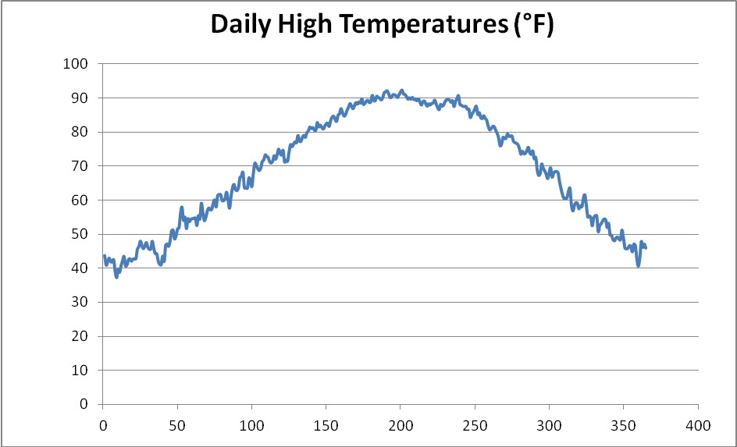

Smooth and De-seasonalizing The Data

In the first attempt to smooth the data, the 7-day moving average is calculated. For each of the 365 days, the average of each day is calculated as the average of the given day and 3 days before and after that given day. The result is a graph which is slightly smoother than the prior chart. However, the data still shows some volatility especially in the tail. The results are illustrated in Figure 2 below.
Figure 2
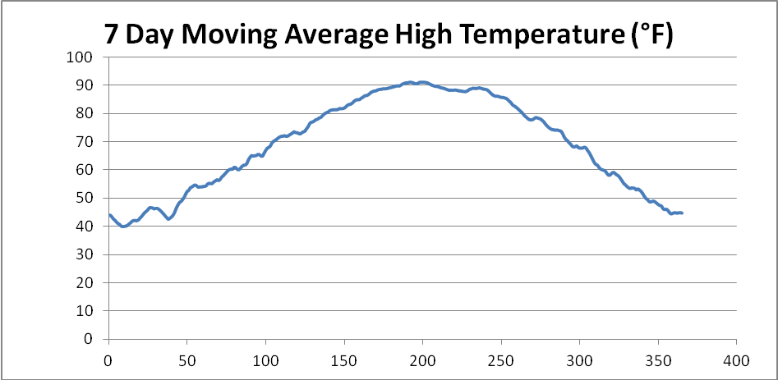

The data can be smoothed further by using a 15-day moving average. Similar to the 7-day moving average, the 15-day moving average day is calculated as the average of the given day and 7 days (instead of 3) before and after that given day. The data is smoother than the 7-day moving average but it still shows some volatility. The results are illustrated in Figure 3 below.

Figure 3
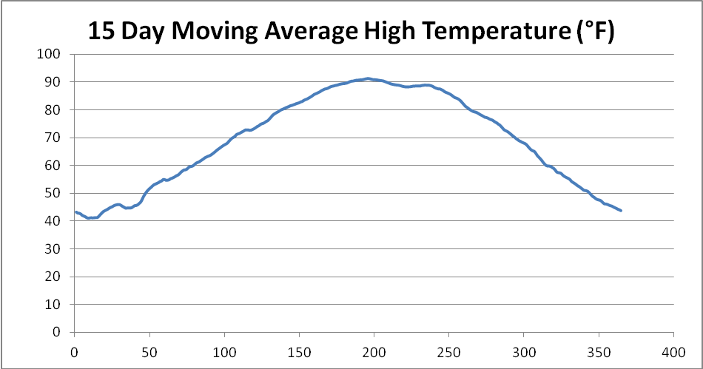

Next a 31-day moving average was calculated. The graph is much smoother compared to the previous one. Most of the volatility is gone with the graph this maintaining the overall shape of the data. The 31-day moving average is the best choice given this data. The results are illustrated in Figure 4 below.

Figure 4
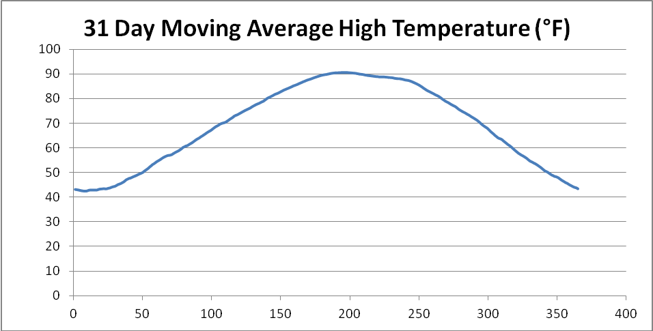

In order to de-seasonalize the data, the difference between the 31-day moving average and the actual temperature on the date was first calculated. The result was seasonally adjusted values which has an average which is close to 0 as expected. To normalize the average to 0, the average of the seasonally adjusted values was subtracted from the seasonally adjusted values resulting in de-seasonalized values. The graph of the de-seasonalized temperatures is given the Figure 5 below.

Figure 5
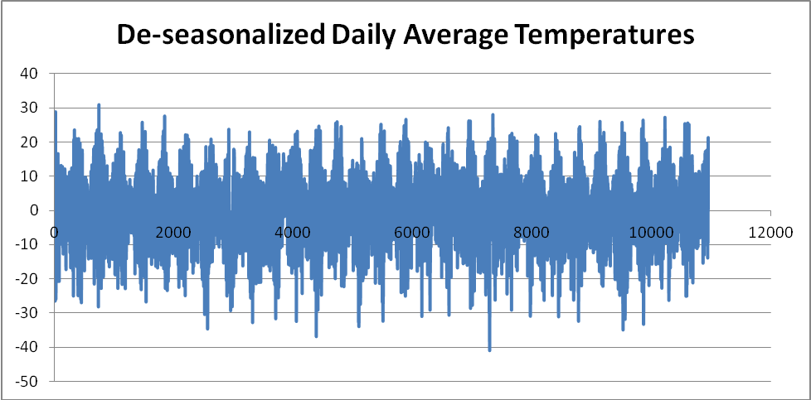

Autocorrelation and Correlogram

The sample autocorrelations were calculated. Figure 6 below shows the graph of the first 100 data points. The correlogram drops quite suddenly but not immediately to 0. It gets closer to 0 as the lag increases. This is indicative of the data not being stationary. It shows that the data does not follow a moving average process but an autoregressive process. The first 3 sample autocorrelations are much greater than the rest so autoregressive models of order 1, 2 and 3 will be tested.

Figure 6
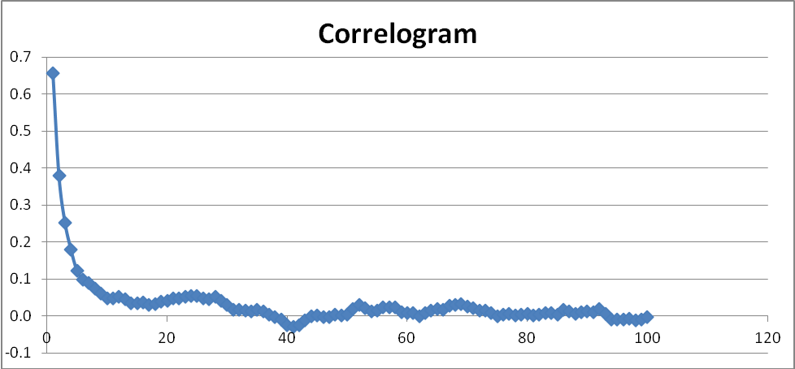

Regression Analysis

AR(1)
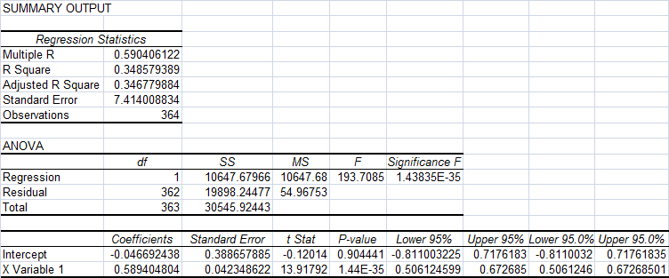
AR(2)
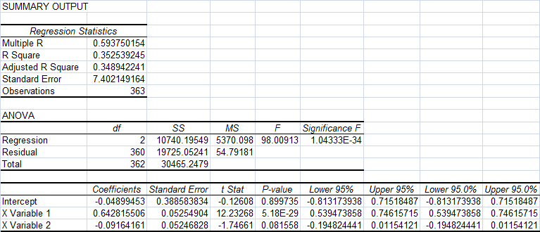

AR(3)
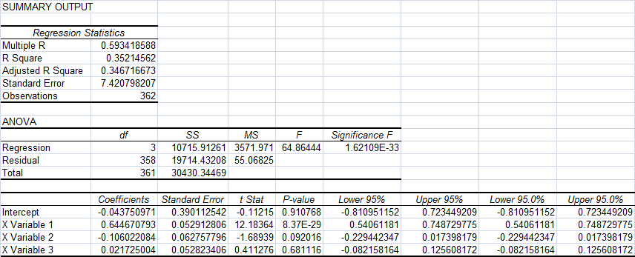

The R statistic does not increase by much as the increases from model to model. The X1 variable for all three models exhibit high T-stats. The conclusion that can be drawn from this is that increasing the lag does not have a significant effect.

Durbin-Watson Test Statistic

To test the residuals for serial autocorrelation, I decided to use the Durbin-Watson test. The null hypothesis is that there is no serial correlation between the residuals. The DW statistics for the chosen models are shown below. All of our models show Durbin‐Watson statistics close to 2.00, so we cannot reject the Null Hypothesis of no serial correlation in the residuals.

Model | Durbin-Watson test
AR(1) | 1.89060
AR(2) | 1.99340
AR(3) | 1.99394

Box-Pierce Q Test

The Box-Pierce Q statistics and the corresponding 10% X² values for k=20 are given below.
Number of Independent variables | Box Pierce Statistic | 10% Critical Value
1 | 13.285 | 27.204
2 | 10.239 | 25.989
3 | 10.596 | 24.769

All the test statistics are much lower than the critical value. This implies that this test does not give much insight into which model is a better fit than the others. Therefore, by the principle of parsimony, I would choose the AR(1) model as best for the data.

