xxxxxx xxxxxxx
Time Series Final Project
Spring 2007

Introduction
For my time series project, I decided to analyze U.S. Natural Gas Consumption. The overall volume of natural gas consumption remained relatively stable for the early part of the 21st century, but since 2010, consumption levels have been steadily increasing. This is mainly due to two reasons: an increase Industrial Consumption as well as a shift from coal to natural gas for Electric Power Consumption.
Data
I analyzed monthly data consisting of Natural Gas Consumption by End Use (million cubic feet), from the U.S. Energy Information Administration, from 2001-2014. (http://www.eia.gov/dnav/ng/ng_cons_sum_dcu_nus_m.htm)
Seasonality
The graph below shows the natural gas consumption by month from 2001-2014.
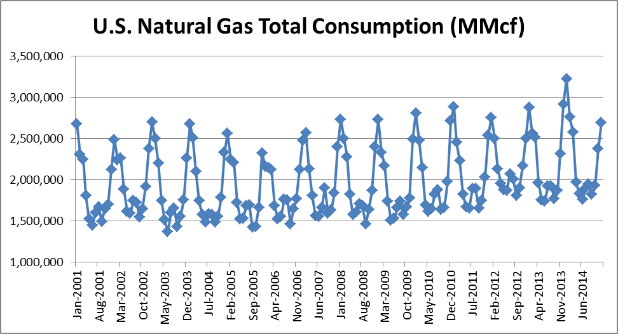
It is rather obvious from the above graph that there is a considerable amount of seasonality. This is due to the high percentage of natural gas used in winter months for heating. To further support the need for a seasonality adjustment, the graph on the next page shows the autocorrelation of the raw data. You will notice that there is a high degree of correlation at lags 12, 24, 36, and 48. This implies that we need to adjust the raw data to account for the expected seasonality each month.
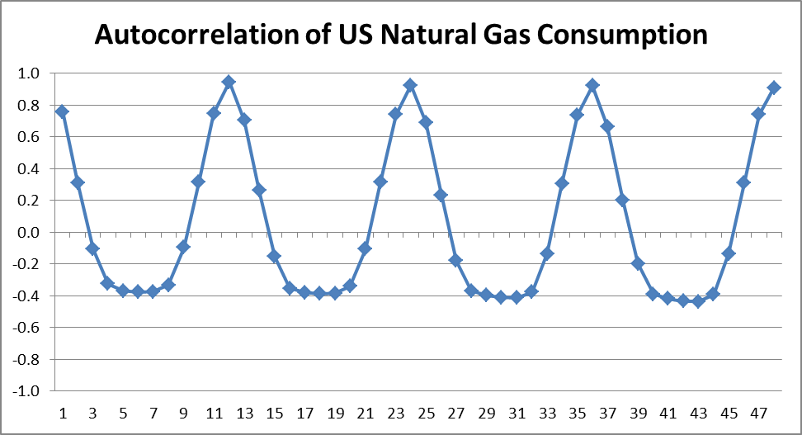
In order to adjust for the seasonality, I calculated a 13 month average around each monthly data point, with 1/12 weight on the current month and each of the 5 months before and after, and 1/24 weight on each of the endpoints, to ensure that each calendar month received 1/12 total weight. Then I produced a ratio of the current month consumption to the corresponding 13 month average. Finally, to obtain the monthly seasonality factors, I calculated an average ratio for each of the 12 months across the 13 year time period (July 2001 – June 2014). The factors are shown in the chart to the right.
The graph below shows natural gas consumption after adjusting for seasonality.
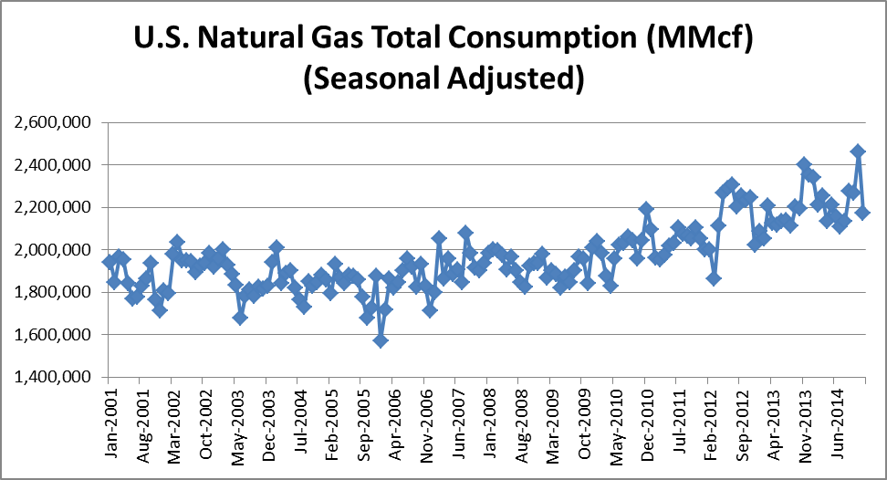

After adjusting for seasonality, the autocorrelation function, calculated with the degrees of freedom adjustment, exhibits a steadily decreasing pattern, dropping to within 0.2 by lag 54.
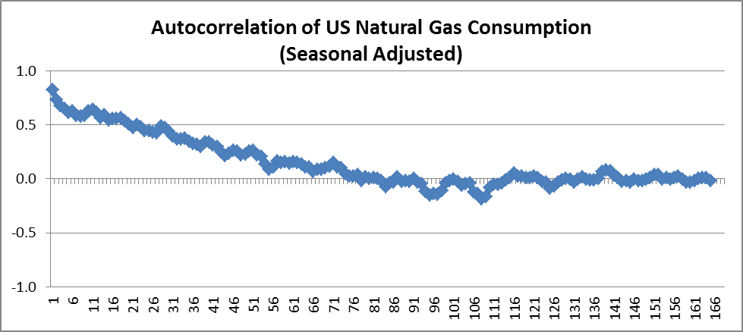
Due to the high autocorrelation of the seasonal adjusted data, it is probably better to look at the first differences to provide a stationary dataset to then build a model. Shown below is a graph of the first differences as well as the autocorrelation of the first differences.
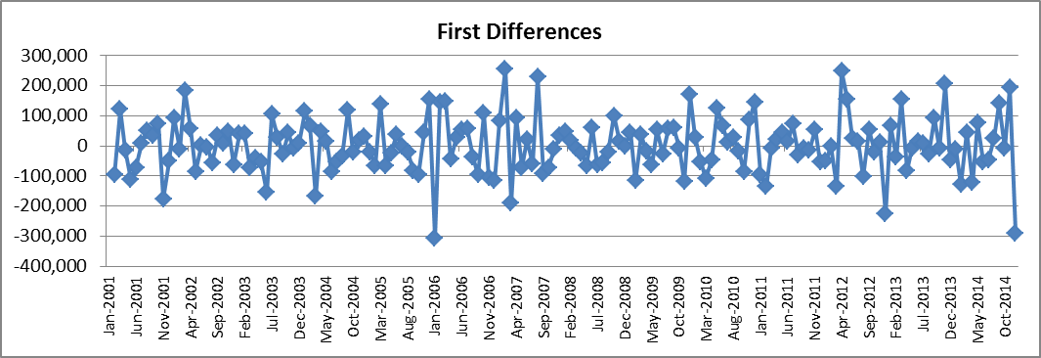
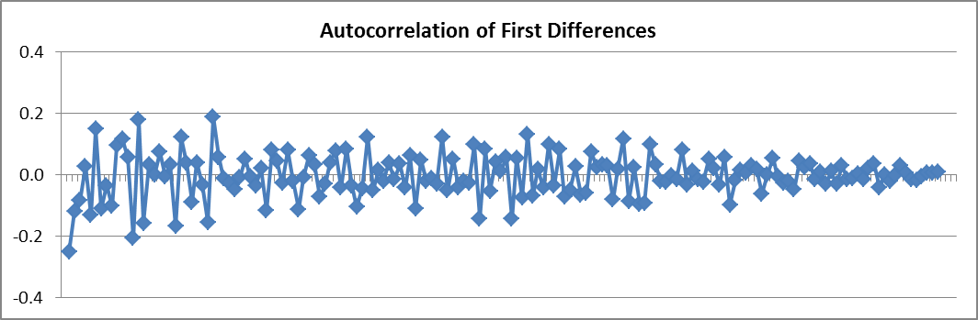
The autocorrelation function of the first differences is between -0.2 and 0.2 at all lags for the most part. This implies that we now have data that is stationary, for which we can use to produce a regression model.
Modeling
The transformed data was used to produce three autoregressive models, using data from 2001-2013, so that we can forecast 2014. The models were produced using RegressIt in Excel and the results are shown below:
- ARIMA (1,1,0)
Regression Statistics: Model 1 for D__1 (1 variable, n=154)
 | R-Squared | Adj.RSqr | Std.Err.Reg. | # Cases | # Missing | t(2.50%,152) | Conf. level
 | 0.048 | 0.042 | 87,022 | 154 | 2 | 1.976 | 95.0%
Summary Table: Model 1 for D__1 (1 variable, n=154)
Variable | Coefficient | Std.Err. | t-Stat. | P-value | Lower95% | Upper95%
Intercept | 3,934 | 7,016 | 0.561 | 0.576 | -9,928 | 17,796
D__2 | -0.220 | 0.079 | -2.783 | 0.006 | -0.375 | -0.064
Analysis of Variance: Model 1 for D__1 (1 variable, n=154)
Source | df | Sum Sqrs | Mean Sqr | F | P-value
Regression | 1 | 58670818300 | 58670818300 | 7.748 | 0.006
Residual | 152 | 1.15107E+12 | 7572849932
Total | 153 | 1.20974E+12
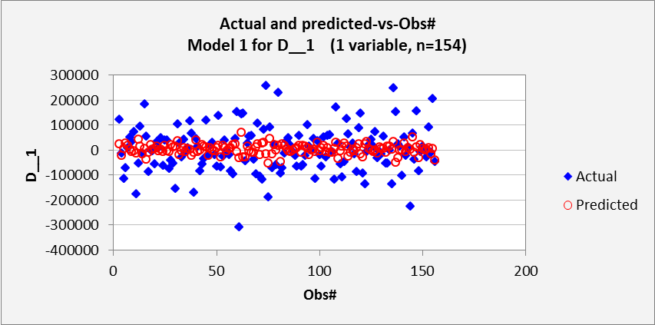
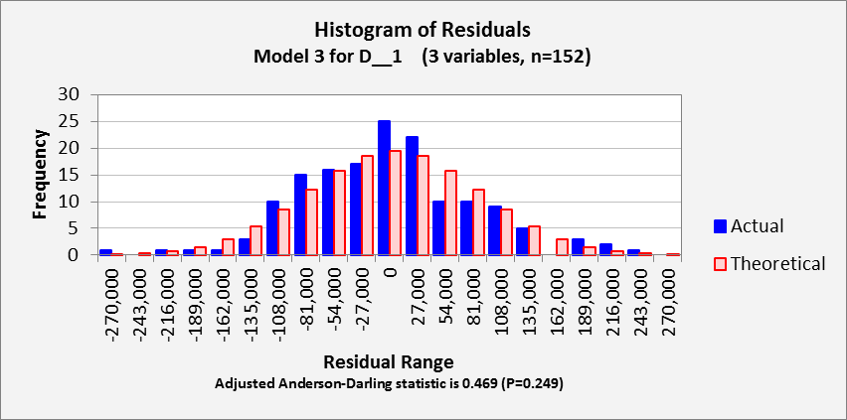
- ARIMA (2,1,0)
Regression Statistics: Model 2 for D__1 (2 variables, n=153)
 | R-Squared | Adj.RSqr | Std.Err.Reg. | # Cases | # Missing | t(2.50%,150) | Conf. level
 | 0.096 | 0.084 | 84,874 | 153 | 3 | 1.976 | 95.0%
Summary Table: Model 2 for D__1 (2 variables, n=153)
Variable | Coefficient | Std.Err. | t-Stat. | P-value | Lower95% | Upper95%
Intercept | 3,840 | 6,870 | 0.559 | 0.577 | -9,734 | 17,415
D__2 | -0.261 | 0.079 | -3.304 | 0.001 | -0.418 | -0.105
D__3 | -0.234 | 0.080 | -2.913 | 0.004 | -0.392 | -0.075
Analysis of Variance: Model 2 for D__1 (2 variables, n=153)
Source | df | Sum Sqrs | Mean Sqr | F | P-value
Regression | 2 | 1.1522E+11 | 57609985830 | 7.997 | 0.001
Residual | 150 | 1.08053E+12 | 7203552651
Total | 152 | 1.19575E+12
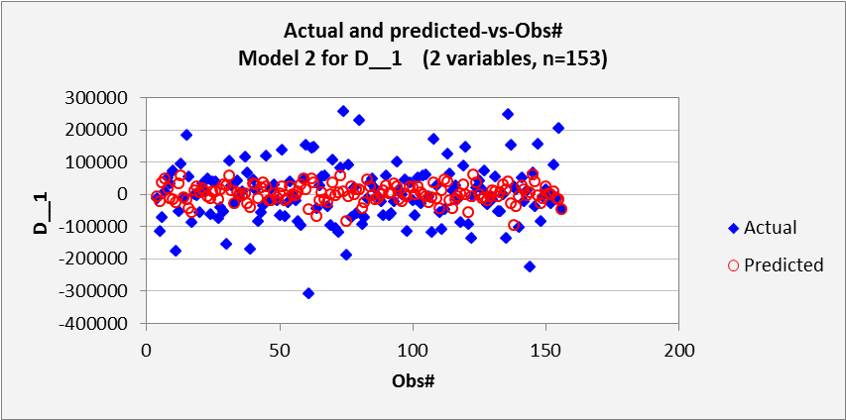
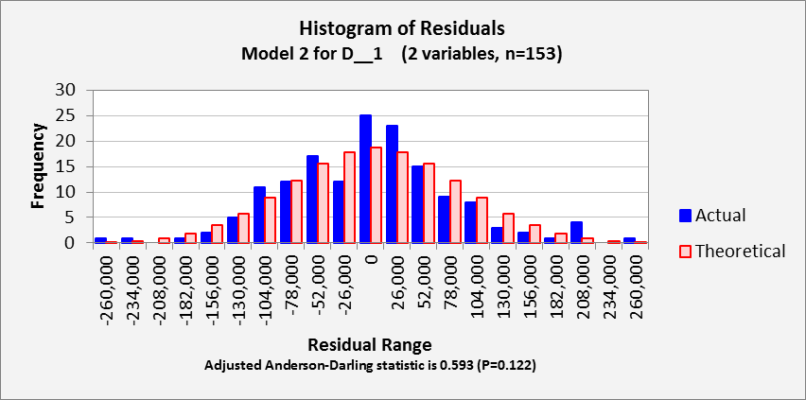

- ARIMA (3,1,0)
Regression Statistics: Model 3 for D__1 (3 variables, n=152)
 | R-Squared | Adj.RSqr | Std.Err.Reg. | # Cases | # Missing | t(2.50%,148) | Conf. level
 | 0.115 | 0.097 | 84,552 | 152 | 4 | 1.976 | 95.0%
Summary Table: Model 3 for D__1 (3 variables, n=152)
Variable | Coefficient | Std.Err. | t-Stat. | P-value | Lower95% | Upper95%
Intercept | 4,324 | 6,870 | 0.629 | 0.530 | -9,251 | 17,900
D__2 | -0.294 | 0.081 | -3.615 | 0.000 | -0.455 | -0.133
D__3 | -0.273 | 0.083 | -3.287 | 0.001 | -0.437 | -0.109
D__4 | -0.145 | 0.082 | -1.771 | 0.079 | -0.308 | 0.017
Analysis of Variance: Model 3 for D__1 (3 variables, n=152)
Source | df | Sum Sqrs | Mean Sqr | F | P-value
Regression | 3 | 1.37452E+11 | 45817259714 | 6.409 | 0.000
Residual | 148 | 1.05805E+12 | 7148963895
Total | 151 | 1.1955E+12
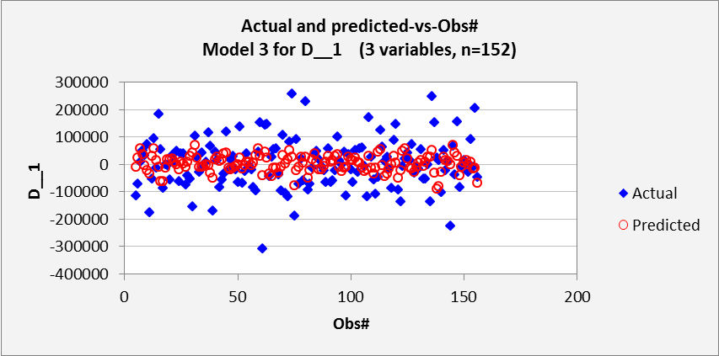
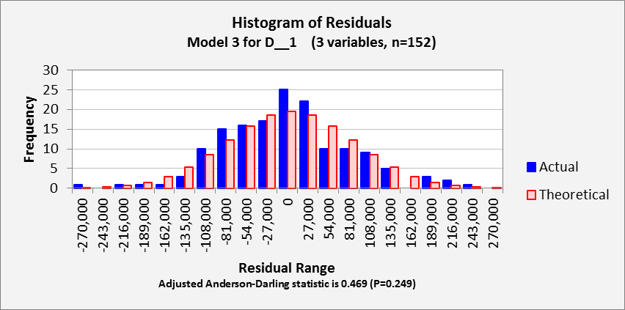

Conclusion
After analyzing the three models, I have concluded that the ARIMA (3,1,0) was the best fit for the data, due to the highest R² and the lowest standard error, as shown in the summary below.
Summary of Regression Model Results
Dependent Variable: D__1
Model | ARIMA (1,1,0) | ARIMA (2,1,0) | ARIMA (3,1,0)
Regression Statistics
R-squared | 0.048 | 0.096 | 0.115
Adjusted R-squared | 0.042 | 0.084 | 0.097
Standard Error of Regression | 87,022.123 | 84,873.745 | 84,551.546
# Cases | 154 | 153 | 152
Regression Coefficients: Beta (p-value)
Intercept | 3933.686 (0.576) | 3840.139 (0.577) | 4324.107 (0.530)
D__2 | -0.22 (0.006) | -0.261 (0.001) | -0.294 (0.000)
D__3 |  | -0.234 (0.004) | -0.273 (0.001)
D__4 |  |  | -0.145 (0.079)

The graph below shows the predicted US Natural Gas Consumption for 2014, using the ARIMA (3,1,0).
