Time Series Project: Burglary Rates

Introduction

Analyzing the pattern of the historic burglary rates gives us good understanding of the social behaviour trend of a society but also allows us to estimate the efficiency of the law enforcements in that area. This project aims to create a forecasting model for the burglary rates in United States.

Data

The data used in this project was collected from the US Disaster Center http://www.disastercenter.com/crime/uscrime.htm. It contains 53 years of information, from 1960 until 2013 and the data is presented as an annual rate per 100,000 people.

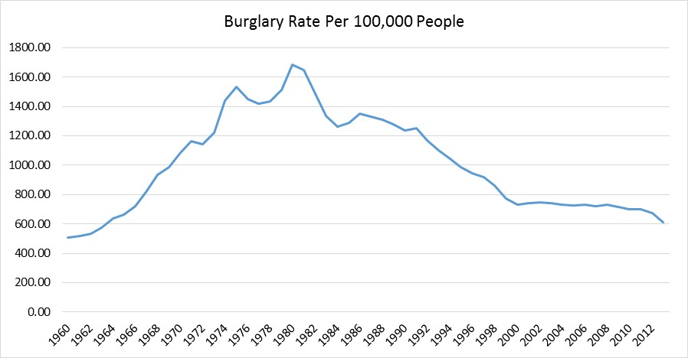

Analysis

From the plot above we can see that the US burglary rates increased between years 1960 to 1980 (from 500 to 1,684 per 100,000 people) followed by downward trend with a faster decrease at first and more steady and consistent decrease afterwards reaching a rate of 610 in year 2013.
To test for stationarity, I calculated the sample autocorrelation function which I included in the graph below.

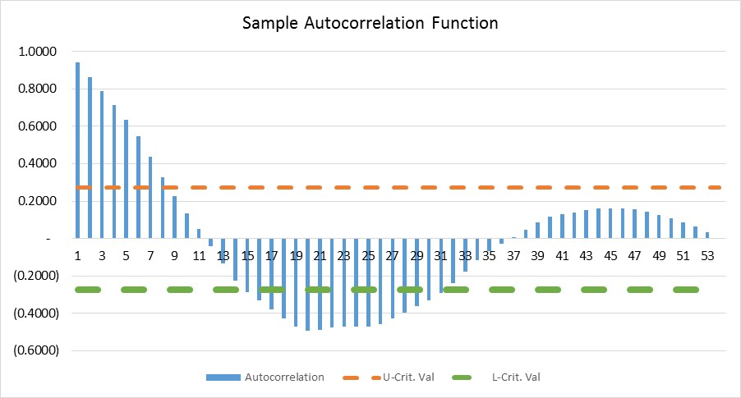

From the graph above, we can see that it does not decline to zero quickly (which implies a very slow decay) and that most of the autocorrelation values are greater than zero which indicates a stationary process. Also based on the lag pattern of the sample autocorrelation which shows a slow decay without cutting off (as it would be the case of a MA model), the series seems more aligned with an autoregressive (AR) model. The stationarity and the appropriatness of an AR model are discussed in more details below.

To be confident that the series is stationary, below I included the graphs for the first difference and the sample autocorrelation for the first difference:

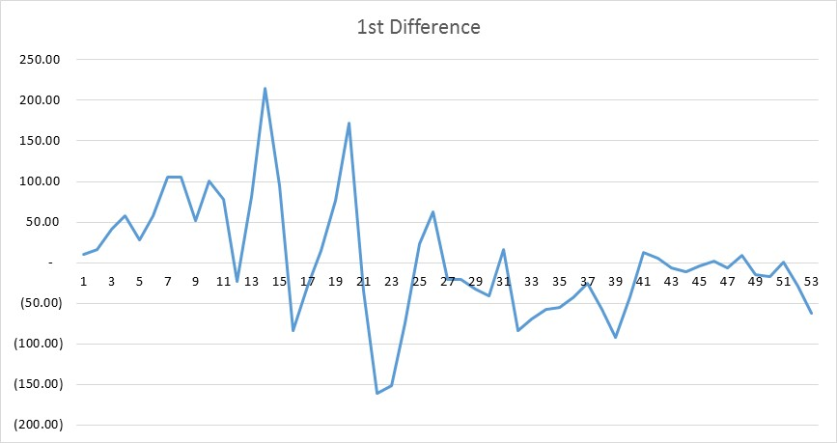

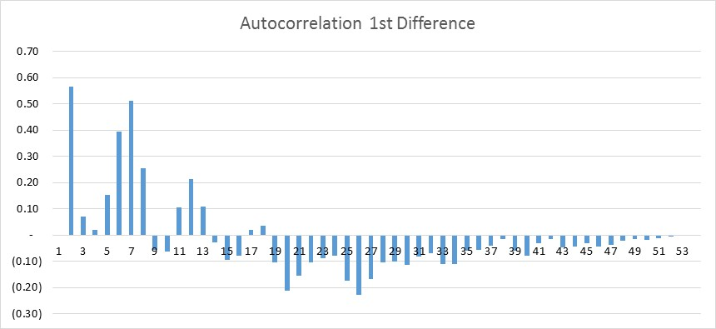

We now can look at the second differences and the sample autocorrelation function of the 2nd differences:
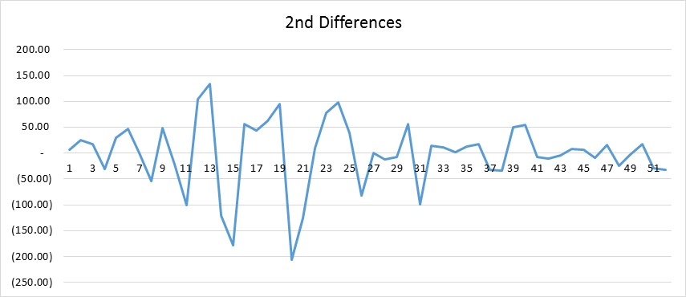

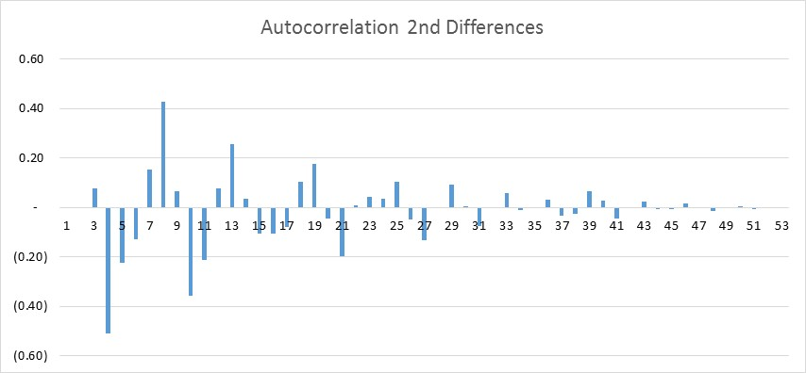

By looking at the results and the graphs of the first and second differences we can see that there are no significant changes. Hence there is a good chance that AR model that we established to teast and use might be equaly good under different number of paramenters. Although we will test this theory, according to the principle of parsimony we should select the model with the smallest numbers of parameters that will represent the series adequately.

Below I tested the appropriateness of the AR(1) and AR(2) models.

AR(1) – the results of the regression ran are included below:

Regression Statistics
Multiple R | 0.9769
R Square | 0.9543
Adjusted R Square | 0.9534
Standard Error | 70.6578
Observations | 53
ANOVA
 | df | SS | MS | F | Significance F
Regression | 1 | 5314391 | 5314391 | 1064.471 | 7.74E-36
Residual | 51 | 254618.4 | 4992.518
Total | 52 | 5569009
 | Coefficients | Standard Error | t Stat | P-value | Lower 95% | Upper 95% | Lower 95.0% | Upper 95.0%
Intercept | 33.6697 | 31.7440 | 1.0607 | 0.2938 | -30.0590 | 97.3984 | -30.0590 | 97.3984
X Variable 1 | 0.9688 | 0.0297 | 32.6262 | 0.0000 | 0.9092 | 1.0284 | 0.9092 | 1.0284

The AR(1) model is: Y_{t} = 33.6697 + 0.9688Y_{t-1} and the predicted values under this model versus the actual values are illustrated in the graph below. The predicted burglary rates under this model fits the actual data very closely, with no gaps which could also be suggested by the high value of adjusted R-square as well.

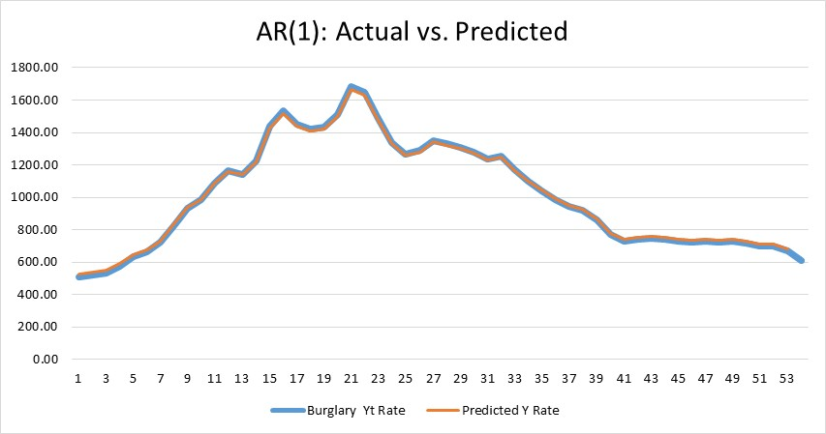

AR(2) – the results of the regression ran are included below:

Regression Statistics
Multiple R | 0.9841
R Square | 0.9684
Adjusted R Square | 0.9671
Standard Error | 58.5132
Observations | 52
ANOVA
 | df | SS | MS | F | Significance F
Regression | 2 | 5145558 | 2572779 | 751.4415 | 1.71E-37
Residual | 49 | 167765.8 | 3423.791
Total | 51 | 5313324
 | Coefficients | Standard Error | t Stat | P-value | Lower 95% | Upper 95% | Lower 95.0% | Upper 95.0%
Intercept | 39.0138 | 27.1378 | 1.4376 | 0.1569 | -15.5217 | 93.5492 | -15.5217 | 93.5492
X Variable 1 | 1.5450 | 0.1173 | 13.1695 | 0.0000 | 1.3092 | 1.7807 | 1.3092 | 1.7807
X Variable 2 | -0.5830 | 0.1158 | -5.0349 | 0.0000 | -0.8157 | -0.3503 | -0.8157 | -0.3503

The AR(2) model is: Y_{t} = 39.0138 + 1.5450Y_{t-1} – 0.5830Y_{t-2} and the predicted values under this model versus the actual values are illustrated in the graph below.

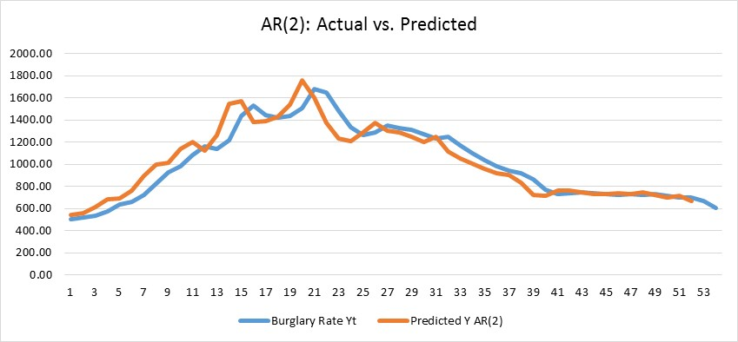

Although the predicted from the AR(2) are not as closely fitted to the actual as the AR(1) model values, the two graphs above, illustrate that both models are reasonably fitted to the historical data. However as stated above, to be consistent with the principle of parsimony, we should select the model with the smallest numbers of parameters given that the extra parameters do not provide a significant improvement.

Conclusions and Recommendations

Based on the results of the analysis, I concluded that AR(1) model is the best fit for this data and to predict future annual burglary rates.

The recommended AR(1) model is:

Y_{t} = 33.6697 + 0.9688Y_{t-1} + e_{t}

Note: For additional calculations or analysis, please refer to the excel file.

