xxx xxxxxx
Time Series Summer 2014
Student Project
Average Price of Airline Ticket

Introduction

For my project I analyzed the average price of a domestic airline ticket in the United States. I used quarterly data from 1995 through the first quarter of 2014.

Data Source

The source of my data was the United States Department of Transportation’s Bureau of Transportation Statistics.

http://www.rita.dot.gov/bts/airfares/national/table

I used the dataset that was adjusted for inflation to remove the impact of inflation over a ten year period.

Analysis

The graph below shows the quarterly average (inflation adjusted) price of a domestic airline ticket from 1995 through Q1 2014.

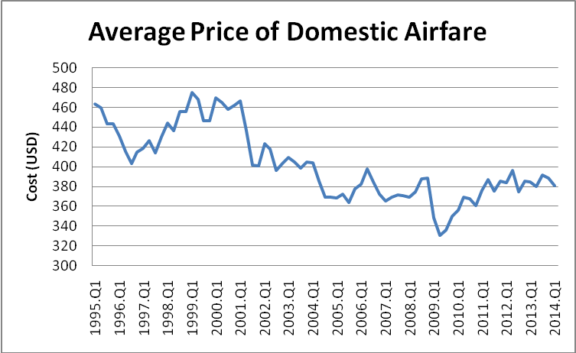
Exhibit 1: Quarterly Average Price of a Domestic Airline Ticket from 1005 through Q1 2014

Exhibit 1 shows that the average price has generally decreased from 1999 through 2009, and has been increasing since. Sample autocorrelation will then be analyzed in order to test for stationarity.
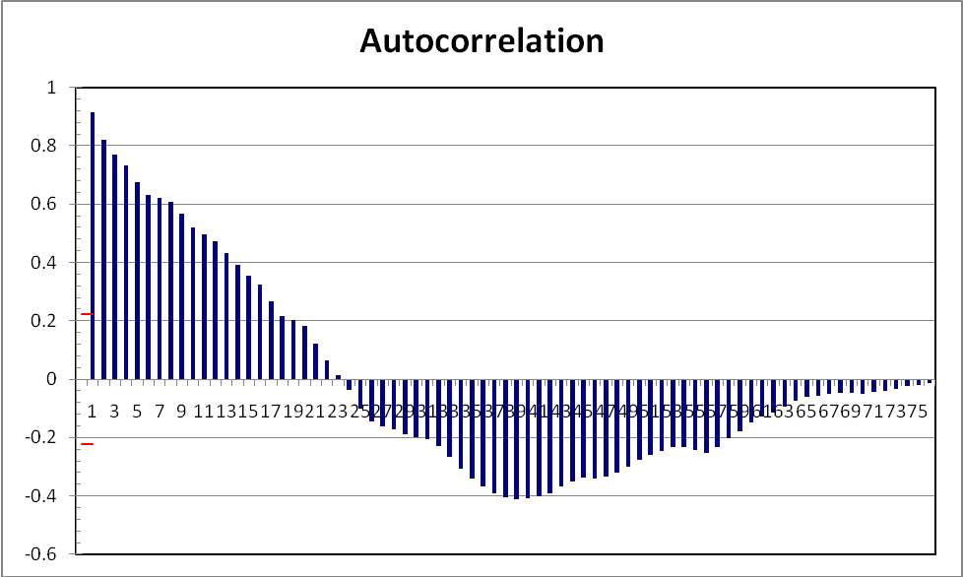
Exhibit 2: Sample Autocorrelation of Zero Difference

Exhibit 2 shows that the average price of a domestic airline ticket does not appear to be a stationary process since the autocorrelation does not cut off to zero as the lags increase.

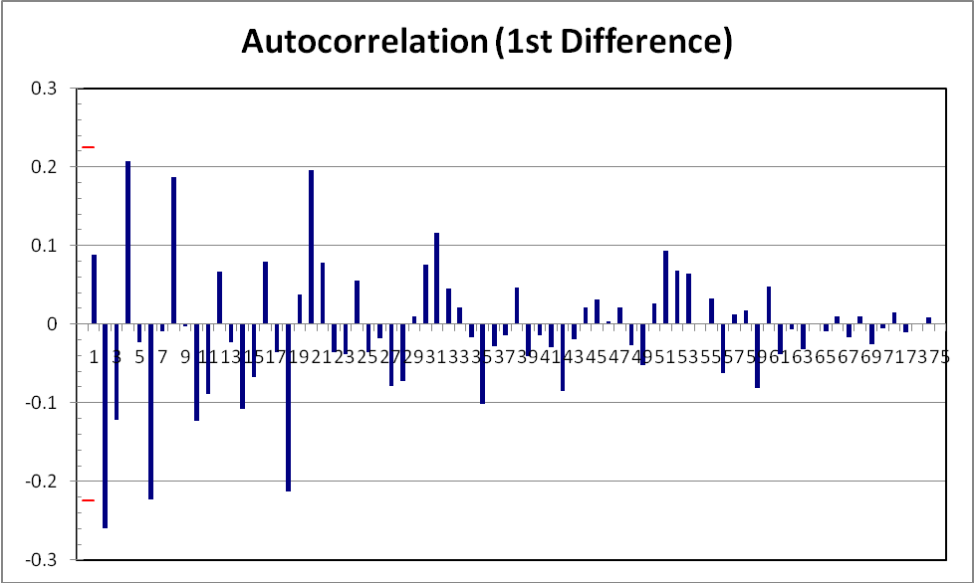
Exhibit 3: Sample Autocorrelation of 1st Difference

Exhibit 3 shows the sample autocorrelations of the first difference oscillate strongly in the early lags (lags 1-20). This graph shows that the sample autocorrelations tend to cut off to zero when lags increase, which implies the process is stationary.

Exhibits 4 and 5 below show scatter plots of Y_{t} versus Y_{t-1} and Y_{t} versus Y_{t-2} which check for trends of correlation.

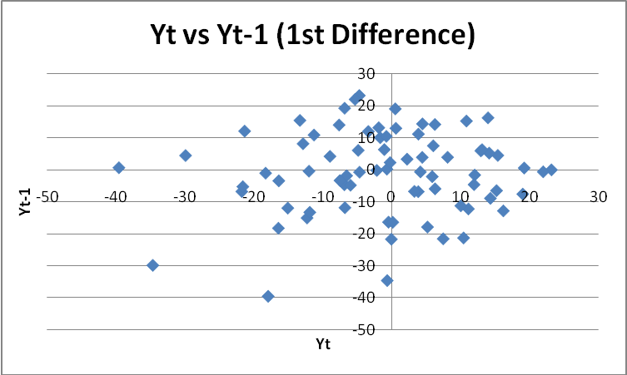
Exhibit 4: Scatter Plot of Y_{t} versus Y_{t-1} of First Difference

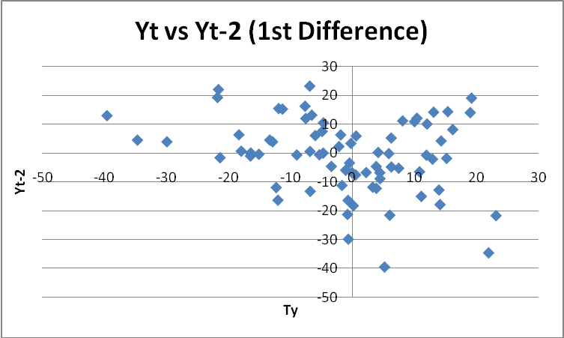
Exhibit 5: Scatter Plot of Y_{t} versus Y_{t-2} of First Difference

There doesn’t appear to be any correlation for lag 1 of the first differences in Exhibit 4, while Exhibit 5 shows a slight positive correlation in lag 2 of the first difference.

In order to confirm the 1st difference is a stationary process, the 2nd difference is also evaluated since the 1st difference of a stationary process is always a stationary process.

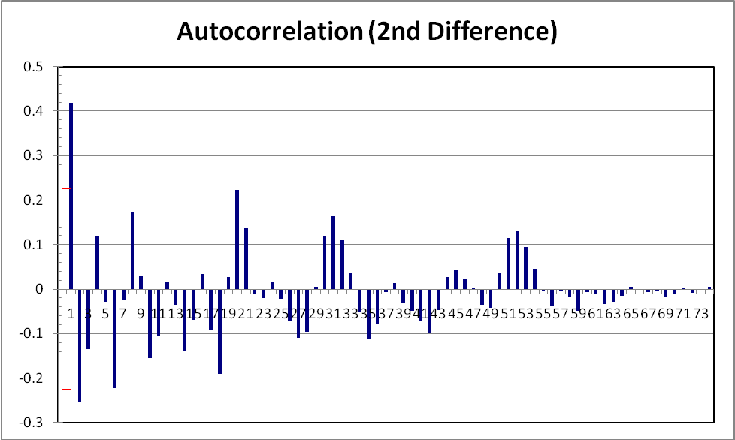
Exhibit 6: Sample Autocorrelation of 2nd Difference

Exhibit 6 above also shows 2nd difference is a stationary process and the sample autocorrelation tends to oscillate and approach zero faster than the 1st difference.

Exhibit 7: Scatter Plot of Y_{t} versus Y_{t-1} of First Difference

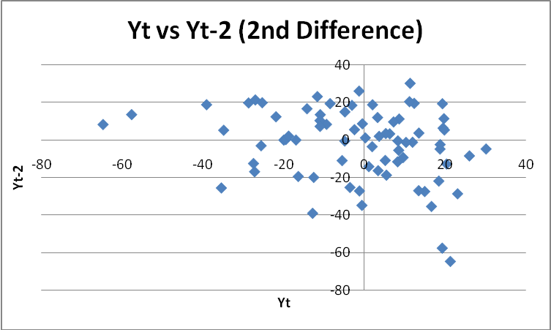
Exhibit 8: Scatter Plot of Y_{t} versus Y_{t-2} of First Difference

Exhibits 7 and 8 above both show a slight negative correlation in lag 1 and lag 2, respectively, of the 2nd difference.

From the above Exhibits, it is reasonable to assume that both 1st and 2nd differences are stationary. An ARIMA model will be used to test for model specification.

Model Specifications
Model | ARIMA(0,1,1) | ARIMA(1,1,0) | ARIMA(1,1,1) | ARIMA(2,1,1) | ARIMA(1,1,2) | ARIMA(1,2,1) | ARIMA(2,2,1) | ARIMA(1,2,2) | ARIMA(2,2,2)
# of Obsv. | 76 | 75 | 75 | 74 | 75 | 74 | 73 | 74 | 73
Coefficients:
φ₁ | N/A | 0.0943 | (0.4548) | 0.2506 | 0.5396 | 0.1164 | 0.1152 | 0.9204 | 0.3982
φ₂ | N/A | N/A | N/A | (0.2785) | N/A | N/A | (0.3018) | N/A | (0.1518)
Θ₁ | 0.1689 | N/A | 0.5970 | (0.1501) | (0.4664) | 0.9804 | 1.0382 | 0.0263 | 0.6421
Θ₂ | N/A | N/A | N/A | N/A | (0.2404) | N/A | N/A | (0.9855) | (0.4636)
R² | 0.0096 | 0.0022 | 0.0274 | 0.0774 | 0.0790 | 0.5447 | 0.6117 | 0.5613 | 0.6145
S.E. of Regression | 12.82 | 12.95 | 12.87 | 12.59 | 12.61 | 12.99 | 12.12 | 12.84 | 12.16
Durbin-Watson | 2.06 | 1.93 | 2.04 | 2.00 | 1.97 | 1.95 | 1.91 | 1.74 | 1.66
Exhibit 9: ARIMA Model Specification Summary

The table in Exhibit 9 shows the results from running nine ARIMA models with differing p, d and q parameters.

The ARIMA(2,2,1) and the ARIMA(2,2,2) models have the highest R² values. The Durban-Watson values for both of these models are relatively close to 2, suggesting that the residuals aren’t correlated. Since the R² values for these two models are close, the principal or parsimony suggests that selecting the model with the fewest number of parameters that adequately represents the time series should be selected. Therefore, the ARIMA(2,2,1) model is most appropriate model.

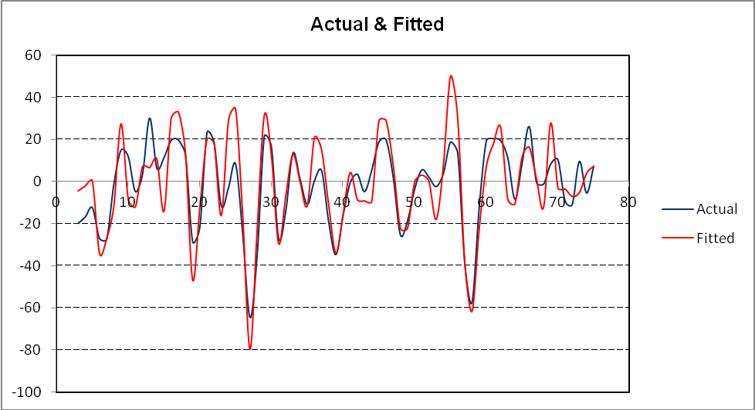
Exhibit 10: ARIMA(2,2,1) Fitted Model vs Actual

The above shows the fitted ARIMA(2,2,1) model compared to the historic data. Based on the above analysis, this model best predicts future price of a domestic airline ticket. Please see the accompanying excel file for more details.

