Daniel Makrides
Time Series Winter 2015 Final Project

US Birth Rates and GDP

I decided to do my project on US Birth Rates using data from 1964 through 2014. I would test to see if this data could be modeled by an ARIMA time series or if it would need to first be transformed, either through segmentation, or differencing. I also decided to regress this data against US GDP growth rates lagged one year to see if using GDP as an explanatory variable produced a better fitting Time Series. Ultimately it seems reasonable that using GDP as an explanatory variable would be reasonable considering economic conditions should play a large factor in the decision to have a child in a developed country like the US.

Data

US Birth Rate data comes from the CDC (http://www.cdc.gov/nchs/births.htm ) and US GDP data comes from the Bureau of Economic Analysis (http://www.bea.gov/national/index.htm#gdp ). The birth rates are per 1000 individuals and are from 1964 – 2014, while the US GDP data is from 1963 – 2013. I chose to use annual data to reduce the need for seasonality adjustments as it is clear that GDP and birth rates are influenced by seasonal factors.

Analysis

Looking at the US Birth Rate data from 1964 – 2014, pictured below, you can see that although rates are declining overall, there appears to be clear smaller trends indicating a variable mean over time. As such, I decided to segment the data into smaller homogenous periods before testing for stationarity, ultimately using the period from 1990 – 2014 which looked more consistent (source – ‘Birth Data’ tabs in excel).

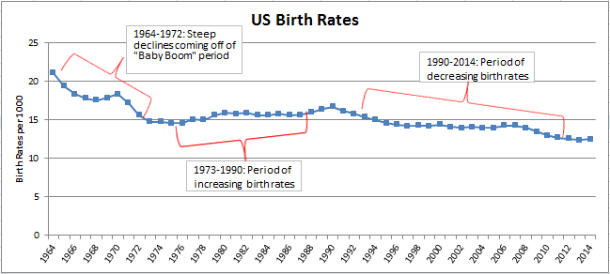
The strong negative trend indicates non-stationarity in this smaller sample and this is further confirmed by looking at the sample ACF for the period 1990 - 2014. You can see that the ACF at early lags does not decrease geometrically, takes several lags before dropping to zero, and then stays negative for several more lags. It is possible that the ACF’s past lag 2 are statistically white noise using 2/sqrt(n=25), but lag 20 and 21 are beyond these “standard deviations” and could suggest statistically significant deviations from zero. I therefore proposed taking 1st differences of the original data and testing again for stationarity.

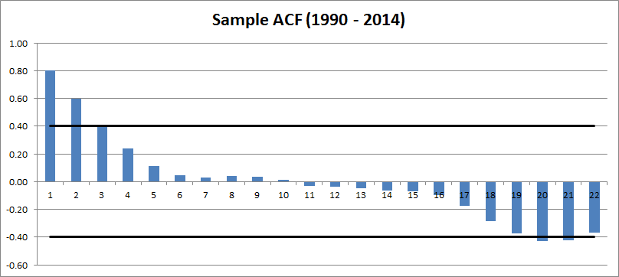

Looking at the chart below, you can see that the first differences oscillate about zero (although not so much in the first few years), indicating stationarity and suggesting differencing was able to detrend the data (I did try taking 2nd differences, but that ended up creating a correllogram that was just a white noise process, so I did not continue down that road…see the ‘Birth Data (1990-2014)’ tab in excel).

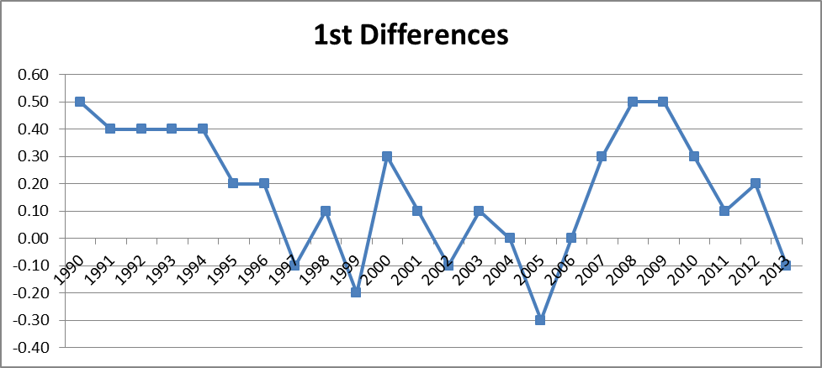

Furthermore, if we look at the sample ACF of 1st differences, we can see that after lag 2, the ACF drops to zero and never deviates beyond what could be considered white noise or statistically differerent from zero. At first glance, my best guess would be that this series could be explained by either an AR(1) or AR(2) process, which we will test for.

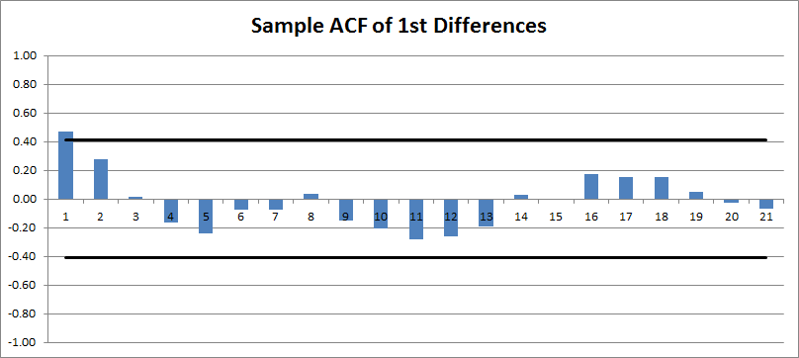

1st Difference Birth Rate ARIMA Model Fitting

An AR(1) fits the first differences of each year's birth rate to the form:

Excel regression was performed using Y_{t} as the dependant and Y_{t-1} as the explanatory variable, taking ϕ as the X coefficient and ϴ as the intercept.

SUMMARY OUTPUT
Regression Statistics
Multiple R | 0.511385201
R Square | 0.261514824
Adjusted R Square | 0.226348863
Standard Error | 0.199764163
Observations | 23

 | Coefficients | Standard Error | t Stat | P-value
Intercept | 0.06655481 | 0.054140381 | 1.229300735 | 0.23255564
Y(t-1) | 0.504474273 | 0.184991643 | 2.727011144 | 0.012629176

The R Squared value of 0.26 is quite low and the intercept and Y(t-1) coefficient are not statistically significant at the 0.01 level, indicating this is not perhaps a good model and leaves room for improvement. This is especially apparent with the intercepts p-value of 0.23 meaning we can’t be so confident this value is non-zero.

Next an AR(2) model fits the data to the form:

Excel regression was performed using Y_{t} as the dependent and Y_{t-1} and Y_{t-2} as the explanatory variables, taking ϕ₁ as the X₂ coefficient, ϕ₂ as the X₂ coefficient and ϴ as the intercept.

SUMMARY OUTPUT
Regression Statistics
Multiple R | 0.482824214
R Square | 0.233119221
Adjusted R Square | 0.152394929
Standard Error | 0.208301001
Observations | 22

 | Coefficients | Standard Error | t Stat | P-value
Intercept | 0.059494912 | 0.060098138 | 0.989962663 | 0.334632974
Y(t-1) | 0.432113522 | 0.238431807 | 1.812314922 | 0.085771883
Y(t-2) | 0.085141596 | 0.227734294 | 0.373863746 | 0.712645029

In this higher order model, the R square value of 0.23 is actually worse than the AR(1) model, and the Y(t-2) coefficient has an extremely high p-value, casting doubt on this models accuracy and being that the coefficient is already close to zero, it is likely that it is effectively zero.

Overall, using 1st differences of absolute birth rates does not appear to generate a good fitting ARIMA model, so we will now investigate using GDP Growth rates, lagged one year as an explanatory variable for birth rates, and see if the residuals can be fitted to an ARIMA model.

US Birth Rates and GDP Growth Rates

I took the logs of US GDP and then first differences as a proxy for GDP growth rates. The hypothesis is that changes in the growth rate of GDP in one year can be a predictor of US birth rates in the following year. Below you can see a graph illustrating this lagged relationship which visually appears to be reasonable, especially around the time of the 2008 Great Recession which precedes a steeper decrease in birth rates. I also graphed the residuals produced from regressing birth rates (dependent variable) against GDP growth rates (explanatory variable), and from looking at the graph it seems reasonable that this is a stationary process, although the first several data points look distorted from the Baby Boom period.

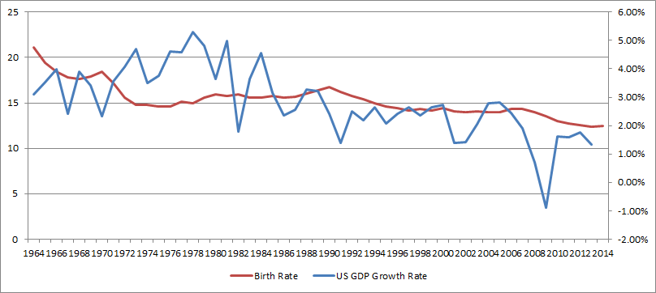

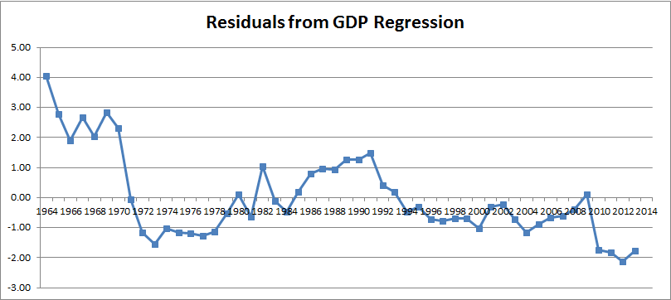

To confirm stationarity of this time series, I graphed the ACF of the residuals which is pictured below. Here you can see a pattern of a high ACF at lag 1 and 2, followed by ACF’s dropping steeply and then fluctuating within 2 estimated deviations of zero (2/sqrt(n=50)) and thus indistinguishable from white noies past lag 4. This seems to support the idea of an AR(p) ARIMA model for this seemingly stationary process. Next we will test an AR(1) and AR(2) model and see if this gives a better ARIMA model than the absolute birth rates tested earlier.

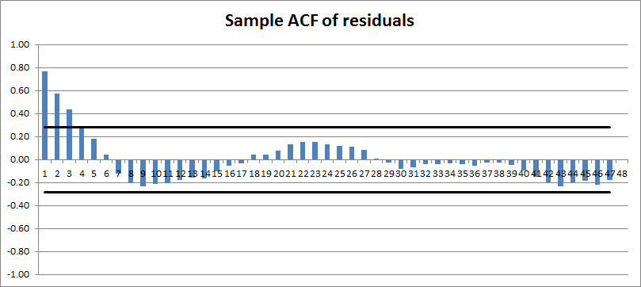

Residual ARIMA Model Fitting

An AR(1) fits the residuals of the lagged GDP/Birth Rate regression to the form:

Excel regression was performed using Y_{t} as the dependant and Y_{t-1} as the explanatory variable, taking ϕ as the X coefficient and ϴ as the intercept.

SUMMARY OUTPUT
Regression Statistics
Multiple R | 0.859709786
R Square | 0.739100916
Adjusted R Square | 0.733549872
Standard Error | 0.658393711
Observations | 49

 | Coefficients | Standard Error | t Stat | P-value
Intercept | -0.113957292 | 0.094095608 | -1.21107982 | 0.231919375
Y(t-1) | 0.796488017 | 0.069026321 | 11.53890299 | 2.58975E-15

Right away we can see this model has a much higher R-square value than the previous AR(p) models. Also, the p-value of the Y(t-1) coefficient is extremely small which is also promising, suggesting the coefficient is clearly non-zero and significant. However, for thoroughness we will test an AR(2) model as well.

Next an AR(2) model fits the data to the form:

Excel regression was performed using Y_{t} as the dependant and Y_{t-1} and Y_{t-2} as the explanatory variables, taking ϕ₁ as the X₂ coefficient, ϕ₂ as the X₂ coefficient and ϴ as the intercept.

SUMMARY OUTPUT
Regression Statistics
Multiple R | 0.842403462
R Square | 0.709643593
Adjusted R Square | 0.696738864
Standard Error | 0.670599692
Observations | 48

 | Coefficients | Standard Error | t Stat | P-value
Intercept | -0.104269964 | 0.09838749 | -1.059788835 | 0.294896101
Y(t-1) | 0.830149205 | 0.148620796 | 5.585686693 | 1.28133E-06
Y(t-2) | -0.017416126 | 0.138309649 | -0.125921267 | 0.900355169

Here as well, we have a high R-square value and an extremely low p-value for the Y(t-1) coefficient. However, the Y(t-2) coefficient has a very high p-value, casting doubt on the efficacy of using an AR(2) model and suggesting a zero coefficient. Even if all things were equal, the principle of parsimony says to take the simpler model unless a significant improvement can be made. Therefore I would definitely lean toward the AR(1) model for the residuals.

Durbin-Watson Statistic

Now that we have 4 potential ARIMA models (an AR(1) and AR(2) for the absolute birth rates, and an AR(1) and AR(2) for the residuals of the GDP/Birth Rate regression), we can test for serial correlation to further analyze which model is most appropriate. A Durbin-Watson statistic of 2 indicates no serial correlation. The following are the results for the four regressions:

Absolute Birth Rate |  | Residual of GDP/Birth Rate
ARIMAModel | DWS | ARIMA Model | DWS
AR(1) | 2.041 | AR(1) | 1.927
AR(2) | 1.900 | AR(2) | 2.007

For all 4 models, the Durbin Watson Statistics are close to 2, indicating no serial correlation among the residuals. This supports the expectation that the residuals should be a stochastic process if we are choosing the correct model. This result was expected, at least empirically, when looking at the residual plots from each regression. The plots showed no clear pattern and indicated a stochastic relationship (the residual plots can be seen on each red tab in the excel workbook). Again, we are still leaning toward the AR(1) model of the residuals of GDP/Birth Rate relationship.

Box-Pierce Q Statistic

The Box Pierce Q Statistic(BPQS) is used to test if the residuals are a white noise process, which is what we would expect if the ARIMA model chosen is correct. This statistic is estimated using the following formula:

$$\text{BPQS}=T\sum_{k=1}^{K}{{\hat{r}}_{k}^{2}}$$
The Box-Pierce Q statistic has a χ² distribution with K-p-q degrees of freedom. If the BPQS is greater than the critical value at a 10% level we would reject the null hypothesis that the residuals are indeed a white noise process, casting doubt on the appropriateness of the ARIMA model generating said residuals.

If you look at the 4 tabs in the excel workbook colored red, you can see that for each model, we cannot reject the null hypothesis that the residuals are white noise, as the BPQS is lower than the critical value for every K. I will show the results at K=10 below just as an example. Notice the high p-values telling us with good certainty that we will not reject the null that these residuals are white noise.

ARIMA Model | BPQS | Crit Value | p-value
AR(1) | 1.67081 | 14.68366 | 0.99567
AR(2) | 1.34707 | 14.68366 | 0.99813
AR(1) GDP Residual | 4.55085 | 14.68366 | 0.87158
AR(2) GDP Residual | 5.63761 | 14.68366 | 0.77557

Conclusion

In conclusion I have determined that using absolute birth rates did not provide a good basis for fitting an ARIMA model. I saw that the data had clear trends over time indicating a variable mean and therefore first tried segmenting the data (choosing 1990-2014) and taking first and second differences (‘Birth Data (1990-2014)’ tab in excel) to remove trends. The resulting correllogram of first differences weakly appeared to reflect an AR(p) process, and thus I tested AR(1) and AR(2) models. However as seen in the summary chart below, these two models had very low R-square values, and the Y(t-1) and Y(t-2) coefficients, respectively, had high p-values, ultimately leading me to reject their usefulness.

As an alternative I tried regressing the birth rates against GDP growth rates from the prior year to see if the residuals of this regression would be a better fit for an ARIMA process. The correllogram produced from the ACF’s of these residuals exhibited the tell-tale signs of a AR(p) model much better than the first attempt using absolute birth rates (namely a high lag 1 ACF followed by geometrically declining ACF’s eventually dropping to zero). When fitting the AR(1) and AR(2) models, the key results were very similar but the AR(1) model had a slightly higher R-squared value. Ultimately, using the principle of parsimony, I used the simpler model as my final choice. The results are summarized below for reference.

 | ARIMA Model | R-Squared Value | Durbin-Watson Statistic | BPQS  Result
Absolute Birth Rates (1990-2014) | AR(1) | 0.262 | 2.041 | Do Not Reject
Absolute Birth Rates (1990-2014) | AR(2) | 0.233 | 1.901 | Do Not Reject
Residuals of GDP/Birth Rate Regression (1964-2014) | AR(1) | 0.739 | 1.927 | Do Not Reject
Residuals of GDP/Birth Rate Regression (1964-2014) | AR(2) | 0.710 | 2.007 | Do Not Reject

Finally, using the chosen AR(1) model with the following equation, I ended up graphing the actual residuals versus the predicted residuals seen below.

$Y_{t}$= −0.114 + 0.796$Y_{t−1}$+ $ε_{t}$

