Modeling average age of women at first birth in Korea 1981 - 2014
NEAS Time Series
Spring 2016 Semester
xxxxxxx xxxxx

Contents
Introduction: 2
Data: 2
Plot of data:………………………………………………………………………………………………………………………………………………………….2
Model Selection 3
Forecasting Results 7
Conclusion 8

Introduction:

In many developed countries, the average age of women at first birth has risen over the past decades. This could be due to many factors including more women staying in the workforce after marriage, increasing housing and living cost, and so on. As delayed childbearing affects the future population growth in Korea, I wanted to understand this phenomenon further. The main goal of this paper is to determine a time series model to forecast the average age of Korean female women at first birth.

Data:
The data used for this project comes from the Korean Statistical Information Services (KOSIS). KOSIS began constructing their statistical database from 1976, and served as a national statistical database service for use by government agencies since 1991.

The URL for the data table is as follows:
http://kosis.kr/statHtml/statHtml.do?orgId=101&tblId=DT_1B80A01&conn_path=I2&language=en

In order to obtain all years used, one must click "Time" tab, select all prior years, and hit search button to refresh data. In this project, I used all data points from year 1981 to 2014.

Plot of data:
Exhibit 1 shows a graph of the average age of Korean women at first birth. X-axis represents the year, and Y-axis represents the average age of Korean women at first birth. It is clear that there is an increasing trend since 1984.
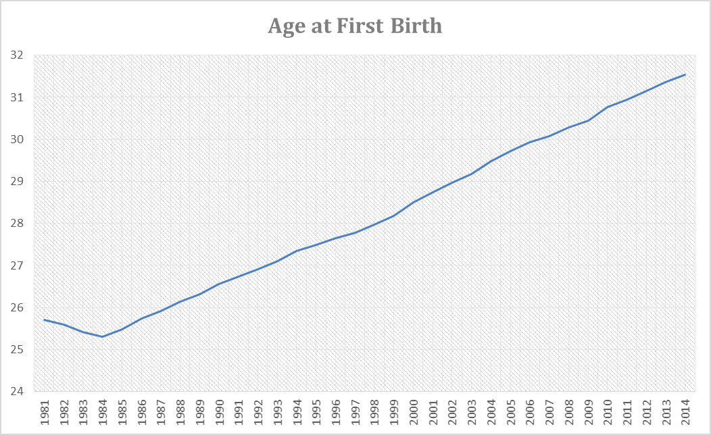
[Exhibit 1. Age at First Birth]

Model Selection
Various models will be fit to the data series in order to select a model that will provide the best estimate.
First, to help in selecting a tentative model, I further look at the sample autocorrelation function (ACF). Formula used for calculating the sample autocorrelation function is as follows:
$r_{k}=\frac{\sum_{t=k+1}^{n}{\left(Y_{t}−\overline{Y}\right)\left(Y_{t−k}−\overline{Y}\right)}}{\sum_{t=1}^{n}{{\left(Y_{t}−\overline{Y}\right)}^{2}}}$ , where k is from 1 to 33
Exhibit 2 below shows a graph of ACF and lag. X-axis represents the lag and Y-axis represents the value of autocorrelation between -1 and 1. It clearly shows that there is a slow decaying pattern. This implies that the time series is not stationary.
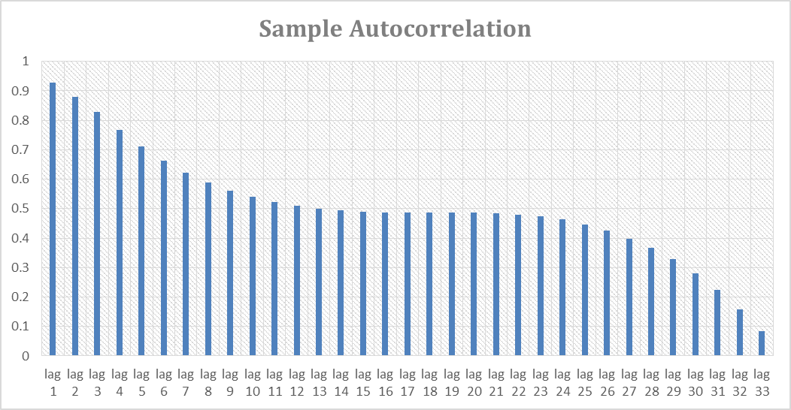
[Exhibit 2. Sample Autocorrelation]
Exhibit 3 shows the summary statistics of the data series.

Summary Statistics | 1981 – 2014
Mean | 28.1299739
Standard Error | 0.3411827
Median | 27.8808028
Standard Deviation | 1.98941989
Sample Variance | 3.9577915
Kurtosis | -1.2853888
Skewness | 0.18416989
Range | 6.23716212
Minimum | 25.3040958
Maximum | 31.5412579
Sum | 956.419111
Count | 34
Confidence Level (95.0%) | 0.69414142
[Exhibit 3. Summary Statistics]
We can also test if the time series is stationary by fitting AR(1) model. I used the Excel regression add-in to fit the data to the following AR(1) model:
The result is shown in the below exhibit.
SUMMARY OUTPUT
Regression Statistics
Multiple R |  |  | 0.99870
R Square |  |  | 0.99740
Adjusted R Square |  |  | 0.99732
Standard Error |  |  | 0.10215
Observations |  |  | 33.00000
ANOVA
 |  |  | df |  | SS |  | MS |  |  | F |  |  |  | Significance F
Regression |  | 1 |  |  | 124.204 |  | 124.204 |  |  | 11902.751 |  |  |  | 1.200E-41
Residual |  | 31 |  |  | 0.323 |  | 0.010
Total |  | 32 |  |  | 124.527
 | Coefficients |  |  | Standard Error |  |  |  | t Stat |  |  | P-value |  | Lower 95% |  |  | Upper 95% |  | Lower 95.0% |  | Upper 95.0%
Intercept | -0.47536 |  |  | 0.26347 |  |  |  | -1.80421 |  |  | 0.08092 |  | -1.01271 |  |  | 0.06199 |  | -1.01271 |  | 0.06199
X Variable 1 | 1.02328 |  |  | 0.00938 |  |  |  | 109.09973 |  |  | 0.00000 |  | 1.00415 |  |  | 1.04240 |  | 1.00415 |  | 1.04240
[Exhibit 4. AR(1) Summary Output]
The series is represented by:
Y_{t} = -0.47536 + 1.02328Y_{t-1} + ε_{t}
Where θ₀ = -0.47536, φ = 1.02328. This confirms that the model is not stationary, since φ > 1.
Since the time series is non-stationary, most likely due to a clear increasing trend, I will take first differences create a stationary time series. Since the correlogram in the below exhibit shows no spikes after lag 3 and remains near zero further out, this is a good method to make a time series stationary.

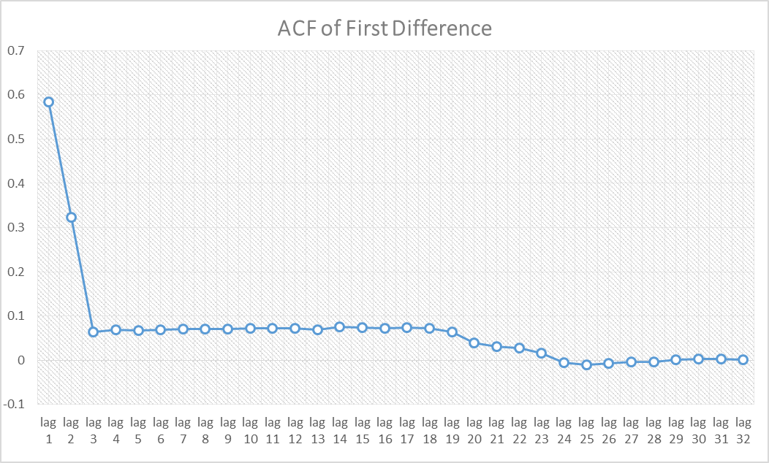
[Exhibit 5. Autocorrelation of First Difference]
After we take the first difference of the original time series, we can then describe the transformed series by the autoregressive model with different orders as listed below:

$$Y_{t}=δ+\sum_{i=1}^{p}{φ_{i}Y_{t−i}}+ε_{t}$$
where $Y_{t}$ is the difference in observed average age of Korean female at first birth between time t and t-I,
$δ$ is a constant, $φ_{i}$ is the coefficients for lag i data, $ε_{t}$ is the error term at time t,$p$ is the order of auto-regression to be determined.
I used the Excel regression add-in to fit the data to the following AR(1) and AR(2) model:
SUMMARY OUTPUT
Regression Statistics
Multiple R |  |  | 0.66386
R Square |  |  | 0.44071
Adjusted R Square |  |  | 0.42207
Standard Error |  |  | 0.07486
Observations |  |  | 32
ANOVA
 |  |  | df |  | SS |  | MS |  |  | F |  |  |  | Significance F
Regression |  | 1 |  |  | 0.132 |  | 0.132 |  |  | 23.639 |  |  |  | 3.439E-05
Residual |  | 30 |  |  | 0.168 |  | 0.006
Total |  | 31 |  |  | 0.301
 | Coefficients |  |  | Standard Error |  |  |  | t Stat |  |  | P-value |  | Lower 95% |  |  | Upper 95% |  | Lower 95.0% |  | Upper 95.0%
Intercept | 0.08271 |  |  | 0.20504 |  |  |  | 3.30302 |  |  | 0.00248 |  | 0.03157 |  |  | 0.13385 |  | 0.03157 |  | 0.13385
X Variable 1 | 0.58450 |  |  | 0.12022 |  |  |  | 4.86204 |  |  | 0.00003 |  | 0.33899 |  |  | 0.83002 |  | 0.33899 |  | 0.83002
[Exhibit 6. AR(1) Summary Output]
SUMMARY OUTPUT
Regression Statistics
Multiple R |  |  | 0.53252
R Square |  |  | 0.28357
Adjusted R Square |  |  | 0.23240
Standard Error |  |  | 0.06578
Observations |  |  | 31
ANOVA
 |  | df |  | SS |  |  | MS |  |  | F |  |  | Significance F
Regression |  | 2 |  | 0.048 |  |  | 0.024 |  |  | 5.541 |  |  | 9.384E-03
Residual |  | 28 |  | 0.121 |  |  | 0.004
Total |  | 30 |  | 0.169
 | Coefficients |  |  |  | Standard Error |  |  | t Stat |  | P-value |  | Lower 95% |  |  | Upper 95% |  | Lower 95.0% |  | Upper 95.0%
Intercept | 0.12202 |  |  |  | 0.02576 |  |  | 4.73654 |  | 0.00006 |  | 0.06925 |  |  | 0.17479 |  | 0.06925 |  | 0.17479
X Variable 1 | 0.36613 |  |  |  | 0.16078 |  |  | 2.27715 |  | 0.03678 |  | 0.03678 |  |  | 0.69547 |  | 0.03678 |  | 0.69547
X Variable 2 | 0.04207 |  |  |  | 0.14183 |  |  | 0.29666 |  | 0.76892 |  | -0.24844 |  |  | 0.33259 |  | -0.24844 |  | 0.33259
[Exhibit 7. AR(2) Summary Output]
The result is summarized as follows:
ARIMA(1,1,0): Y_{t} = 0.08271 + Y_{t-1} + 0.58450(Y_{t-1}-Y_{t-2}) + ε_{t}
ARIMA(2,1,0): Y_{t} = 0.12202 + Y_{t-1} + 0.36613(Y_{t-1}-Y_{t-2}) - 0.04207 (Y_{t-2}-Y_{t-3}) + ε_{t}
Both models have absolute values Σφ_{ι} of less than 1, which indicates that the transformed times series is stationary. Because ARIMA(1,1,0) model has higher R² and adjusted R², I will use that model to forecast.

Forecasting Results
Based on the result of above analysis, ARIMA(1,1,0) model used for the data is
Y_{t} = 0.08271 + Y_{t-1} + 0.58450(Y_{t-1}-Y_{t-2}) + ε_{t}
Since Y₂₀₁₄ = 31.54126 and Y₂₀₁₃ = 31.35947, we can forecast the average age at first birth for 2015 as follows:
Y₂₀₁₅ = 0.08271 + Y₂₀₁₄ + 0.58450 x (Y₂₀₁₄ - Y₂₀₁₃)
= 0.08271 + 31.54126 + 0.58450 x (31.54126 - 31.35947)
= 31.73023
Similarly, we can use the predicted life expectancy in 2015 to forecast the life expectancy in 2016.
Y₂₀₁₆ = 0.08271 + Y₂₀₁₅ + 0.58450 x (Y₂₀₁₅ - Y₂₀₁₄)
= 0.08271 + 31.54126 + 0.58450 x (31.54126 - 31.35947)
= 31.92339

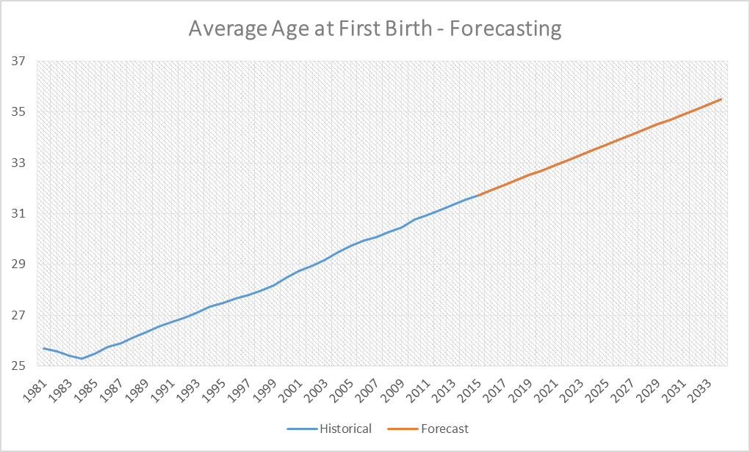
[Exhibit 8. Forecasting using ARIMA(1,1,0)]

Conclusion
Average age of women at first birth in Korea was examined in this paper. After fitting different models, ARIMA(1,1,0) was selected as a model with the best fit. There has been an obvious increasing trend in past 30 years, and the trend is expected to continue in future years. Using the ARIMA(1,1,0) fitted model, the 2015 average age of women at first birth in Korea was forecasted to be 31.73.

