xxxx xxxxxx
Time Series Project – Spring 2016

Time Series Analysis for Dental Claim Costs

A key component of pricing dental insurance is to trend or forecast future claims from the experience period to the effective period. Trend is the increase in claims cost from one period to the other that is rooted in dentist’s contractual increases, utilization mix, and underlying population mix. This paper introduces the use of time series analysis to predict future dental claim amounts on a per employee per month (PEPM) basis.

Microsoft excel was used to formulate the data and to perform initial graphs, but R software was utilized to develop the actual time series components of the analysis. To complete the analysis, we first had to determine if the time series was stationary, and if it was deemed to be non-stationary then by taking the first, second, or a seasonal difference we could transform the time series into being stationary.

After we have a stationary time series, a correlogram of the time series is used to determine the type of ARIMA model to be used. A Q-Q plot is used to analyze the normality of the residuals to determine the appropriateness of the model. Finally, the time series was forecasted.

Analysis

Here is the original plot of the time series data:
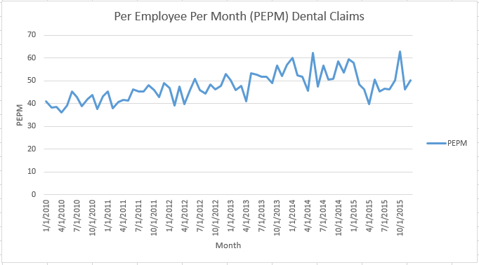

We use the per employee per month claim cost to average out an employer’s claim cost by month. Dental claims are more elective than health claims, and therefore are more subject to seasonality of when people (primarily children) are free of responsibilities. Meaning that dental claims are subject to seasonality in March, summertime, and at the end of year during the holidays. To remove this seasonal trend I took a seasonal difference of lag 12 which resulted in the following:

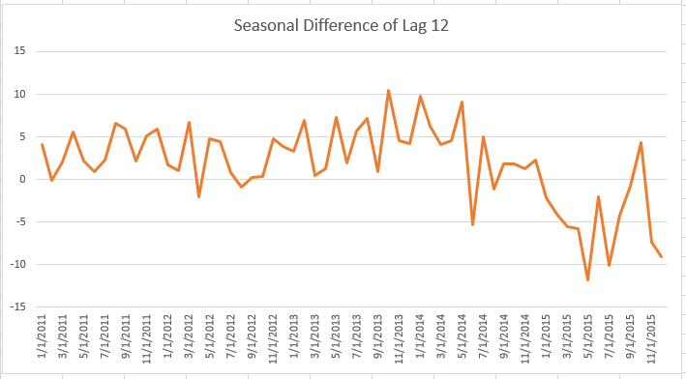

The data has a slightly negative trend indicating that is not fully stationary. To remove this negative trend a first difference will also be taken:

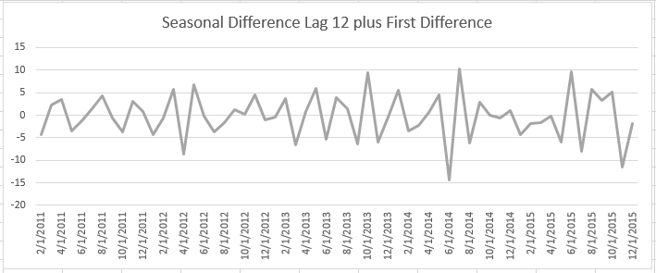

There does not seem to be any obvious patterns, and the data appears to have a mean of roughly zero. With these two parameters the data can be deemed stationary. By plotting a correlogram we can decide of the time series is autoregressive or moving average.

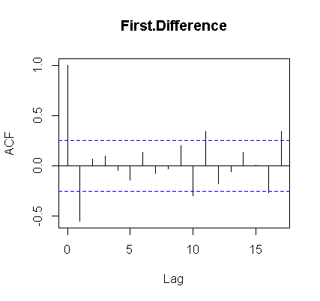
The correlogram shows an initial strong positive autocorrelation, followed by a significant negative autocorrelation. The positive and negative correlations went away quickly indicating that a moving average time series should be utilized. I fitted a seasonal moving average assumption -0.7069 arima model to the dental claims using built in functions in R.

To validate the fit of the model, the residuals where charted in both an autocorrelation function graph and Q-Q plot to test correlation and normality of residuals.
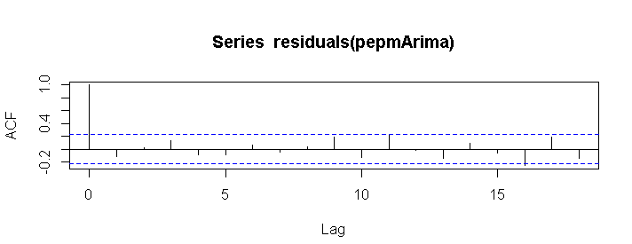
It is assumed by analyzing the above graph that the error terms are random and there is not autocorrelation between the residuals.

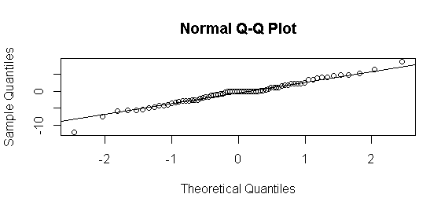
The above graph confirms that the residuals of the model are random and normally distributed. Residuals appear to be normal for the most part except for at the very extreme tails of the distribution, where the first point is below the line and the last point is above the line.
The following forecast graph was prepared to show how well the model predicts dental claims per member.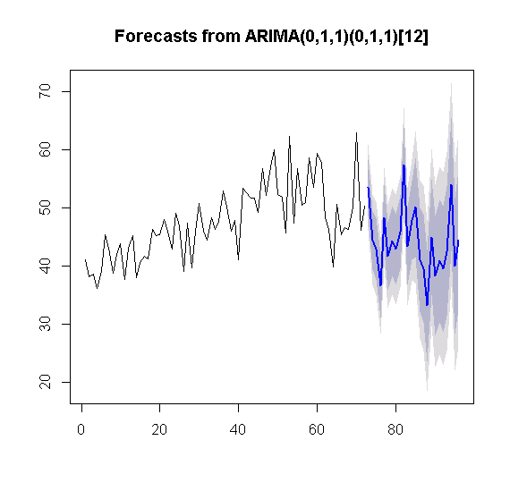
The data is through 2015, and the blue line represents the forecast for years 2016 and 2017. The shape of each year looks similar to the prior years, however the moving average model is continuing the negative trend that was shown in 2015.

Conclusion

The ARIMA(0,1,1)(0,1,1)[12] model passed all of the preceding tests, but unfortunately it is very rare and dental claims to have continued negative trends. I do not necessarily suggest a drastic change to the model, but a change to the data. Something appeared to happen in 2015 that lowered the average claim costs that needs to be normalized for before developing the time series analysis. An improvement to this study would be to dig into the data to determine why the data changed from historical trend. Then this model will become more efficient. An enhancement to the model would be to move to a second order moving average model. This may produce a better fit, and slow the impact from negative trend in the most recent year.

