xxxxxx xxxxxx
Time Series
Summer 2016

Iceberg Lettuce Time Series Model

Introduction

I have noticed that the price of lettuce always seems higher or lower than I expect and I was curious to see general trends in the price over time. I normally buy more interesting varieties of lettuce such as redleaf or romaine, but iceberg was the variety that had the most data to use for analysis so I decided it would be a reasonable substitute for my usual favorites. I used the time series data and techniques learned in the time series course to attempt to fit an ARIMA model to this data. The three steps used to determine the best ARIMA model are Model Specification, Parameter Estimation, and Model Diagnostics.

Data
The data was historical price per pound of iceberg lettuce by month from March 1987 until July 2016 from the Bureau of Labor Statistics and is located at: http://data.bls.gov/timeseries/APU0000712211?data_tool=XGtable#
There was one data point missing out of 353 total, so this data point was approximated using nearby values.

Model Specification
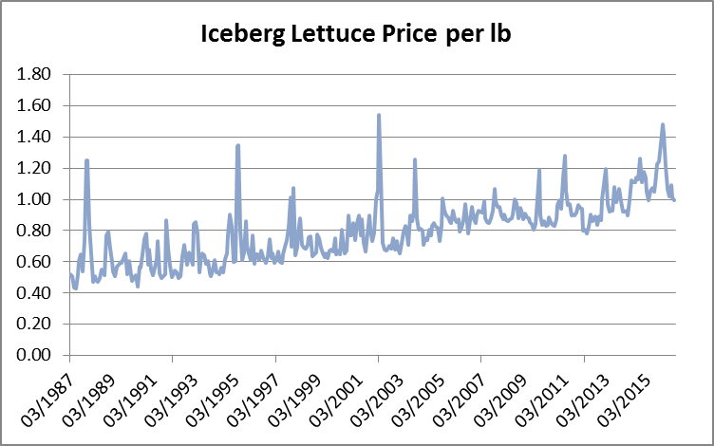
The plot of the data is seen below. There is a definite upward trend (although not too steep) but this implies that the time series is nonstationary. I plotted the sample autocorrelation at each lag for this series (seen below) to confirm nonstationary, and from this graph, it is clear that the time series is nonstationary, as the graph does not rapidly decline to zero and stay there.
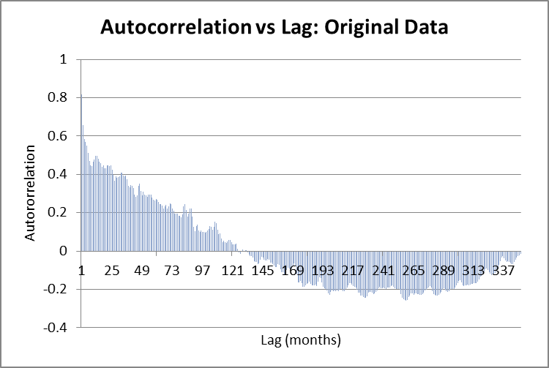
Seasonality:
My first thought when determining an appropriate model, was that there may be some seasonality for the price of lettuce. I attempted to adjust for seasonality by using factors for each month of the year, but this did not simplify the model at all. There is little difference between the seasonally adjusted time series and its correlation vs lag graph compared to the original time series. The graphs for the seasonally adjusted data are seen below. Because the seasonality adjustment did not simplify the time series, I determine that it is an inappropriate adjustment to use, as I do not want to introduce unnecessary complications to the model.
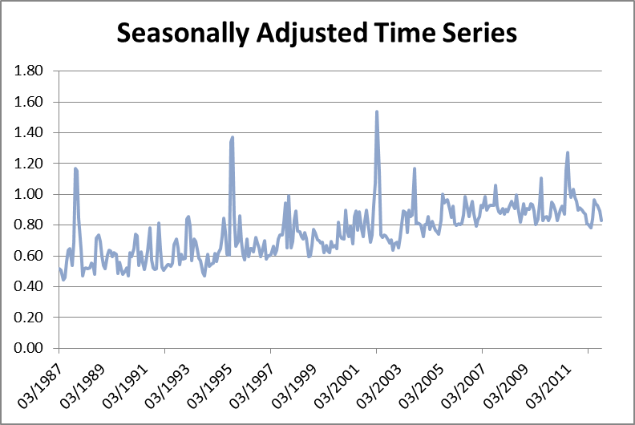
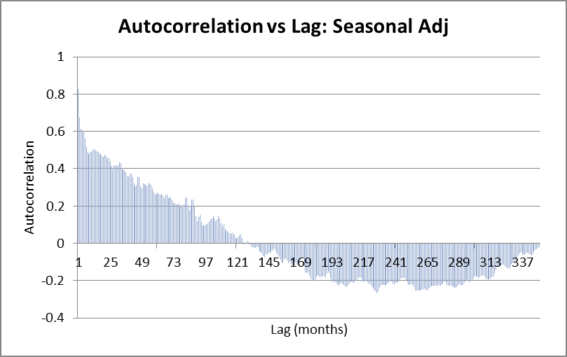
Differencing:
Since the original data was non-stationary, I attempted to take differences to get to a stationary time series. Below are the graphs of autocorrelation vs lag for 1st and 2nd differences. The autocorrelations for 1st differences decrease very quickly and oscillate around 0 which implies stationarity. For the 2nd differences, the autocorrelations also quickly reach 0 and oscillate, but it appears there may be too much changing of sign which is indicative of over-differencing. I am inclined to believe 1st differences are more appropriate, but will proceed with analysis of 1st and 2nd differences by considering models ARI(1,1), ARI(1,2), ARI(2,1), and ARI(2,2).
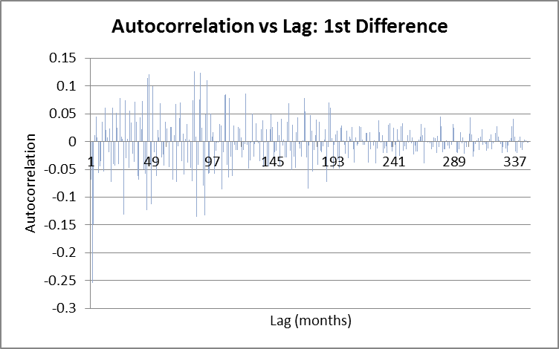

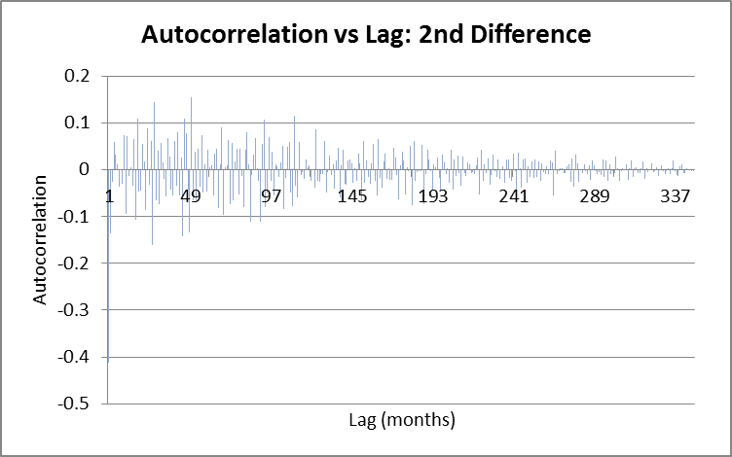

Parameter Estimation
I proceeded with considering AR(1) and AR(2) models for both 1st and 2nd differences. The general equations for these two types of models are
AR(1) Y_{t} = φ₁Y_{t-1} + ε_{t}
AR(2) Y_{t} = φ₁Y_{t-1} + φ₂Y_{t-2} + ε_{t}
To determine the parameters φ in each equation, I used Excel’s Regression tool. The output from these tools can be found in the attached excel file on the corresponding AR(p,d) tab, and is summarized in the table below.
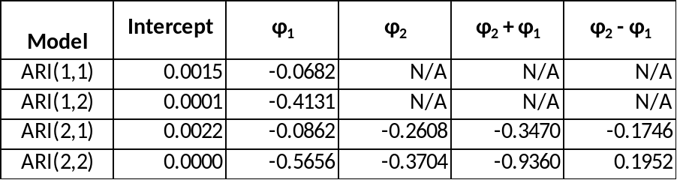

As a check, for the AR(1) models, |φ₁| < 1 which satisfies the requirement for stationarity of an AR(1) model, and for the AR(2) models, the conditions φ₁ + φ₂ < 1, φ₂ - φ₁ < 1, and |φ₂| < 1 are all satisfied. This implies that all of the above ARI(p,d) models are stationary.

Model Diagnostics
To analyze the appropriateness of the models, I used the adjusted R² and the Durbin-Watson Statistic to determine which would be the most appropriate model to use.
Adjusted R²:
The adjusted R² is the value from the Excel Regression tool. A value of 1 indicates that the model perfectly describes the data, whereas a value of 0 indicates that the model does not explain the variability of the data. Our adjusted R² values (seen in the table below) are all relatively small. This does not necessarily imply that a model is inappropriate, just that there is some variability that the model cannot explain. Due to the fact that all of the models have low adjusted R² values, I decided not to use this as a factor for determining my model. The adjusted R² for models with more parameters will of course be higher, but that does not necessarily mean the model is more appropriate, just that it can explain the data better.
Durbin-Watson Statistic:
The Durbin-Watson statistic is defined as
$$d = \frac{\sum{{(e_{t}-e_{t-1})}^{2}}}{\sum{{e_{t}}^{2}}}$$
where the $e_{t}$ are the residuals (actual value – fitted value) for each AR(p) model. The purpose of this statistic is to determine autocorrelation of the residuals; a value of $d$ close to 2 implies no autocorrelation, and values higher or lower indicate positive or negative autocorrelation. We ideally want that value to be 2. Looking at the Durbin-Watson statistic for the four models, shown below, the AR(1,1) model has a value closest to 2.
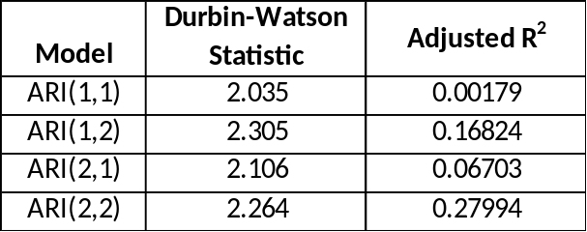
Using the fact that the ARI(1,1) model has the best Durbin-Watson statistic along with the principle of parsimony (one should choose the simplest model possible to describe the data), I tentatively choose the ARI(1,1) model as my choice for the time series. To verify that this is an appropriate model, I performed some analysis of the residuals from the ARI(1,1) model.
Residual Analysis:
I first plotted the standardized residuals at each time for the ARI(1,1) model. These appear to be equally distributed between positive and negative values, mostly between +/-1, which is what we would like to see for an appropriate model. This graph is shown below.

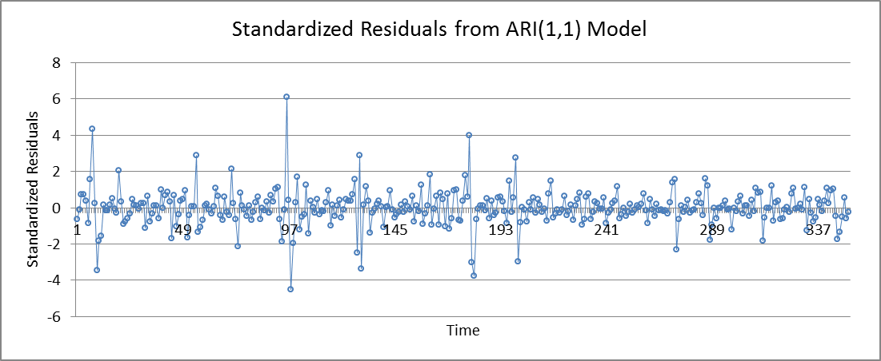
I also considered the quantile-quantile plot for residuals from the ARI(1,1) model. The residuals should be normally distributed, which would be indicated by the residuals being plotted along the line y=x on this graph. The residuals look reasonably close to that line, which leads me to conclude that they are approximately normally distributed, and the model is a decent fit.
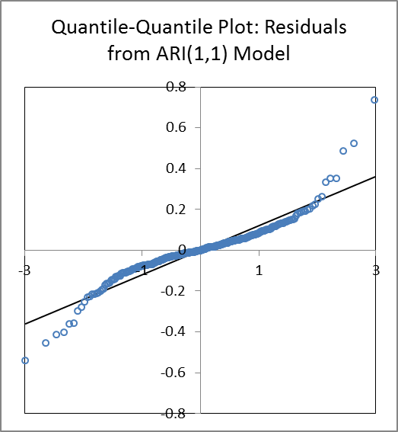

Conclusion
The final model I have chosen is an ARI(1,1) model, with no seasonality adjustment. The fitted model along with the actual data is seen in the graph below. The main factor for choosing this model was the principle of parsimony: it was the least complicated model that appropriately fit the data. From the graph below, the model appears to be a reasonably good fit.
