Time Series Student Project
Passed the Time Series exam in spring 2009 session

Time Series analysis of average age at first marriage

Introduction
More and more women in the Taiwan are getting married at late age. The average age of first marriage is increasing because of busyness, freedom or high expectations. Delay in marriage may put off the average age of mothers having their first child. Delayed childbearing affects the size, composition, and future growth of the population in Taiwan. The main goal of this analysis is to determine a time series model to forecast the average age of female having their first marriage in Taiwan.

Data
Data is obtained from Ministry of the Interior of Government. It includes age of first marriage for female from 1974 to 2015 in Taiwan.
Source:http://www.gender.ey.gov.tw/gecdb/Stat_Statistics_DetailData.aspx?sn=aeFG0R2tHwmrDtITC%2fJSaA%3d%3d&d=m9ww9odNZAz2Rc5Ooj%2fwIQ%3d%3d

Analysis
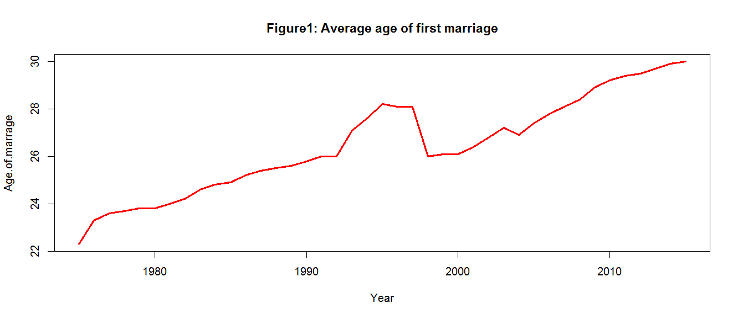
From Figure1, we find that age of first marriage has increasing trends obviously. An increasing trend may means nonstationarity. In order to confirm it, I further look at the sample autocorrelation function (ACF). Formula used for calculating the sample autocorrelation function is as follows:
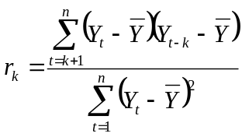
The Figure2 is ACF of data. We can see that ACF decrease and become to zero gradually. The autocorrelation function decays slowly. This may indicate nonstationarity of the series or AR model. As a result, we will perform sample partial autocorrelation function and find the slope $ϕ$ to pick a appropriate model.
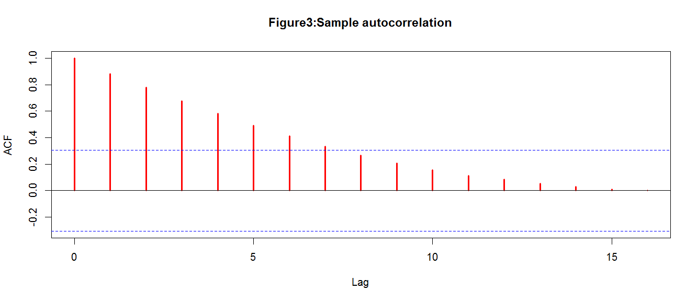
The partial autocorrelation function is used to determine the order of an AR model. From Figure3, we find that function seems to cut off after lag 1.This indicates that an AR(1) model may be applicable. As a result, we will be fitting an AR(1) model:
$$Y_{t}={ϕY}_{t-1}+θ_{0}+e_{t}$$

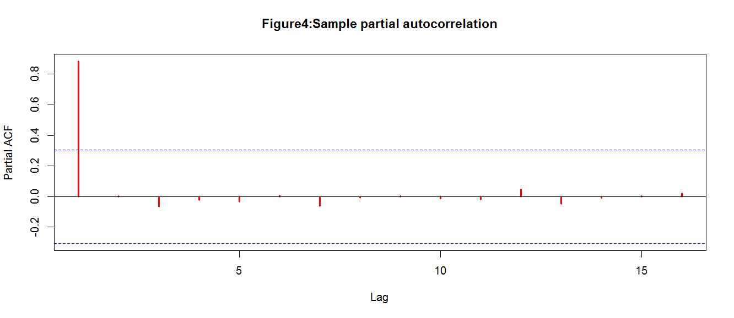
We estimate the slope $ϕ$ and the intercept $θ$ of an AR(1) model by using Excel’s regression add-in. The coefficient of $Y_{t-1}$ is 0.957085 lower than 1 which means AR(1) is stationary.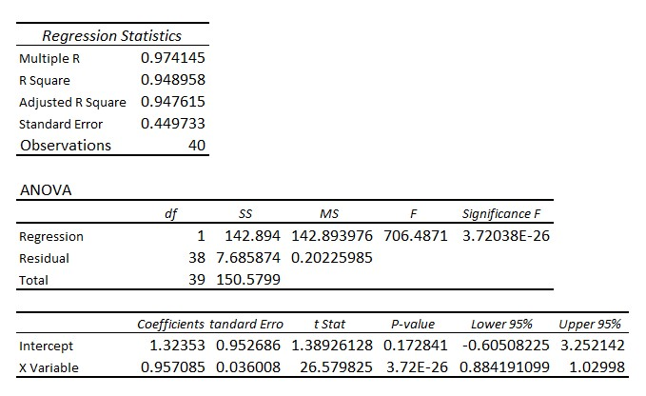
And the AR(1) model we get is $Y_{t}={0.957085Y}_{t-1}+1.32353+e_{t}$. We can see $R^{2}=0.948958$ which indicates good fit of this model. R-squared indicates the proportion of the variance in the dependent variable that is predictable from the independent variable. The higher the adjusted R-squared value the greater the fit of the model.
Model Diagnostics
Figure 5 is a comparison of actual age and forecasted age. Actual age and forecasted age are close and it shows the good fit of the model.

Then we plot the standardized residual of the model as Figure6. If the model is a proper fit to the data, the residuals must be independent, normally distributed random variables. I will be using the standardized residuals here since they are better in displaying any unusual behavior. By Figure6, the residuals spread well between -1.5 and 1.5 and we don’t see any trends or behavior of them.

Finally, we use QQ plot to check if the standardized residuals fit normal distribution. From Figure7, we can find that the standardized residuals are close to 45 degree line which means the residuals have a distribution close to normal.

Conclusion
By ACF and PACF, we pick AR(1) as our model and fit it. In order to make sure stationarity, we check the coefficient of $Y_{t-1}$ and it is lower than 1. Then we get $Y_{t}={0.957085Y}_{t-1}+1.32353+e_{t}$. We can see $R^{2}=0.948958$ which indicates good fit of this model. Besides, we plot actual age and forecasted age by our model and find that they are close. It also shows the good fit of this model. Finally, we analyze standardized residuals and observe they are independent, random and close to normal distribution. As a result, we think $Y_{t}={0.957085Y}_{t-1}+1.32353+e_{t}$ is an appropriate model.

