Course: Time series
Name: xx xxxx xxxxx
Country: VietNam
Session: 2016 summer
---------------------------------------------------------------------------------------------------------------------------------- TIME SERIES STUDENT PROJECT
DIVORCE RATE
- Introduction
Nowadays, the society have been developing, the living standard increases resulting in people to be less and less dependent to each other. They are able to take care of themselves and want to live alone for independence as well as freedom. In this project, I would like to analyze divorce rate time series. The high divorce rate may be a problem to society where children have less care and support from their parents
My working is to choose the model to well forecast the rate in the future which we can use to anticipate or investigate future society issues.
- Data
The data which I use is from http://www.infoplease.com/ipa/A0005044.html. This is divorce rate table in US from 1900-2012. In the table, from year 1900 to 1980, we only have the rates every 5 years or 10 years. Afterward, we have the rates on yearly basis. To precisely model, I only use the rates from year 1980 and try to predict the future rate from existing rates.
The chart below shows the divorce rates from 1980-2012

The rates are vary in 3/1000-6/1000. They are not stationary, have the downtrend.
- Analysis and Model
Because there may be relationship between current number with past numbers which is key consideration to model, I will check the relationship first with sample autocorrelation function. At lag k, the autocorrelation function is calculated as
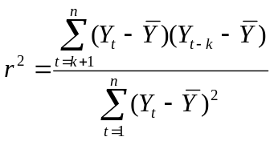 for k=1,2,3,…
The results are below.

The sample autocorrelation (SA) start from near 1 then go down under 0 at lag 12 to -0.4, then go up to 0 at long lag which suggests that the time series may not be stationary
Next, I consider the 1st different of the time series to check if it is stationary. The chart of 1st difference of the time series are as below

The numbers are rather close to 0 which suggests the stationary of the time series. Then, I further check the sample autocorrelation of 1st difference of the time series. The results are as following

The AS vary at first lags then converge to 0 at long lags which suggests that the time series may come from autoregressive model.
Because if 1st difference of the time series is stationary, the 2nd difference is too. Thus the graph for 2nd difference will be the same as ones for 1st difference.
From analysis above, I will fit the time series to AR(1) and AR(2) model. If AR(2) model is much better than AR(1), it will be chosen.
Below the statistic results for fitting the time series to AR(1) and AR(2) model

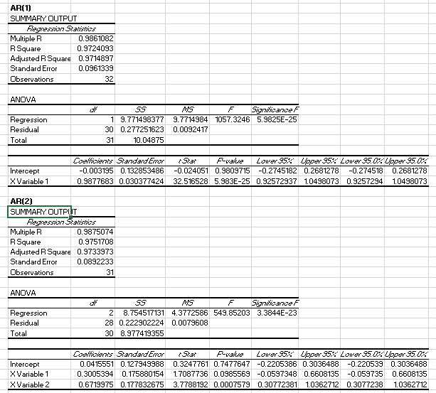
Because Standard Error between 2 models are rather similar while the Adjusted R Square is around 97%, there is no reason to choose 2nd model to make the forecast more complicated. I will chose 1st model to fit the time series.
The model is Y_{t} = 0.99Y_{t-1} – 0.003
- Conclusion
The model is chosen to Y_{t} = 0.99Y_{t-1} – 0.003% with Adjusted R Square = 97% and Standard Error = 0.096.
I also test the model with fitted chart to compare the actual value vs fitted value.

The chart shows that the fitted model is good enough to use.

Appendix: Data and Working file


