Global Earthquakes Greater than 6.0 Magnitude

Time Series Student Project
xxxxx xxxxxxx
November 4th, 2016

Introduction
Earthquakes happen all over the world and more frequently than it seems most Americans would guess. Typically in the news we hear about the larger and/or more devastating earthquakes. For my Time Series project, I have decided to look at strong earthquakes worldwide each year and see what type of model best fits the data.
In general I am interested in earthquakes and recognize that historically a lot of research has been put into pursuing being able to predict earthquakes. In Seattle, we are reminded frequently by the media about the likelihood that the “big one” will hit in the next n years. That said, it is no secret that individual earthquakes cannot be predicted reliably.
Data
Earthquake data is readily available from the USGS website for a variety of regions and magnitudes. I chose to look only at earthquakes with magnitude 6.0 or higher as these are less frequent but would represent a significant event in whatever region they occur. Since 1950, there have been 9,297 recorded earthquakes worldwide that meet or exceed this 6.0 magnitude threshold. To analyze, I have chosen to roll up this data into the calendar year in which the earthquakes occurred. Annual frequency can be seen in the line graph below:
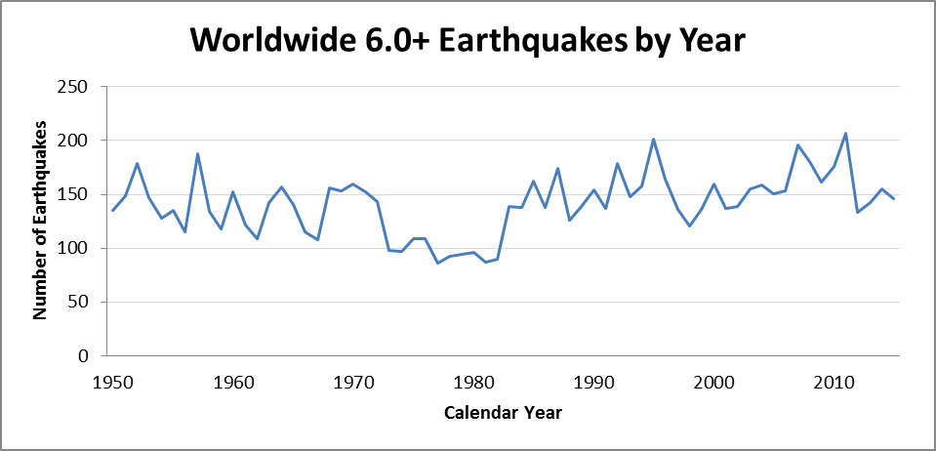
Model estimation
At first glance, the data does not appear to have any seasonality and it looks to be stationary as it does not trend up or down over time. Visually, this data looks like it could be modeled as a white noise process. To determine this we must find the sample mean and analyze the residuals (difference between the sample mean and each value). If the process is white noise, the residuals will be approximately normally distributed with a mean of zero.
The average number of significant earthquakes observed in a single year is 140.9. Since there are only 66 data points (1950 – 2015), a histogram of residuals looks roughly normal with a mean of zero but is not all that convincing:
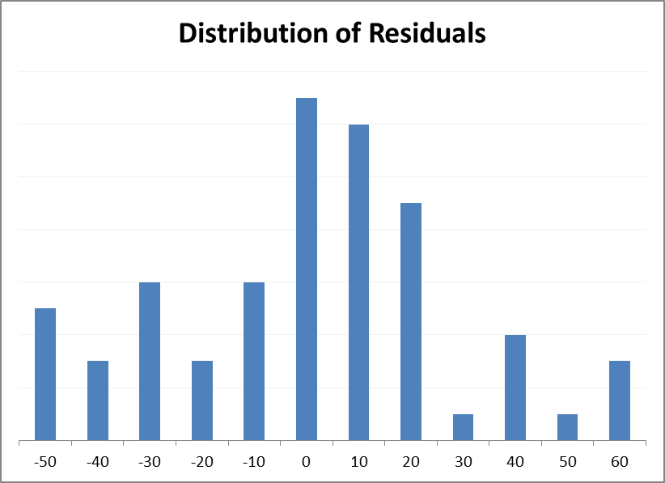
The mean of the residuals is in fact zero, so that is promising. A Q-Q plot shows that a normal distribution is a good fit, with a mean of zero and a standard deviation of 27.96. Also included is a line fitted to the scatter plot that shows the theoretical percentiles are almost equal to the actual percentiles.
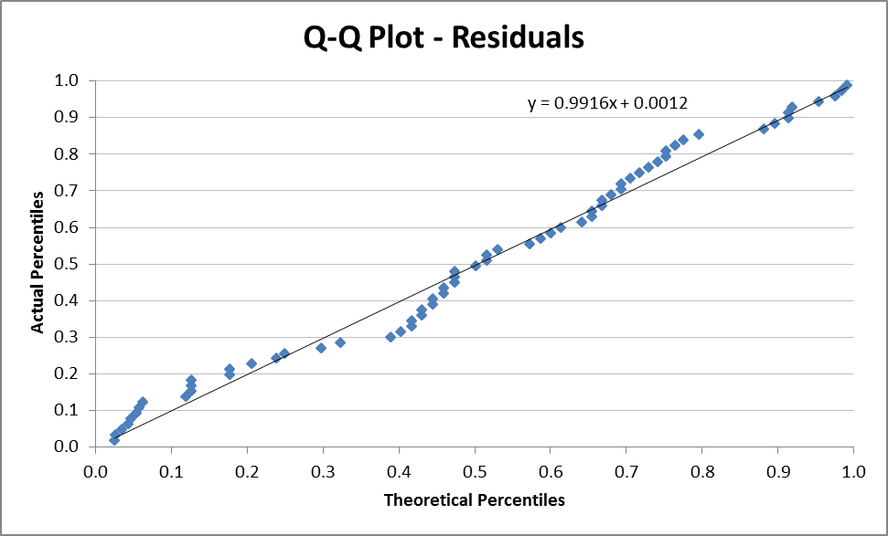
Based on this information, the model that best fits the data is a white noise process:
Y_{t} = µ + e_{t}
Where µ = 140.9 and e_{t} is distributed normally with a mean of 0 and a standard deviation of 28:
Y_{t} = 140.9 + e_{t}
While this is not a particularly interesting result, it is a reasonable. If strong earthquakes experienced in one year gave a meaningful indication of the number of strong earthquakes expected in the next year, this would likely be a well-known fact used by the media.
Additional Analysis
While confident that this time series is a white noise process, I wanted to probe further into some interesting observations related to correlation with various lags. Below is the autocorrelogram for lags 1 to 50:
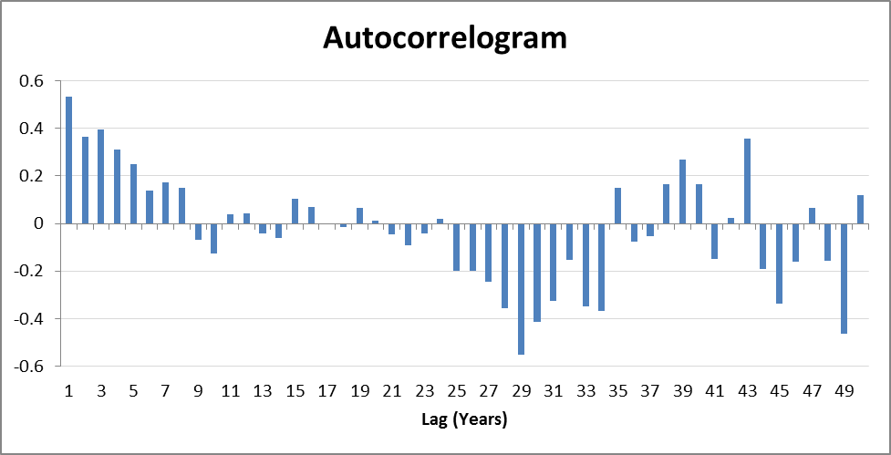
The high correlation with small lags is quite high and if zoomed in to lags 1 through 30, this looks like a cosine wave. A scatter of this year’s and last year’s earthquakes is below:
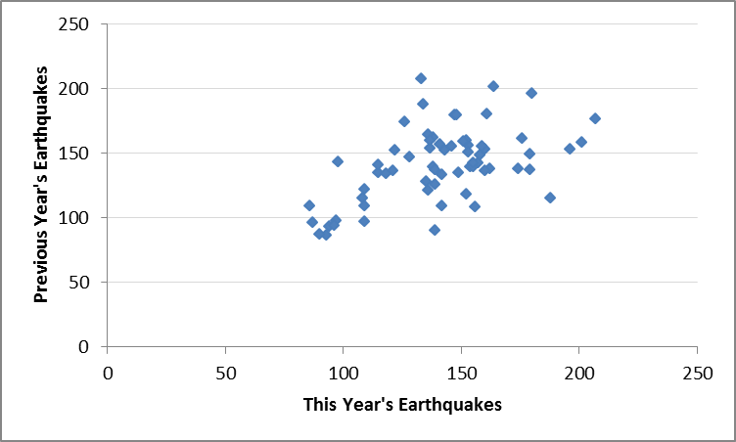
This does not show any consistent pattern. To further explore, a regression was run on this year’s vs last year’s earthquakes. The outcome was an R-squared value of just 0.285, which is not high enough to reject the white noise process.
Conclusion
Data related to earthquakes is constantly being captured in real time, so there is a large amount of it to be analyzed. With my limited scope, it is not particularly surprising that a white noise process fits my data quite well. The 66-year data period, at least from a geological perspective, is quite short. If we could look at a significantly longer period of time, some interesting patterns may be observed. For example, there might be periods of high geologic activity and corresponding periods of low activity. Based on my data I would still suspect these to be white noise processes, just with different means and a different distribution of the residuals.

