xxxxxxxx xxxxxx
Winter 2006
Time Series Student Project

A Time Series Model of Strawberry Prices

Introduction
The price of strawberries seem to fluctuate wildly in the grocery store and from my layperson analysis appears to have no direct correlation to anything in particular. As a result I’m interested in if there are any strawberry price trends. For my project I looked at the historical price of strawberries to determine an appropriate model for future forecasting. My initial thought is that an AR(p) model would work because strawberries are a consumer good and consumer demand as well as supply issues are likely correlated with prior months. For example, if the strawberry production is low due to bad weather that impacted the strawberry crops, that trend will be impacted for many months as the amount of strawberries is directly correlated to the number of plants producing strawberries, so prices may continue to rise during this time.

Please note that I’ve utilized the template provided by the NEAS under student projects entitled “A Time Series Model of Ice Cream Prices” from the winter 2016 TS course, but all analysis and conclusions are my own.

Data
Historical data for the price of strawberries per 12 ounce can be found here:
http://data.bls.gov/timeseries/ APU0000711415?data_tool=XGtable
I pulled monthly data for over ten years, from January 2006 to October 2016. The plot of the price per 12 ounce over time is shown in Chart 1. There were two months in the dataset that were missing data. To estimate these two months I took the average of the preceding and subsequent month as a proxy.
Chart 1: Strawberry Prices over Time
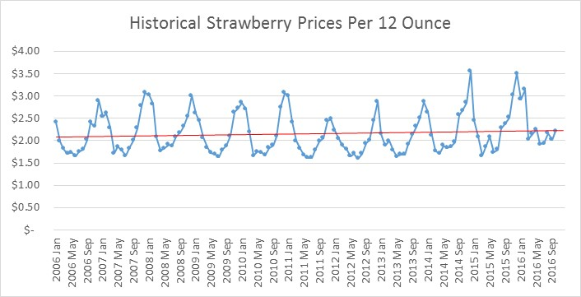
The seasonality can be clearly seen in the graphing of the price per 12 ounces. The trend line (which is shown with the red line) is not as clearly defined as the seasonality. In fact it seems that strawberry prices have not been trending upward like most cost of goods over a 10 year period. This suggests that this time series could potentially be stationary. Chart 2 is an analysis of the correlogram for the series to confirm whether it is stationary. Based on Chart 2 it appears that this series is in fact stationary.
Chart 2: Auto-Correlation Plot of AR Process of Strawberry Prices
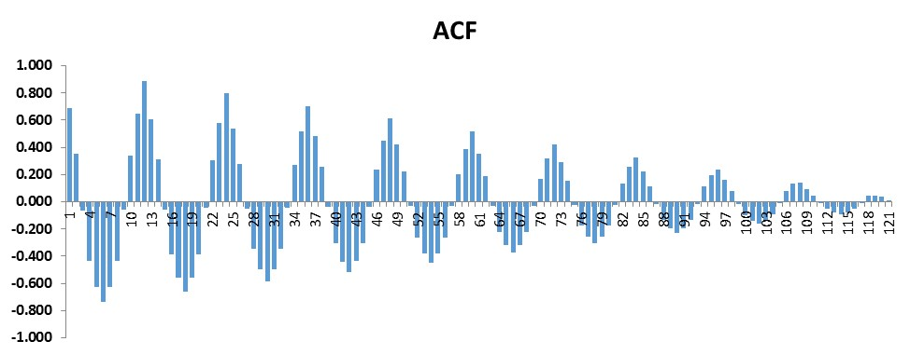

Seasonality
Next an analysis of seasonality is important, and intuitively based on the previous charts it appears that there is marked seasonality in the data. There are a variety of different types of strawberry plants and all have different growing seasons and as a result different crop timings. Most strawberries are grown in California, which grows approximately 88% of the country’s total fresh and frozen strawberries and has an approximate 12 month growing season. The marked seasonality in Chart 1 however leads me to believe that there are more factors at play than just supply and demand for strawberries must have a critical impact on the seasonality of the prices. To better understand the seasonality I took an average price per month and then calculated a seasonal factor by looking at the monthly relativities as a ratio of total. The relativities are shown in Chart 3.
Chart 3: Seasonality Relativities of Price by Month
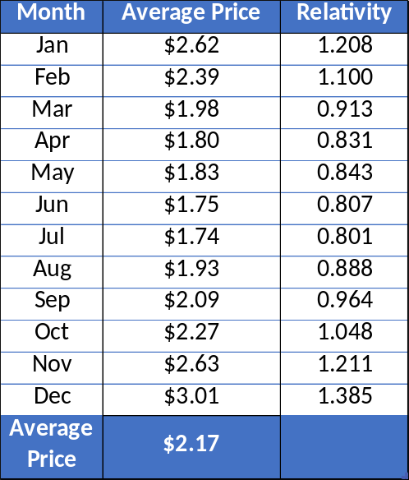

Based on these relativities it is recommended to use seasonally adjusted data. The adjustments are along the lines of -19.9% to +38.5% which is extremely significant, and it is customary to use seasonally adjusted data to get a more accurate trend. The ACF graph shown in Chart 4 with the seasonally adjusted data looks smoother and even more stationary than Chart 2.
Chart 4: Auto-Correlation Plot of AR Process of Seasonally Adjusted Strawberry Prices

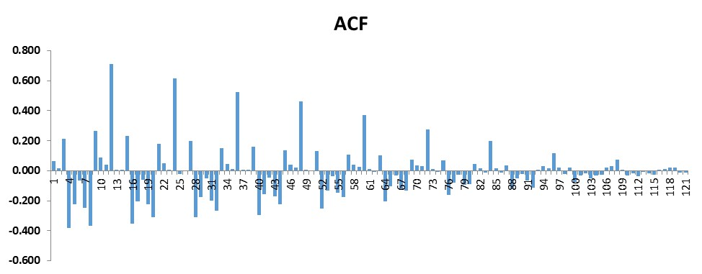

Differencing
I have decided to focus on the seasonally adjusted data and because I wish to have a stationary model, an analysis of the first difference is important to complete.
Chart 5: Auto-Correlation Plot of First Difference AR Process of Seasonally Adjusted Strawberry Prices
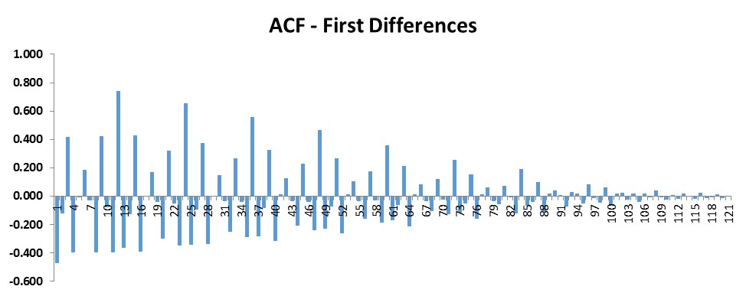
The standard deviation of the first differences is 0.16472, which is an increase to the standard deviation of seasonally adjusted only (no differences) of 0.12095. This means that the no order of differencing seasonality adjusted model is the best fit. Just to be sure I ran a second differences model and looked at the graph and the standard deviation as shown in Chart 6.

Chart 6: Auto-Correlation Plot Second Difference AR Process of Seasonally Adjusted Strawberry Prices
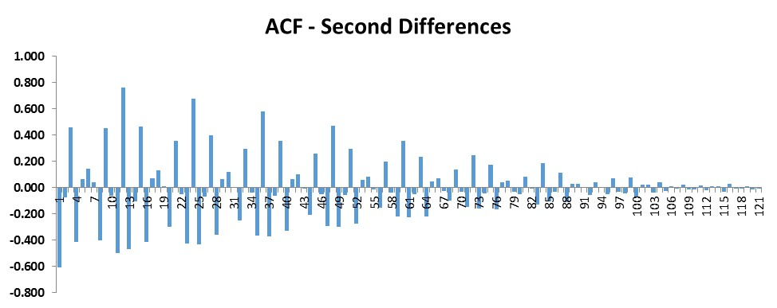
The standard deviation of the second differences has increased from the first differences, as the second differences standard deviation is now 0.28221 (the standard deviation of the first differences is 0.16472). Since the standard deviation continues to increase this means that the seasonally adjusted model with no orders of difference was already stationary and that we do not need to difference our model to produce a stationary result.

Model Specification and Diagnostics
Running regression statistics for the seasonally adjusted no order differencing model shows a couple of very surprising statistics – and that is the R² is tiny (i.e. statistically non-existent) and there is positive autocorrelation in the data. Below is the regression statistics and the Durbin-Watson statistic for the no order differencing seasonally adjusted model (AR1).
Chart 7: Regression and Durbin-Watson Statistics for AR1 model
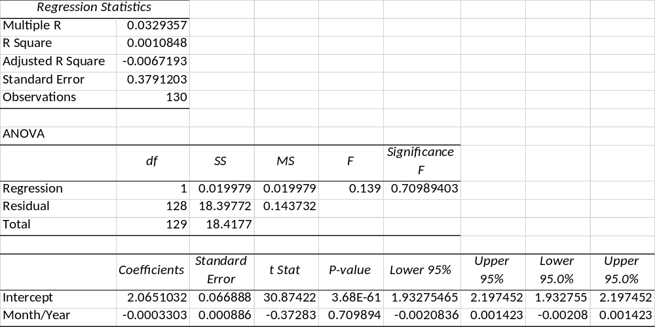
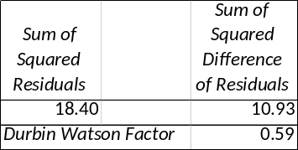

Chart 8 is the Plot Fit for this AR(1) model and Chart 9 is the residual plot which clearly shows the positive autocorrelation.
Chart 8: Plot Fit for AR1 model
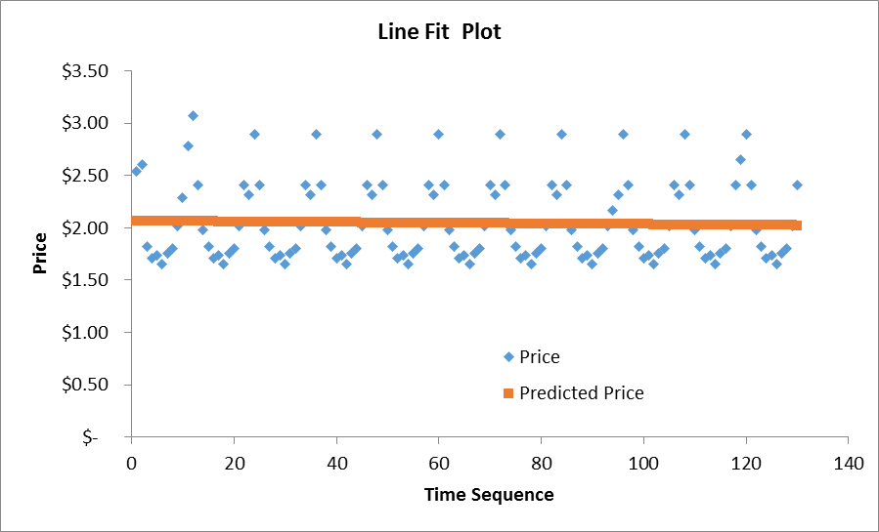

Chart 9: Residual Plot for AR1 model
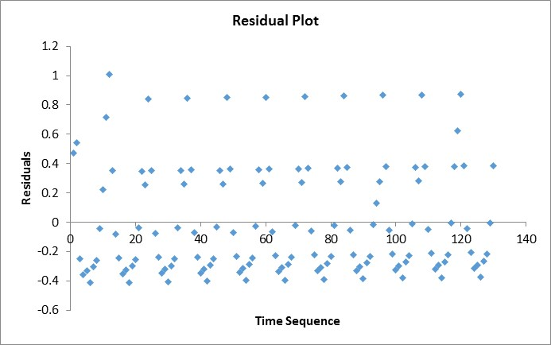

Due to the intense seasonality patterns (even after adjusting for seasonality) the definite lack of trend in the data and the low R² value I re-ran the model and instead of using each month and year as a corresponding time sequence I dropped the values into month only indicators. This produced a much stronger R2 value however, it did not have a real impact on the positive autocorrelation.

Chart 10 is the Regression and Durbin-Watson output. Chart 11 is the Plot Fit for this AR(1) model and Chart 12 is the residual plot which shows the slightly lessened positive autocorrelation.
Chart 10: Regression and Durbin-Watson Statistics for AR1 model Using Monthly Indicators
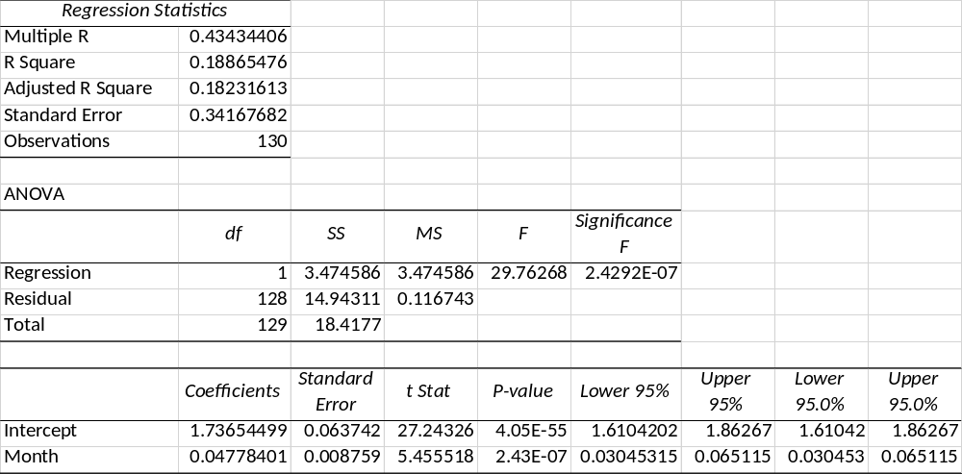
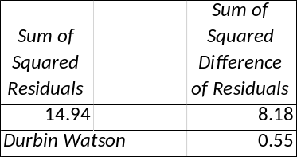
Chart 11: Plot Fit for AR(1) model Using Monthly Indicators
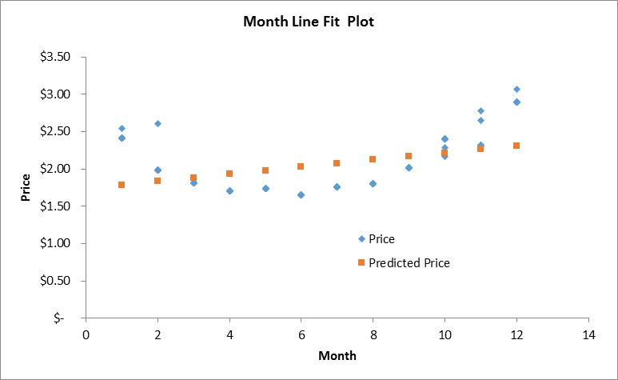

Chart 12: Residual Plot for AR1 model Using Monthly Indicators
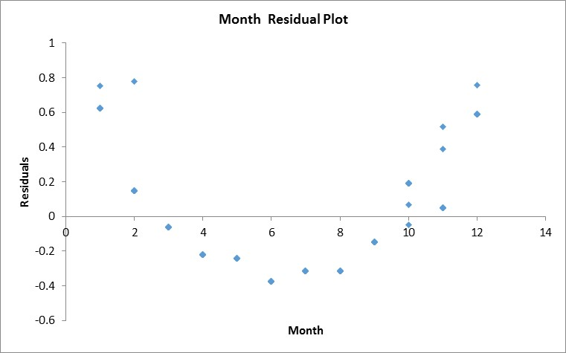

Final Model and Fit
Based on the all of the data available to me I am recommending that we use the seasonally adjusted AR(1) model that uses monthly groupers.

