xxxx xxx xxxx
NEAS Time Series Student Project
Winter 2016
Modeling Worldwide Automobile Sales

Introduction
I am interested in the product sales and recently I want to buy a new car. So I try to model the worldwide automobile sales. In the series of research and analysis, we usually make some assumption from the experienced data in order to forecast the future. Similarly, I would like to use the knowledge and the skills I learned in the book to model the product sales in worldwide auto sales. I will fit experienced data by selecting suitable model and forecast the future.

Data

The Data has been collected from the Honda website. http://world.honda.com/investors/financial_data/monthly/.
I used the monthly data from Jan 2010 to Dec 2015 from database to build the model.

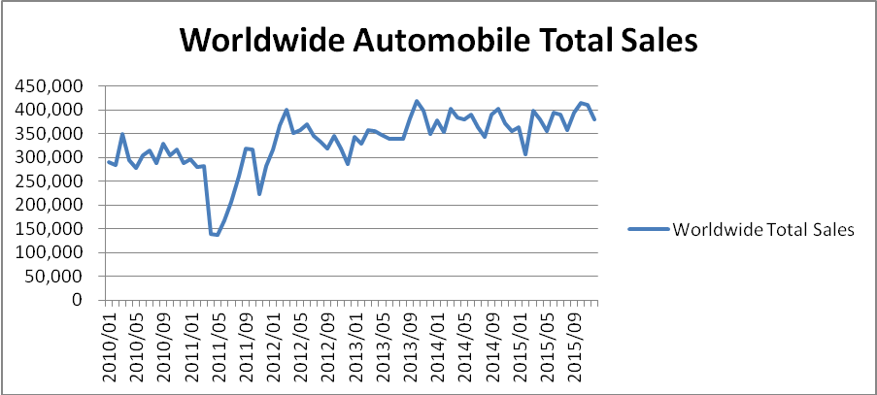

From the graph above, we can see that generally the data trends upwards. In addition, we can also see that there seems to be a seasonal trend of 12-month cycle. Every twelve months, there seems to be an upward trend and then a downward trend in the first 3 quarter, and in the final quarter ,to be an upward trend and then a downward trend slightly , which is consistently repeated every twelve months except 2011. We can daringly assume the data has seasonality.

We do more by performing the autocorrelation function to confirm the seasonality.

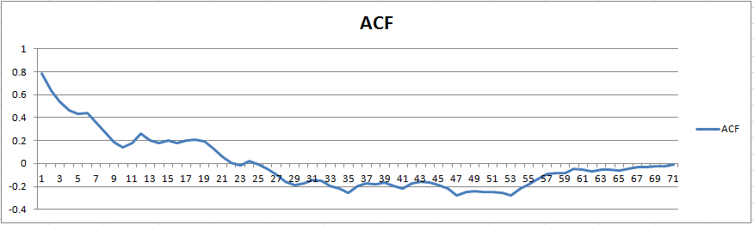

The ACF graph supports our assumption above. We can see peaks at the lags in multiples of 12 which show the annual seasonal pattern. The differenced data can be used to deseasonalize the data. Therefore, the first data point considered would be the difference between the sales data from January 2010 and December 2015.

The First Difference in Worldwide Automobile sales
The graph below is showing the first differences in monthly worldwide automobile sales from 2010 to 2015. It oscillates in x-axis but does not show any trend of being stationary.

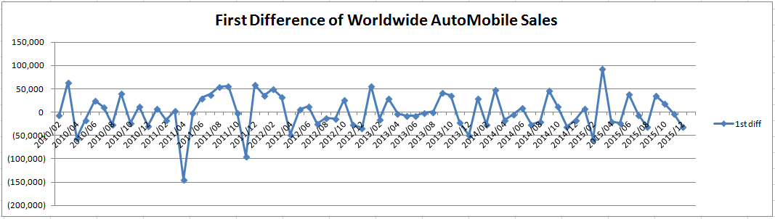

Let’s look at autocorrelation function of the first differences to see if we can have more information.

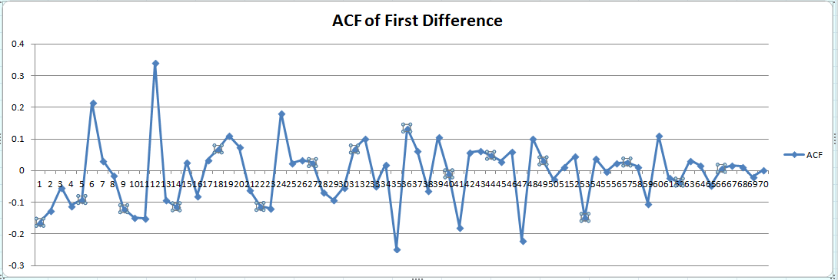
Although it does not decay quickly, we can still tentatively conclude that the autocorrelation values are stationary. We can see clearly it decays to zero starting from lag 65.

The Second Difference in Worldwide Automobile sales
The graph below is showing the second differences in monthly worldwide automobile sales from 2010 to 2015. It is similar to first difference oscillating in x-axis but does not show any trend of being stationary.

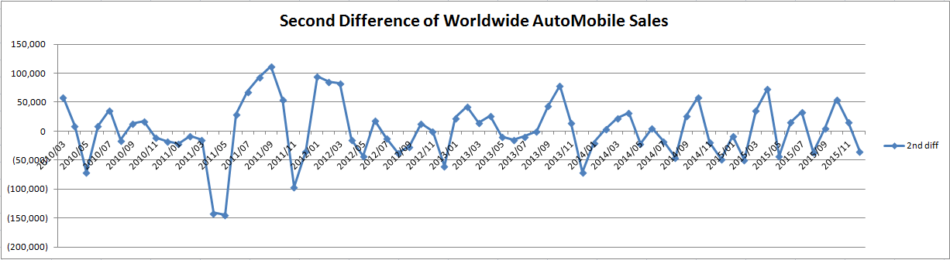

The graph below is autocorrelation function of second difference.
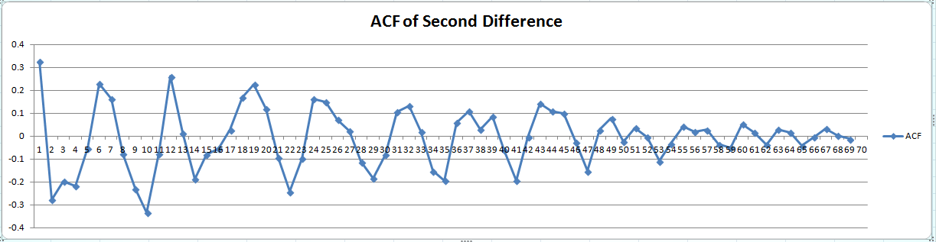

This time, the trend is more clearly decaying than the ACF of first difference. It approaches to zero in lag 55.

Since the adjusted ACF of sample data doesn't have any sharp drop-offs and instead decreases gradually to 0, this suggested an autoregressive model rather than the moving-average model.

Autoregressive Model
The equations are estimated using the Regression tool in Excel.
AR(1): Yt =70105.78123823 +0.793200376618191 Yt-1.
AR(2): Yt =66890.9057613981 +0.741481088774255 Yt-1 +0.0623628208237974 Yt-2

Here is the AR(1) model with R square value of 0.628.

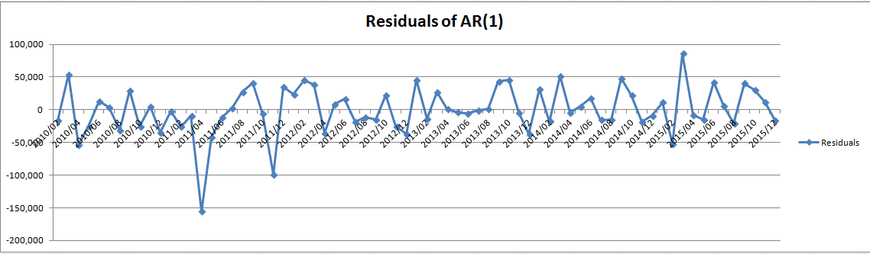

The graph above shows the residuals of AR(1). It is mostly within 50,000. Some of them are a bit off from actual data.

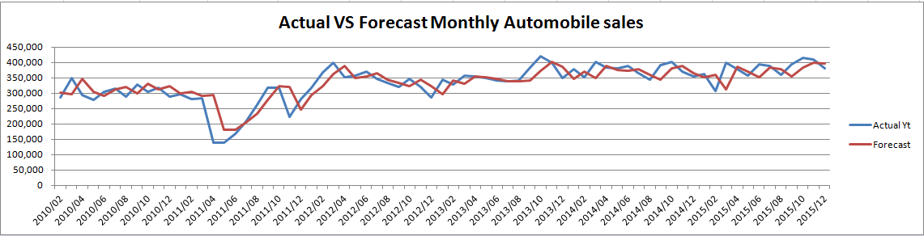

The graph above shows the comparison of the actual data with the forecast data using AR(1) model. They seem highly correlated between each other. We can see a bigger difference around 50,000 in Year 2011.

Here comes the AR(2) with R square value of 0.627.
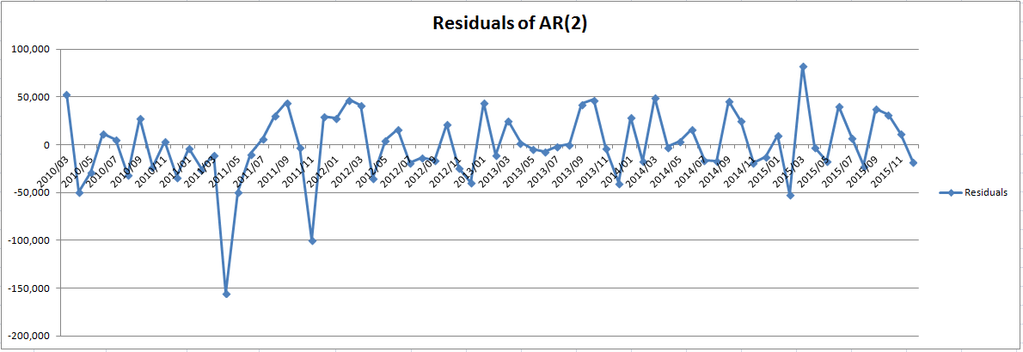
The above graph is the residuals of AR(2). It looks similar to AR(1) but if we look into more detail, we can find the variance of AR(2) is slightly smaller than AR(1).

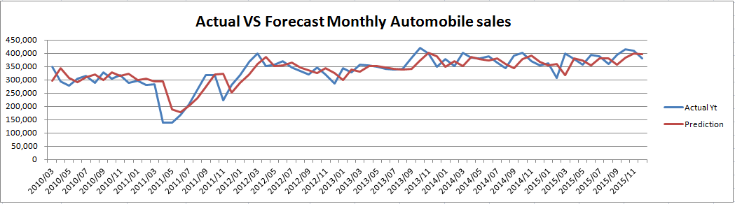
Here is the comparison of the actual and forecast model of monthly automobile sales. We can see the regression model predicts the monthly car sales values well from January 2013 to December 2015. It seems to be able to predict the pattern of the forecasted values well from January 2010 to December 2015.

Conclusion

The autocorrelation model is able to forecast the trend. The graph about comparing actual and predicted monthly car sales above demonstrate the AR(2) model is a well-predicted model. From the residuals graph, AR(2) does a better job than AR(1). We know there is no perfect model. The regression model cannot predict the extreme values but the overall trends.

